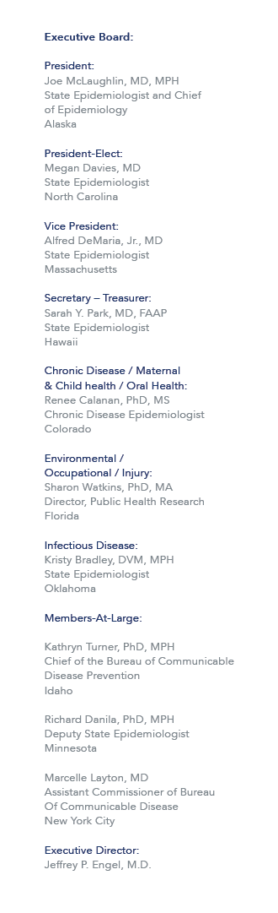October 14, 2015

Re: Travel Arrangements to the Council of State and Territorial Epidemiologists (CSTE) Occupational Health (OH) Surveillance Subcommittee Meeting in Cincinnati, OH on Dec 2, 2015.

Dear Sponsored Traveler,

As a recipient of funding support through the CSTE-CDC Cooperative Agreement for your participation in the 2015 CSTE OH Surveillance Subcommittee Meeting, you will be funded for airline transportation, ground transportation (excludes rental cars and taxi service other than transportation to and from the hotel and airport), hotel accommodations, and per diem allowance Please read the full disclosure of the CSTE Travel Support Guidelines that includes guidelines regarding expenses and cancellations:
http://c.ymcdn.com/sites/www.cste.org/resource/resmgr/PDFs/2014TravelPolicyRevisedFINAL.pdf.

Airline Transportation
Airline transportation will be provided to and from your originating city to the venue city, Cincinnati, OH. Flight reservations must be made through the CSTE official travel agent, American Express (800-872-9954). Airline reservations must be made no later than Monday, November 16, 2015. The CSTE National Office must pre-approve travel arrangements not made through our travel agent in order for the traveler to receive reimbursement. If you have questions or need assistance with airline transportation, contact the CSTE National Office at 770-458-3811 or travel@cste.org.

Ground Transportation
CSTE will reimburse up to $35 roundtrip for ground transportation to and from the Cincinnati/Northern Kentucky International Airport (CVG). The Hotel offers Airport Shuttle Service through Executive Shuttle for $32.00 round trip ($22 one-way). Please call Executive Airport Shuttle directly at 513-352-2135 to book your service. Taxi transportation from the CVG Airport to the hotel is approximately $25 one way.

Hotel Accommodations
Arrangements for hotel accommodations must be made directly with the Hilton Cincinnati Netherland Plaza by Monday, November 9th. Place your reservation online at: http://www.hilton.com/en/hi/groups/personalized/C/CVGNPHF-CSTE-20151130/index.jhtml. Online booking is preferred, but you can also call 800-445-8667 to book your room under the “CSTE” room block. A discounted per diem rate has been negotiated ($125 + tax) as well as free basic wireless internet. CSTE will reimburse only room and tax for up to three nights.

Per Diem
Meal expenses are reimbursed at the federal per diem allowance for Cincinnati, OH of $69.00 per day.

Reimbursement Procedure
After the meeting, complete the reimbursement form provided and include any receipts greater than $50.99 and all airline boarding passes. Please send the signed expense reimbursement form to the CSTE National Office via email to travel@cste.org or via fax to (770) 458-8516. Expenses will not be reimbursed until after the meeting. If you are unsure if an expense will be reimbursed, contact msharpe@cste.org for clarification.

Sincerely,

Mone’ Sharpe
Meeting and Travel Coordinator

