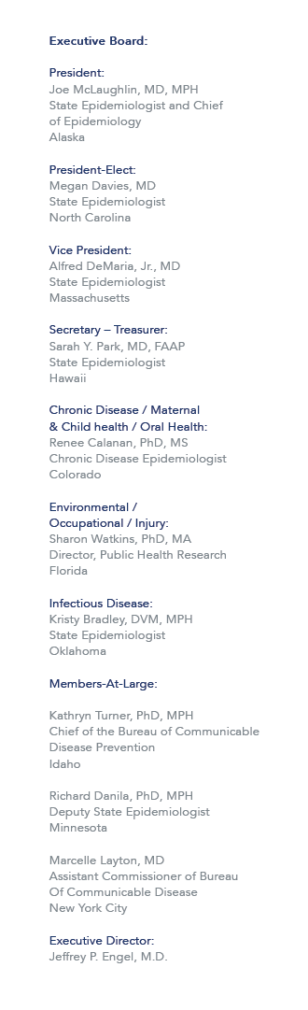

October 14, 2015

Re: Travel Arrangements to the Council of State and Territorial Epidemiologists (CSTE) Occupational Health (OH) Surveillance Subcommittee Meeting in Cincinnati, OH on Dec 2, 2015.

Dear Sponsored Traveler,

As a partial recipient of funding support through the CSTE-CDC Cooperative Agreement for your participation in the 2015 CSTE OH Surveillance Subcommittee Meeting, you will be funded for hotel accommodations, and per diem allowance, up to $400.00. Please read the full disclosure of the CSTE Travel Support Guidelines that includes guidelines regarding expenses and cancellations:
http://c.ymcdn.com/sites/www.cste.org/resource/resmgr/PDFs/2014TravelPolicyRevisedFINAL.pdf.

Hotel Accommodations
Arrangements for hotel accommodations must be made directly with the Hilton Cincinnati Netherland Plaza by Monday, November 9th. Place your reservation online at: http://www.hilton.com/en/hi/groups/personalized/C/CVGNPHF-CSTE-20151130/index.jhtml. Online booking is preferred, but you can also call 800-445-8667 to book your room under the “CSTE” room block. A discounted per diem rate has been negotiated ($125 + tax) as well as free basic wireless internet. CSTE will reimburse only room and tax for up to two nights.

Per Diem
Meal expenses are reimbursed at the federal per diem allowance for Cincinnati, OH of $69.00 per day.

Reimbursement Procedure
After the meeting, complete the reimbursement form provided and include any receipts greater than $50.99 and proof of meeting attendance. Please send the signed expense reimbursement form to the CSTE National Office via email to travel@cste.org or via fax to (770) 458-8516. Expenses will not be reimbursed until after the meeting. If you are unsure if an expense will be reimbursed, contact msharpe@cste.org for clarification.

Sincerely,

Mone’ Sharpe
Meeting and Travel Coordinator

