

2016 State Reportable Conditions Assessment (SRCA)
User Instructions

SRCA INTRODUCTION & BACKGROUND

The State Reportable Conditions Assessment (SRCA) is an annual, web-based assessment of reportable conditions. Ongoing since 2007, this joint effort by the Council of State and Territorial Epidemiologists (CSTE) and Centers for Disease Control and Prevention (CDC) collects publicly available information on what conditions are reportable in states, territories, and other large jurisdictions and who is required to report them. The SRCA is intended to be a publicly available, national repository of information that can be used by public health, researchers, and healthcare providers. CSTE is charged with providing a comprehensive and accurate list of reportable conditions by state and territory, and with your participation, CSTE will achieve a 100% response rate.

WHAT SHOULD BE REPORTED IN SRCA?

The SRCA covers reporting requirements, as defined by regulation or legislation, for conditions defined as reportable by clinicians (i.e., healthcare providers), laboratories, hospitals, and other reporters in your jurisdiction. SRCA responses should reflect these reporting regulations or rules as closely and accurately as possible. Any conditions that must be reported to the state public health agency should be considered reportable in the SRCA. If a condition is reportable to another department within your state (e.g., Department of Agriculture) but the state health agency receives this information as the result of a data-sharing agreement, then the condition should also be considered reportable. Conditions that are not named on your jurisdiction’s lists but fall under general, catch-all reporting language, such as “all outbreaks,” “disease of public health importance,” etc., are considered implicitly reportable in the SRCA and should be included in your responses. More information on implicitly reportable conditions may be found further in the instructions.

In addition, the information entered into the SRCA should be accurate and reflective of your jurisdiction’s reporting rules prior to July 1, 2016 in order to reflect reporting requirements effective for the majority of the year.

HOW SRCA DATA IS USED

Data from the 2016 SRCA pertaining to nationally notifiable infectious diseases will be used in generating tables for the Morbidity and Mortality Weekly Report (MMWR) Annual Summaries. In addition, CSTE will build a queriable results database on the CSTE website in which 2016 SRCA data will be displayed after the assessment is completed and results have been validated.
SRCA DATA COLLECTION TOOL

CSTE has an online data collection tool for 2016. Jurisdiction responses from 2015 SRCA have been pre-populated into the 2016 SRCA in order to decrease the respondent burden. More details on the tool’s functionality are included further in this document.

Divide and conquer: The SRCA is divided by section based on condition types. You may find it helpful to delegate or assign certain sections to colleagues specializing in these areas (See Appendix 1 for full list of conditions in each section):
TIPS TO COMPLETING THE SRCA

- Birth Defects and Congenital Anomalies
- Blood Borne Diseases
- Enteric Diseases
- Healthcare Associated Events
- Infectious Disease Not Otherwise Specified
- Injuries
- Neurologic and Toxin-Mediated Conditions
- Respiratory Conditions (Infectious)
- Selected Non-Infectious Diseases
- Sexually Transmitted Diseases
- Systemic Conditions
- Toxic Effects of Non-Medicinal Substances
- Vaccine-Preventable Conditions
- Zoonotic and Vectorborne Diseases

Have references handy: It may be helpful to have your jurisdiction’s reportable conditions laws, regulations, lists, and other documents readily available.

GETTING STARTED ON THE SRCA

Logging in:
- Access the SRCA: http://srca.cste.org
- Click “Log In” in the top right corner of the webpage.
- Enter your username and password as you received via email. Click “Log in.”
  - Checking the “Remember me” box should keep you logged in if you navigate away from the SRCA.
  - If you forget your password, please email SRCA@cste.org.
- Click “Begin or resume the SRCA.”

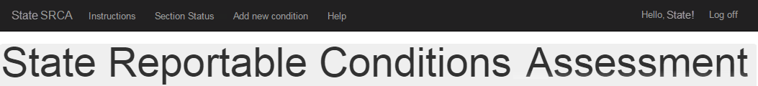
Navigation Toolbar: Once you log in, you will see a toolbar with the following functions:
- State SRCA
  - Access overall SRCA with all conditions listed as default view.
  - Select a condition section to view or edit.
  - Select Nationally Notifiable Conditions Only view.
  - Search for a condition.
  - Download summary of SRCA responses.
- Instructions
- Section Status
  - Update section completion status (reviewed and complete) and include contact information for QA follow-up purposes.
- Add new condition
- Form to be completed for any new condition or condition subset. Note: Clicking will open form in same browser tab.
- Help
- Access contact information for SRCA help.
- Access frequently asked questions, which will be added as CSTE receives those questions.
- Log off
COMPLETING THE SRCA

Review pre-populated responses:
Since the 2016 SRCA was pre-populated with last known jurisdiction responses from 2015, the majority of conditions will already have responses recorded. Respondents should review their assigned sections for any changes or inaccuracies. Note: State Epidemiologists will indicate which section(s) each respondent should complete. To track the review/completion process, utilize the “Section Status” page located in the navigation toolbar.

Enter or Edit data for conditions by section:
- Choose a single condition section to edit by accessing the “Choose a Condition Section” dropdown list at the top of the table.
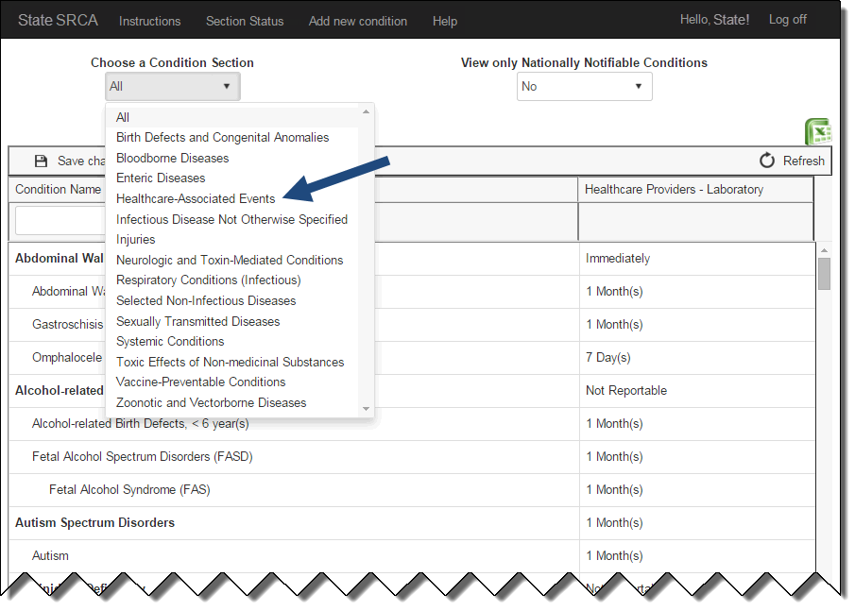

- Review all pre-populated data, including reporter type(s) and reporting requirement responses.

Note: Reporter types were customized and updated for each jurisdiction in 2015 and verified by the State Epidemiologist. If your jurisdiction has a single column with multiple reporter types (e.g., Healthcare Providers – Laboratory), then reporting requirements chosen apply to all reporter types in that column. If you require changes to the reporter types, please contact SRCA@cste.org.

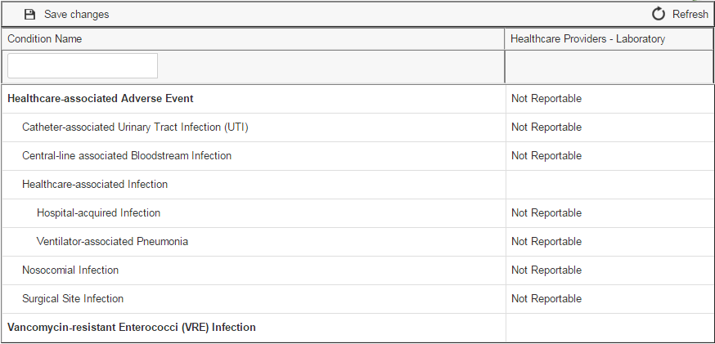
- To edit a reporting requirement or to fill in a blank reporting requirement, click on the relevant cell to access a dropdown list of jurisdiction-specific reporting timeframes. Choose reporting timeframe.

Note: Jurisdiction-specific reporting timeframes were also customized for each jurisdiction and updated in 2016. If you require any changes to your reporting timeframe options, please contact SRCA@cste.org.
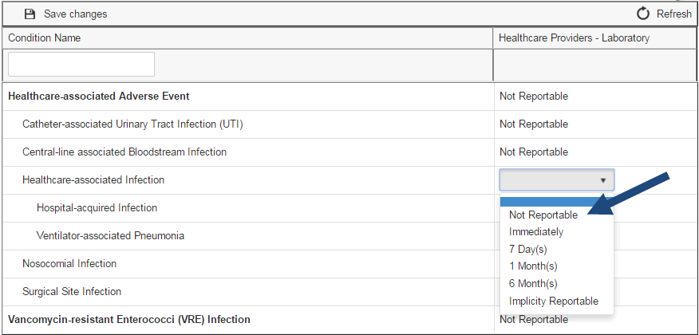

- Once a change has been made to a reporting requirement, the tool will flag the cell until the changed data is saved.

- Review all reporting requirements within the section, complete any incomplete requirements, and edit existing requirements as necessary.

Note: The State Epidemiologist will be unable to submit the SRCA unless every reporting requirement is completed.
Saving SRCA responses:
The SRCA data collection tool automatically saves every 60 seconds. The tool will then automatically refresh and any flags in changed cells will disappear. If you finish editing a section and do not want to wait for the tool to automatically save, you may manually save using the “Save changes” button in the top left of the table.
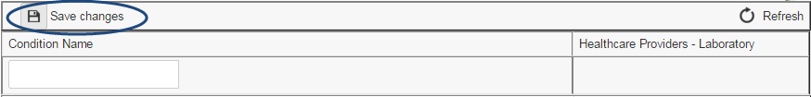

Searching for conditions:
You may search for individual conditions within a section by using the search box at the top of the table. To search within all sections, you must expand the table to all conditions by choosing “All” in the “Choose a Condition Section” dropdown menu.
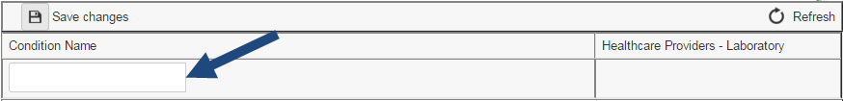

Implicitly reportable conditions:
All jurisdiction timeframe options include “Implicitly Reportable.”. Conditions that are not specifically listed as reportable but would be considered reportable under general language in the jurisdiction’s laws, such as calling for reporting of "any condition of public health importance” or other similar terms are considered “implicitly reportable” in the SRCA. In previous iterations of the SRCA data collection tool, respondents were required to select all appropriate implicit reporting categories (e.g., “event, bioterrorist,” “outbreaks or clusters of public concern,” or “occurrence of any unusual disease of public health importance”). The 2016 SRCA does not collect data on implicit reporting categories. For any questions or concerns, please contact SRCA@cste.org.

Section Status:
The “Section Status” page in the navigation toolbar will help State Epidemiologists and users keep track of the completion status of the SRCA. Once you review and complete a section of the SRCA, go to “Section Status,” mark which section you completed, and include your name for QA follow-up purposes.
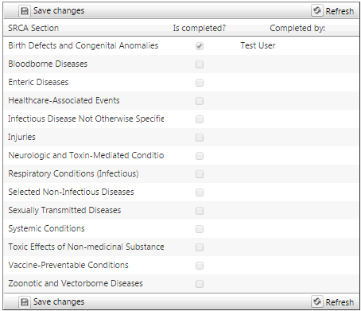

ADD NEW CONDITION/CONDITION SUBSET

To add a new condition to your SRCA, or to add a new subset to a condition already in your SRCA, navigate to the “Add new condition” page in the navigation toolbar. Clicking “Add new condition” will open the “New Subset Form Information” form in your same browser tab. In order to standardize the nomenclature of additional conditions or subsets, CSTE standardized the condition modifier choices. The full list of modifiers may be found in Appendix 2.

The form will require you to enter your contact information in case CSTE staff have questions about your condition form submission.

You will also need to select the condition for which you are creating a subset. For example, if blood lead level by itself (“Lead Level”) is not reportable in your jurisdiction, but elevated blood lead level in children younger than 5 years of age (“Lead Level, Blood, <5 years, ≥10 µg/dL”) is reportable, you may submit the new subset form requesting that “Lead Level, Blood, <5 years, ≥10 µg/dL” be added to your SRCA.

SUBMITTING COMPLETED SRCA

State Epidemiologists are required to review his/her jurisdiction’s completed SRCA prior to submission. Once every SRCA condition has a reporting requirement for each reporter type, a “Submit” button will appear above the SRCA table. The “Submit” button will not appear if there are any blank cells within your SRCA responses.
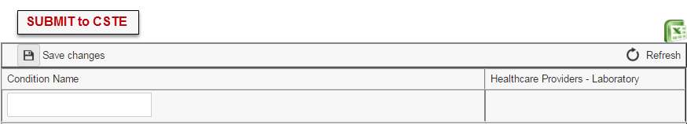

Printing SRCA Responses:
To print a summary of your jurisdiction’s completed responses to the SRCA, please click the green Excel button at the top right of the table. This will initiate the download of the spreadsheet.

FOR HELP

Please do not hesitate to contact CSTE at SRCA@cste.org with any questions, clarifications, concerns or edits to your SRCA.

APPENDIX 1: Alphabetical List of Conditions by Condition Category Grouping
(*Nationally Notifiable Conditions [NNC])

Birth Defects and Congenital Anomalies

Abdominal Wall Defects
Alcohol-related Birth Defects
Anencephaly
Autism
Autism Spectrum Disorders
Biotinidase Deficiency
Cardiac Defect
Cleft Lip
Cleft Lip/Palate
Cleft Palate
Congenital Hyperthyroidism
Down's Syndrome (Trisomy 21)
Epispadia
Fetal Alcohol Spectrum Disorders (FASD)
Fetal Alcohol Syndrome (FAS)
Galactosemia
Gastroschisis
Hypospadia
Inborn Errors of Metabolism
Infant Hearing Loss
Limb Reduction
Maple Syrup Urine Disease
Neural Tube Defect
Omphalocele
Other Specified Developmental Deformity
Other Specified Genetic Disorder
Other Specified metabolic Disorder
Phenylketonuria
Primary Congenital Hypothyroidism
Spina Bifida
Sudden Infant Death Syndrome (SIDS)

Bloodborne Diseases

Acquired Immunodeficiency Syndrome (AIDS)/HIV Stage III
Hepatitis B
*Hepatitis B, Acute
*Hepatitis B, Chronic
*Hepatitis B, Perinatal
Hepatitis C
*Hepatitis C, Acute
*Hepatitis C, Past or Present
Hepatitis D
Hepatitis Viral Infection
Hepatitis Viral Infection, Non-A Non-B
*HIV Infection

Enteric Diseases

Amebiasis
Campylobacteriosis
*Cholera
Clostridium difficile Infection
Clostridium perfringens Infection
Clostridium perfringens Toxin Poisoning
Cryptococcosis
*Cryptosporidiosis
*Cyclosporiasis
Enterobacteriaceae Infection
Enterobacteriaceae Infection, Carbapenem, Resistant
Enterovirus Infections
Escherichia coli Infection
*Escherichia coli Infection, Escherichia coli (shiga-toxin producing)
Foodborne Disease
*Foodborne Disease, Outbreak
*Giardiasis
*Hepatitis A
*Hepatitis A, Acute
Hepatitis E
*Listeriosis
Norovirus Infections
Rotavirus Infections
Salmonella spp. Infections
*Salmonellosis
*Shigellosis
Staphylococcal Disease
Staphylococcal Enterotoxin B Intoxication
*Trichinellosis
*Typhoid Fever
Vibriosis
*Vibriosis, Vibrio cholerae non-O1/-O139
Waterborne Disease
*Waterborne Disease, outbreak
Yersiniosis

Healthcare-Associated Events

Catheter-associated Urinary Tract Infection (UTI)
Central-line associated Bloodstream Infection
Healthcare-associated Adverse Event
Healthcare-associated Infection
Hospital-acquired Infection
Nosocomial Infection
Surgical Site Infection
Vancomycin-resistant Enterococci (VRE) Infection
Ventilator-associated Pneumonia

Infectious Disease Not Otherwise Specified

Acanthamoeba Disease (excluding keratitis)
Acanthamoeba Keratitis
Balamuthia mandrillaris Disease
Conjunctivitis
Primary Amebic Meningoencephalitis
Trachoma

Injuries

Animal Bites
Burns
Contaminated Sharps Injury
Disaster Casualty
Drownings and Submersions
Drug (Controlled Substance) Overdose
Farm-related
Gunshot Wounds
Hazardous Substances Emergency Event
Head Injury
Hyperthermia
Hypothermia
Intimate Partner Violence
Motor Vehicle Injury
Noise-induced Hearing Loss
Smoke Inhalation
Spinal Cord Injury
Suicide
Traumatic Fatalities
Traumatic Injuries
Violent Injuries

Neurologic and Toxin-Mediated Conditions

Acute Flaccid Paralysis
Botulism
*Botulism, food
*Botulism, infant
*Botulism, wound
*Botulism, other
Ciguatera
Creutzfeldt-Jakob Disease
Domoic Acid Poisoning
Encephalitis
Fish and Shellfish Poisoning
Guillain-Barre Syndrome
Meningitis
Mushroom Poisoning
Neurotoxic Shellfish Poisoning
Paralytic Shellfish Poisoning
Ricin Poisoning
Scombroid
Variant Creutzfeldt-Jakob Disease

Respiratory Conditions (Infectious)

Acute Upper Respiratory Illness
*Coccidioidomycosis
Histoplasmosis
Influenza-like Illness
*Legionellosis
Pneumonia
*Psittacosis
Respiratory Syncytial Virus (RSV) Infection
*Severe Acute Respiratory Syndrome-associated Coronavirus Disease
Staphylococcal Enterotoxin B Pulmonary Poisoning
*Tuberculosis

Selected Non-Infectious Diseases

Asbestosis
Asthma
Berylliosis
Byssinosis
*Cancer
Cerebral Palsy
Chronic Fatigue Syndrome
Coal Workers' Pneumoconiosis
Diabetes
Hypersensitivity Pneumonitis
Mesothelioma
Parkinson's Disease
Pneumoconiosis
Pneumonitis
Scabies
*Silicosis

Sexually Transmitted Diseases

*Chancroid
*Chlamydia trachomatis Infection
Chlamydial Infection
Genital Warts
*Gonorrhea
Granuloma Inguinale
Herpes Genitalis
Herpes Simplex
Lymphogranuloma Venereum
Mucopurulent Cervicitis (MPC)
*Neurosyphilis
Nongonococcal Urethritis (NGU)
Ophthalmia Neonatorum
Pelvic Inflammatory Disease (PID)
Syphilis
*Syphilis, Primary
*Syphilis, Secondary
*Syphilis, Latent
*Syphilis, Early Latent
*Syphilis, Unknown Duration
*Syphilis, [Late] Non-Neurological
*Syphilis, Congenital
*Syphilitic Stillbirth

Systemic Conditions

*Hansen's Disease
Hemolytic Uremic Syndrome
*Hemolytic Uremic Syndrome, Post-diarrheal
Hepatitis G
Kawasaki Disease
Rash Outbreak
Reye's Syndrome
Rheumatic Fever
Septicemia
Staphylococcus aureus Infection
*Staphylococcus aureus Infection, Vancomycin-intermediate
*Staphylococcus aureus Infection, Vancomycin-resistant
Streptococcal Disease
*Streptococcal Toxic Shock Syndrome (STSS)
Streptococcus pneumoniae Infection
*Streptococcus pneumoniae Infection, invasive
Toxic Shock Syndrome
*Toxic Shock Syndrome other than Streptococcal

Toxic Effects of Non-medicinal Substances

Arsenic Poisoning
Cadmium Poisoning
Chemical Pneumonitis
Farmers' Lung
Lead Level
*Lead Level, Blood, <16 years, ≥10 µg/dL
*Lead Level, Blood, ≥16 years, ≥10 µg/dL
Lead Poisoning
Mercury Poisoning
Toxic Effects of Agricultural Chemicals
Toxic Effects of Carbon Monoxide
Toxic Effects of Chemicals
Toxic Effects of Heavy Metals
Toxic Effects of Pesticides
* Toxic Effects of Pesticides, acute

Vaccine-Preventable Conditions

*Congenital Rubella Syndrome
*Diphtheria
Haemophilus influenzae Infection
*Haemophilus influenzae Infection, invasive
Immunization-related Adverse reaction
Influenza
*Influenza, Pediatric, Mortality
*Influenza, influenza A virus, novel cases
*Measles
Meningococcal Disease
*Mumps
*Non-Paralytic Poliovirus Infection
*Paralytic Poliomyelitis
*Pertussis
*Rubella
*Smallpox
Smallpox Vaccination Adverse Event
*Tetanus
Vaccinia Adverse Event
Vaccinia Disease
*Varicella
*Varicella, mortality

Zoonotic and Vectorborne Diseases

Anaplasmosis
*Anaplasmosis, Anaplasma phagocytophilum
*Anaplasmosis, undetermined
Angiostrongyliasis
*Anthrax
Arboviral Disease
Arenavirus Infection
*Babesiosis
Bartonellosis
Blastomycosis
*Brucellosis
California Serogroup Virus Disease
*California Serogroup Virus Disease, Neuroinvasive
*California Serogroup Virus Disease, Non-Neuroinvasive
Chagas Disease
Chikungunya
Cysticercosis
Colorado Tick Fever
*Crimean-Congo Hemorrhagic Fever Virus Infection
*Dengue Fever
*Dengue Hemorrhagic Fever
*Dengue Shock Syndrome
Eastern Equine Encephalitis Virus Disease
*Eastern Equine Encephalitis Virus Disease, Neuroinvasive
*Eastern Equine Encephalitis Virus Disease, Non-Neuroinvasive
*Ebola Virus Infection
Ehrlichiosis
*Ehrlichiosis, Ehrlichia chaffeensis
*Ehrlichiosis, Ehrlichia ewingii
*Ehrlichiosis, undetermined
Filariasis
Glanders
*Hantavirus Pulmonary Syndrome
Japanese Encephalitis Virus Disease
LaCrosse Virus Infection
*Lassa Virus Infection
Leishmaniasis
Leptospirosis
Louse-Borne Relapsing Fever
*Lujo Virus Infection
*Lyme Disease
*Malaria
*Marburg Virus Infection
Melioidosis
Monkeypox
*New World Arenavirus Infection
Nipah Virus Infection
Orthopox
*Plague
Powassan Virus Disease
*Powassan Virus Disease, Neuroinvasive
*Powassan Virus Disease, Non-Neuroinvasive
Q Fever
*Q Fever, acute
*Q Fever, chronic
Rabies
*Rabies, animal
*Rabies, human
Rickettsial Disease
Rift Valley Fever
Rocky Mountain Spotted Fever
*Spotted Fever Rickettsiosis
St. Louis Virus Disease
*St. Louis Virus Disease, Neuroinvasive
*St. Louis Virus Disease, Non-Neuroinvasive
Taeniasis
Tick-borne Relapsing Fever
Toxoplasmosis
*Tularemia
Typhus Fever
Venezuelan Equine Encephalitis Virus Disease
Vesicular Stomatitis
Viral Hemorrhagic Fever
West Nile Virus Disease
*West Nile Virus Disease, Neuroinvasive
*West Nile Virus Disease, Non-Neuroinvasive
Western Equine Encephalitis Virus Disease
*Western Equine Encephalitis Virus Disease, Neuroinvasive
*Western Equine Encephalitis Virus Disease, Non-Neuroinvasive
*Yellow Fever

APPENDIX 2: Available Modifiers for Creating Subset Conditions (Optional)

Age (Choose AGE GROUP or AGE RANGE)

AGE GROUP:
Congenital
Perinatal
Newborn/Neonatal
Infant
Toddler
Child
Pre-adolescent
Adolescent
Pediatric
Adult
Elderly/Geriatric

AGE RANGE: Enter minimum and/or maximum age

Etiologic Agent

14-3-3 Protein
Acanthamoeba spp.
Acid-Fast Bacillus
Adenovirus
Ajellomyces capsulatum
Ajellomyces dermatitidis
Alphavirus
Anaplasma phagocytophilum
Anaplasma spp.
Arenavirus
Arsenic
Asbestos
Babesia divergens
Babesia duncani
Babesia microti
Babesia spp.
Bacillus anthracis
Balamuthia mandrillaris
Bartonella spp.
Beryllium
Bordetella holmesii
Bordetella parapertussis
Bordetella pertussis
Borrelia afzelii
Borrelia burgdorferi
Borrelia duttoni
Borrelia garinii
Borrelia hermsii
Borrelia parkeri
Borrelia recurrentis
Borrelia spp.
Brucella abortus
Brucella canis
Brucella melitensis
Brucella spp.
Brucella suis
Bunyaviridae
Burkholderia mallei
Burkholderia pseudomallei
Cadmium
California Serogroup Virus
Campylobacter coli
Campylobacter enteritis
Campylobacter fetus
Campylobacter jejuni
Campylobacter spp.
Carbon Monoxide
Chemical
Chikungunya Virus
Chlamydia psittaci
Chlamydia trachomatis
Chlamydiaceae
Clostridium botulinum
Clostridium botulinum Toxin
Clostridium difficile
Clostridium perfringens
Clostridium perfringens Toxin
Clostridium tetani
Coal
Coccidioides immitis
Coccidioides posadasii
Coccidioides spp.
Colorado Tick Fever Virus
Corynebacterium diphtheriae
Cotton Dust
Coxiella burnetii
Crimean-Congo Hemorrhagic Fever Virus
Cryptococcus gattii
Cryptococcus neoformans Species Complex
Cryptococcus neoformans var. grubii
Cryptococcus neoformans var. neoformans
Cryptococcus non. V.neoformans
Cryptococcus spp.
Cryptosporidium parvum
Cryptosporidium spp.
Cyclospora cayetanensis
Cyclospora spp.
Dengue Virus
Eastern Equine Encephalitis Virus
Ebola Virus
Echovirus
Ehrlichia chaffeensis
Ehrlichia ewingii
Ehrlichia spp.
Entamoeba histolytica
Enterobacter sakazakii
Enterobacteriaceae
Enterobacter spp.
Enterobacter cloacae
Enterobacter aerogenes
Enterococcus spp.
Enterovirus
Escherichia coli
Escherichia coli (Enteroaggregative)
Escherichia coli (Enterohemorrhagic)
Escherichia coli (Enteroinvasive)
Escherichia coli (Enteropathogenic)
Escherichia coli (Enterotoxigenic)
Escherichia coli (Shiga-Toxin Producing)
Escherichia coli (Sorbitol-Negative)
Escherichia coli O157:H7
Filovirus
Flavivirus
Francisella tularensis
Giardia intestinalis
Giardia spp.
Haemophilus ducreyi
Haemophilus influenzae
Haemophilus influenzae Non-Type b
Haemophilus influenzae Type b
Hantavirus
Heavy Metal
Hepatitis A Virus
Hepatitis B Virus
Hepatitis C Virus
Hepatitis D Virus
Hepatitis E Virus
Hepatitis G Virus
Human Herpes Virus 1
Human Herpes Virus 2
Human Immunodeficiency Virus 1
Human Immunodeficiency Virus 2
Human Papillomavirus
Human T-Cell Leukemia Virus 2
Human T-Lymphotropic Virus Type 1
Influenza A Virus
Influenza Virus
Jamestown Canyon Virus
Japanese Encephalitis Virus Group
Keystone Virus
Klebsiella spp. Klebsiella granulomatis
Klebsiella oxytoca
Klebsiella pneumoniae
LaCrosse Virus
Lassa Virus
Lead
Legionella pneumophila
Legionella spp.
Leptospira interrogans
Leptospira spp.
Leishmania spp.
Listeria Monocytogenes
Listeria spp.
Marburg Virus
Mercury
Monkeypox Virus
Mumps Virus
Mycobacterium africanum
Mycobacterium avium Complex
Mycobacterium bovis
Mycobacterium bovis BCG
Mycobacterium canettii
Mycobacterium caprae
Mycobacterium leprae
Mycobacterium microti
Mycobacterium pinnipedii
Mycobacterium spp.
Mycobacterium spp. (Non-leprae and Non-TB)
Mycobacterium spp. (Non-leprae)
Mycobacterium spp. (Non-TB)
Mycobacterium tuberculosis
Mycobacterium tuberculosis Complex
Naegleria fowleri
Neisseria gonorrhoeae
Neisseria meningitidis
Nipah Virus
Norovirus
Orthopoxvirus
Pesticide
Plasmodium falciparum
Plasmodium malariae
Plasmodium ovale
Plasmodium spp.
Plasmodium vivax
Pneumocystis jiroveci
Poliovirus
Powassan Virus
Rabies Virus
Respiratory syncytial Virus
Ricin Toxin
Rickettsia akari (rikettsialpox)
Rickettsia felis
Rickettsia prowazekii
Rickettsia rickettsii
Rickettsia spp.
Rickettsia typhi
Rift Valley Fever Virus
Rotavirus
Rubella Virus
Rubeola Virus
Salmonella spp.
Salmonella spp. (Non-typhi)
Salmonella typhi
Sarcoptes scabiei
Saxitoxin
Severe Acute Respiratory Syndrome-related Coronavirus
Shigella boydii
Shigella dysenteriae
Shigella flexneri
Shigella sonnei
Shigella spp.
Silica
Snowshoe Hare Virus
St. Louis Virus
Staphylococcal Enterotoxin B
Staphylococcus aureus
Staphylococcus aureus (Coagulase-Positive)
Staphylococcus aureus Toxin
Staphylococcus spp.
Streptococcus agalactiae (Group B)
Streptococcus haemolyticus
Streptococcus pneumoniae
Streptococcus pyogenes (Group A)
Streptococcus spp.
T-2 Mycotoxin
Taenia solium
Taenia spp.
Toxoplasma gondii
Toxoplasma spp.
Treponema pallidum
Trichinella spiralis
Trichinella spp.
Trivittatus
Trypanosoma cruzi
Undetermined
Unspecified
Vaccinia Virus
Varicella Zoster Virus
Variola Virus
Venezuelan Equine Encephalitis Virus
Vesicular Stomatitis Virus
Vibrio alginolyticus
Vibrio cholerae
Vibrio cholerae Non-O1
Vibrio cholerae Non-O1/-O139
Vibrio cholerae O1
Vibrio cholerae O139
Vibrio damsela
Vibrio fluvialis
Vibrio furnissii
Vibrio hollisae
Vibrio imicus
Vibrio parahaemolyticus
Vibrio spp.
Vibrio spp. (Non-cholera)
Vibrio vulnificus
West Nile Virus
Western Equine Encephalitis Virus
Yellow Fever Virus
Yersinia Enterocolitica
Yersinia pestis
Yersinia pseudotuberculosis
Yersinia spp.
Yersinia spp. (Non-pestis)

Etiologic Type

Bacterial
Fungal
Parasitic
Particulate
Prion
Protozoal
Toxin
Viral

Special Circumstances

Bioterrorist event
Cluster
Community-acquired
Community-associated
Healthcare facility onset
Healthcare associated
Hospitalization
Imported case
Initial diagnosis
Institutional setting
Intentional release
Intentional transmission
International
Morbidity
Mortality
Naturally-occurring
Novel cases
Outbreak
Perinatal exposure
Post-diarrheal
Post-infectious
Post-streptococcal
Pregnant woman

Treatment

Change in treatment outcome
Post-exposure prophylaxis
Responding to treatment
Treatment administered
Treatment prescribed

Occupational

All work related cases
In a child care worker
In a food handler
In a healthcare worker
Other occupation

Disease Status

Active
Acute
Carriers
Cases
Chronic
Colonization
Critical
Early latent
Late latent
Latent
Latent (unknown duration)
Primary
Secondary
Tertiary

Infected Species

Alternative livestock
Animal
Aquaculture
Cats
Cattle
Dogs
Goats
Horses
Human
Poultry
Sheep
Swine
Wildlife – avian
Wildlife – mammal
Wildlife – reptile/amphibian

Antibiotic (Choose one value each from ANTIBIOTIC and ANTIBIOTIC SENSITIVITY)

ANTIBIOTIC:
Carbapenem
Doripenem
Drug
Ertapenem
Glycopeptide
Imipenem
Meropenem
Methicillin
Oxacillin
Penicillin
Vancomycin
ANTIBIOTIC SENSITIVITY:
Intermediate
Resistant

Lab Finding (*Will not appear as part of condition name)
CD4 count
Carbapenemase
ESBL
Hemoglobin A1c*
IMP
KPC
NDM
OXA-48
VIM
Viral load*

Threshold (Enter minimum and/or maximum value with unit)

Cell Count %
Cells/µL
IU/L
µg/dl
µg/g

Lab Outcome

Indeterminate lab test
Negative lab test
Ordered lab test
Positive lab test
Positive culture
Quantitative lab test result

Source/Site

Blood
Clinical
CNS
CSF
Food
Genital
Invasive
Neuroinvasive
Neurological
Non-neurological
Ophthalmic
Oral
Perirectal
Rectal
Sterile site
Stool
Urine
Wound

Case Details (Will not appear as part of condition name)

CASE CLASSIFICATION:
Confirmed
Probable
Suspect

REPORTING METHOD:
Aggregate Count
Individual Case Report

DATE EFFECTIVE: Enter date

