

State Reportable Condition Assessment

(SRCA) Query Results Website
FUNCTIONAL REQUIREMENTS

PURPOSE

The results from the joint CSTE-CDC State Reportable Conditions Assessment (SRCA) must be made available to the public through a related query and report module. Results must be easy to view, download, and use for public health purposes. These data may eventually reduce the burden for reporters to determine the requirements with which they must comply by viewing the reporting requirements for each jurisdiction.
Information about what conditions are reportable in each state will also be extracted for use by CDC to calculate incidence rates for the National Notifiable Diseases Surveillance System (NNDSS) tables in the Morbidity and Mortality Weekly Report (MMWR).

GLOSSARY OF TERMS

Term | Description
CDC | Centers for Disease Control and Prevention
CSTE | Council of State and Territorial Epidemiologists
IRC | Implicit reporting categories
MMWR | Morbidity and Mortality Weekly Report
NNC | Nationally notifiable conditions
NNDSS | National Notifiable Diseases Surveillance System
SRCA | State Reportable Conditions Assessment
System Administrators | CSTE and CDC representatives who maintain, update, and initialize the SRCA, as well as set up customized data entry form for states.
State Administrators | This user type can enter data, add users, and assign users to sections for their jurisdiction and is responsible for final approval and submission of their jurisdiction’s data to CSTE. State Epidemiologist or other designated point person.
State Users | This user type may enter data for assigned sections for their jurisdiction. State Health Department staff.
Core SRCA Conditions | Conditions that are added to the SRCA by System Administrators to appear on all state forms
User-created Subset Conditions | Non-core SRCA conditions added by State Users and State Administrators for their own jurisdiction’s form

FUNCTIONAL REQUIREMENTS

- DATABASE REQUIREMENTS

- Compatible with the State Reportable Conditions Assessment (SRCA) Collection Tool
The database created to collect the information for the SRCA must be compatible with the database used to query and report the results of the assessment. CSTE does not have any software preferences for housing the query-results website. The database must conform to CSTE’s existing databases for housing (or linking to) www.cste.org.

These requirements include:
- SQL
- Windows X.X
- (Ask CSTE IT for any database requirements necessary for CSTE website compatibility)

- Functional Saving and Printing of All Query Results
Results from all queries or searches performed by the database will be downloadable via a “save” button into .xls, .csv or .pdf format. The screen may also be printed using the “print” button on the screen. The “back arrow” button allows a user to return to the “build a query” home screen to perform another search.

- USER REQUIREMENTS
- Standard/Pre-defined Queries
Many users will be using standard searches for general information on a specific condition, all conditions for one state, the NNCs or one condition across all states. Due to this, we suggest creating standard queries that upload the static information, rather than pulling information from the large database.

These standard queries include:
- All conditions for one state, by reporter
- One condition for one state, by reporter
- One condition for all states, by reporter
- All NNCs for one state, by reporter

- Due to the limited space available for displaying results, “All conditions for all states” queries will not be available to users.
- All queries will be sortable by row header
- General Queries
In general, all conditions will be available for user-built queries. The database will contain all conditions – core SRCA conditions and user-created subset conditions – for querying. Upon searching, a user will begin to type in the name of the condition and will be able to select from the populated list (similar to a www.google.com search).
Condition names entered into the search field will be recognized if part of the term is supplied in the name. For example, searching for “AIDS” will result in displaying all conditions similarly named such as, “Acquired Immunodeficiency Syndrome (AIDS)/HIV Stage III, < 14 Cell Count %, CD4 count”. Similarly, a search for “CD4 count” will also result in the display of these same results as that information is provided in the name of the condition.
Figure 1. General user-created search for conditions within the SRCA Query Results Website

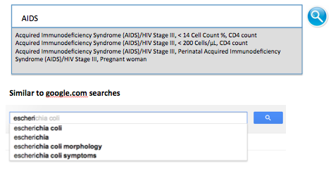

- Building a Query
When building a customized (not standard/pre-defined) query, users will be able to select information for a query with certain limitations.

Users will perform the following steps to build a query:
- Select year
- Selecting category will modify the list of available conditions to select
  - Include all user-created subset conditions found in the category
  - Selecting “All conditions” results in a master list of all core and user-created subset conditions to be chosen below
- Select jurisdiction(s) to display
  - Selecting “All jurisdictions” limits the condition selection to one (gray out “All conditions”)
  - Users can check up to 5 jurisdictions for comparison if selecting 1-3 conditions
- Select reporter(s) to display
- Select condition(s)
  - Users may select “All conditions” if only one jurisdiction is selected
  - Users may select 1-3 conditions only if <5 jurisdictions are selected
- Press the search button

Figure 2. How to build a query in the SRCA Query Results Website
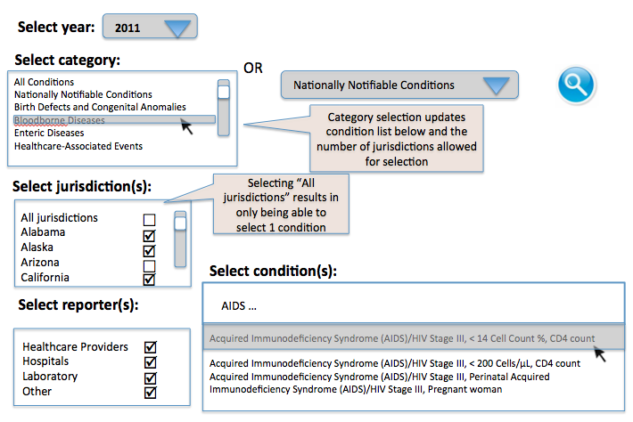

- Reporter Display
Some states grouped the reporting requirements for multiple reporters, as they were the same. These data should be able to be displayed individually when queried across other states. For example, Wyoming’s reporting requirements are identical for Healthcare Providers – Hospitals – Laboratory. However, when a user queries, “Tick-borne relapsing fever, Hospitals” the data will be presented for Hospitals only.
- Special Relationships Amongst Conditions
As many conditions have associated child conditions that contain important data, each query of a single parent condition should also display the associated child conditions and vice versa – queries for a child condition will result in the display of its associated parent condition.
- Aggregate Counts
After a query, the aggregate count of jurisdictions for which a condition is reportable will display in the top left of the page, above the query results table.
- Spatial Visualization
For all states one condition, the map displaying the full continental united states and associated territories should highlight with the results of the query.

- Condensed Display
The condensed display is suitable for queried conditions that have multiple associated parent/child conditions. When querying a condition that has a parent condition and affiliated user created subset conditions, the queried condition will be displayed but each jurisdiction will have a “plus” symbol next to it. If a user clicks on this icon, the page will expand to show all of the related conditions and the associated hierarchy. This display is the expanded display.

Figure 3. Condensed display of one condition, multiple states in the SRCA Query Results Website
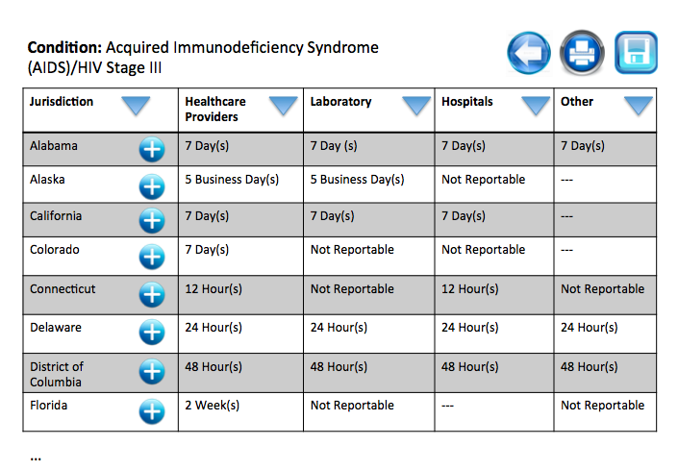

- Expanded Display
The expanded display is user-controlled and is the default display for printing and saving. In the expanded display, there is a “minus” symbol next to the jurisdiction name so when the user presses this icon, the rows will disappear to show only the queried condition.

Figure 4. Expanded display of one-condition query with multiple conditions associated for multiple states within the SRCA Query Results Website
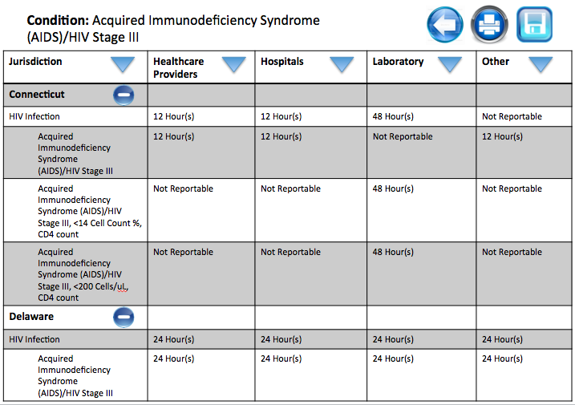

Figure 5. Display of all-conditions, one jurisdiction for all reporters within the SRCA Query Results Website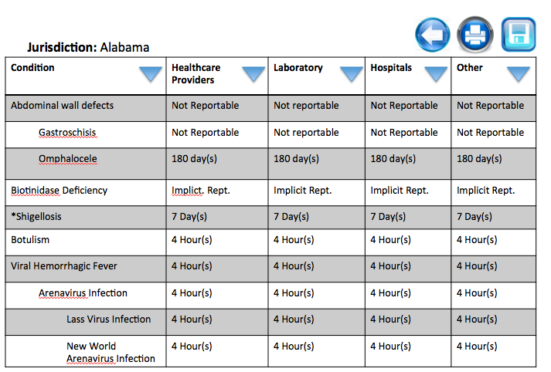

- Implicit reporting detailed display
Conditions with Implicit Reporting details will have this information displayed when a user “hovers over” display.

Notes from respondant’s feedback

Know info gathered by SRCA is disease-specific (e.g., CRE or cyclospora) and want to know who many other states have is reportable, which states have it reportable (count and listing) and for each state, what timeframe is it reportable? Are there any additional stipulations? E.g., add Zika explicitly in notifiable conditions, AL could make it Zika in pregnant woman reportable in 24 hours vs Zika in non pregnant woman as standard.

All 50 states – standard reporting timeframe within each state

Reporting timeframe is important

Disease-specific info: diff reporting req for labs vs hospitals in a state for a condition, or just an indicator that there are differences nd could expand

Liked map, but couldn’t use it. Didn’t provide count of reportable in all jurisdictions – could use the map

Who its reportable from is important

Listing and visualization is important

Select from dropdown for condition
States light up
Count shows up
Then listing of state, type of reporter, and timeframe

List of all disases and how many states have them reportable
States across top and diseases as rows, and first column be aggregate count
NNC report – Y/N in states for all NNCs across all states (no matter reporter and timeframe) – good to be printed

Look into timeframe data

Do you care about seeing children as possible suggestions for alternate ssearches? Also say or would you like these to be included in overall count?

Do you want to see parents? Yes, not

