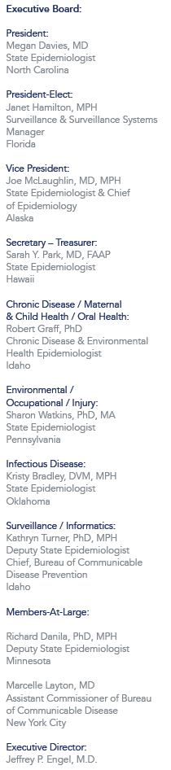 | August 11, 2016  RE: Travel Arrangements to the Western States Occupational Network (WestON) meeting  in Denver, CO on September 29-30, 2016  Support for non-federal employees to attend the WestON Meeting will be provided for your airfare, mileage, hotel accommodations at the designated rate for two nights, and per diem allowance. Please read the full disclosure of the CSTE Travel Support Guidelines that includes guidelines regarding expenses and cancellations at: http://c.ymcdn.com/sites/www.cste.org/resource/resmgr/PDFs/2014TravelPolicyRevisedFINAL.pdf  Transportation:  Airline transportation will be provided to and from your originating city to the venue city, Denver, CO. Flight reservations must be made through the CSTE official travel agent, American Express at 1.800.872.9954. Airline reservations should be made as soon as possible. The CSTE National Office must pre-approve travel arrangements not made through our travel agent in order for the traveler to receive reimbursement.  Mileage to and from your house to the originating airport will be reimbursed at the federal rate of $0.54 per mile. Airport parking in your originating city will be reimbursed for up to  three days.  Hotel Accommodations:  A room block (“CSTE/WestON”) for meeting participants has been held at the Curtis  Denver at the federal lodging rate of $172.00 plus tax, through August 29, 2016.  Daily parking is $20.00 per day. Reservations can be made at the following link:  http://doubletree.hilton.com/en/dt/groups/personalized/D/DENCHDT-CWC-20160928/index.jhtml  or by phone by calling 303-571-0300. The hotel and meeting address:  The Curtis Denver – a Doubletree by Hilton Hotel  1405 Curtis Street  Denver, Colorado 80202  Ground Transportation:  Denver International Airport has a direct rail connection from the airport to downtown.  The Curtis Hotel is about a ten-minute walk from downtown Denver’s Union Station.  Cost: $11.00 one-way  Getting From your Flight to the Station:  When you exit the aircraft, follow signs for baggage claim or the transit center. From  the B and C Concourses, you must board the airport people mover tram to get to Jeppesen Terminal where baggage claim and ground transportation is located. From the A Concourse, you may ride the tram or walk across the pedestrian bridge following the signs to the terminal.  Domestic arrivals are located in the center of the main terminal on Level 5. Baggage claim is also located on Level 5. To get to Denver Airport Station, follow signs to the "Transit Center" and proceed to the south end of the main terminal on Level 5 (located under the large American flag). Exit the terminal through the sliding glass doors and take the escalator located in the center of the plaza down to Level 1.  Super Shuttle: http://www.supershuttle.com/Locations/DenverDEN  800-258-3826  Cost: $25 one-way  Taxi: $60 one-way  Reimbursement Procedure  After the meeting, please complete the reimbursement form provided and include any receipts $50.99 or greater and all airline boarding passes. Please send the signed expense reimbursement form to the CSTE National Office via email to travel@cste.org or via fax to (770) 458-8516. Expenses will not be reimbursed until after the meeting. If you are unsure if an expense will be reimbursed, contact msharpe@cste.org for clarification.  Sincerely,  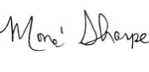  Mone’ Sharpe  CSTE National Office  Meeting and Travel Coordinator  2872 Woodcock Blvd., Suite 250  Atlanta, Georgia 30341  770-458-3811
  Per Diem
  Meal expenses are reimbursed at the federal per diem allowance for Denver, Colorado
  of $69.00 per day, no meals are provided at the meeting.

