
THIS MESSAGE INTENDED FOR WIDEST DISTRIBUTION  Table of Contents  - General Updates  - Lifeline Sector Updates  - State Updates  - Requests for Information  - Re-Entry Information  - Current Storm Tracks  - Virtual Resources  General Updates  HPH Sector Members,  ASPR CIP is preparing for the response to multiple storm systems in the Atlantic and Pacific Ocean, including (but not limited to) Hurricane Florence.  - Florence has been upgraded to a Category 4 Hurricane. It is forecast to make landfall between North Carolina and South Carolina during the afternoon on Thursday September 13 or early Friday morning, September 14.  - Thursday will see life-threatening storm surge on the coast of Virginia, North Carolina, and South Carolina.  Lifeline Sector Updates  From our partners at FEMA's National Business Emergency Operations Center:  - Most ports open with restrictions; pre-storm assessments in process  - NC ports will close to both incoming and outgoing vessels on September 12  - Amtrak and NCDOT Rail Division will suspend passenger rail service through North Carolina starting September 12 and will likely remain closed through September 16, 2018  State Updates  Evacuation Orders  - North Carolina: Mandatory evacuations in place from Barrier Islands to the SC border; congestion reported on evacuation routes (est. 400K potential evacuees).  - South Carolina: Mandatory evacuations for Horry, Georgetown, Charleston, Berkeley, and Dorchester counties as well as Edisto Beach.  - Virginia: Mandatory Evacuation Order in place for Hampton Roads, VA Beach, Newport News, and areas around the Chesapeake River.  Declarations  - Public Health Emergency declared September 11, 2018 for North Carolina and South Carolina.  - Stafford Act Emergency Declaration in effect as of September 10, 2018 for North Carolina, South Carolina, and Virginia.  - State of Emergency declared in South Carolina, North Carolina, Virginia, Maryland, and Washington, D.C.  State Emergency Management Websites  - South Carolina Emergency Management Division  - North Carolina Department of Public Safety - Hurricane Florence Updates  - Virginia Department of Emergency Management  Requests for Information  As we prepare for a response, we wanted to reach out both to help prioritize where our private sector partners may need assistance and support an effective response.  Please see below for our initial list of concerns. Please let us know if is there anything we should be considering for needs and impacts in the anticipated storm tracks.  * Local public health needs, including lab tests and transportation of lab samples  * Hospitals  - Flooding and other anticipated challenges  - Availability of generators/fuel  * Nursing homes and elderly populations  * Dialysis centers and patient access to treatment  * Issues related to re-entry and access credentialling  * Manufacturing supply issues related to:  - Pharmaceuticals  - Device  - Medical Gases (including medical oxygen)  - Vaccines  * Distribution supply issues related to pharmaceutical and med. surg. distribution to both acute and non-acute  * Blood Banks and blood products  * Pharmacies  Additionally, one of our goals is to help support your decision support needs. If you have critical information requirements, or any concerns we should be tracking on your behalf we are happy to do so. Please let us know at cip@hhs.gov.  Re-Entry Information  The links below included additional information on re-entry guidelines for states anticipating impacts from Hurricane Florence:  Region IV  - North Carolina and South Carolina  - Georgia and Florida  Virginia  - Any business that would like to reenter an evacuation area in Virginia needs to register with the following links. This applies to businesses in the evacuated area and businesses (i.e. insurances, etc.) that need to access the area for recovery). Re-entry registration applies to businesses ONLY.  - Organizations will register through https://www.eritn.com  - a. https://www.eritn.com/virginia  - b. https://www.eritn.com/virginiaregistration  - c. https://fs22.formsite.com/er-itn/form24/index.html (Registration Form, also on https://eritn.com/virginiaregistration)  Transportation Waivers  - Georgia  - Florida (Weigh Stations)  - Florida (Animal Movement)  - Kentucky  Current Storm Tracks  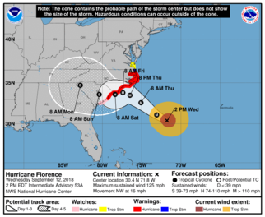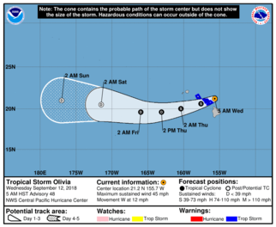  For up to date mapping of the affected areas, consult the National Oceanic and Atmospheric Administration's (NOAA) National Hurricane Center.  Virtual Resources  HPH Sector 2018 Hurricane Response Dashboard  Power Resilience Emergency Response Checklist: Developed by HPH SCC member Powered for Patients  ASPR TRACIE Select Hurricane-Related Resources Page  Twitter  - Humanity Road – Includes a summary of evacuation centers and alerts.  - FEMA - Up to date notifications of storm impacts and on island activities  - FEMA Happening Now - Additional up to date notifications of storm impacts and on island activities  - Hawaii Emergency Management Agency  Facebook  - NOAA NWS National Hurricane Center  YouTube  - Hurricane Preparedness – What You Should Know | September 12, 2018  FEMA National Business Emergency Operations Center  Atlantic Dashboard  Pacific Dashboard  NBEOC Daily Conference Call  Time: 3:00 - 4:00 p.m. ET  Dial: 1-888-877-0354  Participant passcode: 9132924  For more information, email NBEOC@fema.dhs.gov.

This announcement has been produced by the Department of Health and Human Services (HHS) Office of the Assistant Secretary for Preparedness and Response (ASPR) Division of Critical Infrastructure Protection (CIP) on behalf of the Healthcare and Public Heatlh Sector. For more information on our program and participating with the HPH Sector, contact us at CIP@HHS.gov.

Privacy Policy | GovDelivery is providing this information on behalf of U.S. Department of Homeland Security, and may not use the information for any other purposes.
Unsubscribe

