
THIS MESSAGE INTENDED FOR WIDEST DISTRIBUTION

September 17, 2018
HPH Sector Members,
ASPR CIP and the HPH Sector continues to monitor healthcare and public health critical infrastructure impacts due to storm systems in the Atlantic and Pacific, including but not limited to Tropical Depression Florence.
The HPH Sector 2018 Hurricane Response Dashboard continues to provide resources to assist our partners and stakeholders in their preparedness and response efforts. Additionally, the FEMA National Business Emergency Operations Center (NBEOC) is maintaining situational awareness and engagement for the private sector through their Atlantic Dashboard and Pacific Dashboard.
Daily conference calls are being hosted by the NBEOC. For more information, email NBEOC@fema.dhs.gov.
Time: 3:00 - 4:00 p.m. ET
Dial: 1-888-877-0354
Participant passcode: 9132924
If you have any reports of impacts or disruptions to healthcare and public health critical infrastructure, or have any requests for information or resources, email ASPR CIP at CIP@hhs.gov.

Table of Contents
- Current Storm Track
- Imminent Flooding in Impacted Areas
- *New* SC DHEC CareLine
- State Updates
- 1135 Waiver Guidance
- Volunteer and Donation Guidance
- ASPR TRACIE Resources
- Virtual Resources

Current Storm Track
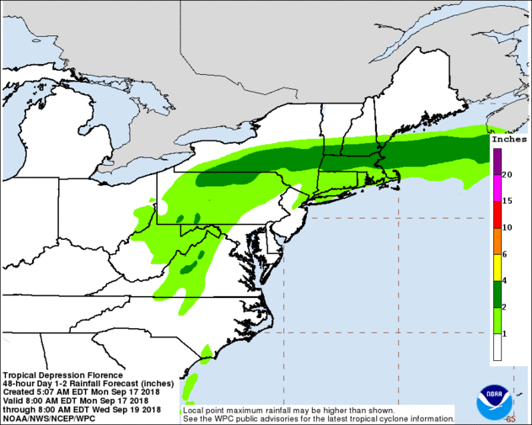
For up to date mapping of the affected areas, consult the National Oceanic and Atmospheric Administration's (NOAA) National Hurricane Center.

Imminent Flooding in Impacted Areas
Tropical Depression Florence will continue to produce heavy rain across the Southeast and into the Northeast as as the system moves slowly inland and northward. Up to 15 inches additional rain will exacerbate ongoing flooding. Farther inland, this rainfall will cause new areas of catastrophic, historic river flooding, flash flooding, and even a potential for landslides. Additionally, gusty winds may bring down trees and power lines from saturated soils. Check out USACE's Trafficability Dashboard at: https://usace.maps.arcgis.com/apps/webappviewer/index.html?id=d9b3aab757f64e1897f8a75efd4d3975 for specific flood information (Internet Explorer recommended).
ASPR TRACIE resources, listed below, may help facilities prepare for flooding events.

*New* SC DHEC CareLine
The South Carolina Department of Health and Environmental Control (SC DHEC) has activated their CareLine at 1-855-472-3432 to help connect people impacted by the storm with various health care services, including prenatal care, transportation to medical appointments, and Medicaid. More information can be found at: https://www.scdhec.gov/health/family-planning/family-planning-services/get-help-finding-services.

State Updates
Stay updated to states directly and indirectly impacted by Hurricane Florence through the FEMA website with links to all state and territorial emergency management agencies.
While many private sector telecommunications companies pre-staged restoration crews there are many areas without power at this time. Emergency response centers (PSAPs) in these impacted area are diverting calls to alternate facilities until power is restored.
WEST VIRGINIA - Division of Homeland Security and Emergency Management
- There are Flood Watches and Flash Flood Watches through areas of West Virginia.
- A blanket Special Hauling Authorization has been approved for Vehicles and Loads Delivering Relief Supplies (overweight and oversized loads).
VIRGINIA - Department of Emergency Management
- All Virginia facilities have returned to normal operations.
- The Stafford Act Emergency Declaration of September 10, 2018 and State of Emergency remain in effect.
- All ports are open for operations but cannot return to full operations until environmental conditions allow and port assessments are completed
- Any business needing to reenter an evacuation area continues to need to pre-register for entry. This applies to businesses in the evacuated area and businesses (i.e. insurances, etc.) that need to access the area for recovery. Organizations can register through https://www.eritn.com, https://www.eritn.com/virginia, https://www.eritn.com/virginiaregistration, or https://fs22.formsite.com/er-itn/form24/index.html.
- Fuel blend waivers are in effect for Southern Virginia.
NORTH CAROLINA - Department of Public Safety
- The Stafford Act Emergency Declaration of September 10, 2018, Public Health Emergency declared September 11, 2018, and State of Emergency remain in effect.
- Ports of Wilmington and Morehead City remain closed. USACE currently conducting survey on Port of Wilmington, and Port of Morehead City survey begins September 17;
- Airports - Wilmington International Airport (ILM) closed except for emergency rotary wing aircraft; 3 regional airports closed; all other major airports open and commercial operators implementing protective measures
- Fuel blend waivers are in effect. 24% of gas stations are out-of-service due to lack of fuel and/or power; the majority of which are located along coastal areas. NC activated an emergency fuel contractor to distribute fuel to priority areas on evacuation routes and for public safety use.
- Curfews are in place for Beaufort, Bertie, Brunswick, Carteret, Greene, Hertford, Hoke, Lenoir, Nash, New Hanover, Pamlico, Pitt, Richmond, Sampson, Tyrrell, and Wayne counties.
- No communities are isolated at this time. Routes into Wilmington and Fort Bragg are limited but accessible. I-40 is anticipated to open on September 19.
- Railway carriers began preliminary assessments where conditions permit
SOUTH CAROLINA - Emergency Management Division
- The Stafford Act Emergency Declaration of September 10, 2018, Public Health Emergency declared September 11, 2018, and State of Emergency remain in effect.
- Port of Georgetown is currently closed, Ports of Beaufort and Charleston open with restrictions. No ports will return to full operations until environmental conditions allow and port assessments are completed.
- Curfews are in place for Chesterfield, Darlington, Dillon, Florence, Horry, Marion and Marlboro counties.
- Fuel blend waivers are in effect. 12% of gas stations out-of-service due to lack of fuel and/or power; majority of which are located in the coastal areas Myrtle Beach-Florence.
- Airports - Myrtle Beach, Charleston AFB/International, and Florence Regional open; Moncks Corner. Berkeley County airports closed (expect to open September 17); all other major airports open
- I-95 SC closed near 186 mile marker with a detour established.
- Rail / Transit: Suspended/modified schedules across impacted area.

1135 Waiver Guidance
If you are experiencing any challenges or have questions on 1135 waivers, you can contact your regional CMS office for assistance. Other 1135 waiver resources are listed below:
- CMS.gov: 1135 Waivers
- 1135 Waivers at a Glance
- This ASPR TRACIE TA response provides a response from the Centers for Medicare and Medicaid (CMS) related to 1135 waivers and what the 17 required provider types need to know in order to meet the CMS Emergency Preparedness (EP) Rule requirements.

Volunteer and Donation Guidance
The National Voluntary Organizations Active in Disaster (NVOAD) offers guidance on best practices for volunteering and donating.

ASPR TRACIE Resources

Virtual Resources
Tips for Retaining and Caring for Staff After a Disaster
A compilation of general promising practices—categorized by immediate and short-term needs—for facility executives to consider when trying to retain and care for staff after a disaster.
Hurricane Resources
Check out ASPR TRACIE’s Select Hurricane Related Resources (UPDATED) page for helpful resources in preparing for hurricanes and their aftermath (flooding, utility outages, etc.). Additional resources available through the TRACIE platform include Utility Failure Collection, After the Flood: Mold-Specific Resources, Considerations for Oxygen Therapy in Disasters, Durable Medical Equipment in Disasters, Exchange Issue 6: Evacuating Healthcare Facilities, Hurricane Resources at Your Fingertips, Major Hurricanes: Potential Public Health and Medical Implications, Post-Disaster Lessons Learned: Dialysis Patient Management, Tips for Retaining and Caring for Staff after a Disaster, resources for healthcare facility continuity of operations plans and internal flood response plans (plans, templates, and guidelines), and SME perspectives on Essential Elements of Information (EEI) that healthcare coalitions can use in exercises or real world events.
Resources from the Field
This Emergency Management Healthcare Environment Checklist from The Joint Commission can help facilities with identifying fully functioning systems and processes to ensure full patient care delivery after an incident. This checklist is featured in the APSR TRACIE Healthcare Coalition Recovery Plan Template
Healthcare Ready continues their activation for Hurricane Florence response. They have opened Rx Open for east coast states to track the open and closure status of pharmacies. Sign up for alerts at the Healthcare Ready website.
The FEMA Hurricane Incident Journal provides a view into relevant spatial decision-making support used by FEMA leadership and through the FEMA GeoPlatform. This information is also available to the general public.
Power Resilience Emergency Response Checklist: Developed by HPH SCC member Powered for Patients
Twitter
- Humanity Road – Includes a summary of evacuation centers and alerts.
- FEMA - Up to date notifications of storm impacts and on island activities
- FEMA Happening Now - Additional up to date notifications of storm impacts and on island activities
- Hawaii Emergency Management Agency
Facebook
- NOAA NWS National Hurricane Center
YouTube
- Hurricane Preparedness – What You Should Know

This announcement has been produced by the Department of Health and Human Services (HHS) Office of the Assistant Secretary for Preparedness and Response (ASPR) Division of Critical Infrastructure Protection (CIP) on behalf of the Healthcare and Public Heatlh Sector. For more information on our program and participating with the HPH Sector, contact us at CIP@HHS.gov.

