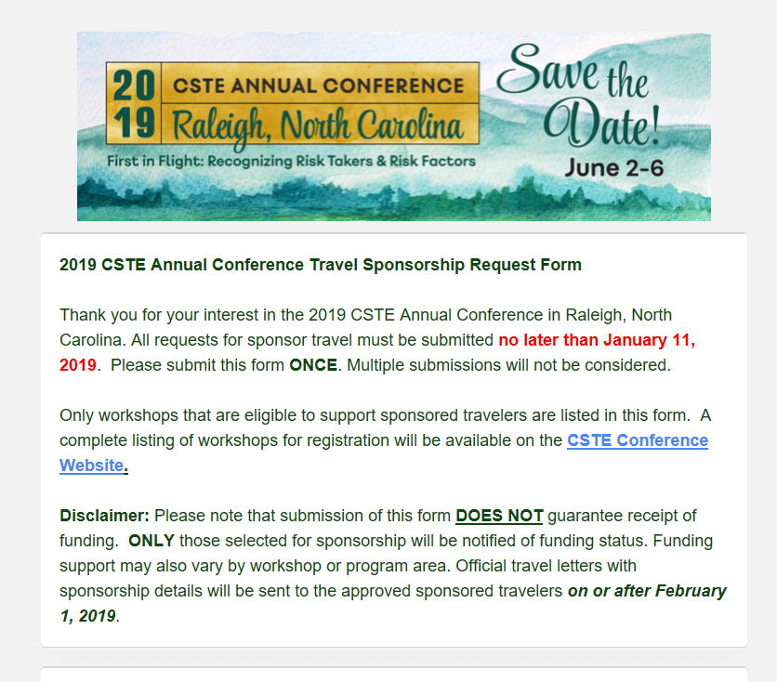

https://cste.co1.qualtrics.com/jfe/form/SV_eroZVHhtbFssXMV

