Please note some screen grabs are from previous years.
- Log-in to Confex with your Email and Password
https://cste.confex.com/cste/2020/gateway.cgi
- Staff with access to 2019 Confex site should use your CSTE email and same password
- New staff should use your CSTE email and create a password

- For those with multiple committee roles, you may select any committee to enter topics

- Select Submit Topic for 2020 AC Committee under the Options section

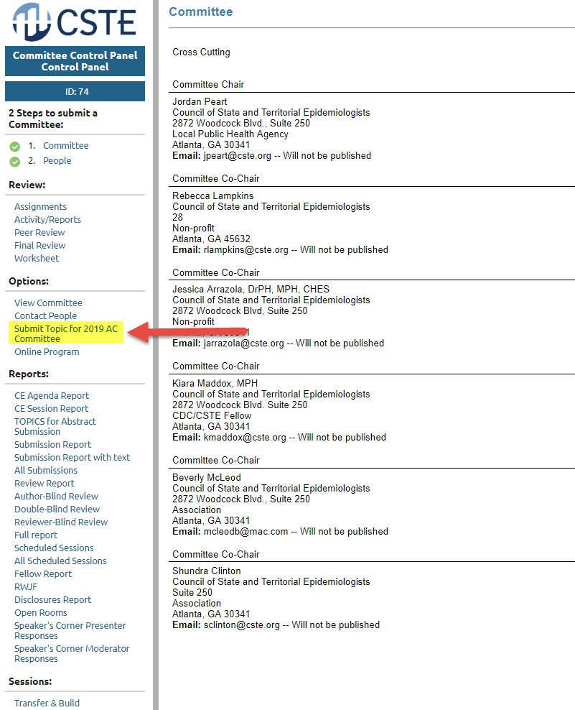

- Select the Committee for which the topic is being submitted (ALL committees will be listed)

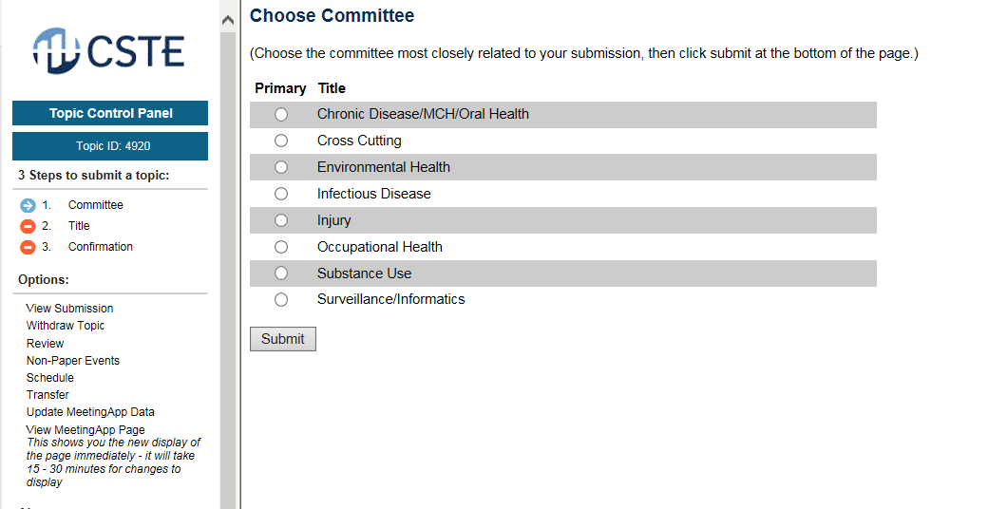

- Enter one Topic at a time and your email, then click Save and Submit. Topics can be edited before submission (for edits after submission see step 8). Yes, each topic must be submitted separately and your email address included each time.
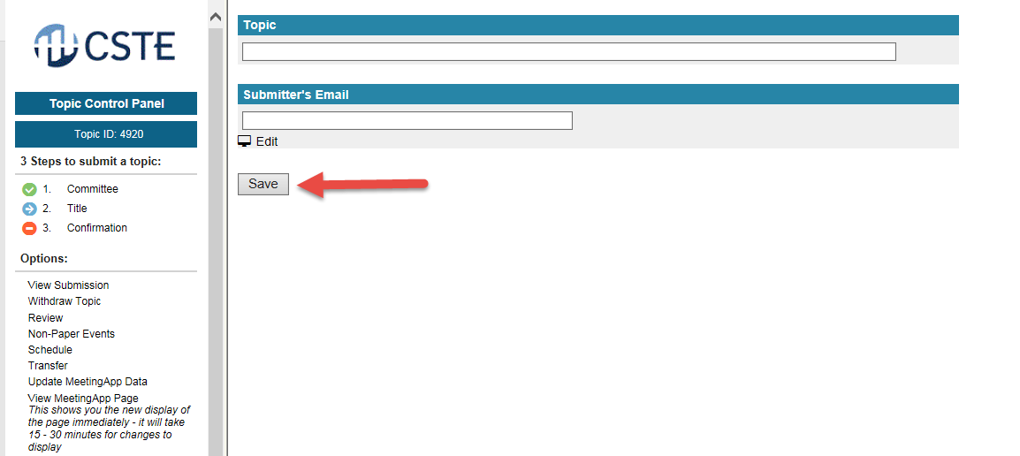

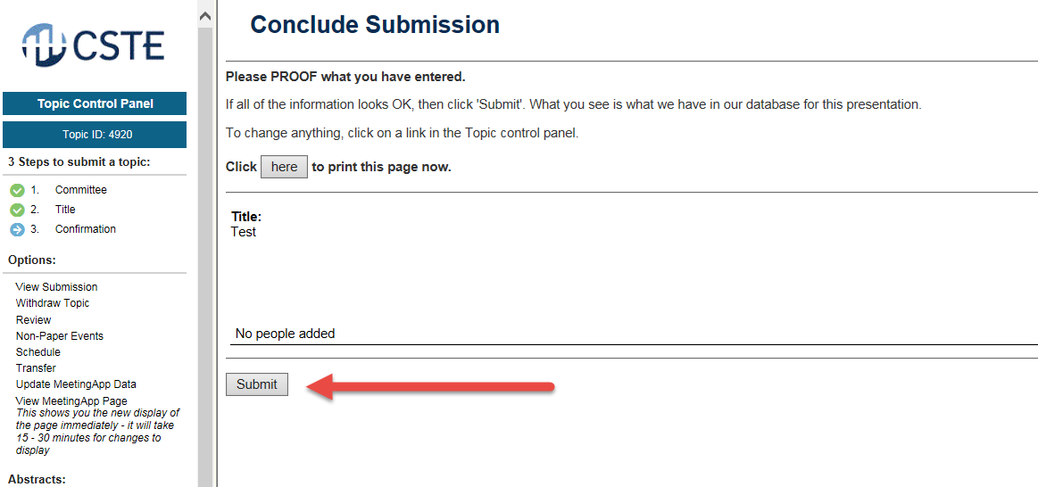

- NEW – Submit another topic from the same page. Select Submit Another Topic from the left navigation panel.

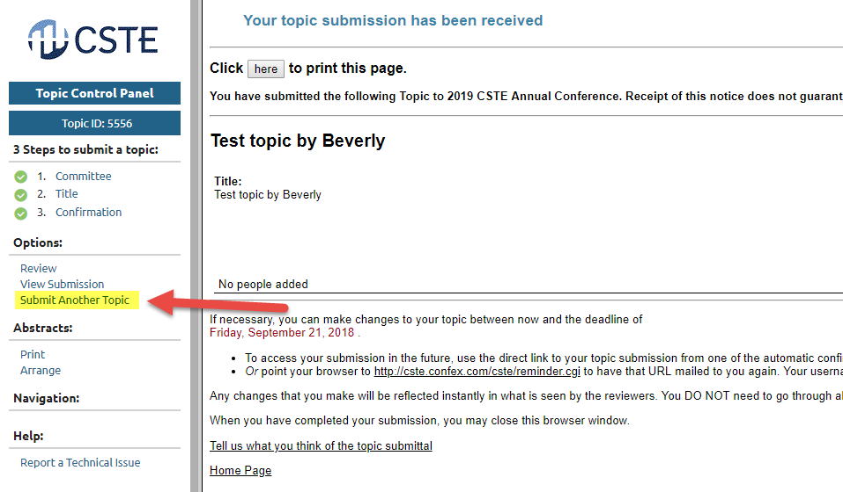
- Review and edit topics submitted for your committee under Reports – Topics for Abstract Submission. Note: Reports are accessed from the Committee Control Panel and not the Topic Control Panel.
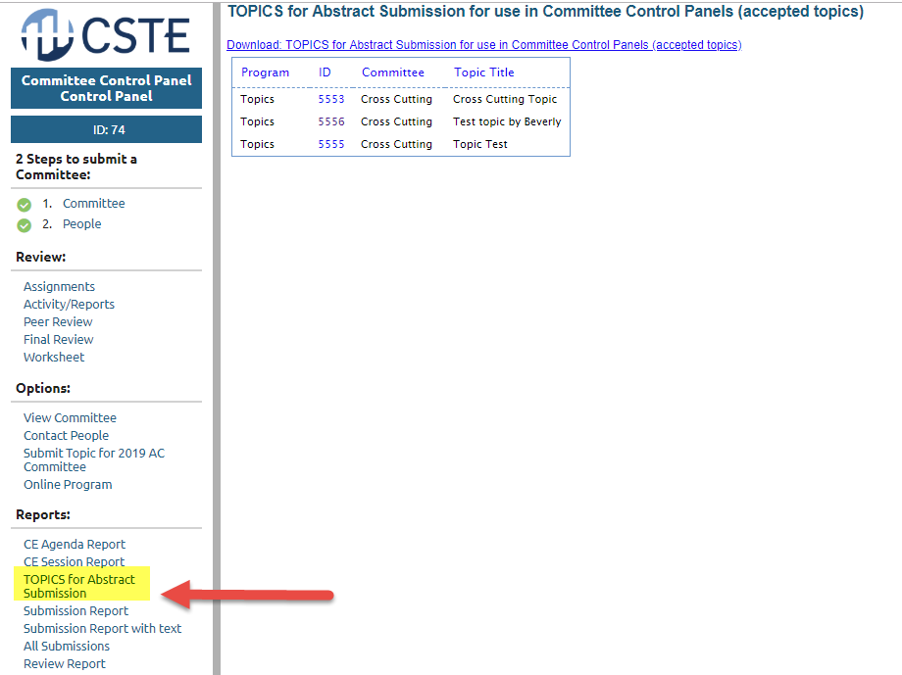
- From the Topics for Abstract Submission Report, edit topics by selecting the ID number and then the Title step. Click Save after you edit.
