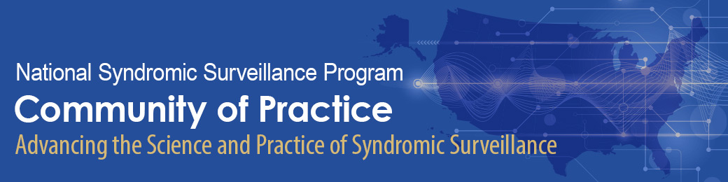

2020 Syndromic Surveillance Symposium

Final Program Packet

Table of Contents

- Event Overview…Page 2
- Session Type Descriptions…Page 2
- Daily Block Schedules…Pages 3-5
  - Description:
    - Visual display and time stamps of sessions being provided each day
    - Color-coded by Track
    - Includes session titles
  - Day 1 – November 17, 2020…Page 3
  - Day 2 – November 18, 2020…Page 4
  - Day 3 – November 19, 2020…Page 5
- Daily Agendas…Pages 6-18
  - Description:
    - Schedule of activities by time blocks (i.e., concurrent sessions)
    - Includes session track, title, descriptions, moderators, and speakers
    - Annotated with RingCentral Meeting links
  - Day 1 – November 17, 2020…Page 6
  - Day 2 – November 18, 2020…Page 11
  - Day 3 – November 19, 2020…Page 15
- Information for Joining Event Sessions…Page 19
- RingCentral Meeting Information by Track…Pages 20-23
  - Description:
    - Includes RingCentral Meeting link and call-in lines


Event Overview

The Council of State and Territorial Epidemiologists (CSTE), in collaboration with the Centers for Disease Control and Prevention’s (CDC) National Syndromic Surveillance Program (NSSP), will virtually convene the 2020 Syndromic Surveillance Symposium from November 17-19, 2020. The event will be held during the following dates and times:
- Tuesday, November 17, 2020 – 1:00-6:00pm EST
- Wednesday, November 18, 2020 – 1:00-5:00pm EST
- Thursday, November 19, 2020 – 1:00-5:15pm EST
All events will be held on CSTE’s RingCentral platform. Instructions on how to join and session links are provided in the detailed agenda. All symposium materials, including the schedule and session links can also be found on CSTE’s Basecamp platform.
CSTE has partnered with Kahuina Consulting to help provide an engaging and interactive virtual forum for the syndromic surveillance community to exchange experiences, share best practices, and take away innovative solutions and strategies for advancing syndromic surveillance practice. Attendees will have opportunities to learn new skills from technical experts, from the basics to latest analytical techniques. There will also be a forum to discuss the future of the NSSP Community of Practice and increasing syndromic surveillance capacity at the state, local, and national levels. The first two days will conclude with informal sessions hosted by colleagues.

Session Type Descriptions

Breakout – 10-minute presentations connected by a common theme followed by a moderated Q&A
Lightning – 5- to 7-minute presentations connected by a common theme followed by a moderated Q&A
Roundtable – Facilitated topical discussions to share experiences, generate ideas, and brainstorm solutions with others
Training – Step-by-step live demonstration or verbal training

Daily Block Schedules

  - Day 1 – Tuesday, November 17, 2020
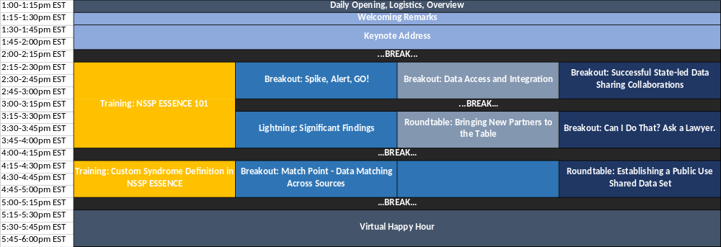
  - 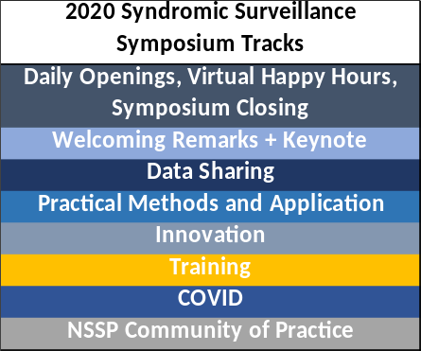
  - Day 2 – Wednesday, November 18, 2020
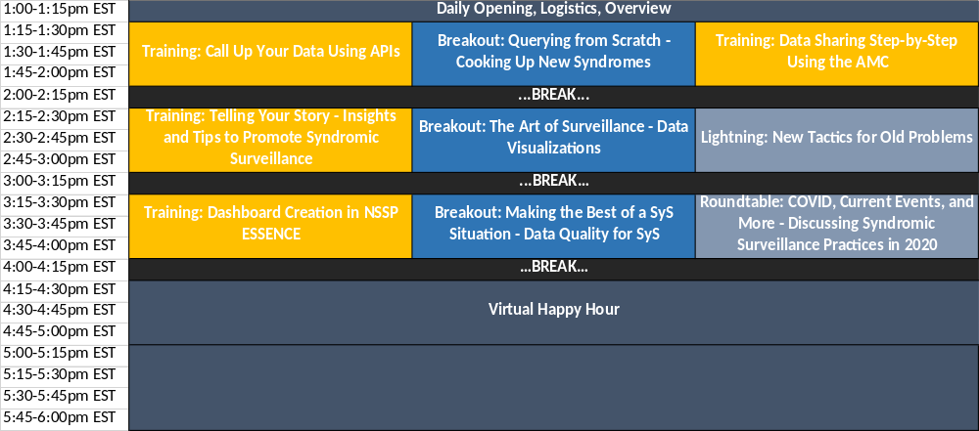
  - Day 3 – Thursday, November 19, 2020
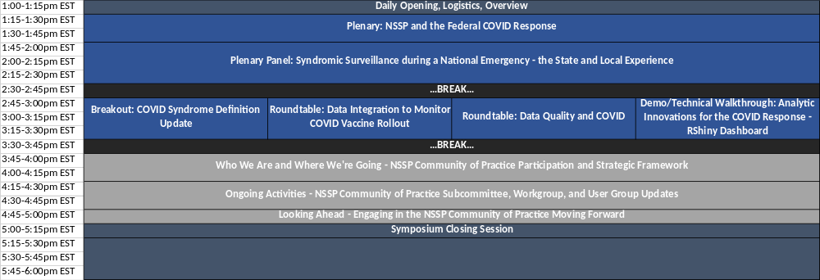

Daily Agendas
  - Day 1 – Tuesday, November 17, 2020
Opening Remarks and Keynote
  - All ‘Daily Open, Opening Remarks, Keynote, Plenary, NSSP Community of Practice, and Symposium Close’ sessions will be held in one large RingCentral Meeting space – join here: https://meetings.ringcentral.com/j/1489200367

1:00 PM EST Daily Open, Logistics, and Overview
Join Here: https://meetings.ringcentral.com/j/1489200367
Charlie Ishikawa, MSPH
Kahuina Consulting, LLC
President & Principal Consultant

1:15 PM EST Welcoming Remarks
Join Here: https://meetings.ringcentral.com/j/1489200367
Speakers:
    - CAPT Loren Rodgers, PhD – CDC/NSSP, Acting National Syndromic Surveillance Program Lead
    - Krystal Collier, BA – Arizona Department of Health Services, NSSP CoP Core Committee Chair
    - Yushiuan Chen, MPH – Tri-County Health Department (Colorado), NSSP CoP Core Committee Deputy Chair
    - Hayleigh McCall, MPH – CSTE, 2020 Syndromic Surveillance Symposium Staff Lead

1:30 PM EST Keynote Address: Exploring the Past, Present, and Future of Public Health Surveillance
Join Here: https://meetings.ringcentral.com/j/1489200367
Janet Hamilton, MPH
Executive Director
Council of State and Territorial Epidemiologists (CSTE)

15 MINUTE BREAK STARTING AT 2PM EST

Block 1 [Sessions Starting at 2:15pm EST]

2:15 PM EST Training: NSSP ESSENCE 101
Join Here: https://meetings.ringcentral.com/j/1496282212

Track: Training (Training Track 1 RingCentral Space)
Description: An orientation for new users including 1) a brief introduction to syndromic surveillance and the NSSP and 2) an NSSP-ESSENCE step-by-step live demonstration highlighting how to navigate the tool and run, save, and share a query.
Trainer: Wayne Loschen, MS – Johns Hopkins University Applied Physics Laboratory (JHUAPL)
Additional Speaker: Aaron Kite-Powell, MS – CDC/NSSP

2:15 PM EST Breakout: Spike, Alert, GO!
Join Here: https://meetings.ringcentral.com/j/1490506578
Track: Practical Methods and Application
Description: Learn about experiences determining, setting, and utilizing syndromic surveillance alerts for public health action.
Moderator: Anna Frick, MPH – Alaska Department of Health and Human Services
Presenters:
- Tim Collins, MPH, MS, MA – Alaska Native Tribal Health Consortium (ANTHC)
- Kara Manchester, MS – Ohio Department of Health
- Sindu Shamasunder, MPH + Hailey Hartman, MPH– North Carolina Department of Health and Human Services
- Howard Burkom, PhD – Johns Hopkins University Applied Physics Laboratory (JHUAPL)

2:15 PM EST Breakout: Data Access and Integration
Join Here: https://meetings.ringcentral.com/j/1493860534

Track: Innovation
Description: Hear how APIs can be used to access and integrate other data sources with syndromic data.
Moderator: Caleb Wiedeman, MPH – Tennessee Department of Health
Presenters:
- Sara Chronister, MPH – Maricopa County Department of Public Health (Arizona)
- Josh Love, MPH – Metro Public Health Department (Nashville-Davidson County, Tennessee)

2:15 PM EST Breakout: Successful State-led Data Sharing Collaborations
Join Here: https://meetings.ringcentral.com/j/1481438612

Track: Data Sharing
Description: Setting the foundation for the day’s Data Sharing Track sessions, hear of CDC and CSTE activities that have advanced syndromic data sharing and examples of successful state-led data sharing collaborations.
Moderators:
- Dave Swenson, MEd, PMP – New Hampshire Department of Health and Human Services
- CAPT Loren Rodgers, PhD – CDC/NSSP
- Charlie Ishikawa, MSPH – Kahuina Consulting, LLC
Presenters:
- Charlie Ishikawa, MSPH – Kahuina Consulting, LLC
- CAPT Loren Rodgers, PhD – CDC/NSSP
- Zach Faigen, MSPH, REHS + Mike Dolan Fliss, PhD, MPS, MSW – North Carolina Department of Health and Human Services
- Veronica Fialkowski, MPH – Vermont Department of Health
15 MINUTE BREAK STARTING AT 3PM EST
Block 2 [Sessions Starting at 3:15pm EST]

3:15 PM EST Lightning: Significant Findings
Join Here: https://meetings.ringcentral.com/j/1490506578
Track: Practical Methods and Application
Description: Discover 1) different analyses/statistics to assist in using syndromic data for decision-making and 2) syndromic surveillance alerts and how they can be interpreted to trigger public health action.
Moderator: MisChele Vickers, MPA – Alabama Department of Public Health
Presenters:
- MisChele Vickers, MPA – Alabama Department of Public Health
- Ami Gandhi, MPH – Georgia Department of Public Health
- Diksha Ramnani, MPH – Wisconsin Department of Health Services
- Darcy Phelan-Emrick, DrPH, MHS – Baltimore City Health Department (Maryland)
- Kelley Bemis, MPH – Cook County Department of Public Health (Illinois)

3:15 PM EST Roundtable: Bringing New Partners to the Table
Join Here: https://meetings.ringcentral.com/j/1493860534
Track: Innovation
Description: Discuss 1) approaches to engaging new partners and stakeholders with syndromic surveillance data and 2) methods to utilize new data and partnerships to address public health concerns.
Moderator: LT Kathleen Hartnett, PhD, MPH – CDC/NSSP
Invited Panelists:
- Alexander Senetcky, MPH – Connecticut Department of Public Health
- Grace Marx, MD, MPH – CDC/Division of Vector-Borne Diseases
- Marc Paladini, MPH – New York City Department of Health and Mental Hygiene
- Stephanie Dietz, PhD, MSc – CDC/NSSP
- Jamaal Russell, DrPH, MPH – Contractor DoD/Armed Forces Health Surveillance Division

3:15 PM EST Breakout: Can I Share That? Ask the Lawyers.
Join Here: https://meetings.ringcentral.com/j/1481438612
Track: Data Sharing
Description: Hear varying perspectives on 1) the legal framework that applies to sharing public health surveillance data, 2) ways to overcome barriers to sharing data, 3) approaches to working with privacy officers on data sharing projects, and 4) best practices for working within your jurisdiction on data sharing projects.
Moderator: Deborah Gould, PhD, MS – CDC/NSSP
Presenters:
- Rachel Hammond, CIPP/G/US, HCISPP, CIPM – New Jersey Department of Health
- Matthew Penn, JD, MLIS – CDC/Office of Public Health Law Services
- Carrie Waggoner, JD – Network for Public Health Law
15 MINUTE BREAK STARTING AT 4PM EST
Block 3 [Sessions Starting at 4:15pm EST]

4:15 PM EST Training: Custom Syndrome Definition in NSSP ESSENCE
Join Here: https://meetings.ringcentral.com/j/1496282212
Track: Training (Training Track 1 RingCentral Space)
Description: Receive instruction on creating a custom syndrome query in NSSP ESSENCE, including information on which data sources to use for validation and analysis and tips to limit processing time.
Trainers:
- Rasneet Kumar, MPH – Tarrant County Public Health (Texas)
- Rosa Ergas, MPH – Massachusetts Department of Public Health
- Zach Stein, MPH – ICF Consultant, CDC/NSSP

4:15 PM EST Breakout: Match Point – Data Matching Across Sources
Join Here: https://meetings.ringcentral.com/j/1490506578
Track: Practical Methods and Application
Description: Hear about multiple methods for matching data across different data sources and systems.
Moderator: Kelley Chester, DrPH, MPH – Thought Bridge, LLC
Presenters:
- Josh Levy, MS – Levy Informatics, LLC + Kelley Chester, DrPH, MPH – Thought Bridge, LLC
- Dana Quesinberry, JD – Kentucky Injury Prevention and Research Center
- Madison Schaeffer, MS, MPH + Keaton Hughes, MPH + Lori Zigich, MPH – New Mexico Department of Health

4:15 PM EST Roundtable: Establishing a Public Use Shared Data Set
Join Here: https://meetings.ringcentral.com/j/1481438612
Track: Data Sharing
Description: Discuss and build community consensus on a public HHS-region level syndromic surveillance summary dataset.
Moderator: CAPT Loren Rodgers, PhD – CDC/NSSP
Invited Panelists:
- Zach Faigen, MSPH, REHS – North Carolina Department of Health and Human Services
- Krystal Collier, BA – Arizona Department of Health Services
- Rob Mathes, MPH – New York City Department of Health and Mental Hygiene
- Scott McNabb, PhD, MS – Rollins School of Public Health at Emory University
- Rachel Hammond, CIPP/G/US, HCISPP, CIPM – New Jersey Department of Health
15 MINUTE BREAK STARTING AT 5PM EST
Virtual Happy Hours
  - Information to be shared day of Virtual Happy Hours

5:15 PM EST Virtual Happy Hours
Hosts, meeting spaces, and topics will be shared with registrants the day of each Virtual Happy Hour.

  - Day 2 – Wednesday, November 18, 2020
Daily Open
  - All ‘Daily Open, Opening Remarks, Keynote, Plenary, NSSP Community of Practice, and Symposium Close’ sessions will be held in one large RingCentral Meeting space – join here: https://meetings.ringcentral.com/j/1489200367

1:00 PM EST Daily Open, Logistics, and Overview
Join Here: https://meetings.ringcentral.com/j/1489200367
Charlie Ishikawa, MSPH
Kahuina Consulting, LLC
President & Principal Consultant

Block 1 [Sessions Starting at 1:15pm EST]

1:15 PM EST Training: Call Up Your Data Using APIs
Join Here: https://meetings.ringcentral.com/j/1496282212
Track: Training (Training Track 1 RingCentral Space)
Description: Receive instruction on how to access and utilize NSSP data through APIs.
Trainer: Michael Sheppard, MS – CDC/NSSP

1:15 PM EST Breakout: Querying from Scratch – Cooking Up New Syndromes
Join Here: https://meetings.ringcentral.com/j/1490506578
Track: Practical Methods and Application
Description: Hear about the process of designing a new syndrome definition query, including how surveillance objectives inform query design.
Moderator: Rosa Ergas, MPH – Massachusetts Department of Public Health
Presenters:
- Ashley Hawes, MPH – Austin Public Health (Texas)
- Gabriel Ann Haas, MPH – Kansas Department of Health and Environment
- Catherine Wolff, MS + Danielle Brathwaite, BA – University of North Carolina at Chapel Hill

1:15 PM EST Training: Data Sharing Step-by-Step Using the AMC
Join Here: https://meetings.ringcentral.com/j/1486741588
Track: Training (Training Track 2 RingCentral Space)
Description: Go through step-by-step instructions on how to share data with other jurisdictions through the AMC and discuss how building relationships, defining the purpose of shared-data surveillance, and defining AMC data sharing rules are involved in the process.
Trainer: Herbert Okam – Deloitte Consultant, CDC/NSSP
15 MINUTE BREAK STARTING AT 2PM EST
Block 2 [Sessions Starting at 2:15pm EST]

2:15 PM EST Training: Telling Your Story – Insights and Tips to Promote Syndromic Surveillance
Join Here: https://meetings.ringcentral.com/j/1496282212
Track: Training (Training Track 1 RingCentral Space)
Description: Learn from public health communication experts on identifying and successfully communicating syndromic surveillance success stories.
Trainers:
- Oona Powell, MA – CDC/Division of Health Informatics and Surveillance
- Michael Latham, BBA – CDC/Division of Health Informatics and Surveillance

2:15 PM EST Breakout: The Art of Surveillance – Data Visualizations
Join Here: https://meetings.ringcentral.com/j/1490506578
Track: Practical Methods and Application
Description: Hear about different visualizations that can be used to effectively share syndromic surveillance analyses through engaging dashboards and presentations.
Moderator: Yushiuan Chen, MPH – Tri-County Health Department (Colorado)
Presenters:
- Amanda Dylina Morse, MPH – Washington State Department of Health
- MisChele Vickers, MPA – Alabama Department of Public Health
- Michelle Carr, MPH + Yifang Dang, MS – Houston Health Department (Texas)

2:15 PM EST Lightning: New Tactics for Old Problems
Join Here: https://meetings.ringcentral.com/j/1493860534
Track: Innovation
Description: Learn about examples of new ways to apply syndromic surveillance to public health problems.
Moderators:
- Bill Smith, MS – Maricopa County Department of Public Health (Arizona)
- Fatema Mamou, MPH – Michigan Department of Health and Human Services
Presenters:
- Amy Ising, MSIS – University of North Carolina at Chapel Hill
- Sandra Gonzalez, PhD, MPH – Nebraska Department of Health and Human Services
- James Muncy, MPH – South Carolina Department of Health and Environmental Control
- Dave Atrubin, MPH – Florida Department of Health
- Lakshmi Radhakrishnan, MPH – CDC/NSSP
- Zach Stein, MPH – ICF Consultant, CDC/NSSP
15 MINUTE BREAK STARTING AT 3PM EST
Block 3 [Sessions Starting at 3:15pm EST]

3:15 PM EST Training: Dashboard Creation in NSSP ESSENCE
Join Here: https://meetings.ringcentral.com/j/1496282212
Track: Training (Training Track 1 RingCentral Space)
Description: Walk step-by-step through a demonstration of myESSENCE dashboard functionalities.
Trainer: Amanda Dylina Morse, MPH – Washington State Department of Health

3:15 PM EST Breakout: Making the Best of a SyS Situation – Data Quality for Syndromic Surveillance
Join Here: https://meetings.ringcentral.com/j/1490506578
Track: Practical Methods and Application
Description: Learn different methods for identifying and interpreting varying data quality elements.
Moderator: Harold Gil, MSPH – Washington Start Department of Health
Presenters:
- Dave Atrubin, MPH – Florida Department of Health
- Viacony Herzi, MPH, MLS(ASCP)^{CM} – Maricopa County Department of Public Health (Arizona) + Sasha Harb, MPH – Pima County Health Department (Arizona)
- PJ Gibson, BS – Indiana Department of Health

3:15 PM EST Roundtable: COVID, Current Events, and More – Discussing Syndromic Surveillance Practices in 2020
Join Here: https://meetings.ringcentral.com/j/1493860534
Track: Innovation
Description: Discuss definitions and/or other SyS activities regarding protests, police-involved shootings, COVID race inequalities, health equity, etc.
Moderator: Jim Nowicki, MBA – GDIT
Invited Panelists:
- Arden Norfleet, MPH – Virginia Department of Health

15 MINUTE BREAK STARTING AT 4PM EST
Virtual Happy Hours
  - Information to be shared day of Virtual Happy Hours

4:15 PM EST Virtual Happy Hours
Hosts, meeting spaces, and topics will be shared with registrants the day of each Virtual Happy Hour.

  - Day 3 – Thursday, November 19, 2020
Daily Open
  - All ‘Daily Open, Opening Remarks, Keynote, Plenary, NSSP Community of Practice, and Symposium Close’ sessions will be held in one large RingCentral Meeting space – join here: https://meetings.ringcentral.com/j/1489200367

1:00 PM EST Daily Open, Logistics, and Overview
Join Here: https://meetings.ringcentral.com/j/1489200367
Charlie Ishikawa, MSPH
Kahuina Consulting, LLC
President & Principal Consultant

Plenaries
  - All ‘Daily Open, Opening Remarks, Keynote, Plenary, NSSP Community of Practice, and Symposium Close’ sessions will be held in one large RingCentral Meeting space – join here: https://meetings.ringcentral.com/j/1489200367

1:15 PM EST Plenary: NSSP and the Federal COVID Response
Join Here: https://meetings.ringcentral.com/j/1489200367
Paula W. Yoon, ScD, MPH
Director, Division of Health Informatics and Surveillance
Centers for Disease Control and Prevention (CDC)

1:45 PM EST Plenary Panel: Syndromic Surveillance during a National Emergency – the State and Local Experience
Join Here: https://meetings.ringcentral.com/j/1489200367
Moderator: Charlie Ishikawa, MSPH – Kahuina Consulting, LLC
Panelists:
- Natasha Close, PhD, MPH – Washington State Department of Health,
- Stacey Hoferka Jensen, MPH, MSIS – Illinois Department of Public Health,
- Rob Mathes, MPH – New York City Department of Health and Mental Hygiene
- Kathy Turner, PhD, MPH – Idaho Division of Public Health
15 MINUTE BREAK STARTING AT 2:30PM EST

Block 1 [Sessions Starting at 2:45pm EST]

2:45 PM EST Breakout: COVID Syndrome Definition Update
Join Here: https://meetings.ringcentral.com/j/1482687887
Track: COVID (COVID Track 1 RingCentral Space)
Description: Hear and discuss 1) updates to the national COVID syndrome definition, 2), information being considered by CDC about the definition, and 3) jurisdictional experiences in refining the COVID definition for specific surveillance purposes
Moderators/Presenters:
- Amanda Smith, PhD, MPH – CDC/NSSP (EIS Officer)
- Zach Stein, MPH – ICF Consultant, CDC/NSSP
- Michael Sheppard, MS – CDC/NSSP

2:45 PM EST Roundtable: Data Integration to Monitor COVID Vaccine Rollout
Join Here: https://meetings.ringcentral.com/j/1483562364
Track: COVID (COVID Track 2 RingCentral Space)
Description: Discuss how NSSP data, adverse event data, poison control data, and other sources can be leveraged for rapid analysis to identify potential issues from rollout of COVID-19 vaccines.
Moderator: Jim Nowicki, MBA – GDIT

2:45 PM EST Roundtable: Data Quality and COVID
Join Here: https://meetings.ringcentral.com/j/1486502635
Track: COVID (COVID Track 3 RingCentral Space)
Description: Discuss the unique data quality challenges identified or exposure during the COVID response.
Moderators:
- Diksha Ramnani, MPH – Wisconsin Department of Health Services
- Jamie Smimble, MPH – CDC/NSSP
- Lakshmi Radhakrishnan, MPH – CDC/NSSP
Invited Panelist: Stephanie Dietz, PhD, MSc – CDC/NSSP

2:45 PM EST Demo/Technical Walkthrough: Analytic Innovations for the COVID Response – R Shiny Dashboard
Join Here: https://meetings.ringcentral.com/j/1484743637
Track: COVID (COVID Track 4 RingCentral Space)
Description: Participate in a demonstration and technical (i.e., code) walkthrough of the R Shiny Dashboard created for the COVID response.
Demonstrators:
- Aaron Kite-Powell, MS – CDC/NSSP
- Douglas Wirtz, MS – ICF Consultant, CDC/NSSP
15 MINUTE BREAK STARTING AT 3:30PM EST
NSSP Community of Practice (CoP) Sessions
  - All ‘Daily Open, Opening Remarks, Keynote, Plenary, NSSP Community of Practice, and Symposium Close’ sessions will be held in one large RingCentral Meeting space – join here: https://meetings.ringcentral.com/j/1489200367

3:45 PM EST Who We Are and Where We’re Going – NSSP CoP Participation and Strategic Framework
Join Here: https://meetings.ringcentral.com/j/1489200367
Moderator: Charlie Ishikawa, MSPH – Kahuina Consulting, LLC
Presenters:
    - Deborah Gould, PhD, MS – CDC/NSSP, NSSP CoP Technical Monitor
    - Krystal Collier, BA – Arizona Department of Health Services, NSSP CoP Core Committee Chair
    - Yushiuan Chen, MPH – Tri-County Health Department (Colorado), NSSP CoP Core Committee Deputy Chair
    - Hayleigh McCall, MPH – CSTE, NSSP CoP Staff Lead

4:15 PM EST Ongoing Activities – NSSP CoP Subcommittee, Workgroup, and User Group Updates
Join Here: https://meetings.ringcentral.com/j/1489200367
Moderator: Charlie Ishikawa, MSPH – Kahuina Consulting, LLC
Presenters: NSSP CoP Core Committee Representatives and Workgroup Co-Chairs

4:45 PM EST Looking Ahead – Engaging with the NSSP CoP Moving Forward
Join Here: https://meetings.ringcentral.com/j/1489200367
Moderator: Charlie Ishikawa, MSPH – Kahuina Consulting, LLC
Presenters:
    - Deborah Gould, PhD, MS – CDC/NSSP NSSP CoP Technical Monitor
    - Krystal Collier, BA – Arizona Department of Health Services, NSSP CoP Core Committee Chair
    - Yushiuan Chen, MPH – Tri-County Health Department (Colorado), NSSP CoP Core Committee Deputy Chair
    - Hayleigh McCall, MPH – CSTE, NSSP CoP Staff Lead

Symposium Close
  - All ‘Daily Open, Opening Remarks, Keynote, Plenary, NSSP Community of Practice, and Symposium Close’ sessions will be held in one large RingCentral Meeting space – join here: https://meetings.ringcentral.com/j/1489200367

5:00 PM EST Symposium Closing Session
Join Here: https://meetings.ringcentral.com/j/1489200367
Charlie Ishikawa, MSPH
Kahuina Consulting, LLC
President & Principal Consultant

Information for Joining Event Sessions
Joining the Meeting
- The indicated weblinks will take you to a landing page that should trigger a download of the RingCentral Meetings software. If you are unable to install the software due to security protocols, you can still join the meeting using a web browser – do so by clicking “join from your browser” on the same page.
- Note: We have found issues when using Internet Explorer – we highly recommend joining via Chrome, Edge, Safari, or Firefox instead.
- Note: If you join RingCentral using a web browser, you may be unable to participate and view any launched polls.
Add Your Jurisdiction
- Once you have joined, we ask that users rename themselves to include their jurisdiction or organization. Please see the following instructions on how to edit your webinar username.
- In the Participant panel, hover your mouse over your own name to reveal the “Rename” button. Click this button.
- A pop-up window should appear. Enter your name and jurisdiction in parentheses (e.g. “Sherri Davidson (AL)”).
- Click the “OK” button to save.
Audio
- During large sessions (i.e., Daily Open, Opening Remarks, Keynote, Plenary, NSSP Community of Practice, and Symposium Close), attendees will be muted upon entry.
  - If you join through the RingCentral Meeting platform, you may unmute by hovering your mouse over the “unmute” button and clicking.
  - If you join by phone only, you may unmute to ask a question by pressing *6 (star + the number six).
- During smaller sessions (i.e., all other sessions), attendees will NOT be muted on entry.
  - To avoid background noise, please be sure to mute your line when not speaking.
Video Feeds
- We encourage all attendees to turn on their webcams during the event for greater engagement.
Recording
- Note that all sessions are being recorded for later viewing purposes.
Technical Assistance
- If you encounter issues when attempting to join the call, please review the system requirements and the RingCentral troubleshooting webpage. You may also email CSTE IT staff at symposiumsupport@cste.org.

RingCentral Meeting Information by Track

Welcoming Remarks, Keynote, Plenary, NSSP Community of Practice, and
Symposium Closing Sessions
- Join from PC, Mac, Linux, iOS or Android: https://meetings.ringcentral.com/j/1489200367
- Or iPhone one-tap:
  - +1(470)8692200,,1489200367# (US East)
  - +1(773)2319226,,1489200367# (US North)
  - +1(720)9027700,,1489200367# (US Central)
  - +1(469)4450100,,1489200367# (US South)
  - +1(623)4049000,,1489200367# (US West)
- Or Telephone:
  - +1(470)8692200 (US East) || Meeting ID: 148 920 0367
  - +1(773)2319226 (US North) || Meeting ID: 148 920 0367
  - +1(720)9027700 (US Central) || Meeting ID: 148 920 0367
  - +1(469)4450100 (US South) || Meeting ID: 148 920 0367
  - +1(623)4049000 (US West) || Meeting ID: 148 920 0367

Data Sharing Track Sessions
- Join from PC, Mac, Linux, iOS or Android: https://meetings.ringcentral.com/j/1481438612
- Or iPhone one-tap:
  - +1(470)8692200,,1481438612# (US East)
  - +1(773)2319226,,1481438612# (US North)
  - +1(720)9027700,,1481438612# (US Central)
  - +1(469)4450100,,1481438612# (US South)
  - +1(623)4049000,,1481438612# (US West)
- Or Telephone:
  - +1(470)8692200 (US East) || Meeting ID: 148 143 8612
  - +1(773)2319226 (US North) || Meeting ID: 148 143 8612
  - +1(720)9027700 (US Central) || Meeting ID: 148 143 8612
  - +1(469)4450100 (US South) || Meeting ID: 148 143 8612
  - +1(623)4049000 (US West) || Meeting ID: 148 143 8612

Practical Methods and Application Track Sessions
- Join from PC, Mac, Linux, iOS or Android: https://meetings.ringcentral.com/j/1490506578
- Or iPhone one-tap:
  - +1(470)8692200,,1490506578# (US East)
  - +1(773)2319226,,1490506578# (US North)
  - +1(469)4450100,,1490506578# (US South)
  - +1(623)4049000,,1490506578# (US West)
  - +1(720)9027700,,1490506578# (US Central)
- Or Telephone:
  - +1(470)8692200 (US East) || Meeting ID: 149 050 6578
  - +1(773)2319226 (US North) || Meeting ID: 149 050 6578
  - +1(469)4450100 (US South) || Meeting ID: 149 050 6578
  - +1(623)4049000 (US West) || Meeting ID: 149 050 6578
  - +1(720)9027700 (US Central) || Meeting ID: 149 050 6578

Innovation Track Sessions
- Join from PC, Mac, Linux, iOS or Android: https://meetings.ringcentral.com/j/1493860534
- Or iPhone one-tap :
  - +1(470)8692200,,1493860534# (US East)
  - +1(773)2319226,,1493860534# (US North)
  - +1(469)4450100,,1493860534# (US South)
  - +1(623)4049000,,1493860534# (US West)
  - +1(720)9027700,,1493860534# (US Central)
- Or Telephone:
  - +1(470)8692200 (US East) || Meeting ID: 149 386 0534
  - +1(773)2319226 (US North) || Meeting ID: 149 386 0534
  - +1(469)4450100 (US South)|| Meeting ID: 149 386 0534
  - +1(623)4049000 (US West) || Meeting ID: 149 386 0534
  - +1(720)9027700 (US Central) || Meeting ID: 149 386 0534
Training Track 1 Sessions
- Join from PC, Mac, Linux, iOS or Android: https://meetings.ringcentral.com/j/1496282212
- Or iPhone one-tap:
  - +1(470)8692200,,1496282212# (US East)
  - +1(773)2319226,,1496282212# (US North)
  - +1(469)4450100,,1496282212# (US South)
  - +1(623)4049000,,1496282212# (US West)
  - +1(720)9027700,,1496282212# (US Central)
- Or Telephone:
  - +1(470)8692200 (US East) || Meeting ID: 149 628 2212
  - +1(773)2319226 (US North) || Meeting ID: 149 628 2212
  - +1(469)4450100 (US South) || Meeting ID: 149 628 2212
  - +1(623)4049000 (US West) || Meeting ID: 149 628 2212
  - +1(720)9027700 (US Central) || Meeting ID: 149 628 2212

Training Track 2 Session
- Join from PC, Mac, Linux, iOS or Android: https://meetings.ringcentral.com/j/1486741588
- Or iPhone one-tap:
  - +1(470)8692200,,1486741588# (US East)
  - +1(773)2319226,,1486741588# (US North)
  - +1(469)4450100,,1486741588# (US South)
  - +1(623)4049000,,1486741588# (US West)
  - +1(720)9027700,,1486741588# (US Central)
- Or Telephone:
  - +1(470)8692200 (US East) || Meeting ID: 148 674 1588
  - +1(773)2319226 (US North) || Meeting ID: 148 674 1588
  - +1(469)4450100 (US South) || Meeting ID: 148 674 1588
  - +1(623)4049000 (US West) || Meeting ID: 148 674 1588
  - +1(720)9027700 (US Central) || Meeting ID: 148 674 1588

COVID Track 1 Session (Syndrome Update)
- Join from PC, Mac, Linux, iOS or Android: https://meetings.ringcentral.com/j/1482687887
- Or iPhone one-tap:
  - +1(470)8692200,,1482687887# (US East)
  - +1(773)2319226,,1482687887# (US North)
  - +1(469)4450100,,1482687887# (US South)
  - +1(623)4049000,,1482687887# (US West)
  - +1(720)9027700,,1482687887# (US Central)
- Or Telephone:
  - +1(470)8692200 (US East) || Meeting ID: 148 268 7887
  - +1(773)2319226 (US North) || Meeting ID: 148 268 7887
  - +1(469)4450100 (US South) || Meeting ID: 148 268 7887
  - +1(623)4049000 (US West) || Meeting ID: 148 268 7887
  - +1(720)9027700 (US Central) || Meeting ID: 148 268 7887

COVID Track 2 Session (Vaccine Rollout)
- Join from PC, Mac, Linux, iOS or Android: https://meetings.ringcentral.com/j/1483562364
- Or iPhone one-tap:
  - +1(470)8692200,,1483562364# (US East)
  - +1(773)2319226,,1483562364# (US North)
  - +1(469)4450100,,1483562364# (US South)
  - +1(623)4049000,,1483562364# (US West)
  - +1(720)9027700,,1483562364# (US Central)
- Or Telephone:
  - +1(470)8692200 (US East) || Meeting ID: 148 356 2364
  - +1(773)2319226 (US North) || Meeting ID: 148 356 2364
  - +1(469)4450100 (US South) || Meeting ID: 148 356 2364
  - +1(623)4049000 (US West) || Meeting ID: 148 356 2364
  - +1(720)9027700 (US Central) || Meeting ID: 148 356 2364
COVID Track 3 Session (Data Quality)
- Join from PC, Mac, Linux, iOS or Android: https://meetings.ringcentral.com/j/1486502635
- Or iPhone one-tap:
  - +1(470)8692200,,1486502635# (US East)
  - +1(773)2319226,,1486502635# (US North)
  - +1(720)9027700,,1486502635# (US Central)
  - +1(469)4450100,,1486502635# (US South)
  - +1(623)4049000,,1486502635# (US West)
- Or Telephone:
  - +1(470)8692200 (US East) || Meeting ID: 148 650 2635
  - +1(773)2319226 (US North) || Meeting ID: 148 650 2635
  - +1(720)9027700 (US Central) || Meeting ID: 148 650 2635
  - +1(469)4450100 (US South) || Meeting ID: 148 650 2635
  - +1(623)4049000 (US West) || Meeting ID: 148 650 2635

COVID Track 4 Session (R Shiny Demo)
- Join from PC, Mac, Linux, iOS or Android: https://meetings.ringcentral.com/j/1484743637
- Or iPhone one-tap:
  - +1(470)8692200,,1484743637# (US East)
  - +1(773)2319226,,1484743637# (US North)
  - +1(469)4450100,,1484743637# (US South)
  - +1(623)4049000,,1484743637# (US West)
  - +1(720)9027700,,1484743637# (US Central)
- Or Telephone:
  - +1(470)8692200 (US East) || Meeting ID: 148 474 3637
  - +1(773)2319226 (US North) || Meeting ID: 148 474 3637
  - +1(469)4450100 (US South) || Meeting ID: 148 474 3637
  - +1(623)4049000 (US West) || Meeting ID: 148 474 3637
  - +1(720)9027700 (US Central) || Meeting ID: 148 474 3637

