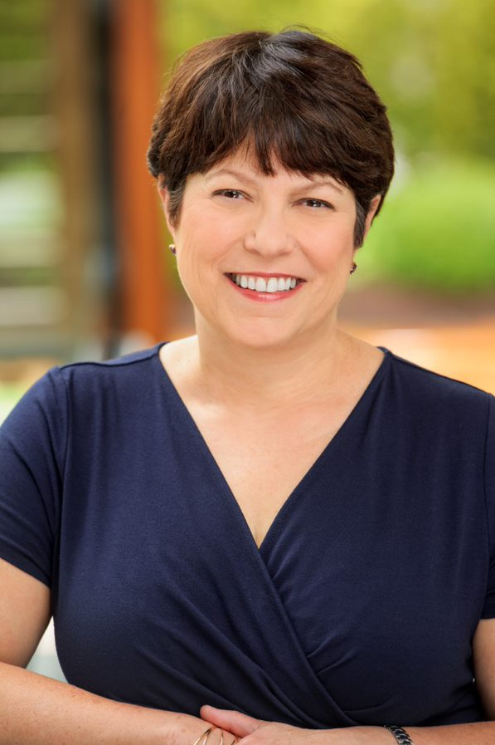

Dr. Kelly Henning Biography

Dr. Kelly Henning is a medical doctor and epidemiologist trained in internal medicine, infectious diseases, and public health in the United States of America. She received her epidemiology training in the Epidemic Intelligence Service at the US Centers for Disease Control and Prevention. Subsequently, Dr. Henning has been an associate professor in infectious disease and hospital epidemiology at the University of Pennsylvania School of Medicine. Dr. Henning was the Director of the newly formed Division of Epidemiology at the New York City Department of Health and Mental Hygiene from 2003 - 2006 before joining Bloomberg Philanthropies in January 2007. She currently directs global health programs at Bloomberg Philanthropies, including the $1 billion, 16 year Bloomberg Initiative to Reduce Tobacco Use -- a global project aimed at curbing the tobacco epidemic in low and middle income countries and the Bloomberg Global Road Safety Program – an 18 year, $500 million global program to reduce road traffic deaths in low and middle income countries. Since March 2020, Dr. Henning has been leading the $40 million COVID-19 global response for Bloomberg Philanthropies – to support immediate action in preventing or slowing the spread of COVID-19 in vulnerable low and middle-income countries, particularly those in Africa.

