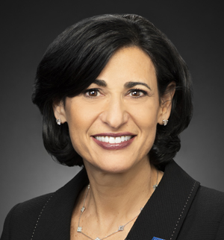

Dr. Rochelle Walensky Biography

Rochelle P. Walensky, MD, MPH, is the 19th Director of the Centers for Disease Control and Prevention and the ninth Administrator of the Agency for Toxic Substances and Disease Registry. She is an influential scholar whose pioneering research has helped advance the national and global response to HIV/AIDS. Dr. Walensky is also a well-respected expert on the value of testing and treatment of deadly viruses.
Dr. Walensky served as Chief of the Division of Infectious Diseases at Massachusetts General Hospital from 2017-2020 and Professor of Medicine at Harvard Medical School from 2012-2020. She served on the frontline of the COVID-19 pandemic and conducted research on vaccine delivery and strategies to reach underserved communities.
Dr. Walensky is recognized internationally for her work to improve HIV screening and care in South Africa and nationally recognized for motivating health policy and informing clinical trial design and evaluation in a variety of settings.
She is a past Chair of the Office of AIDS Research Advisory Council at the National Institutes of Health, Chair-elect of the HIV Medical Association, and previously served as an advisor to both the World Health Organization and the Joint United Nations Programme on HIV/AIDS.
Originally from Maryland, Dr. Walensky received her Bachelor of Arts from Washington University in St. Louis, her Doctor of Medicine from the Johns Hopkins School of Medicine, and her Masters in Public Health from the Harvard School of Public Health.

