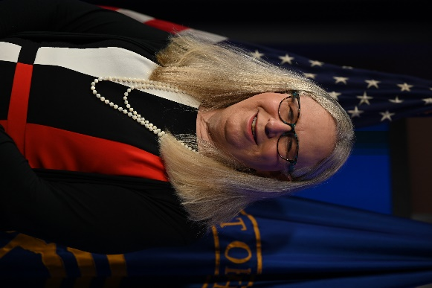

Rachel L. Levine, M.D.
Assistant Secretary for Health
U.S. Department of Health and Human Services
Dr. Rachel L. Levine serves as the 17th Assistant Secretary for Health for the U.S. Department of Health and Human Services (HHS) where she fights every day to improve the health and well-being of all Americans. She’s working to help our nation overcome the COVID-19 pandemic and build a stronger foundation for a healthier future - one in which every American can attain their full health potential. Dr. Levine’s storied career, first in academic medicine, and as a physician then Pennsylvania’s Physician General and then as Pennsylvania’s Secretary of Health, has focused on the intersection between mental and physical health, often treating children, adolescents, and young adults.

