2022 CSTE Annual Conference
Session Allocations
2022 Hybrid Conference and Planning for Virtual Only (IF happens!)
Outcome:
The goal of this exercise is to support all CSTE Members who plan to attend the CSTE Conference and have options to participate in sessions in person, virtually and/or on demand.
Purpose:
For 2022, the CSTE Conference is currently (Jan 2022) planned as a Hybrid conference. This means CSTE will make available the following three options for members to engage.
In-Person | Refers to Live, in person, in Kentucky
Virtual | Refers to Live, on the computer
On-Demand | Refers to a recorded session, to be viewed at members convenience

Goal:
To ensure CSTE Staff have adequate resources and information to plan committee sessions in February/March 2022 and to ensure members who register for Virtual Only, have opportunities to engage in Roundtable and Breakout sessions. They will also have access to the Plenary sessions. Please Note: CSTE will not live stream any in person sessions (except Plenary Sessions). To take a proactive approach, start planning for a virtual only conference, if this happens. More information on the current agenda and session formats can be found here: https://www.csteconference.org/index.php/2022-preliminary-daily-schedule/.
Proposal:
First ask: CSTE staff to collaborate with your committees (as usual) to identify current sessions (Round Table and Breakout) and make some of those either Virtual or On Demand. It is important to note that all allocations per committee remain the same as what you currently see in Confex Scheduled Sessions Report. From the sessions allocated to each committee, please designate which sessions will remain in person (Confex currently has all sessions listed in-person), which sessions will move to a Virtual session, and which session will be On-Demand. Note: You can add On-Demand sessions beyond sessions you currently see listed in Confex. This updated session schedule will be due on February 24, 2022 to allow adequate time for changes to be made in Confex prior to sessioning.
Second ask: Taking a proactive approach, start to build a rough draft of a Virtual Only conference. We should know if we need to go virtual by March/April. This process at least gives us a head start on moving all in person sessions to either Virtual or On Demand.
Instructions:
First:
Take some time to review this spreadsheet. This is an export of all sessions from Confex.
https://cste-my.sharepoint.com/:x:/g/personal/agil_cste_org/EaT_b1BnXB5JmpOxn1Ir3VsBOyXyC8hXS9g_cW5_oNLsYQ?e=5qdPBN
Second:
With your committees, work to update the current conference session schedule to include a mix of In Person, Virtual and On Demand Options.
Excel Spreadsheet Viewing Options
- Sort by your committee
- Sort by Date
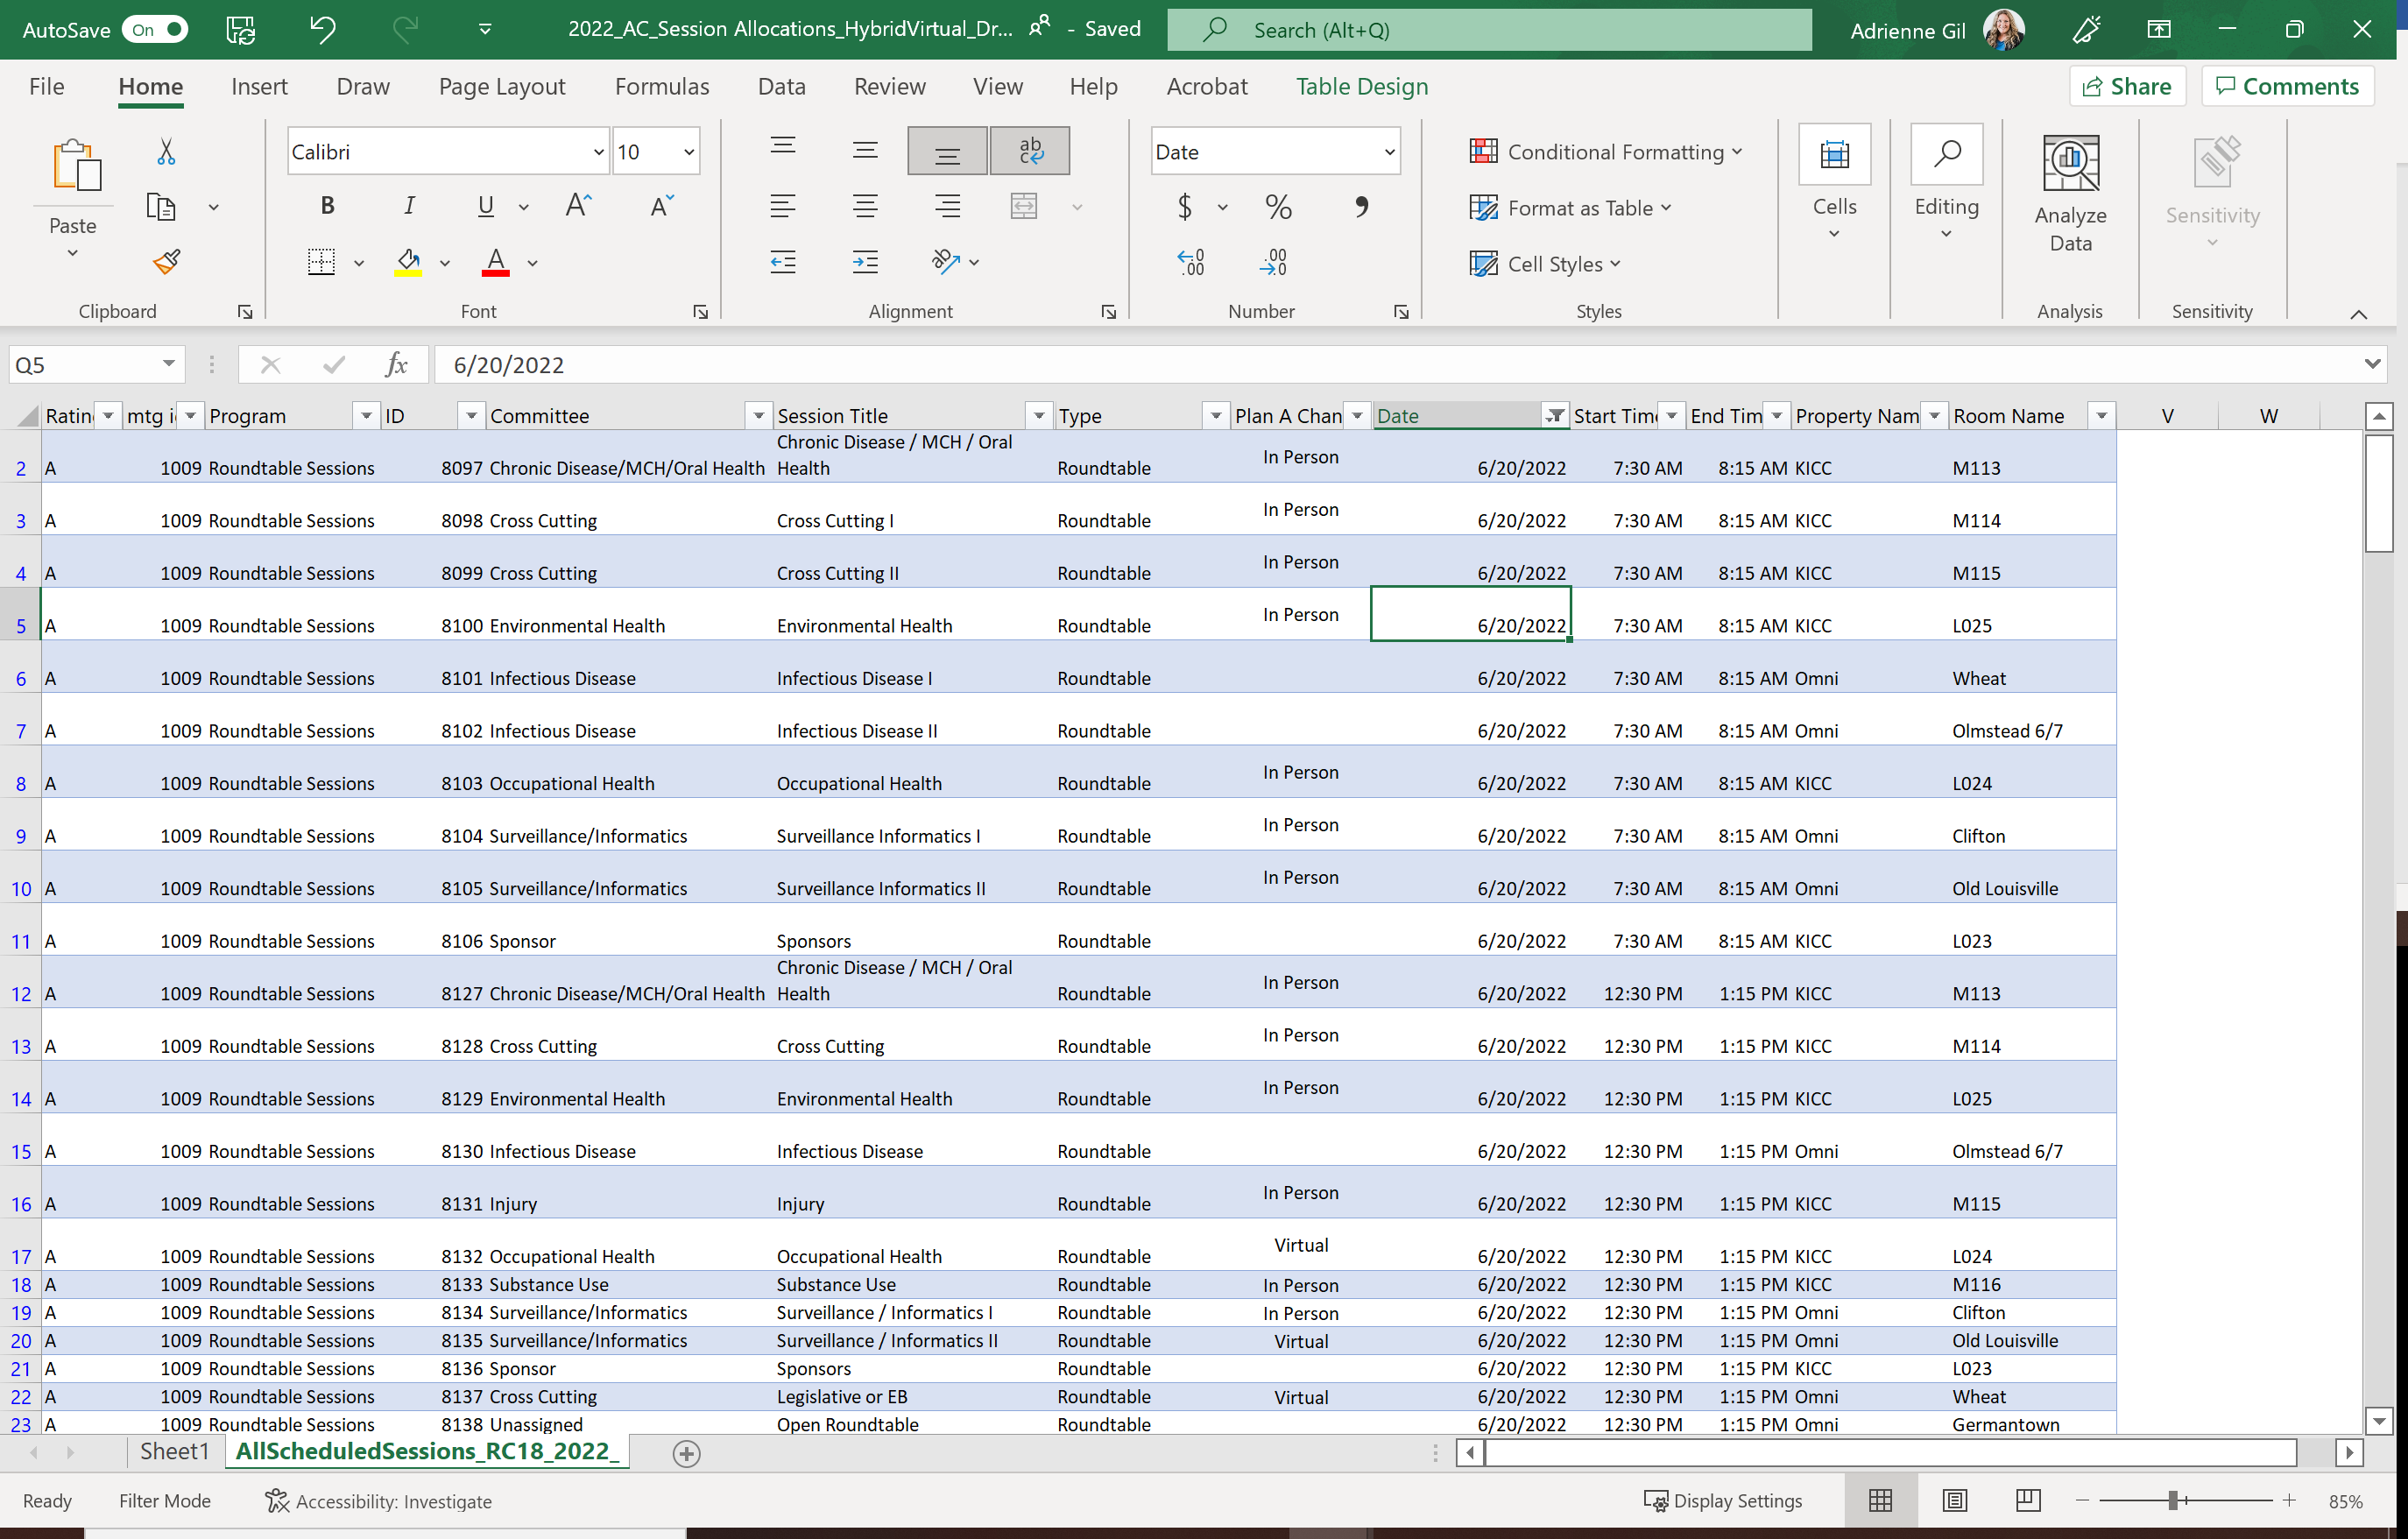

Once you are looking at your committee and a specific date, now focus on the Type of Session and Plan A Change Column. We went through and proposed some ideas, so you can get an idea of a Hybrid Conference/options. These are just suggestions. Please work with your committee to finalize the current CSTE Conference schedule. You will be limited to changing from In Person to either Virtual or On Demand. These changes are due 2/24/2022
Current schedule indicates a physical room/location for every session. The goal is to amend some of the current in-person session to either Virtual or On Demand.
Please note, you will have the same number of live sessions, whether they are in-person or virtual While there are currently meeting rooms being held for all sessions, if a session is determined to be held virtually, that does not open up the option for an additional in-person session. There are no limits on how many on-demand sessions may be added, so any additional session will need to be on-demand.
The virtual attendees will not have the ability to participate in the In Person sessions, CSTE is not live streaming roundtables or breakouts. Virtual registrants will only have access to Plenary, virtual, and on demand.
CSTE In Person conference attendees will have access to in person sessions, virtual and on demand.
Currently, all sessions before 10:30am are automatically in-person or on demand (there will be no virtual sessions before 10:30am). If the conference transitions to an entirely virtual conference, all sessions before 10:30am will need to be moved to afternoon slots. A suggested date/time has been given for sessions before 10:30 am if the conference transitions to entirely virtual (can be edited) - see Columns J, K, and L for suggestions.
Current Plan (Hybrid Event) | Future Plan, if we move to 100% Virtual
Roundtables (In Person or Virtual) | Roundtable can be switched to Virtual only. If the session is scheduled before 10:30, move the time to the afternoon.
Breakouts/Quicks (In Person, Virtual, or On-Demand)  *Breakouts, Quicks and Lightnings should be designated from total Breakout allocation | Breakouts/Quicks can be switched to either a Virtual or On Demand Session, If the session is scheduled before 10:30, move the time to the afternoon.
Lightnings (On-Demand) | Lightning Sessions will automatically be on-demand, regardless of if the conference follows a hybrid or virtual format.
Posters (On-Demand or In Person)  In-Person = 30 minutes discussion with attendees  On-Demand = 5 min video presentation | Posters will move to all on-demand with 5 min pre-recorded presentation to accompany poster

Flow Chart of Session Changes
