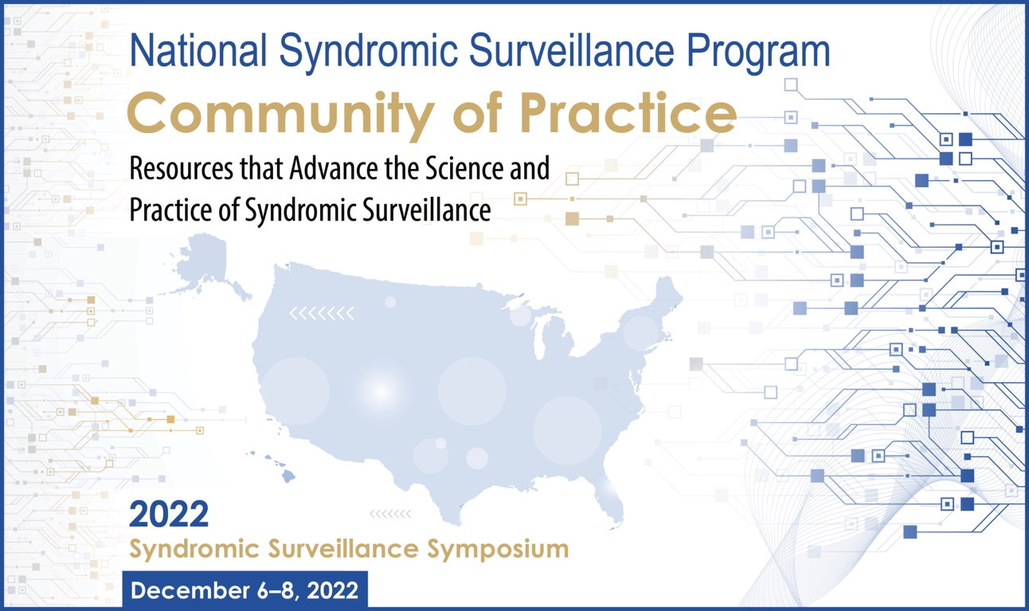

2022 Syndromic Surveillance Symposium

Speaker Bios

  - Day 3 – Thursday, December 8, 2022
Daily Open
  - All ‘Daily Open, Opening Remarks, Keynote, Plenary, NSSP Community of Practice, and Symposium Close’ sessions will be held in one large Zoom Meeting space

12:30 PM EST Daily Open, Logistics, and Overview
Charlie Ishikawa, MSPH
Kahuina Consulting, LLC
President & Principal Consultant

Block 1 [Sessions Starting at 12:45pm EST]

12:45 PM EST Roundtable: Syndromic Surveillance Pre-Production – Asking the Right Questions
Track: Surveillance and Syndrome Refinement
Description: Explore questions to be addressed before syndrome definitions begins and non-traditional uses of syndromic surveillance data.
Facilitator:
- David Atrubin, MPH – Florida Department of Public Health
David Atrubin has worked for the Florida Department of Health since 2002 and currently manages the Florida Department of Health’s syndromic surveillance system. David has played a role in using syndromic surveillance during Super Bowls, political conventions, post-storms, and for everyday purposes. Prior to his current job, David was a part of the Florida Epidemic Intelligence Service and later worked as an epidemiologist in Hillsborough County.

- Jose Lojo, MPH – Philadelphia Department of Public Health
José Lojo is a senior epidemiologist at the Philadelphia Department of Public Health (PDPH) where he currently manages PDPH’s syndromic surveillance and wastewater surveillance programs. Prior to this, he completed a fellowship with the Florida Epidemic Intelligence Service, where he assisted local health departments with a variety of epidemiologic investigations and surveillance initiatives, including hurricane disaster response. Previous work with the Centers for Disease Control and Prevention included research into childhood lead poisoning and diabetes surveillance.

12:45 PM EST Roundtable: Now Casting – Putting Clinicians in Supporting Roles
Track: Communicating and Sharing SyS
Description: Discuss the benefit of engaging clinicians in syndromic surveillance to improve data quality and surveillance activities.
Facilitator:
- Gabriel Ann Haas, MPH – Kansas Department of Health and Environment
Gabe Haas has served as the epidemiologist and program manager for the Kansas Syndromic Surveillance Program at the Kansas Department of Health and Environment since 2019. She received her MPH from Saint Louis University in 2018 with a dual concentration emphasis in biosecurity, disaster preparedness, and epidemiology.

- Kellie Wark, MD, MPH – University of Kansas Medical Center
Dr. Wark is a physician and assistant professor in the division of infectious diseases at the University of Kansas Medical Center. She also serves as the subject matter expert at the Kansas Department of Health and Environment in infectious diseases and serves on the state healthcare associated infections and antimicrobial resistance advisory board.

- Adrienne Malik, MD – University of Kansas Medical Center
Dr. Malik is a physician and assistant professor of emergency medicine at the University of Kansas Medical Center, core faculty for the University of Kansas Medical Center emergency medicine residency, and the Director of Research for the emergency medicine program.

- Brittani Valentine, DO – University of Kansas Medical Center
Dr. Valentine is a third year Emergency Medicine resident at the University of Kansas and board member of Kansas ACEP with specific interests in medical education and participating in healthcare policy changes at statewide and nationwide level.

12:45 PM EST Roundtable: Protecting the Set – A Look Into Environmental Health Data
Track: Expanding Quality Data
Description: Discover how to effectively use environmental health data for public health action.
Facilitators:
- Emily Prezzato, MPH – Centers for Disease Control and Prevention (CDC)
Emily Prezzato is a Health (Data) Scientist with the CDC’s Environmental Public Health Tracking Program. She received her BS in Biology from Michigan Technological University and her MPH from San Diego State University.

- Angela Werner, PhD, MPH – Centers for Disease Control and Prevention (CDC)
Dr. Angela Werner is currently the Science Development Team Lead with the CDC’s Environmental Public Health Tracking Program. She received her MPH from the George Washington University and her PhD in Environmental Health and Epidemiology from the University of Queensland.

- Chelsea Eastman Langer, PhD, MPH – New Mexico Environmental Public Health Tracking Program
Dr. Chelsea Eastman Langer is an Advanced Epidemiologist with the New Mexico Environmental Public Health Tracking Program. She received her MPH and PhD in Epidemiology from the University of California, Davis.

- Henri Menager, MD, MPH – Kansas Department of Health and Environment
Dr. Henri Menager is currently the Senior Epidemiologist of the Environmental Health Section at the Kansas Department of Health and Environment. Among other EH programs, he supports the Environmental Public Health Tracking Program. He received his MPH from the University of Illinois and his Medical Degree from the State University of Haiti.

12:45 PM EST Roundtable: Increased Aperture – Incorporating New Data Sources into the SyS Conversation
Track: Expanding Quality Data
Description: Discover how new data sources can be integrated with syndromic data to produce more comprehensive public health surveillance.
Facilitators:
- Edward Lockhart, PhD – Centers for Disease Control and Prevention (CDC)
Dr. Lockhart began his CDC career in 2014 as a Genomics and Health Informatics fellow in the Center for Surveillance, Epidemiology, and Laboratory Services (CSELS) in the Division of Laboratory Systems (DLS). During his time in DLS, Ed worked with several teams including the CDC Biorepository team (where he served as SME for LIMS, laboratory information management systems) and the data science team. In late 2021, Ed joined CDC’s National Syndromic Surveillance Program (NSSP) as the Mortality Data Source Lead.

- Stephanie Dietz, PhD – CDC/NSSP
Stephanie Dietz is the lead for commercial laboratory data in the National Syndromic Surveillance Program at CDC. She is a statistician and has been at the CDC for seven years. Prior to joining the CDC, Stephanie worked at the University of Technology and Design in Singapore and taught statistics at Georgia State University.

- Neha Shanker, PhD, MPH – NC Division of Public Health
Dr. Neha Shanker is a Public Health Epidemiologist working at the Communicable Disease Branch, North Carolina Division of Public Health. As a member of the systems surveillance unit, she monitors and analyzes data from Emergency Departments, Urgent Care Centers, and the NC Health Information Exchange network. Dr. Shanker holds an MPH from the Johns Hopkins University and a PhD in Virology.

- Aaron Kite-Powell, MS – CDC/NSSP

- Kirk Bol, MSPH – Colorado Department of Public Health and Environment
Mr. Bol has worked at the Colorado Department of Public Health and Environment since 1999, focusing on the collection, analysis and dissemination of critical public health surveillance data, including cancer, birth defects and vital statistics. He has managed Colorado’s Vital Statistics Program since 2013, and also oversees Colorado’s violent death reporting system, unintentional drug overdose reporting system, and medical aid-in-dying reporting. With a great interest also in education, Mr. Bol has also taught courses in public health surveillance, research strategies, and analytic methods as an adjunct instructor with the Colorado School of Public Health.

- Richard Raines, MPH – Alaska Health Analytics and Vital Records

- Caprice Edwards, MS – NAPHSIS
Ms. Edwards has been with NAPHSIS for over four years, previously working for the Association of Public Health Laboratories. Her bachelors of science is in Community Health from the University of Maryland, College Park, and her masters of science is in Information Technology, Informatics, from the University of Maryland, Global Campus. She has experience leading systems projects, working with CDC programs at the state and national level, as well as supporting or leading national workgroups on systems use.

- Krystal S. Collier, BA – CDC NSSP Contractor
Krystal S. Collier is an Onboarding Specialist for InductiveHealth Informatics, and a contractor on the Centers for Disease Control and Prevention’s National Syndromic Surveillance Program’s (NSSP) Onboarding Team. She is working with sites to onboard their data sources to the BioSense Platform, including the mortality and emergency department data, and improve the data quality of syndromic surveillance data. Prior to joining NSSP, she was the Syndromic Surveillance Program Coordinator for the Arizona Department of Health Services (ADHS) Syndromic Surveillance Program for three years and former Chair of the NSSP Community of Practice Core Committee for two years.
30 MINUTE BREAK STARTING AT 1:45PM EST
Coffee Breaks [Optional Sessions Starting at 1:45pm EST]

1:45 PM EST Coffee Break: NSSP Mentoring Program: Seeking Input
Track: Coffee Break
Description: Join members of CSTE and the CoP Core Committee to provide input on an NSSP mentoring program. Community members are encouraged to bring their questions and ideas about future program activities.
Hosts:
    - Becky Lampkins, MPH – CSTE
    - Yushiuan Chen, MPH – CDC

1:45 PM EST Coffee Break: NSSP CoP Syndrome Definition Subcommittee
Track: Coffee Break
Description: Join members of the CoP Syndrome Definition Subcommittee to discuss current group activities and future opportunities for growth.
Hosts:
    - Rosa Ergas, MPH – Massachusetts Department of Public Health
    - Sara Chronister, MPH – Washington State Department of Health
    - Rasneet Kumar, MPH – Tarrant County Public Health

Carrying Forward our Community Discussion
  - All ‘Daily Open, Opening Remarks, Keynote, Plenary, NSSP Community of Practice, and Symposium Close’ sessions will be held in one large Zoom Meeting space

2:15 PM EST Community Discussion: Turning Ideas into Action
Moderator: Charlie Ishikawa, MSPH – Kahuina Consulting, LLC

Speakers:
    - Rosa Ergas, MPH – Massachusetts Department of Public Health
    - Andrew Farrey, BA, MPH – Kentucky Injury Prevention Research Center (KIPRC)
- Jade Hodge, MPH – Kansas Department of Health and Environment
- Anna Frick, MPH – Alaska Department of Health

Symposium Close

3:00 PM EST 12:45 PM EST Closing Remarks
Speakers:
    - Janet Hamilton, MPH – CSTE, Executive Director
    - Karl Soetebier, MAPW – CDC/NSSP
- Anna Frick, MPH – Alaska Department of Health

