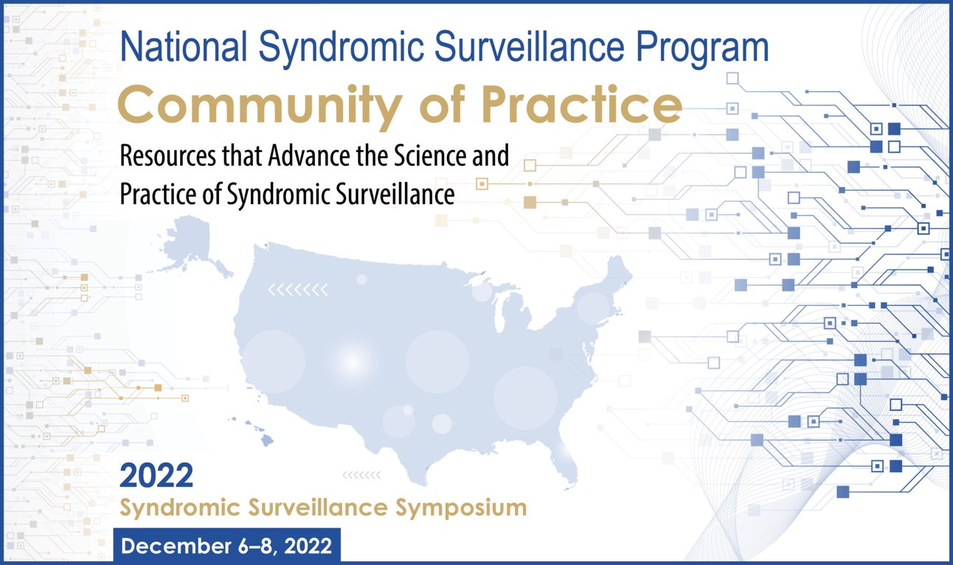

2022 Syndromic Surveillance Symposium

Speaker Bios
  - Day 1 – Tuesday, December 6, 2022
Opening Remarks and Keynote
  - All ‘Daily Open, Opening Remarks, Keynote, Plenary, NSSP Community of Practice, and Symposium Close’ sessions will be held in one large RingCentral Meeting space – join here:

12:30 PM EST Daily Open, Logistics, and Overview
Charlie Ishikawa, MSPH
Kahuina Consulting, LLC
President & Principal Consultant

12:45 PM EST Welcoming Remarks
Speakers:
    - Janet Hamilton, MPH – CSTE, Executive Director
    - Karl Soetebier, MAPW – CDC/NSSP
    - Yushiuan Chen

1:15 PM EST Opening Community Discussion
Moderator: Charlie Ishikawa, MSPH – Kahuina Consulting, LLC

Speakers:
    - Victoria Troeger, MSPH – Montana Department of Public Health and Human Services
    - Nick Hill, MPH – Great Plains Tribal Epidemiology Center
    - Alana Vivolo-Kantor, PhD, MPH – Division of Overdose Prevention, CDC

30 MINUTE BREAK STARTING AT 2:15PM EST
Block 1 [Sessions Starting at 2:45pm EST]

2:45 PM EST Training: SyS State of Mind
Track: Training/Demonstration
Description: Prepare learners to look at public health surveillance through a SyS lens by (a) exploring the common data sources and methods that define SyS practice, and (b) querying data and crafting syndromes for many public health problems. By the end of the session, participants will be able to describe the general process to categorize records into syndromes, apply characteristics of SyS data when assessing SyS results, and distinguish between which public health issues are and are not well suited for SyS
Trainers:
- Alexa Meinhardt, MPH, CPH – Delaware Division of Public Health
Alexa Meinhardt is an Epidemiologist at the Delaware Division of Public Health’s Office of Infectious Disease Epidemiology, where she leads surveillance, data, and informatics efforts and supervises COVID epidemiologists supporting schools and long-term care facilities. She has previously worked in community and population health and emergency preparedness and response. As Delaware’s former Preparedness Epidemiologist, she was the Syndromic Surveillance System Administrator and Program Manager.

- Zachary Stein, MPH – CDC CSELS
Zachary Stein is a health scientist for the CDC’s National Syndromic Surveillance Program. A recent addition to the CDC, Zach specializes in syndrome definitions, user platforms, and tutorials and trainings. He has been in the Syndromic Surveillance field for 6 years combined in state, contract, and federal work.

- Lowrie Ward, MPH, CPH – Alaska Native Tribal Health Consortium, AK Native Epidemiology Center
Lowrie Ward manages the syndromic surveillance program and several other data products at the Alaska Native Epidemiology Center, which is part of the Alaska Native Tribal Health Consortium in Anchorage, Alaska. Prior to her work in Alaska, Lowrie worked in healthcare quality improvement in Washington, DC.

2:45 PM EST Roundtable: Nominees for Best Current Health Threat – Using SyS for Monkeypox and Hepatitis Investigations
Track: Surveillance and Syndrome Refinement
Description: Learn how syndromic surveillance is being used to address health threats that have emerged over the past year.
Facilitators:
- Dylan E Johns, MS – ICF (CDC Contractor)
Dylan Johns is an epidemiologist for ICF and a CDC contractor focused on syndromic surveillance and the NSSP/ESSENCE platform. He previously worked as an epidemiologist for local and state health departments and began his career in hospital epidemiology. Dylan studied at Binghamton University and the University at Albany. He currently resides in Albany, New York.

- Andzelika Rzucidlo, MPH – InductiveHealth Informatics
Andzelika Rzucidlo is an epidemiologist working for InductiveHealth Informatics and as a contractor in the National Syndromic Surveillance Program at the CDC. She has been working in syndromic surveillance supporting the CDC for the past year. Prior to this role, she worked on injury and vaccine-preventable disease surveillance at the Indiana Department of Health.

- Meredith Davis, MPH – Virginia Department of Health
Meredith Davis is an epidemiologist with the Virginia Department of Health Enhanced Surveillance program. She conducts surveillance using ESSENCE for a variety of topic areas, including communicable disease and firearm injury. Her previous experience includes working as a field epidemiologist in Virginia, providing training to local health department staff in North Carolina, and serving as a CSTE/CDC Applied Epidemiology Fellow in Maine.

- Jessica Shultz, MPH – Tennessee Department of Health
Jessica Schultz is an epidemiologist working for the Tennessee Department of Health’s Emergency Preparedness Program. She has been working in syndromic surveillance and emergency preparedness for the past three years. Previously, Jessica has worked as an epidemiologist at the local level in Kentucky and Virginia, as well as serving as a Zika Field Support Specialist. She has over 12 years of experience in public health.

2:45 PM EST Roundtable: Lights, Camera, Action! Promoting SyS Across Public Health
Track: Communicating and Sharing SyS
Description: Join members of the CoP Core Committee in discussing ways to promote the use of syndromic surveillance up to leadership and out to other public health programs.
Facilitators:
- Anna Frick, MPH – Alaska Department of Health
Anna Frick is an epidemiologist with the State of Alaska Department of Health, where she’s run the syndromic surveillance program for 6 years. She earned her MPH in Hospital and Molecular Epidemiology from the University of Michigan.

- Sara Chronister, MPH – Washington State Department of Health
Sara Chronister is an Epidemiologist with the Rapid Health Information NetwOrk (RHINO) team at Washington State Department of Health. She co-chairs the Syndrome Definition Subcommittee and is a fierce advocate for increasing state and local participation within the NSSP CoP.

- Caleb Weideman, MPH – Tennessee Department of Health
Caleb Wiedeman is an epidemiologist in the Emergency Preparedness program at the Tennessee Department of Health. Caleb has worked in applied epidemiology at the State level for nearly 15 years and has been part of the syndromic surveillance community since 2013.

- Gabriel Ann Haas, MPH – Kansas Department of Health and Environment
Gabe Haas has served as the epidemiologist and program manager for the Kansas Syndromic Surveillance Program at the Kansas Department of Health and Environment since 2019. She received her MPH from Saint Louis University in 2018 with a dual concentration emphasis in biosecurity, disaster preparedness, and epidemiology.

3:30 PM EST Training: ESSENCE 101
*Note: this session will be a 90 minute session*
Track: Training/Demonstration
Description: An orientation for new users including 1) a brief introduction to syndromic surveillance and the NSSP and 2) an NSSP-ESSENCE step-by-step live demonstration highlighting how to navigate the tool and run, save, and share a query.
Trainer: Travis Lim, MS, MPH, DrPH – Johns Hopkins University Applied Physics Laboratory (JHUAPL)
Travis is an epidemiologist at the Johns Hopkins University Applied Physics Laboratory, with over ten years of experience in data analytics, data management, and research in infectious disease epidemiology and health systems. His current public health interests include health equity, statistical innovation for disease surveillance, and climate change. Prior to APL, Travis worked for CDC for eight years on data analytics, management and health systems research in the Global HIV program, including various data skills trainings for PEPFAR staff, Ministries of Health and partner organizations from over 30 countries.
30 MINUTE BREAK STARTING AT 3:45PM EST
Coffee Breaks [Optional Sessions Starting at 3:45pm EST]

3:45 PM EST Coffee Break: Meet and Greet
Description: Meet and network with syndromic surveillance colleagues across the country.
Facilitators: CSTE and Kahuina 2021 Syndromic Surveillance Symposium planning committee

3:45 PM EST Coffee Break: NSSP CoP Data Quality Subcommittee
Description: Meet and network with syndromic surveillance colleagues across the country.
Facilitators: CSTE and Kahuina 2021 Syndromic Surveillance Symposium planning committee
- Jade Hodge, MPH – Kansas Department of Health and Environment

- Andrew Farrey, MPH – Kentucky Injury Prevention and Research Center
Andrew Farrey, MPH is an epidemiologist with the Kentucky Injury Prevention and Research Center at the University of Kentucky College of Public Health. He works with syndromic surveillance data, emergency medical services (EMS) data, and Kentucky Poison Control Center data. His research interests include syndromic surveillance data quality, ESSENCE syndrome development, anomaly detection, and spatiotemporal cluster detection.

Block 2 [Sessions Starting at 4:15pm EST]

4:15 PM EST Breakout: Highlighting SucceSyS – SyS for Surveillance and Monitoring
Track: Surveillance and Syndrome Refinement
Description: Hear how three health departments across the country are using syndromic surveillance to monitor ongoing public health concerns.
Moderator: Jessica Pavlick, DrPH, MPH – Georgia Department of Public Health
Presenters:
- Bridget J. Anderson, PhD – NYSDOH
Bridget J Anderson holds a Doctorate in Sociology with concentrations in Demography, Urban Studies, and Research Methods and has worked in public health in the NYS Department of Health for over 20 years. Since December 2020 she has directed the Bureau of Communicable Disease Control’s Quality Improvement and Performance Management Program, a team of data scientists and epidemiologists providing technical expertise in electronic communicable disease surveillance and case/outbreak investigation reporting. Additionally, the team conducts enhanced surveillance, including all phases of investigation and reporting for a variety of priority conditions (e.g., MIS-C, COVID-19, acute flaccid myelitis (AFM), influenza, pediatric hepatitis of unknown etiology, legionellosis, and most recently MPXV and polio). Effective September 2022, she assumed the directorship of the Emerging Infections Program, a network of state health departments using public health practice to address emerging infections in collaboration with the CDC, academic institutions, and other key public health stakeholders.

- Hannah Collins, MPH – Seattle & King County Public Health
Hannah Collins, MPH is an epidemiologist at Public Health – Seattle & King County and uses syndromic surveillance for a variety of topics including overdose surveillance, injury, and extreme weather events.

- Graham Crawbuck, MS – Washington State Department of Health
Graham Crawbuck, MS is an epidemiologist with the Washington State Department of Health. As a CSTE fellow at Public Health – Seattle & King County, he developed syndromic surveillance tools to monitor extreme heat, adverse events following SARS-CoV-2 immunization, and notifiable conditions.

- Walaa Elbedewy, MBBCh, MPH, MPA – Georgia Department of Public Health
I am a general practitioner trained in public health and program evaluation. I am passionate about improving maternal and child health, and addressing social determinants of health to improve health and reduce disparities. I am an epidemiologist working on multisystem inflammatory syndrome in children (MIS-C) associated with COVID-19 at the Georgia Department of Public Health.

4:15 PM EST Breakout: Rolling! Ensuring High-Quality Data for Public Health Use
Track: Expanding Quality Data
Description: Learn unique methods for optimizing data quality and improving outbreak detection
Moderator: James Muncy, MPH – CSTE
Presenters:
- Kelly Carey, MPH – Division of Health Informatics and Surveillance (DHIS), CDC
Kelly Carey is a mathematical statistician in the Surveillance and Data Branch (SDB) in the Division of Health Informatics and Surveillance (DHIS). She has an MPH in Epidemiology and has been at the CDC for two years. Prior to joining the CDC, Kelly worked as an Emerging Leaders in Data Science Fellow at the National Institute for Allergy and Infectious Diseases.

- Howard Burkom, PhD – Johns Hopkins Applied Physics Laboratory (JHUAPL)
Howard Burkom is a Principal Professional Staff Mathematician at the Johns Hopkins University Applied Physics Laboratory. He has worked exclusively in the field of biosurveillance since 2000, adapting analytic methods from various fields for advanced disease monitoring systems and contributing to the enhancement of ESSENCE surveillance systems and the National Syndromic Surveillance Program’s Community of Practice.

- Breanna Swan Hovey, PhD – Johns Hopkins Applied Physics Laboratory (JHUAPL)
Breanna is a Health Systems Engineer in the Health and Human-Machine Systems group at JHU-APL. She holds a Ph.D. in Industrial and Systems Engineering with a Statistics minor from North Carolina State University, a M.S. in Mathematics from UW-Milwaukee, and a B.S. in mathematical physics. Her research interests include integrating techniques like predictive modeling, decision theory, simulation, optimization, bioinformatics and more to develop frameworks that improve health and wellbeing through data-driven decision support tools.

4:15 PM EST Breakout: Broadening Our Audience: Increasing Participation and Collaboration
Track: Communicating and Sharing SyS
Description: Hear how jurisdictions are increasing participation and connecting with local partners to expand the reach of their syndromic surveillance program.
Moderator: Becky Lampkins, MPH - CSTE
Presenters:
- Lowrie Ward, MPH, CPH - Alaska Native Tribal Health Consortium, AK Native Epidemiology Center
Lowrie Ward manages the syndromic surveillance program and several other data products at the Alaska Native Epidemiology Center, which is part of the Alaska Native Tribal Health Consortium in Anchorage, Alaska. Prior to her work in Alaska, Lowrie worked in healthcare quality improvement in Washington, DC.

- Anna Frick, MPH – Alaska Department of Health
Anna Frick is an epidemiologist with the State of Alaska Department of Health, where she’s run the syndromic surveillance program for 6 years. She earned her MPH in Hospital and Molecular Epidemiology from the University of Michigan.

- Heidi Jonson, MPH – Minnesota Department of Health
Heidi Jonson is a Syndromic Surveillance Epidemiologist on the Drug Overdose Epidemiology Unit in the Injury and Violence Prevention Section (IVPS) at the Minnesota Department of Health (MDH). She leads Minnesota’s first near real-time syndromic surveillance system where she monitors and identifies emerging public health concerns using presenting signs and symptoms from emergency department and inpatient hospitalization data. Her recent work focuses on COVID-19, drug overdose, and mental health-related conditions.

- Matthew Giljork, MSc – Olmstead County Public Health Services
Matthew Giljork is an epidemiologist for Olmsted County Public Health Services in Rochester, MN. His research experience ranges from alcohol and tobacco policy to serological surveillance of dengue. In his tenure at Olmsted County, Matthew has gained experience in surveillance, investigation, and data analysis which has provided the foundation for this project.

- Scott Johnston, MPH – Kansas Department of Health and Environment
Scott Johnston is the drug overdose epidemiologist for the Kansas Department of Health and Environment and holds a Master of Public Health degree from the University of Kansas School of Medicine. He primarily works on the Overdose Data to Action grant and utilizes a variety of data sources to monitor both fatal and non-fatal overdoses across Kansas.

