To submit updates or amendments to this working document, please email shiratzka@clackamas.us
Updated March 3, 2020
A field-by-field guide to entering data to the OHA Opera COVID-19 Database
Opera Data entry instructions
Clackamas County

Opera Data Entry Instructions

Contents
LEFT PANE (demographics, basic case and investigation information) 2
CASE ENTRY TABS 5
CLINICAL TAB 6
TREATMENT TAB 8
RISKS TAB 9
FOLLOWUP TAB 12
EPILINKS TAB 15
SEARCHING DUDE 17
CONTACTS TAB 19
VACCINE TAB 23
DOCS TAB 25
LETTERS TAB 26
WORK EXCUSE Letter 27
LOG TAB 29
NOTES TAB 29
OPERA Account Unlock and Password Reset 31
MERGING DUPLICATE RECORDS 31
CLACKAMAS SURGE RESPONSE 33
OPERA QA TOOL 35
APPENDIX EPILINKS FLOW CHART 37

Opera Data Entry Instructions

This guide is organized by each section/tab in the Opera Case entry.

LEFT PANE (demographics, basic case and investigation information)
☐ Subtype: COVID-19 (DO NOT leave blank)
☐ Status: Confirmed OR
Presumptive (and Sub-subtype should be specified)
If changing from Suspect to Confirmed or Presumptive, need to delete Sub-Subtype completely before entering in new Status
Refer to the latest Investigative Guidelines for case definitions
☐ Deceased: Unless unable to reach case, should be answered Y/N
If yes, put in a date and whether cause was related (death occurred within 60 days of symptom onset) or unrelated (death occurred more than 60 days from symptom onset) to COVID-19
☐ Age: Should be populated already, but if blank and DOB is known, click on DOB. Press OK and Age should populate.
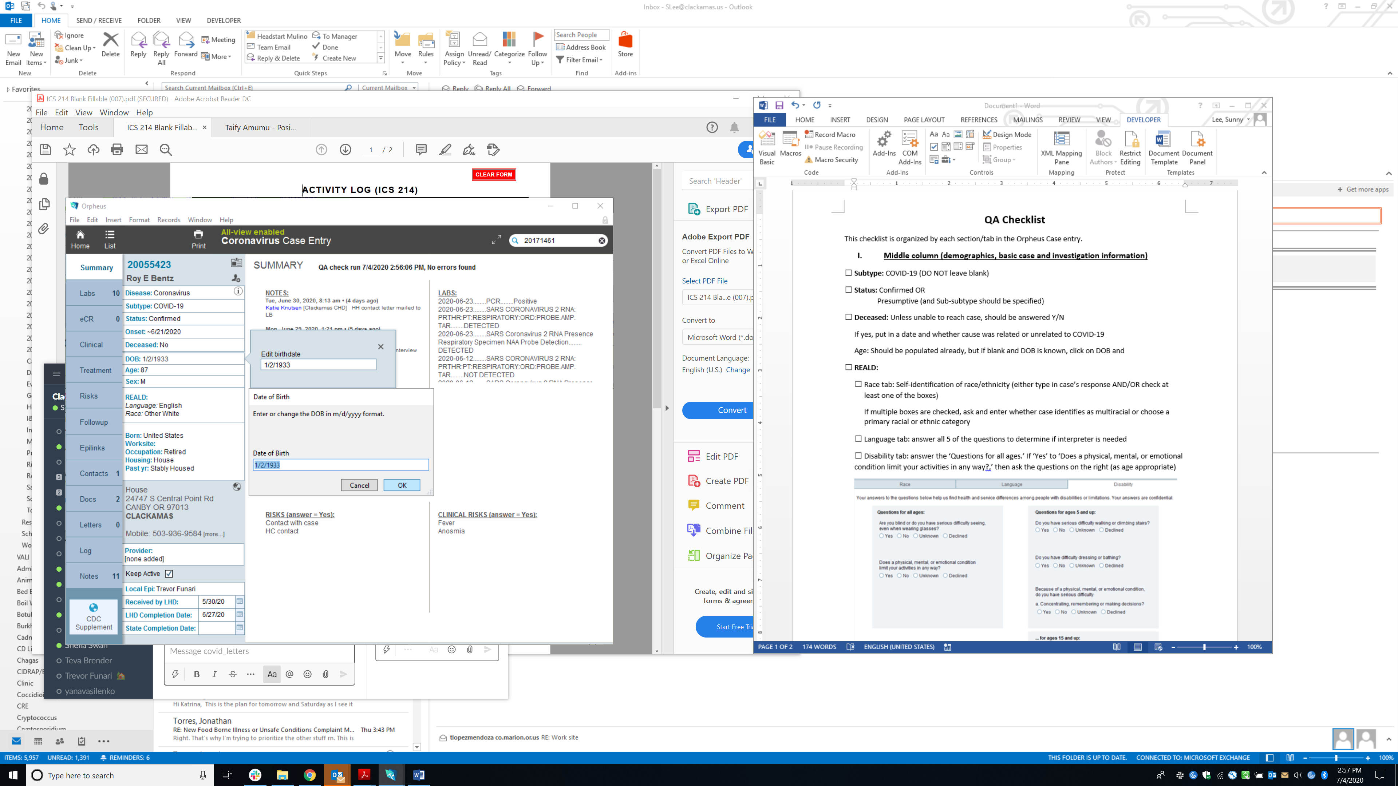

☐ Pregnancy: Assess pregnancy status for all women of childbearing age (aged 15 – 44 years)
☐ REALD: Refer to OHA’s REALD Implementation Guide for more information. REALD is intended to be self-reported data. REALD is a required field and the only way to appropriately fill out REALD is to ask the REALD questions.
☐ Race tab: Self-identification of race/ethnicity (type in case’s response in top green box) and check race boxes as appropriate.
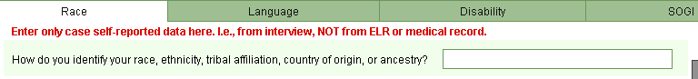

If multiple boxes are checked, ask and enter whether case identifies as multiracial or choose a primary racial or ethnic category
When to use “Other Categories” (bottom right of reald tab):
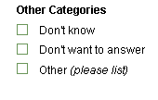
- “Don’t Know”
  - If case responds they do not know their race, select this option
- “Don’t want to answer”
  - If case does not want to answer, select this option
- “Other (please list)”
  - Only use this for a self-identified race that the case provides which is not included in any other REALD race category.
  - From page 23 of the REALD implementation guide “There are a few situations that could require using the “other” category. Identities are fluid and personal. We want respondents to feel comfortable. This means providing an option to write in a racial or ethnic identity not listed. Doing so also helps us track emergent populations.”
  - Please do not use this box as a means to mark “Unknown” for unasked cases. Please leave the REALD race questions blank if REALD was not asked.

☐ Language tab: answer all 5 of the questions to determine if interpreter is needed.
☐ Disability tab: answer the ‘Questions for all ages.’ If ‘Yes’ to ‘Does a physical, mental, or emotional condition limit your activities in any way?,’ then ask the questions on the right (as age appropriate)
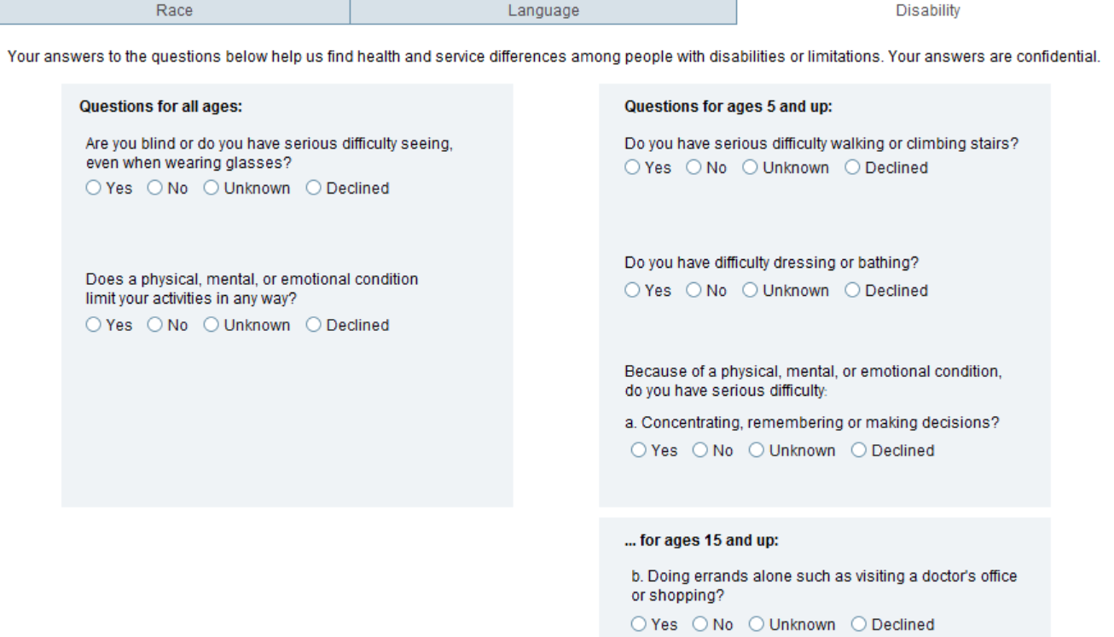
☐ Birth Country/Residency/Refugee: ask and complete these questions and complete as appropriate
☐ Worksite: Unless occupation is ‘Unemployed’, ‘Retired’, ‘Refused’, ‘NA’ then please complete this field for all interviewed cases. You can enter ‘Refused’ if case refused to answer.
Worksite should be specific, especially if it is a chain, indicating address or cross street (e.g., McDonald’s on 82nd and McLoughlin) and/or primary site (e.g., Bob’s Red Mill warehouse A) as appropriate.
If multiple worksites, list main worksite first (with location information), then second worksite (with location information). Separate multiple worksites with semicolon. Note: you can also separate worksite and school with a semicolon for students who work.
School specific documentation:
It is important to collect school information to reopen schools and subsequently track cases occurring in a school setting. Use the worksite and occupation/grade fields to capture school information:
- Students:
  - Document ‘Occupation’ as “Student, Grade x, Remote” or “Student, Grade x, In-person”.
  - Document school in ‘Worksite’, using the Opera copy paste tool to get the school name, then please add the address or city.
- Staff:
  - Document ‘Occupation’ e.g. “Teacher”, “Janitor”, “Administrator”, “Nurse”, etc.
  - Document school in ‘Worksite’, using the Opera copy paste tool to get the school name, then please add the address or city.

Report any cases in students or school staff to PHIDCP@clackamas.us

☐ Industry: Complete if case is employed; otherwise leave blank. The list of responses for field is based on NIOSH categories; however, it is possible to type in manually by double clicking in the box if none of the responses apply.
☐ Occupation/Grade: DO NOT leave blank. The list of responses is based on common occupations; it is possible to type in manually by double clicking in the box if none of the responses apply. If multiple occupations, list both and separate with semicolon.
If retired, Occupation should say ‘Retired’
If student, Occupation should say ‘Student’
If unemployed, Occupation should say ‘Unemployed’
If refused, Occupation should say ‘Refused’
If unable to reach, Occupation should say ‘Unknown’
Note: You can type in ‘NA’ for babies/toddlers (non-students) to minimize blanks.
☐ Housing: can be left blank UNLESS case lives in a congregate setting
☐ Past Year Housing: DO NOT leave blank. There are ‘Declined’ and ‘Unknown’ options.
☐ Address: confirm case’s address during interview. Verify:
☐ Address is in Clackamas County and full address is given (ensure apartment number is included if case lives in an apartment). Use USPS Zip Code Lookup to check addresses.
☐ Zip code should be 5 digits only. If it includes the ZIP+4, please delete the last 4 digits. (This assists OHA for geocoding purposes.)
If case lives in a correctional facility, ensure you set the facility via the ‘Institution’ list.
☐ Local Epi: this should be the Case Investigator who is in charge of assuring that the case interview is done, contacts are entered correctly, letter is sent, and LHD Completion Date is entered.
☐ LHD Completion Date: enter in date when case interview is done, contacts are entered correctly, letter is sent, and one last check that all sections are completed

CASE ENTRY TABS

- Labs Tab
☐ If Confirmed case, ensure there is a positive PCR or antigen result attached or input manually from faxed result (that needs to be attached to the Docs tab) or medical record review (indicate review in Notes section). DO NOT create a confirmed case with only a verbal positive test from a case or contact.
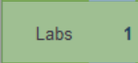
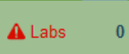
Once a lab is entered, the tab will turn from to

- eCR Tab Health care providers are able to submit Electronic Case Reports (eCRs) online to report suspected or confirmed reportable diseases like COVID-19. Confirmed cases can be created based on eCRs that indicate positive lab results and are verified by medical record review, then entered into the Labs Tab.

CLINICAL TAB
☐ Symptomatic?: DO NOT leave blank. If case was not interviewed, mark ‘unknown’
☐ Onset Date:
Enter date of symptom onset for symptomatic cases.
Enter collection date of first positive lab for asymptomatic cases.
For cases with unknown symptomatic status, leave blank.
It may be difficult for some cases to identify an onset date (i.e., persistent allergies), but do your best to determine a specific onset date since this will be used to determine exposure and infectious period, which is the basis for the questions in the Risk and Followup tabs.
☐ Onset Indeterminate:
If during interview, case had no symptoms or difficult to determine clear onset date, check ‘Onset Indeterminate’ box. Ensure that Diagnosis Date denotes date the tests were resulted.
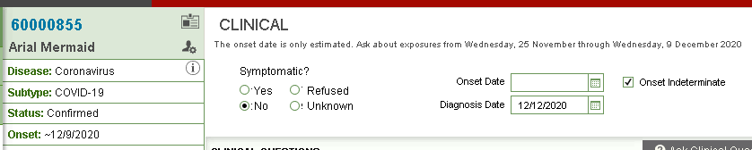
☐ Diagnosis Date: Date that test results were resulted. Only complete if Onset Date is indeterminate or if case is asymptomatic. The date the test results were resulted is found on the lab tab: click on the first positive lab to open the pop-up for that lab. The Report Date (circled in red) is the result date.
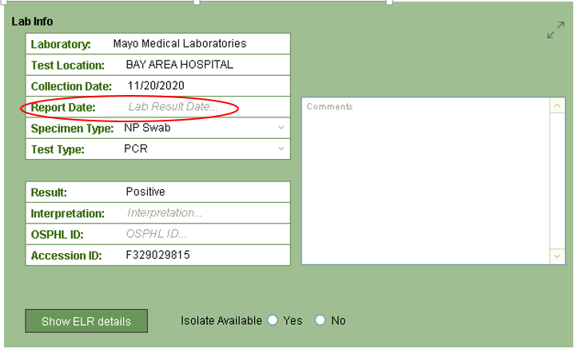
If the result date is missing, but the lab is from ELR, enter the ELR message date. To obtain this, Hit “Show ELR details”. The date is on the bottom right hand corner of the message that displays.
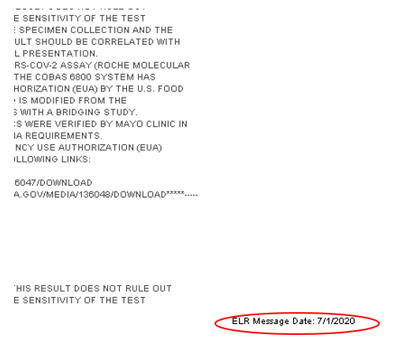
☐ Clinical Questions: Unless not interviewed, complete ‘Yes’ or ‘No’ for each symptom. As case may not be aware of all symptoms associated with COVID-19 illness, ensure to go through all symptoms even if case initially indicates that they did not have symptoms.
Input date of onset for any symptoms that require one when ‘Yes’ is selected.
Use best judgment for questions (i.e., Abnormal Chest Xray, ARDS, Mechanical ventilation, Received ECMO, Other diagnosis/etiology) that may be determined from MR review or is obvious based on you being able to conduct interview directly with case instead of a proxy.
If case complains of symptoms not listed in the symptom profile (e.g. “Fatigue”, you may capture these by including them in the notes tab. Use a separate note and the following syntax:
Additional Symptoms: [Symptom] (onset [date]), [Symptom] (onset [date]),etc.
☐ Hospitalized: DO NOT leave blank.
If case refused interview, click ‘Unknown’
If case was not hospitalized, click ‘No.’ Ensure there is no entry under the Hospital box or the Hospitalized text will turn red to indicate invalid as shown below:
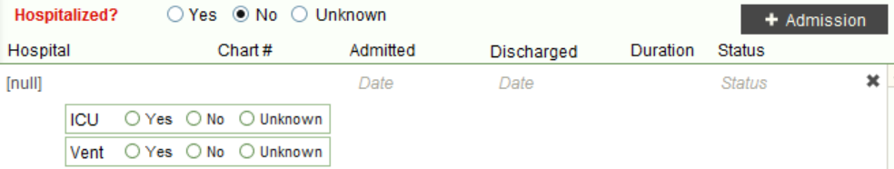
Click the x (circled in green above) to remove.
If case was hospitalized, click ‘Yes,’ then input Hospital Name, Date Admitted, Date Discharged, and Case Status. If case was transferred to another hospital, enter admission information for both hospitals. If case is still in hospital when you interview, leave Discharge Date and Status blank as OHA’s COVID-NET surveillance staff will complete upon review.

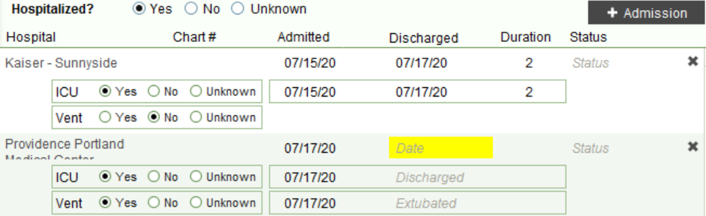

TREATMENT TAB
If case notes they received treatment while hospitalized (e.g., remdesivir), indicate as such by clicking
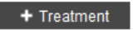
For each drug, enter in Drug Name, Size/Dose/Frequency, Course, Start Date, and End Date.

RISKS TAB
The risk tab collects interview status and information on factors that may have led to increased risk of exposure/infection to the case. If case refuses during middle of interview, input ‘Refused’ for the rest of the questions that were not asked.

☐ 1st Call Try: Complete ASAP after first attempt at interview, regardless of whether or not case was reached. DO NOT leave blank.
☐ Interviewed:
Non-Surge Practice:
Every case should be attempted 3 times before considered ‘Unable to Reach’—DO NOT complete this field before all 3 attempts have been exhausted. Attempts made should be spaced out throughout the day and can be through multiple modes of communication, including by phone, by text, or by email. Please include at least one text attempt, if applicable, before marking unable to reach. Document these attempts in the notes (see notes section for syntax).

Surge Practice:
Cases will not rollover. Every case should be attempted twice by phone and sent one text on the date the case was assigned. If case is not reached, mark ‘Unable to Reach’. If case calls back and an interview is completed, then update ‘interviewed’ to “yes” and add the details.

If case was interviewed, click ‘Yes’ and input date of interview, interviewee (Who: ‘Patient,’ ‘Provider,’ ‘Parent,’ or ‘Other’), and select interviewer (By) from drop down menu.
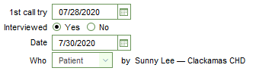
Note: Interviewer name should be the same as user selected in ‘Local Epi’ field.
If case was not interviewed, click ‘No’ and reason (typically either ‘Unable to Reach’ or ‘Refused’). Interviewee and interviewer name should be left blank.
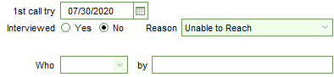
If case is resident at LTCF and paper interview is received from LTCF for resident case, 1st call try should be date that paper interview was first requested from the LTCF.
If case is a resident of a correctional facility, interview by LHD is not required. (Note: ensure residence of case is set to the correctional facility in the demographic section).

☐ Underlying/Pre-existing medical conditions?: Select all that apply. This can either be collected from medical record review and/or from interview.
If done during interview, make sure to go down the list and ask about each condition. If case says yes to ‘Neurologic/neurodevelopmental’ or ‘Other chronic diseases,’ specify in Notes. If case indicates no to all conditions, choose ‘None.’
☐ How was the case first identified?: This can either be collected from medical record review or from interview.
Clinical evaluation: case developed symptoms and sought testing
Contact tracing of case patient: case is a close contact of another known confirmed case
Routine surveillance: case is positive upon surveillance testing (e.g., trace study, mass testing event)
EpiX notification of travelers; if checked, add DGMQID to notes: uncovered case through DGMQ travel notification
Unknown: unable to determine, most likely because unable to reach, interview refusal, or not obvious through medical record review
Other, specify in notes: case was discovered through other means (e.g., out of state notification)
☐ Travel outside home area?: Ask case during interview of any history of travel during the exposure period outside their home area. This includes travel within Oregon, elsewhere in the US, and travel to any foreign countries.
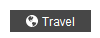
If No, select ‘No.’ Ensure that they understand this question refers to travel anywhere outside the Portland area (including other parts of OR).
If Yes, select ‘Yes.’ A travel pop up screen should appear. If not, click on the Travel button in the Risk tab.
- The ‘Purpose(s),’ ‘Travel Mode(s),’ and ‘Companion(s)’ fields in the Summary tab must be completed in order to exit the pop up. Input details in the Notes section, specifically asking:
  - Elaborating on purpose—business (was it for a conference, work meetings), visit family/friends (weddings, funerals, parties, social gatherings), vacation (public places, excursions, tour group)
  - Did the case stay in one place or travel to multiple cities? If so, what dates?
  - Where did the case stay (e.g., hotel, with family, with friends, etc)?
  - Who were the travel companions (collect names, relationship to case)?
  - Were there any close contacts during trip who became ill (collect names, relationship to case)? If they are a case, then also collect DOB and verify in Opera.
- Check the appropriate ‘Regions Visited’ to the left. In the corresponding region tab, check all state, country, cities/locations that case traveled to.
- Input Domestic Travel Dates and/or Foreign Travel Dates
If case traveled by plane during infectious period, collect flight itinerary details including date, time, airline, flight number, seat number, airports flown to/out of, travel companions. Send to do to Karuna Bollam (OHA), who will notify DGMQ of exposure.
☐ Did the case have any close contact with a confirmed case?: Determine whether case was a close contact to any known cases. If yes, will need to specify whether household, community, or healthcare contact. Ask clarifying questions, including:
- Date(s) and extent of contact. Date of last contact.
- Contact precautions taken, if any.
- Confirmed case’s first and last name and DOB. Confirm in Opera during interview. If unable to find case, ask about location/lab tested and type of test to request test result.
- Confirmed case’s symptom onset, symptom profile.
☐ Does the case live or work in a congregate setting (e.g., LTCF, group home, jail, etc)?: Ask case about exposures in congregate settings.
If case ‘works in a congregate setting,’ ask clarifying questions including:
- Contact with confirmed or symptomatic persons, including date(s) and extent of contact.
- Work schedule during exposure period (i.e., dates worked, shift).
- Job role—patient care, primary work location, team.
- Has anyone around case recently been ill? If so, obtain name, DOB.
If case ‘lives in a congregate setting,’ ask clarifying questions including:
- Date case transferred into facility.
- Location in facility.
- Close contact exposures within facility (e.g., caregivers, group activities, visitors, services received).
- Has anyone around case recently been ill? If so, obtain name, DOB.
If No, then select ‘No.’
☐ Does the case work in a healthcare setting?:
If ‘Yes,’ then ask clarifying questions including:
- Contact with confirmed or symptomatic persons, including date(s) and extent of contact.
- Work schedule during exposure period (i.e., dates worked, shift).
- Job role—patient care, primary work location, team.
- Has anyone around case recently been ill? If so, obtain name, DOB.
If No, then select ‘No.’
☐ Do you use cannabis, THC, or CBD?: Ask case about any cannabis usage during exposure period.
If ‘Yes,’ then ask clarifying questions including:
- What product(s) did the case use?
- Where and when were product(s) purchased?
- When were product(s) used?
- Did case share product(s) with anyone else? If so, was anyone case shared product(s) with ill (collect name, DOB)?
- Contact with confirmed or symptomatic persons, including date(s) and extent of contact.
If No, then select ‘No.’

FOLLOWUP TAB
The followup tab collects information about the circumstances in which a case may have exposed others. Ask cases to consider communicable/infectious period for questions in this section. Communicable period is determined by date entered in Onset Date field.
Unless case refuses interview, ensure all questions are answered. If case refuses during middle of interview, input ‘Refused’ for the rest of the questions that were not asked.

☐ Do you know about anyone else with a similar illness or with Coronavirus?: during communicable period, did case recall anyone else with COVID-19 related symptoms or diagnosis?
If case did have close contact with any persons who had symptoms compatible with COVID-19, select ‘Yes.’ Inquire about:
- Who (collect first and last name, DOB)? Verify if possible during interview whether this person is already a reported confirmed or presumptive case in Opera, as their Opera ID number will also need to be entered into the Epilinks Linkage Notes field in the Epilinks tab.
- When was the case exposed? Name all dates of exposure and note last date of exposure. Determine if case is a close contact to prior case.
- Was anyone else exposed? Note any other persons who may have been exposed to this previous case.
- Where was the case exposed? Collect details about case’s exposure to previous case. This includes addresses, outdoor/indoor exposure
☐ What settings did the case potentially expose other people?: Determine if there were any public settings where the case exposed close contacts while infectious. If case immediately says no, make sure to go through list of settings with the case. This list should serve as a memory tickler. Discuss scenarios that case may not associate with public settings, including examples like church on Sunday, taking family member to ED, gatherings during holidays like July 4th, etc.
If case still indicates no, select ‘No documented spread.’
If case indicates yes, select ‘Yes.’ Ask follow-up questions including:
- What was the context of the exposure? Indicate date(s) and details of exposure (i.e., what was the occasion, how long case was there, was case and others wearing PPE, address of setting, indoor/outdoor exposure, etc).
- Who was considered a close contact to the case at this setting? Collect first and last name, DOB, and contact information to add to Contacts tab. Verify if possible during interview whether this person is already a contact or case in Opera.
☐ If case is employed, what is the last date they were at work?: If case worked during communicable period, enter in last date worked.
☐ If case worked while sick, please indicate their work schedule: Include date(s), shift time(s), work location(s), role(s), etc. during infectious period
☐ How does the case travel to work?: During communicable period, indicate how case traveled to work. Provide details about dates, route (i.e., public transit), or service (e.g., Uber, Lyft).
☐ Does the case need a letter for work?:
If case needs a letter to exclude from work, select ‘Yes.’ Generally speaking, case letter will suffice. Ask for preferred method of delivery (i.e., mailing address or email address) and verify with case. See letter instructions.
If case requests a work letter with return to work date specified, have the case call back at conclusion of isolation period to ensure that isolation requirements have been followed and reassess symptoms to ensure case is safe to go back to work. Ask for preferred method of delivery (i.e., mailing address or email address) and verify with case. Send to do to letter sender after reassessment (see letter instructions).
If No, then select ‘No.’
☐ Did this case have any exposures to vulnerable populations while they were ill?:
If during communicable period case ‘work[ed] in a congregate setting,’ ask clarifying questions including:
- Close contact with any residents or staff persons, including date(s) and extent of contact.
- Work schedule during communicable period (i.e., dates worked, shift).
- Job role—patient care, primary work location, team.
- Has anyone around case recently been ill? If so, obtain name, DOB.
If during communicable period case ‘live[d] in a congregate setting,’ ask clarifying questions including:
- Date case transferred into facility.
- Location in facility (e.g., memory care, assisted living, room number).
- Close contact exposures within facility (e.g., caregivers, group activities, visitors, services received).
- Has anyone around case recently been ill? If so, obtain name, DOB.
If No, then select ‘No.’
☐ Was case educated about how to reduce the risk of disease transmission?: Ask at conclusion of interview whether case has any questions about COVID-19 or about public health follow up. Provide education on COVID-19 transmission, prevention, and isolation guidelines.
☐ Did the case have any significant hospital exposures?: Ask about any time within the hospital setting during case’s infectious period. This could also include accompanying a friend or family member to the ED. This question is asked in the context of the case being a patient, not a health care worker.
If ‘Yes,’ case did go to a hospital setting while infectious, follow up with questions like:
- Which hospital? What part of the hospital?
- Which date(s)/time(s)?
- Who did case go with?
- Why did the case go to the hospital?
- Were they wearing a mask/other PPE?
If No, then select ‘No.’
☐ How was the patient transported to the hospital?: This question assesses EMS contact with COVID-19 cases during their infectious period. This information is used to notify our EMS partners about any potential COVID-19 exposures.
‘EMS/Ambulance’: case arrived to hospital by ambulance. In the notes section, include city from which case was transported, date of transport, and hospital the case was transported to.
‘Personal vehicle’: case arrived to hospital by personal vehicle, either as driver or passenger of family vehicle
‘Public transportation’: case arrived to hospital by bus, rail
‘Other (specify in notes)’: case arrived to hospital by cab, ride share (e.g., Uber, Lyft)
‘N/A (i.e., not hospitalized)’: case was not hospitalized during communicable period
‘Unknown’: case either refused to answer this question or does not recall how they got to the hospital. Specify in notes
☐ Has the case recovered from their illness?: No need to ask during interview. OHA will f/u as necessary.
☐ Would you be interested in receiving information about becoming a participant in COVID-related research studies as OHA becomes aware of them?: No need to ask during interview. OHA will follow up as necessary.

EPILINKS TAB
Information noted in this tab is essential for basic case investigations and documents the source of the case’s infection. Refer to Epilinks Flow Chart for specific scenarios. Only complete Exposure Type, Exposure Date if known, otherwise leave blank.
☐ Associated with known outbreak?: From interview, determine if case is linked to an outbreak. Be sure to ask clarifying questions to determine whether case is truly associated with an outbreak or not. (e.g., whether case works same shift or location as another case and not just the same company, whether case went to just one party and did not have multiple exposures with another case).
If the case is linked to an outbreak, select ‘Yes.’
If the case is not known to be linked to an outbreak, select ‘No.’
If the case refused the interview or were unable to reach case, select ‘Unknown.’

☐ Case a close contact of another case?:
If the case noted close contact during their exposure period with a previous case, and onset dates are consistent with transmission from this previous case, select ‘Yes.’ Include notes describing this encounter in detail (e.g., exposure date(s), length of contact, context of exposure, name, relationship to case, etc.) either in the Notes field corresponding to this question in the Risks tab or in the Notes tab. A brief description should also be in the Epi Linkage Notes field, including onset date for the other case. Please try to verify that the person named is actually a confirmed/presumptive case in Opera during the interview. If the previous case is an out-of-state case, please contact OHA (send a to-do to Karuna Bollam) to facilitate verification of the case.
If the case did not have close contact with a previous case during their exposure, select ‘No.’
If the case refused the interview or were unable to reach case, select ‘Unknown.’
☐ Nature
If above question is ‘yes’, indicate the type of relationship/contact to the previous case (Household, Family (not in same HH), Friend/Social, Health Care Worker, Workplace, Congregate Setting).
☐ Has above case been reported?:
If the case noted close contact during their exposure period with a previous case (i.e. “Case a close contact of another case” is ‘yes’) and this case is verified in Opera, or verified as an out-of-state case, select ‘Yes.’
If the case is not verified select ‘No.’
If the case refused the interview or were unable to reach case, select ‘Unknown.’
☐ Epi Linkage Notes: This field should be used to describe any linkages found between this case and any other previous cases, further describing how this case likely came develop COVID-19. The description can be brief, but be sure to include any Opera ID numbers, onset date of associated cases (if multiple include at least one onset to demonstrate source case), and outbreak numbers as appropriate.
☐ Epilink: DO NOT leave blank. This field is used to calculate the reopening metric, “Percent of cases not traced to a known source in last 7 days,” for which the goal is to keep 30% or less to limit community spread. This essentially means that sporadic (SP) epilinks should be kept to a minimum.
SP (Sporadic): This is the default for this field. Leave if case does not have close contact with a previous verified case during their exposure period, and case is not associated with an outbreak.
HH (Household): Select if case was exposed to a case in the same household who had developed symptoms or tested positive prior to case. This indicates that transmission occurred from household member to case.
CC (Close Contact): Select if case had close contact with a previous case during exposure period. Contact did not occur in direct outbreak situation. Previous case is a person outside the household (e.g., friend, relative, etc).
OB (Outbreak): Select if case is directly associated with an outbreak
CL (Cluster): DO NOT use for COVID-19 cases. This is an artifact from enteric cases.
☐ Outbreak ID: Every outbreak that is reported to OHA is given an outbreak number (typically formatted 2020-XXXXX). Notify team leads about outbreaks as they are able to create an outbreak number to start the outbreak investigation. Any confirmed, presumptive, or suspect cases associated with an outbreak are linked to an outbreak by entering in an outbreak number.
If adding an outbreak id number to link a case to an outbreak, please ensure the appropriate outbreak lead is notified using the method established for the county running the outbreak. At the least, send a courtesy “To do” to the outbreak lead that you are linking a case. You can look up the outbreak lead by searching for the outbreak in DUDE, Opera Outbreaks.
Note: If case is linked to an outbreak with an outbreak id, the answer to “Associated with known outbreak” should be ‘yes’

SEARCHING DUDE
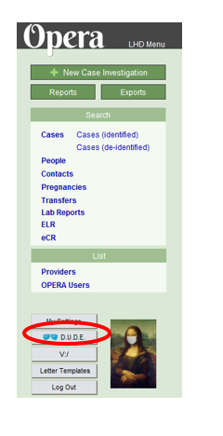
Click on the ‘DUDE’ button. Dashboard of Useful Databases for Epidemiologists at the bottom left of the Opera main screen
Click on the Opera Outbreaks button to open the Outbreaks Database.
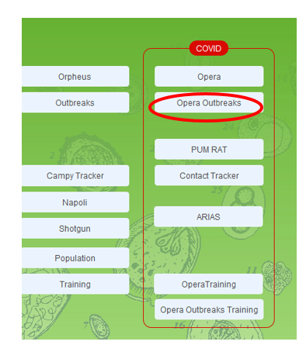

Search for the outbreak using the main search bar. Set “show last” days to something more than 30 so as not to miss long, on-going outbreaks (suggest using 500).
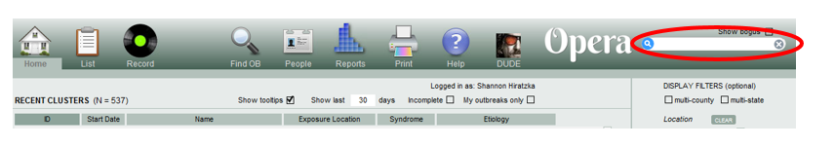

On the ‘Basics’ tab, locate information about the outbreak lead(s) (marked “L”). Send the courtesy “To-do” to the corresponding outbreak lead.

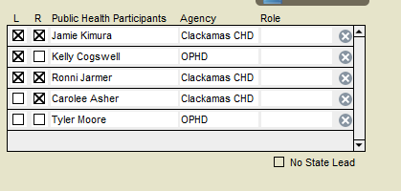

☐ Generation: If adding an outbreak id number to a case, please indicate the manner the case is linked to the outbreak. If multiple outbreaks listed this field is in reference to the first listed outbreak id number.
Select ‘1’ to indicate primary transmission from the outbreak (the exposure was at the site of the outbreak, i.e. case is directly associated with an outbreak (e.g., staff/resident at LTCF, employee at workplace)
Select ‘2’ to indicate secondary transmission from the outbreak (case is indirectly associated with an outbreak (e.g., household member of staff/resident at LTCF affected by outbreak, friend of employee of workplace affected by outbreak). DO NOT link tertiary (or beyond) cases to an outbreak.
If household member, Epilink will be HH
If outside of household, Epilink will be CC

CONTACTS TAB
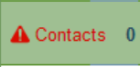
Anyone named by the case who meets the case definition of a close contact who was exposed during the case’s infectious period should be entered into the Contacts Tab. DO NOT leave blank, as this will indicate the tab as incomplete:

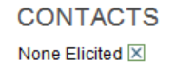
If case indicated that they had no close contacts during their infectious period, check the None Elicited box.

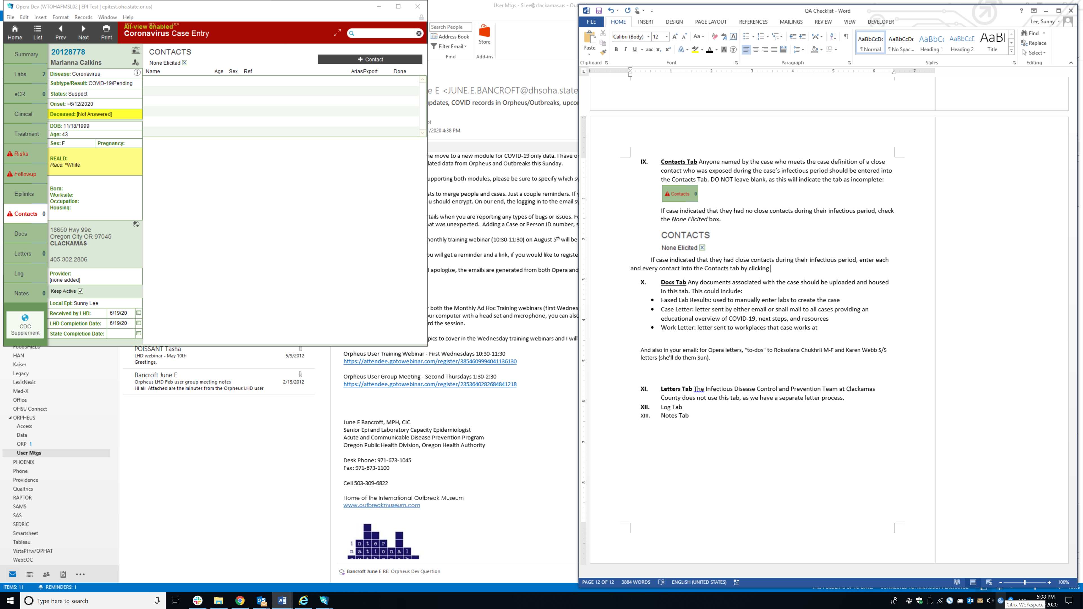
If case indicated that they had close contacts during their infectious period, enter contact into the Contacts tab by clicking
Enter as much information as possible about the contact, paying careful attention to accuracy in spelling of first and last name, and Junior and Senior designation. Obtain DOB, county of residence, Date Last Exposed, and phone number so that contact tracers can connect with them about monitoring. Fill in the ‘relation’ box to indicate household, social/friend, workplace, etc.
Not all fields collected in Opera are imported into Arias, therefore in the notes box, leave helpful information for the ARIAS team, including:
- Contact’s relationship to case (Same HH, not in same HH, workplace, friend/social, etc.)
- Case’s onset date
- Possible vaccination status of contacts
- Parent’s name/number when a contact is a minor
- Case’s name and number to call when there is no number listed for a contact
- Close contact’s last contact with case
- If contact is in same HH as case, if wraparound services have been requested for the case, and from which organization
- If not sending to ARIAS, reason why (for QA purposes so we can tell if a contact was overlooked vs deliberately not sent to ARIAS)

If Contact is Sick:
Any contacts who are known to be symptomatic AND meet the presumptive case definition should be noted in the Notes section and be marked as ‘Sick.’ This will turn their name red. These should have the ARIAS export ready box unchecked to prevent import into Arias. Ensure the case is entered and worked up as presumptive case. Details below to create presumptive case:

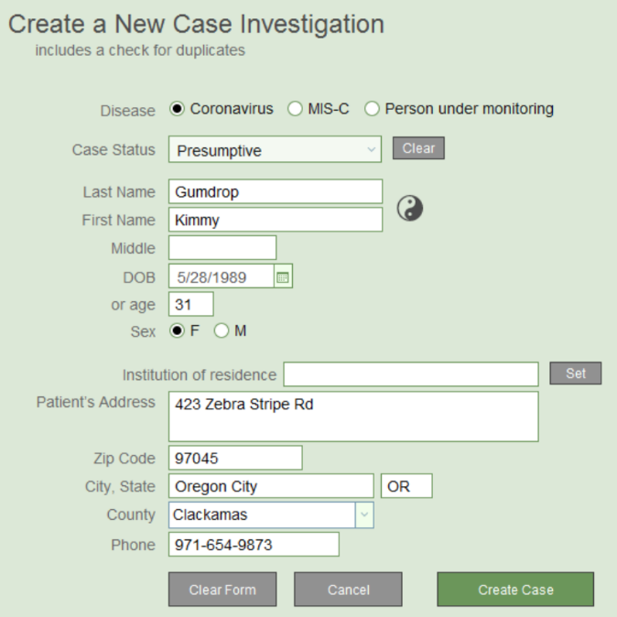
Presumptive cases can be created directly from the contact by clicking on ‘Create Case.’ Make sure Disease is ‘Coronavirus’ and Case Status is ‘Presumptive.’ The rest of the information is culled from the contact record, so make sure this is accurate so that Opera can do a reliable search for duplicate persons. Click Create Case.

Linking to existing persons in Opera:
Opera uses the information input (see top left of picture below) to perform a search of person records already in Opera, but it is ultimately up to the case investigator to determine whether there are any true matching persons in the system. Therefore, consider opening another Opera window and performing a loose person search and manually look through matches to ensure a person record does not already exist for the contact.
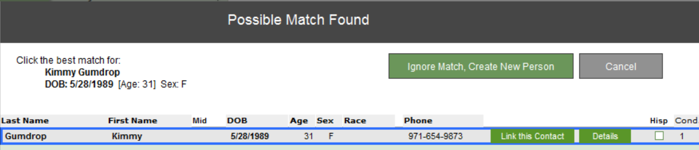

Click ‘Details’ for any of the potential matches to pull up that individual’s person record. From there, can go directly to any cases or contact records for that person already in Opera.
If one of the persons is a highly probable match (i.e., first and last name, DOB), click ‘Link this Contact’ to link new case to that particular person record in Opera.
If none of the persons are highly probable matches, click ‘Ignore Match, Create New Person’ to create a new case and new person record in Opera.
When contact record is complete and is ready for Arias export, ensure ‘ARIAS Export Ready’ box is checked if the contact needs to be sent to ARIAS. The AriasExport field should indicate this contact is ‘Ready’ to be exported into Arias the next day.
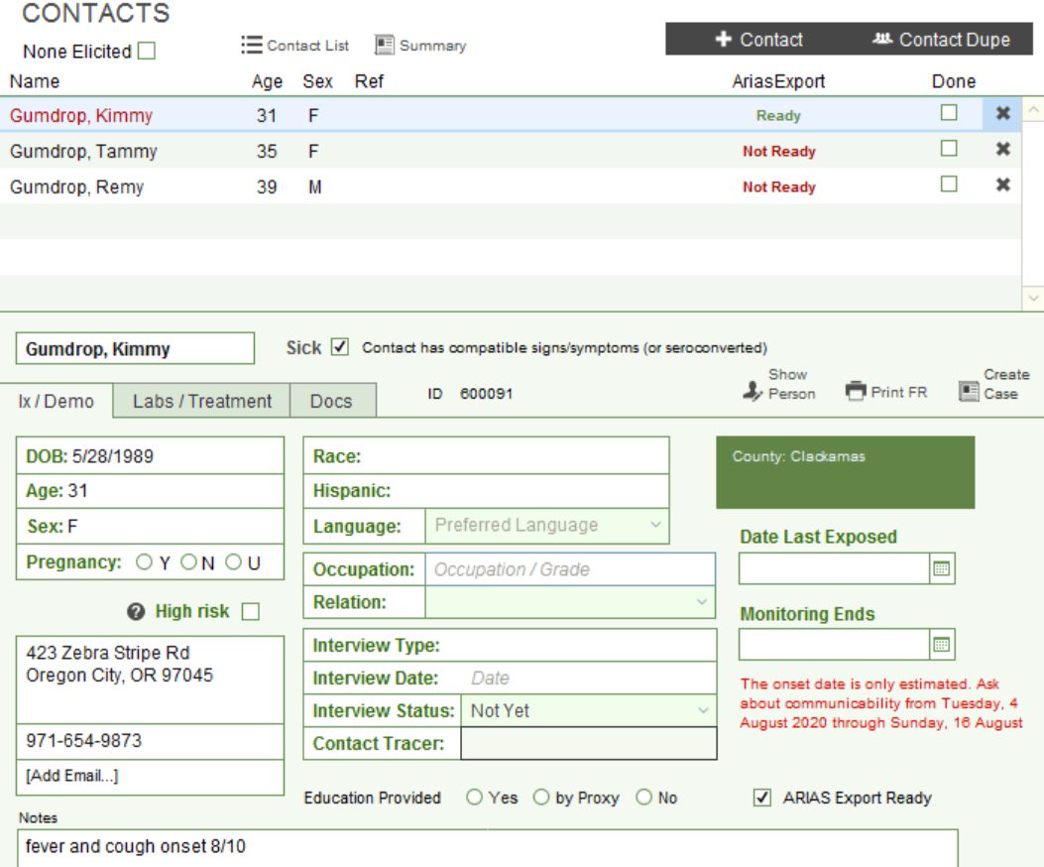

The Contact Dupe function allows a case investigator to simultaneously copy multiple contacts from one case to another.
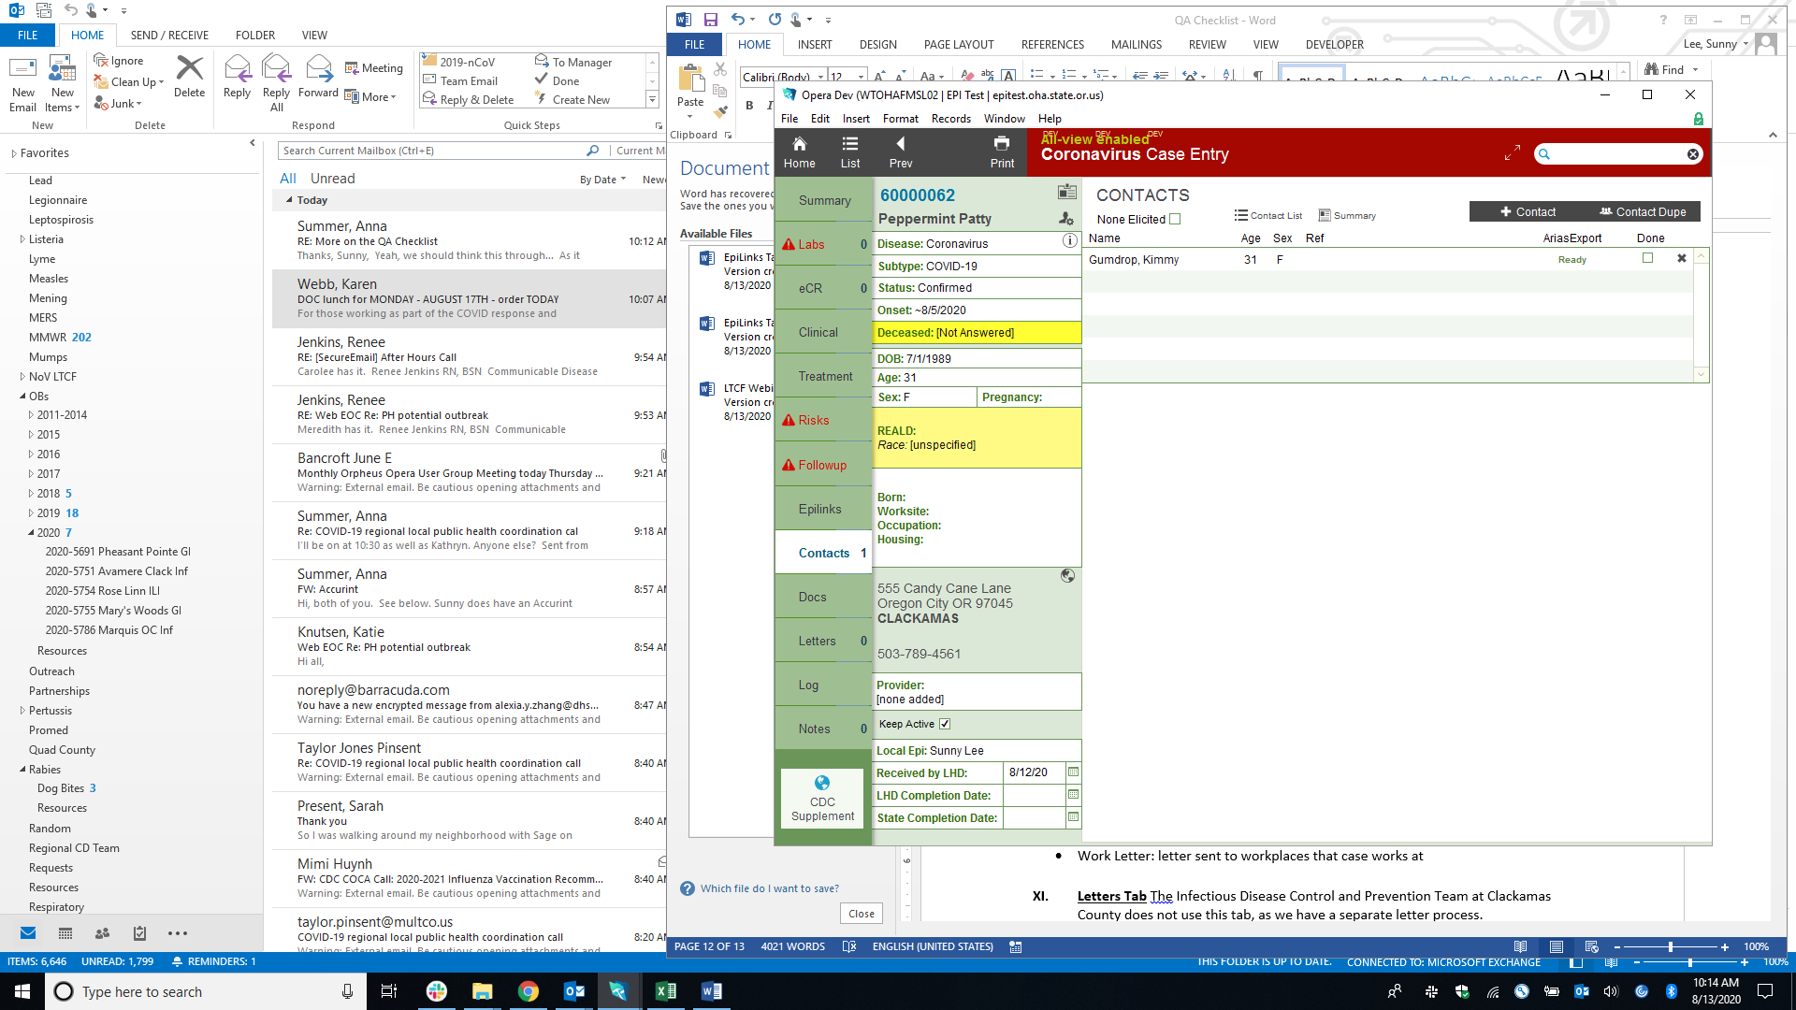
In the example below, confirmed case Peppermint Patty named 3 members of the Gumdrop family as contacts. We also know Peppermint Patty and the Gumdrops are contacts of case Strawberry Shortcake. In order to easily copy these contacts from Peppermint Patty to Strawberry Shortcake, click
Check the Select field for each of the contacts that overlap between cases and need to be copied over to Strawberry Shortcake.
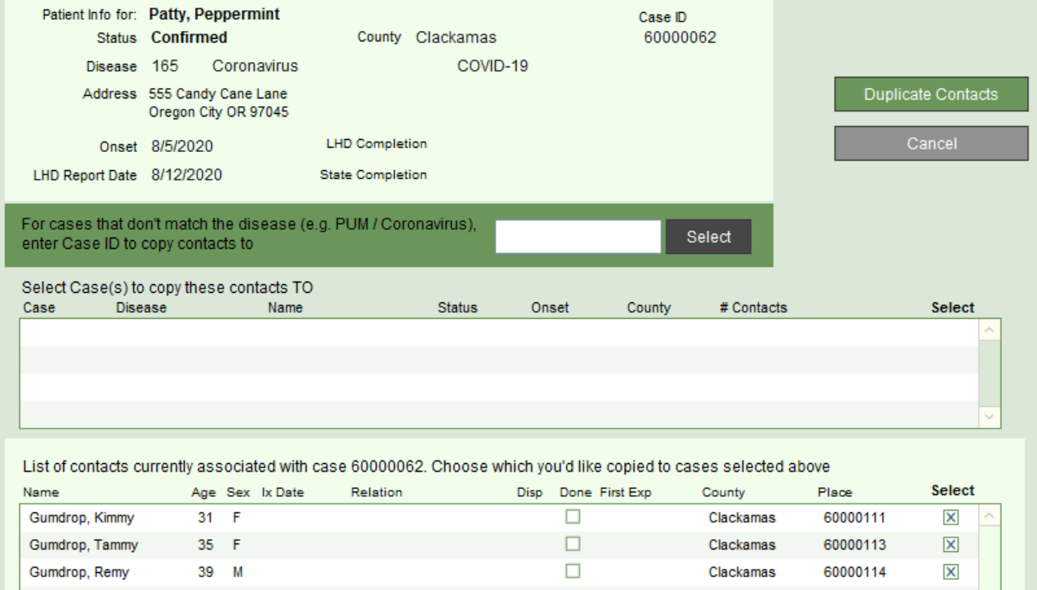
Enter in the Opera case ID number of the case that the contacts need to be copied TO and press Select. The case where the contacts need to be copied to will appear in the box below. Make sure the Select box is checked for this case.
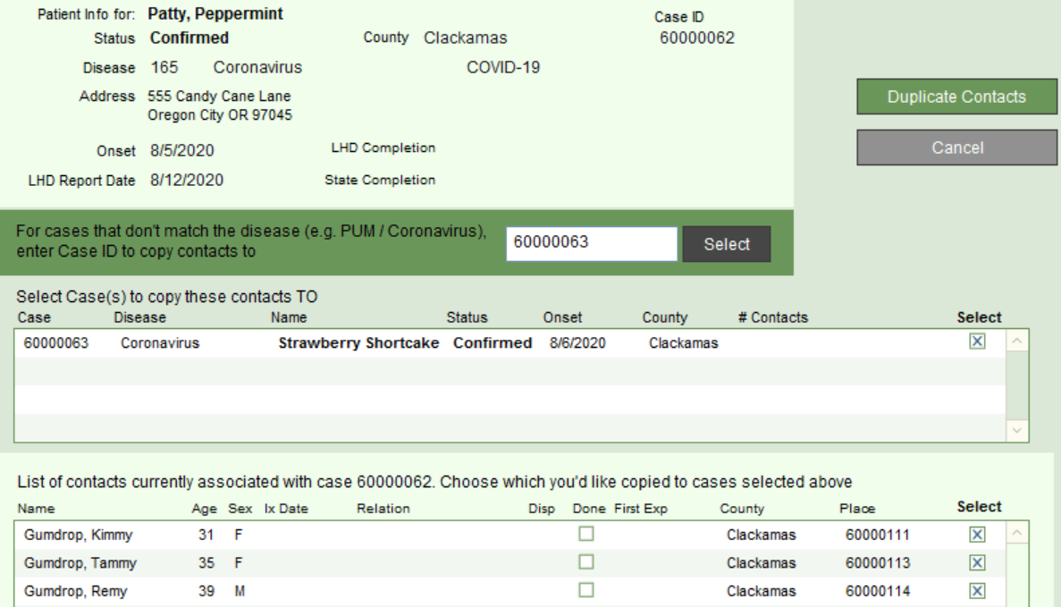
Click ‘Copy’ to duplicate the contacts to Strawberry Shortcake.
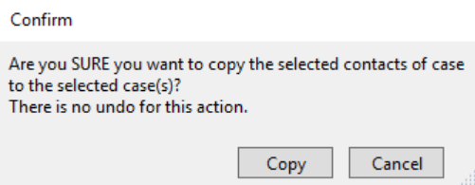

The four contacts have now been added as contacts to Strawberry Shortcake’s case record.
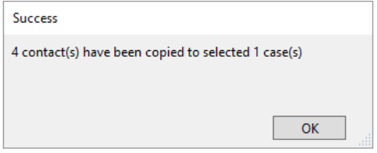
Refer to Contacts Tab training PowerPoint in the share drive for more information about completing the Contacts Tab.
Out-of-state contacts should not be entered into the Contacts tab. Instead, information for anyone who meets the close contact definition (including first and last name, DOB, phone number) needs to be included in a to do to Karuna Bollam in the Notes tab. OHA will notify the state of residence of the contact.

VACCINE TAB
ALERT is a state database that contains vaccination records. COVID vaccinations are entered to this system. OHA would like us to start linking the vaccination records in ALERT to the record in Opera, by visiting the vaccination tab in Opera to run a query in ALERT. This will help OHA identify “break-through” cases (people who got COVID after they were fully vaccinated).

- At the start of call, verify spelling of name and DOB (to help with matching to ALERT)
- For confirmed cases, ask case if they have been vaccinated.
  - If yes, visit the Vaccination tab and hit “Query ALERT” to query the ALERT system
  - At the bottom of your screen you will get a message “Pending”, this means the search is running.
  - When the search finishes it will populate the tab with ALL the case’s vaccines (if records are found)
  - Click “Filter for Coronavirus” (the bottom right hand of window) to list only COVID vaccines

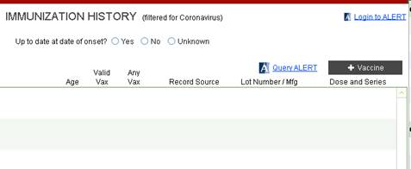

If the case says they are vaccinated but the record is not found (out of state, etc) you can enter the record manually (use judgement and enter if information seems reliable).

Click +Vaccine to manually enter a record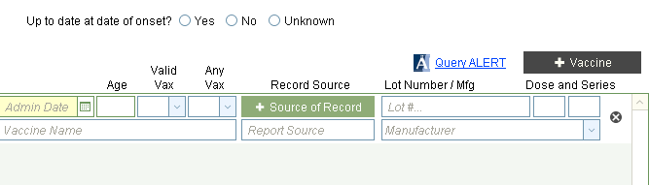Enter date administered, record source, lot number, vaccine name (COVID-19), manufacturer (Type in “MOD” for Moderna, “PFR” for Pfizer, “JJ” for Johnson and Johnson). Leave age, valid vax, any vax, dose and series blank. For record source, click +Source of Record and select from drop down “Verbal (shot card)” or “Verbal (unverified)”, depending on if they can read you back the shot card with the lot number info. (For record source, please do not type in, use drop down only).

If you believe the case does not have enough info to enter a reliable manual record, you can enter whatever information you have in a note in Opera and send as a to do to Shannon Hiratzka (to allow tracking of these to inform whether we should update the process for entering manual records)

- Once vaccine info is populated/entered, determine if the case received last dose of their series.
    - 2 shots of Moderna
    - 2 shots of Pfizer
    - 1 J and J (not yet out there)

(The screen below shows two doses Pfizer 1/2/21 and 1/23/21)
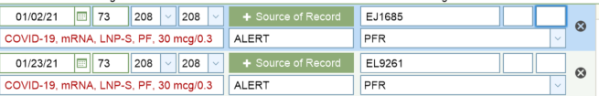

- If completed series, determine if “Up to date at date of onset”. Use information from ALERT record as primary source, can use information from manual record if dose and manufacturer information are available.
  - Yes: case onset is >14 days after receiving final dose (break through case)
    - Send to do to Amanda Faulkner from OHA if you identify a break through case
  - No: case onset is < =14 days from receiving final dose
  - Unknown:

Notes:
Keep in mind there is up to a 72 hour lag for provider to enter vaccine results to Alert, so if case was vaccinated in past few days prior to your interview, their results may not be found. Create a manual record as described above. Send yourself a future to do to re-query in a few days to find the legitimate record. You do not need to delete the manual record if the ALERT record is found, it is acceptable to have both entries in Opera (per OHA 2/24/21).

If a case needs to be looked up in ALERT (the button does not work on vaccine tab (or you get an error like the one below), or the button is not finding a match when you believe there should be one and it’s been more than 72 hours since dose administered, send a request to a lead through slack to query the actual ALERT database. If case says they received their vaccine from Clackamas County then you can also email the vaccine team to search internal records.
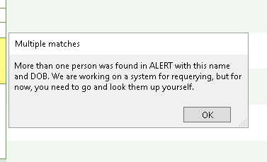

DOCS TAB
Any documents associated with the case should be uploaded and housed in this tab. This could include:
- Faxed Lab Results: used to manually enter labs to create the case
- Case Letter: letter sent by either email or snail mail to all cases providing an educational overview of COVID-19, next steps, and resources
- Work Letter: letter sent to workplaces that case works at

LETTERS TAB
The Infectious Disease Control and Prevention Team at Clackamas County does not use this Opera tab, as we have a separate letter process. Letter Process:
We have 3 main types of letters: 1) Case letter/Work Excuse 2) Return to Work and 3) Contact Letter. The Case Letter/Work Excuse letter is automatically sent. Return to Work and Contact Letters are available upon request. Details on each letter are below.

- Case Letter/Work Excuse:
  - All cases automatically have a case letter/work excuse combined letter mailed in English and Spanish to the address listed on the demographic panel.
    - The cases are selected for the automatic letter 2 days after being “counted” (the count date “TrueCaseDate” is the date the case is created from the ELR; for presumptive cases, the date the case status is toggled to presumptive). This 2 day lag allows time to update and confirm the case’s address if case is interviewed.
      - Example: ELR processed on the morning of 12/7. TrueCaseDate is 12/7. Case assigned for interview on 12/7. Case pulled for mailmerge on morning of 12/9 and letter sent on 12/9. Case receives letter 1-3 days later (12/10-12/13).
    - The mail goes out Monday-Thursday only.
    - Each individual case will receive their own letter in their own envelope (we are not batching by address).
  - As this process is automated, there is no need to request this letter. You should only send a request if your case has a need that is not met by the automatic process outlined above.
    - Special Circumstances Include:
      - Case would like their letter emailed.
      - Case needs an expedited letter in the mail.
      - Case needs a letter in a language other than English/Spanish.
      - Case needs a letter mailed to an address other than the one listed in Opera.

- Return to Work letter
- Case’s employer is requesting more specific information for return to work (dates, etc) beyond the Case Letter/Work Excuse letter (see Work Excuse letter on next page for its content).

    - If, as a case investigator, you interview and “clear” the case for work, annotate that you did so in OPERA and send the request for a return to work letter as a to-do in OPERA including the specific information being requested.
      - Florencia Morgan (physical mail letter)
      - Roksolana Chukhrii (email letter)
    - If you as the case investigator receive a message from a case and would like the case to be called by the letter team and cleared for work, send this request to PHCOVIDLETTERS@clackamas.us Indicate in this email that you have not yet cleared the case but that this person needs to be called/cleared. Someone in the PHCOVID letter group will make this call, document in OPERA, and make the letter request there.

- Contact Letter
  - Available upon request. Contact team sends directly.

Letter Request Team:
Mailed letters: Florencia Morgan
Emailed letters: Roksolana Chukhrii

WORK EXCUSE Letter

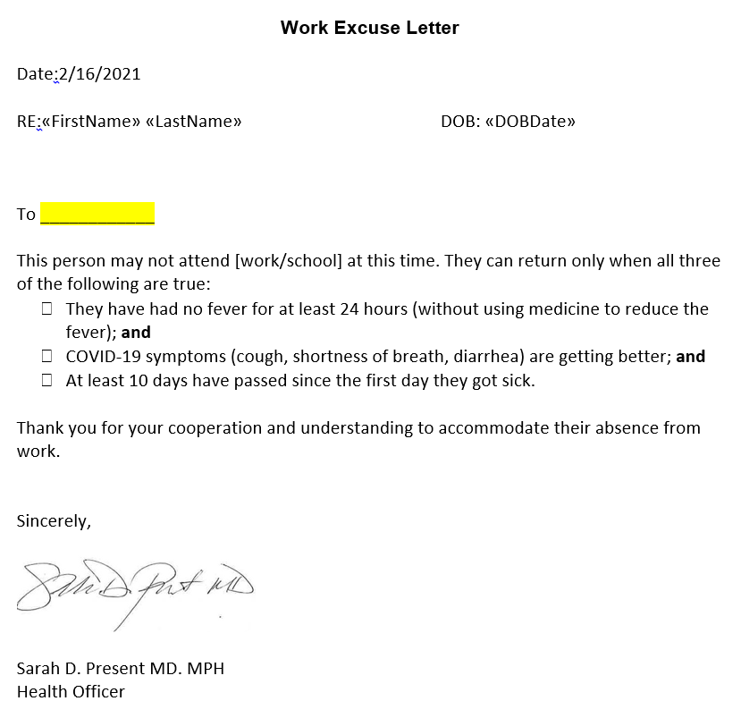

LOG TAB
This tab logs the history of changes made to this particular case, specifically date and time an edit was made, who made the edit, and what change was made. This can be useful if, for example, a case investigator is trying to determine who made a change or if trying to determine who may have worked up the case transferred from another county.

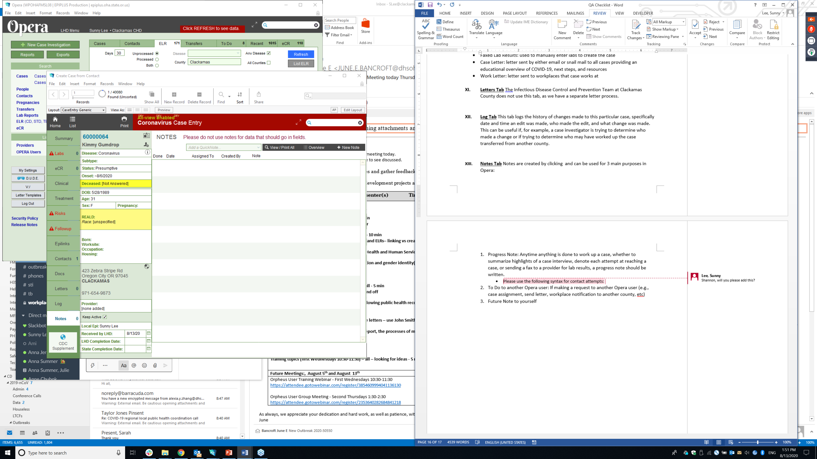
NOTES TAB
Notes are used for 3 main purposes in Opera:
- Progress Note: Anytime anything is done to work up a case, whether to summarize highlights of a case interview, capture information that cannot be entered into existing Opera fields (such as additional symptoms), denote each attempt at reaching a case, or sending a fax to a provider for lab results, a progress note should be written.
  - Please use a separate note to document attempts to reach, with the following syntax:
    - First Attempt Done [Date] @ [military time] by [Method], [Who]
    - Second Attempt Done [Date] @ [military time] by [Method], [Who]
    - Third Attempt Done [Date] @ [military time] by [Method], [Who]
      - Methods: T/C, Text, Email
      - Who: Optional. May wish to specify who was contacted if the attempt is not to the patient; ie Parent, Relative, etc.
  - Use a note to capture symptoms not included on the symptom list on the clinical tab
    - Use the following syntax:
Additional Symptoms: [Symptom] (onset [date]), [Symptom] (onset [date]),etc.
    - Example: Additional Symptoms: Fatigue (onset 12/1/2020)

- To Do to another Opera user: If making a request to another Opera user (e.g., case assignment, send letter, workplace notification to another county, etc). Change the Assign To field to the Opera user for whom the note will be sent.
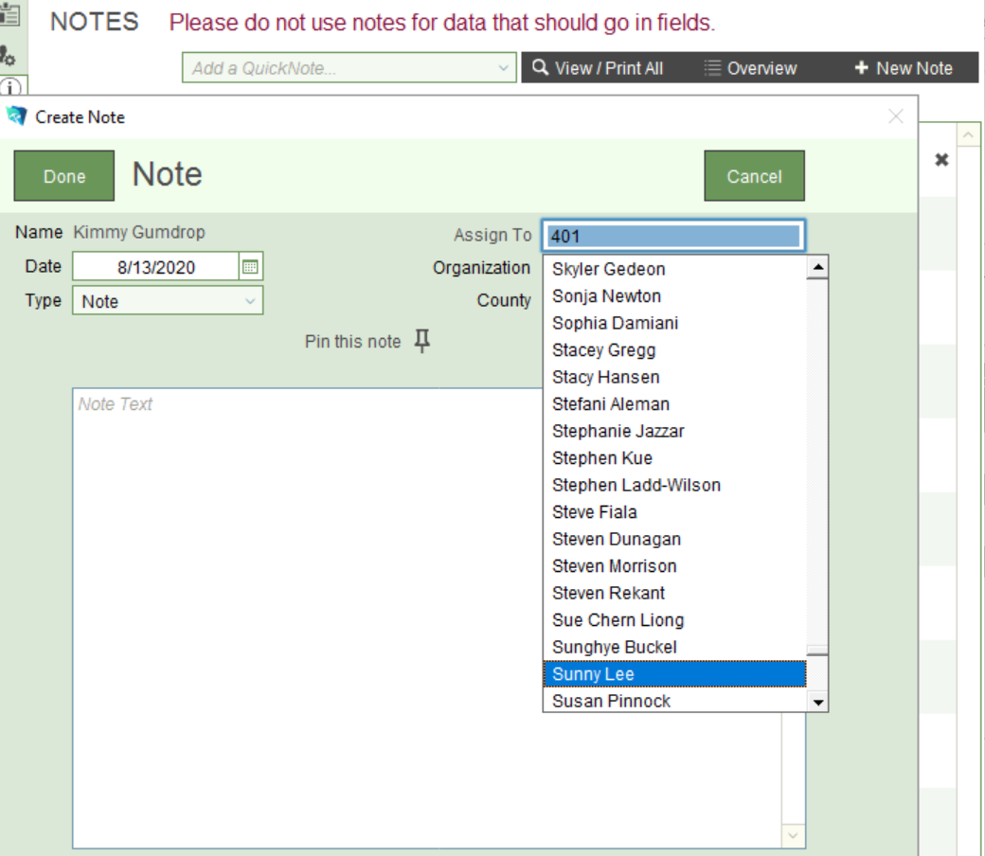
- Future To Do to yourself: Use this function when wanting to send a reminder to yourself on a future date (e.g., case wants an interview on another date).
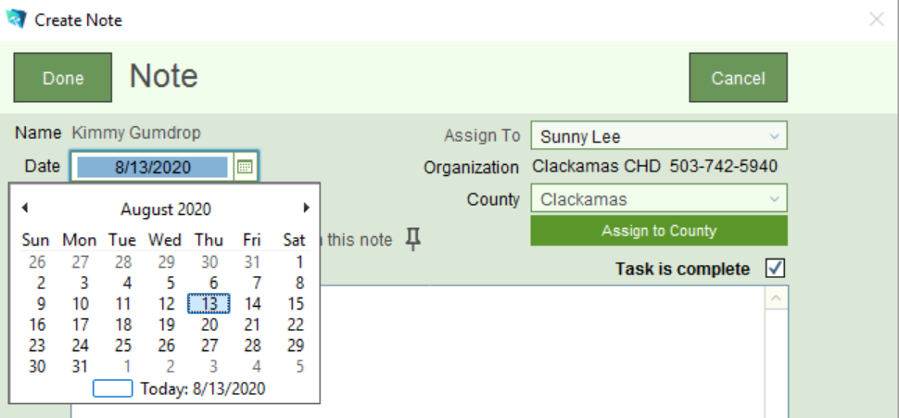

Show these future to dos from the To Do tab on the home screen by clicking on Show Future button

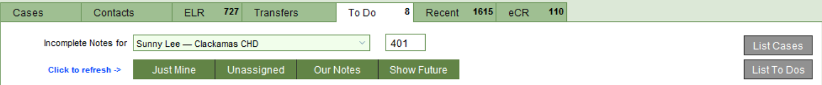

OPERA Account Unlock and Password Reset
The Public Health Escalated Phone Line Number is used for high priority needs such as password resets (account unlocks):
503-947-0691, enter PIN number 1859 followed by # when prompted.
This line will be available from 6AM to 9PM, 7 days/week including weekends and holidays to provide business continuity during this critical time.

MERGING DUPLICATE RECORDS

If you come across duplicate records which need to be merged:
- Send an email to the Orpheus Tech team (ORPHEUS.ODPE-TECH@dhsoha.state.or.us) with the PERSON record ids associated with the duplicates and which is to be retained. Merge PersonID XXXXXXX (keep) with PersonID XXXXXX". If duplicate CASE records are also involved indicate the caseids to be merged and which is to be retained.
- Cc Shannon Hiratzka (shiratzka@clackamas.us) on the merge request to the Opera Tech team
- If case records are to be merged put a note in Opera that the merge has been requested

PersonID vs CaseID:
PERSON ID: The unique id per person. Opera should only have 1 PERSON record per person in the system, however, duplicate people are often created and need to be merged (sources to create people are labs, ecrs, case investigators entering contacts, case investigators creating cases).
CASE ID: The unique id for each case. It is possible to have more than 1 case associated with a person, if the cases are >90 days apart.

How to find PERSON ID and CASE ID:
In the CASE record, the CaseID is on the top left side (screen shot 1). To get to the PersonID hit the icon next to the case’s name that looks like a head with a gear (circled in red). That will bring you to the PERSON record which shows all the ways the person is connected in Opera, including case records, and if they are named as a contact to another case (screen shot 2). From the PERSON record, you can obtain the PersonID on top right hand side, circled in red.
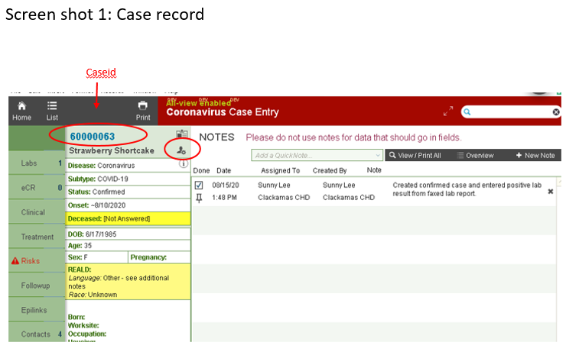

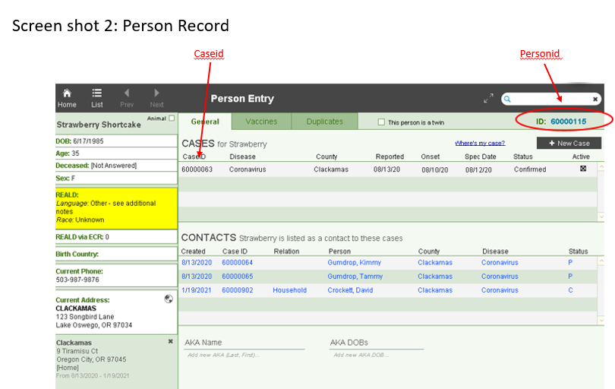

CLACKAMAS SURGE RESPONSE
Updated 2/5/21
Case investigation:
- We will use the abbreviated case interview (see below for questions to ask and questions to omit)
- UPDATE 2/5/21: We will make 2 call attempts, one text attempt. We will not roll-over cases for re-assignment.
- We will continue with our new WEN plan focusing on congregate care and food chain
- We will notify schools when a case is identified among teachers, volunteers or students who are providing or receiving in-person services
- We will attempt to gather all contacts but prioritize “high risk” contacts

Contact investigation:
- We will not make any changes yet to our contact investigation but we will consider discontinuing monitoring as our first change as needed, should we start to roll over contacts
- CBOs will not do monitoring; we need them to focus on social supports

Outbreaks:
- We will continue to define “large” outbreaks as five cases or more until instructed otherwise
- We are adding a shortened interview for LTCF residents
- OHA will close out outbreak records created during surge conditions once 28 days without a new case have elapsed

Case Investigation - Questions to ASK during surge response
updated 2/5/2021
Demographics
- VERIFY (spelling) Full Name
- VERIFY Date of birth
- VERIFY Address
- REALD language
- REALD Race
- REALD Disability—main yes/no question. (If yes, then ask the list of questions).
- Worksite
- Occupation
- Stably Housed
Clinical
- Symptomatic?
- Onset date
- Diagnostic date
- Onset indeterminate (if applicable)
- Symptoms
- Details of hospitalization (if applicable)
Risks
- 1st call try
- Interviewed? (And the rest of these questions, date, who, by)
- Contact with case
- Congregate setting
- Work in healthcare
- Attend or work in daycare or school setting
Follow-up
- Public Settings
- Last day worked
- Work while sick
- Transportation to work
- Letter for work
- Wraparound Services
- Case Education
- EMS Transportations

OPERA QA TOOL
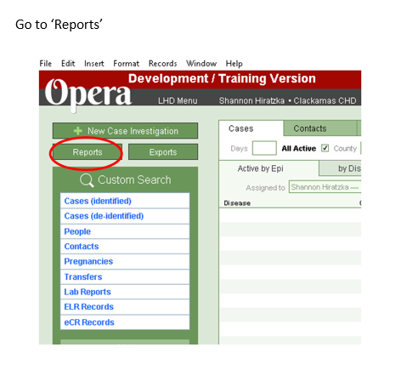
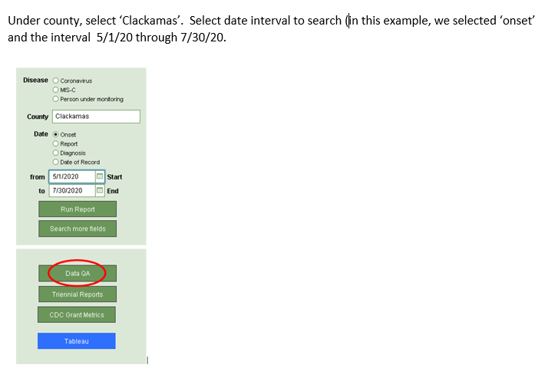
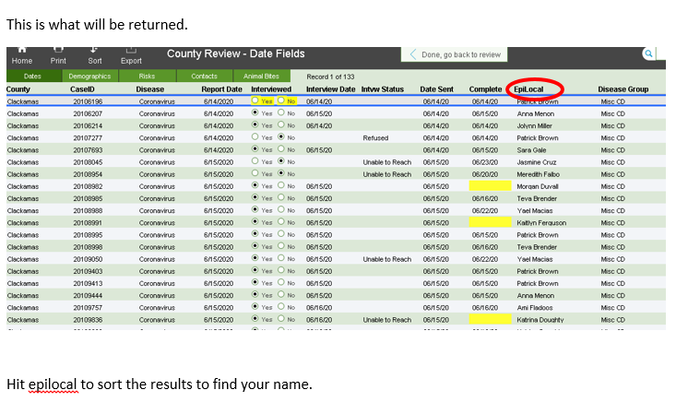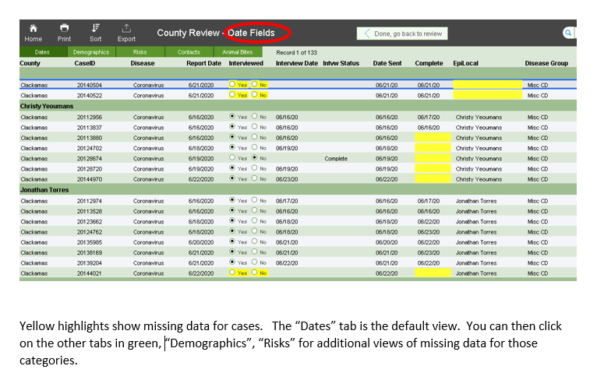

APPENDIX EPILINKS FLOW CHART
Scroll down

This is the process we use to QA epilinks in an attempt to standardize the entry to this field.
