Using CDC Wonder MCOD (Multiple cause of death)
Example: Identifying overdose from any opioid

Navigate to https://wonder.cdc.gov/

Select multiple cause of death (provisional or final)-right now final is up to 2020
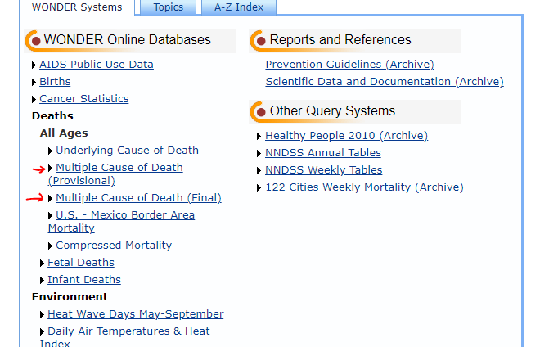

Then Select” Data Request” from the “Current Final Multiple Cause of Death Data” row
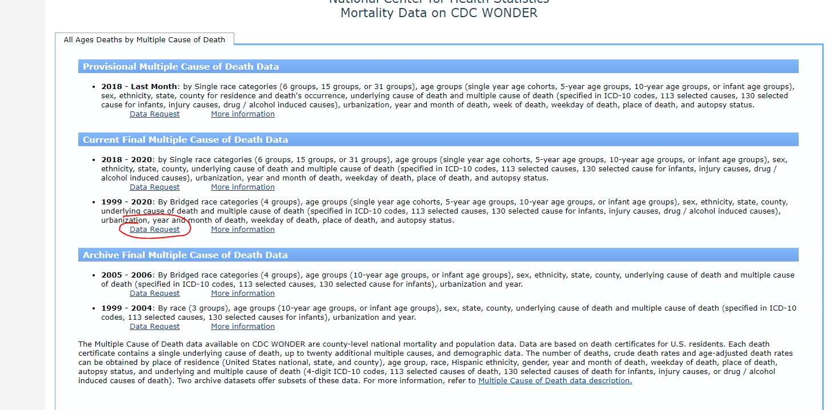

Click “I agree” to move onto to the main data selections fields.

Part 1. Pick a grouping variable. You can leave the default as census region, or change to year or something else you want. For this example, select “year.” Click any checkboxes for more measures, such as “Age adjusted rate”
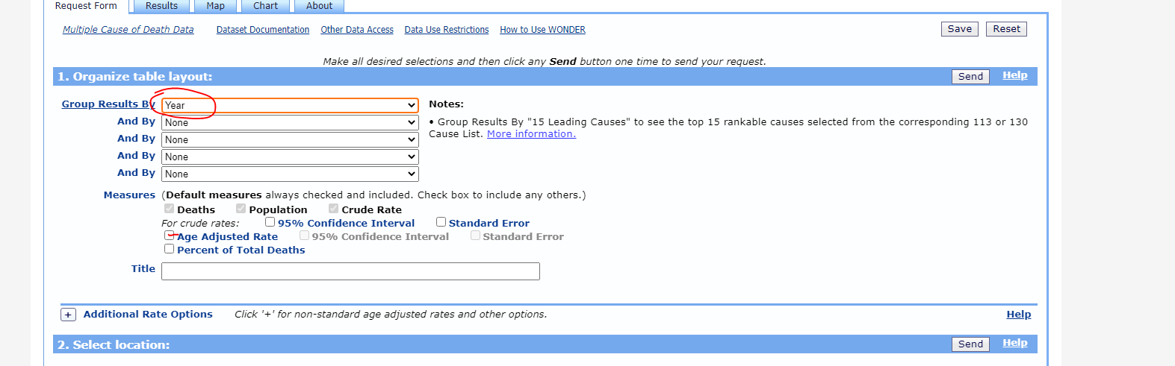

Part 2. Scroll down to Oregon and click “open” then select the county you’re interested in. This example uses Linn County. You don’t need to do anything in the “2013 urbanization box.”
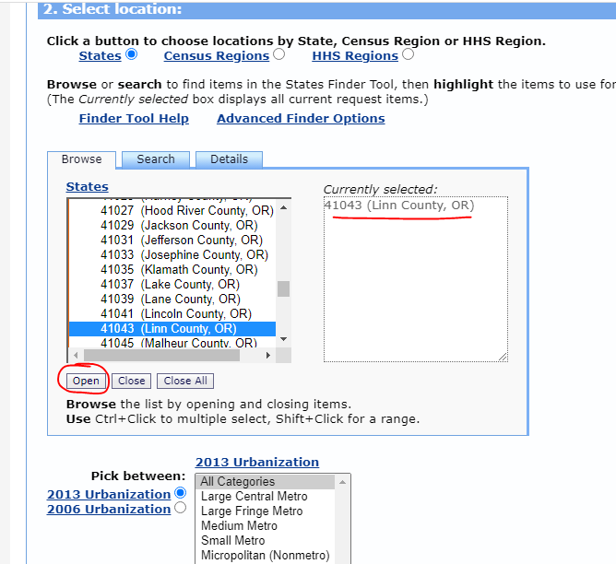

Part 3. Demographics
You can limit by any of these variables. For this example, keep everything to the “Total” defaults.
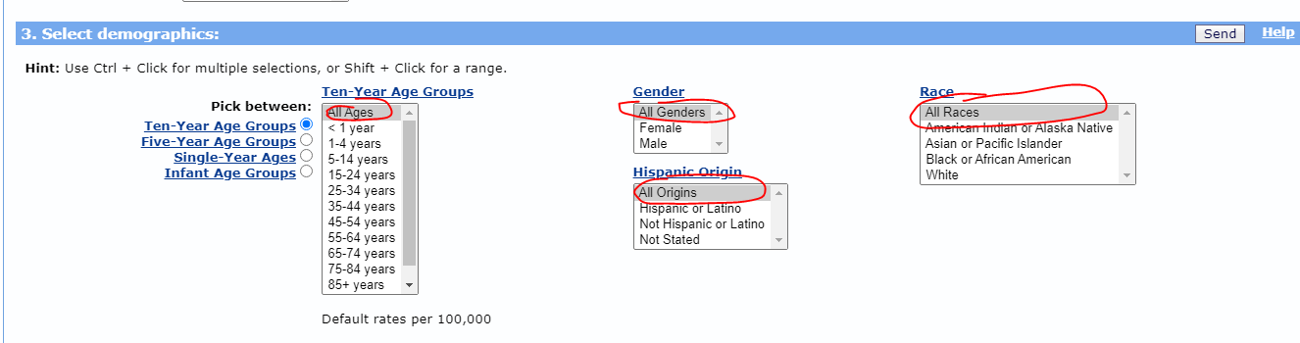

Part 4. Select year and month. Note that in Step 1 we picked “Year” as a grouping variable. Years with counts <10 will be suppressed.
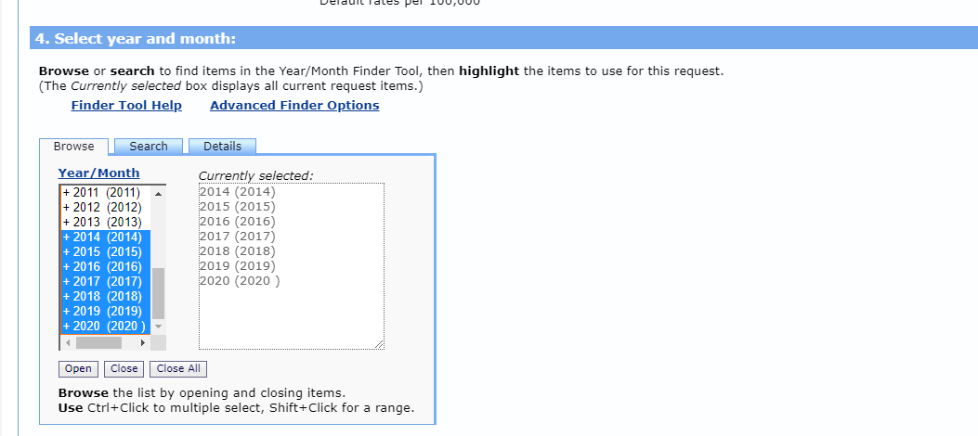

Part 5. Leave the defaults chosen.
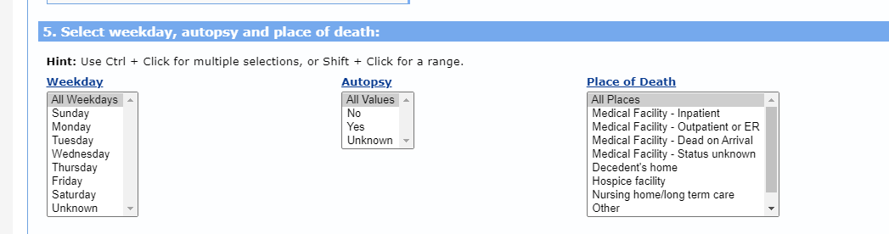
Part 6. Underlying cause of death. This example is how to find “any opioid poisoning” which could have a different case definition depending on who is extracting data. We’re using one common case definition, which is as follows:
Underlying cause of death X40-X44, X60-X64, X85, and Y10-14 and any multiple cause code T400, T401, T402, T403, T404, T406

Change the toggle button to “UCD- Drug/Alcohol Induced Causes“ and control+click the 4 drug causes as noted above:
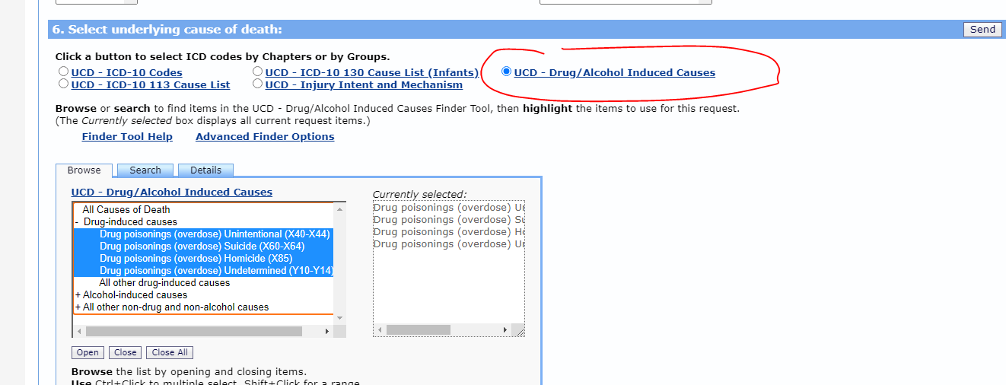

Part 7. Multiple cause of death
In the box that reads “MCD-ICD-10 Codes” select S00-T98 and click “Open Fully”
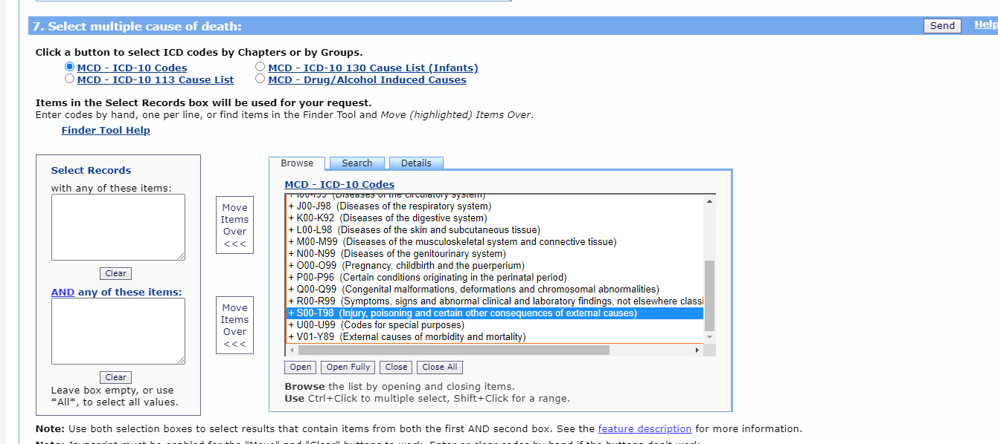
Then control+click these following multiple selections and pick “Move items Over”

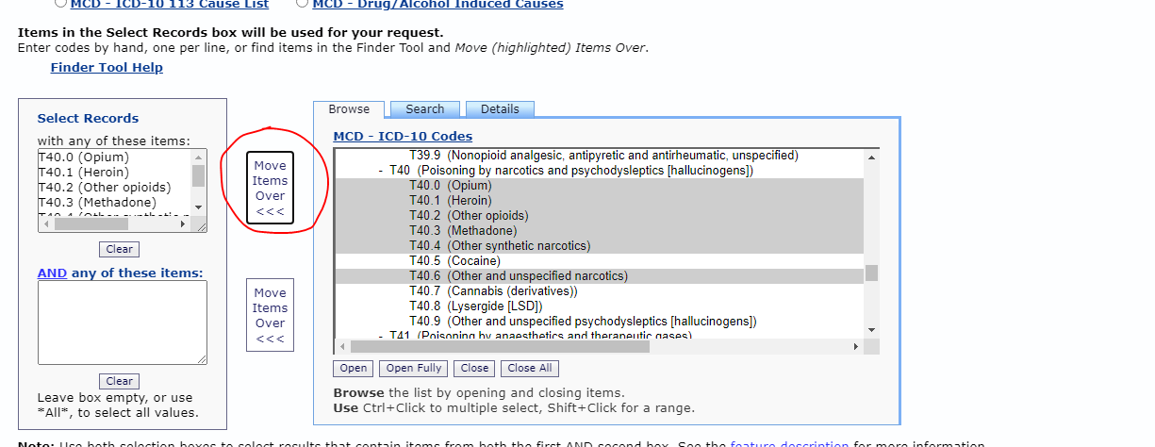

Part 8. Other options-you can save the export to a text file by clicking that checkbox. Otherwise, just hit “Send”

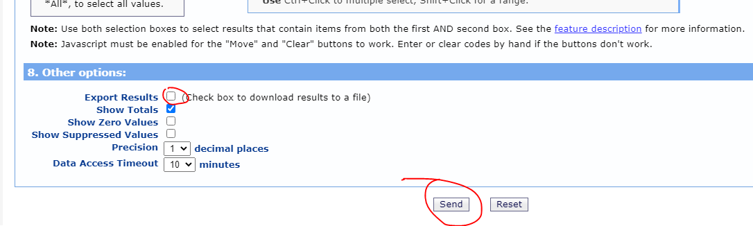

You’ll go to a multi-tabbed window with “Request form” on the left (you can go back and make changes to the query) or just look at “Results.” Here’s what we turned up for Linn County:

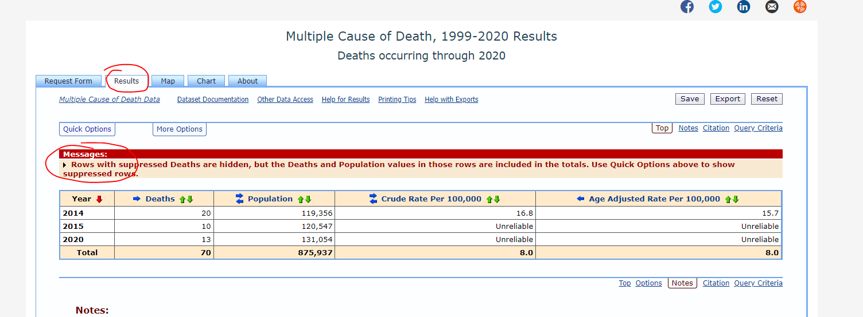

Note we ran into some issues with suppression. You can choose to not aggregate by year. If you want to see the suppressed rows, click “Quick Options” at top left and choose “Show suppressed rows”

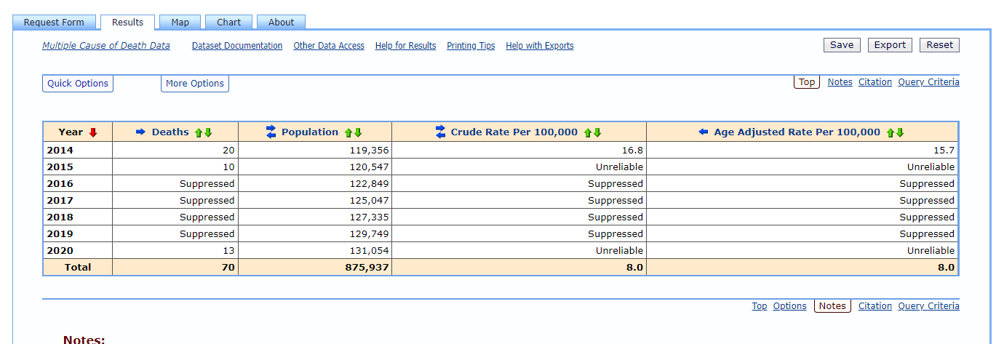

You can see the results in a chart by choosing “Chart” and you can modify or save your query.

Scroll down all the way to the bottom to see your query criteria (case definition):

