AITT Case Study Workshop Scenario 1: Improving Notifiable Disease Case Reporting with Local Healthcare Partners

The number of cases of notifiable disease, especially sexually transmitted disease (STD), are rising and present a growing threat to the health of the US population. Some states reported more than a 40% increase in cases of chlamydia, gonorrhea, and early syphilis between 2010 and 2017. The reason for the dramatic rise in the number of cases is not entirely known, however, the social determinants of health, such as individual behavior, social and economic factors, and access to healthcare services are factors in the increase. With the increase in the number of cases and the increase in the number of antibiotic resistant cases, it is critical for public health agencies, healthcare providers, and their partners to work together to strengthen STD prevention and control programs.

Syphilis, gonorrhea, chlamydia, are reportable diseases in every state. Disease reports originating from healthcare providers and laboratories are an important source of data for public health agencies, however, issues with data quality and timeliness are common. Because of these issues public health practitioners must spend time communicating back and forth with providers to determine if the case meets reporting criteria and gather additional important information concerning the individual diagnosed with the disease. Improved tracking of not only positive cases of disease, but also negative laboratory tests, are needed to determine prevalence and the assist key stakeholders, i.e. local health agencies, STD clinics, laboratorians, other partners to prioritize implementing a public health intervention.

As a public health practitioner, you have been asked to design an informatics-based solution that will strengthen your agency’s STD prevention and control programs, including identifying critical success factors such as stakeholder engagement and communication, proposed workflow, proposed functional requirements for an information system, and an evaluation approach for measuring success. The team must also consider the legal requirements and ramifications of the project. Strategies and solutions to consider are improving STD surveillance, responding to outbreaks, disease investigation and intervention, increase screenings in priority populations, etc. Realizing that there are not enough resources to accomplish all of the possibilities, you and your project team must choose a strategy and propose a project that works within reasonable resource limits.

AITT Case Study Workshop Scenario 2: Utilizing Data to Combat Emerging Population Health Threats

Prescription drug use is a significant threat to the health and well-being of the US population. According to the CDC approximately 66% of drug overdose deaths in 2016 involved an opioid and on average 115 Americans die every day from an opioid overdose. Leaders in healthcare, public health, and government have deemed opioid addiction a “crisis” in the United States that must be addressed. Currently states are working to address the crisis through many programs including prescription drug monitoring programs (PDMP). Per state law, PDMPs monitor controlled substances as defined by Federal and State Controlled Substances Laws. PDMPs are government funded and run databases tracking how healthcare providers and pharmacists prescribe and dispense controlled substances. An example of how a PDMP is structured is in the figure below. PDMPs are in need of additional insight and support to become more effective for all of the stakeholders.

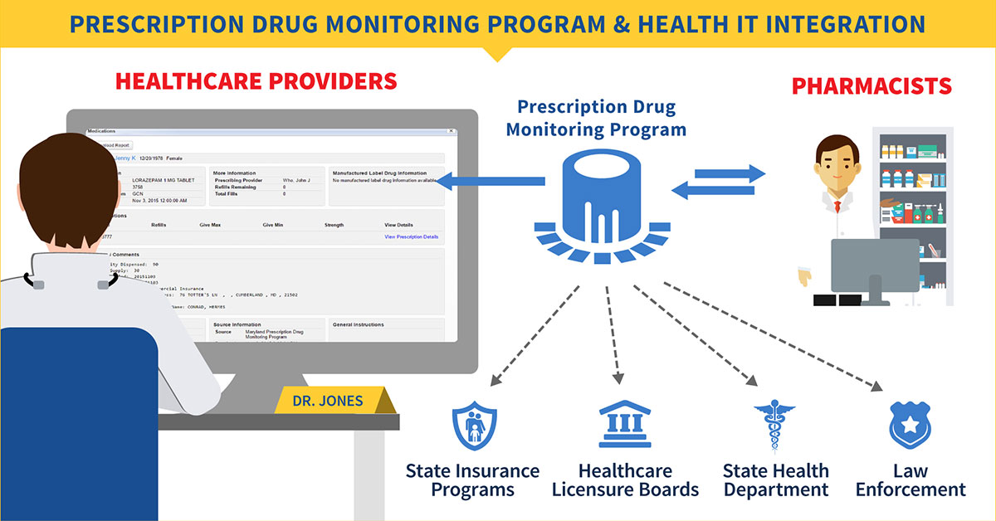
The Office of the National Coordinator for Health IT. Health IT Playbook from https://www.healthit.gov/playbook/opioid-epidemic-and-health-it/

There is a need to identify the occurrences or potential risks for opioid misuse in order to design interventions for preventing abuse and potential overdose. For example, data can be used to identify potential social and clinical determinants for identifying individuals or populations at risk of opioid addiction. Essentially, informatics can play a role in determining a more complete picture of the crisis so that key stakeholders, i.e. clinicians, law enforcement, social services, and public health practitioners can work to identify patterns of abuse in their populations.

As a public health practitioner, you have been asked to design an informatics-based solution that will enhance your state’s PDMP within public health and within your partner’s organizations. The project team will identify critical success factors such as stakeholder engagement and communication, proposed workflow, proposed functional requirements for an information system, and an evaluation approach for measuring success. The team must also consider the legal requirements and ramifications of the project. Strategies and solutions to consider are: improve data collection and analysis around opioid misuse, abuse, and overdose; create strategies that impact behaviors driving dependence and abuse; and work within your community to develop more comprehensive prevention programs. Realizing that there are not enough resources to accomplish all of the possibilities, you and your project team must choose a strategy and propose a project that works within reasonable resource limits.

