Data Dictionary and Implementation Guide
This a brief introduction to the NSSP Data Dictionary and Arizona Syndromic Surveillance Implementation Guide that includes a walk-through using an example from a data field in ESSENCE. These two tools combined will help you understand where data elements come from and what values are allowed for those fields.
Data Dictionary
- Access the Data Dictionary
  - https://www.cdc.gov/nssp/biosense/publications.html
  - Click the “Data Dictionary” tab
  - Click the “Access the NSSP Data Dictionary” hyperlink, which will download an Excel spreadsheet with the Data Dictionary
- Use of the Data Dictionary
  - You will most often use the “ESSENCE” tab
    - The “ESSENCE API...” tabs will be useful for more advanced users wishing to leverage the APIs available
  - Column D “ESSENCE Element Name” is where you will look for fields that you want to use in ESSENCE
  - Column C “Processing (message to Archive)” tells you which part of the HL7 message that data element comes from. This is where you will find the information you need to take to the implementation guide.
  - Column F “Processing (ER Import Staging to ER Base)” tells you how the data is processed, which will help you understand if values are filled, replaced, concatenated, etc.
Implementation Guide
- Access the Implementation Guide
  - https://azdhs.gov/documents/preparedness/epidemiology-disease-control/meaningful-use/syndromic-surveillance/az-ss-implementation-guide.pdf
- Use of the Implementation Guide
  - The first part of the IG has some background on the BioSense Platform, data flow, HL7 message structure, and HL7 message conventions. Read these pages prior to looking at the tables so you have an understanding of what you’re looking at and how to find the information you need.
    - Example question: “What values are allowed for field X?”
  - Use the first 3 characters to identify the table (ie.e OBX, PV1, PID, etc), the first number after the dash to identify the row or field, and the number of the period to identify which component in that field.
Example Walk-Through
C_Visit_Date_Time is what’s known in ESSENCE as a calculated field (as indicated by the C_ prefix). Here’s what this element looks like in the Data Dictionary:
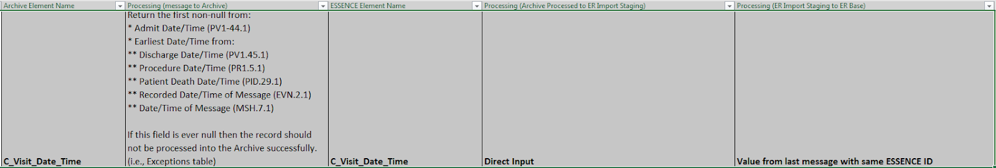
In the “Processing (message to Archive) column it says it takes the first non-null from a list of values. This helps us know how the system prioritizes the date-times available to label the C_Visit_Date_Time for that record. The first option it chooses from is PV1-44.1.
Below is a screenshot of the Implementation Guide with circles indicating the table (PV1), row (44) and column element (1) to look at. This last one is the most confusing to understand for people not familiar with HL7. The column labelled “Required/Recommended/Literal Value” shows what that field (PV-44) will look like, and all the components of that field, separated by a caret (^) if there are multiple. In this case, there is only one component, so there are no carets.
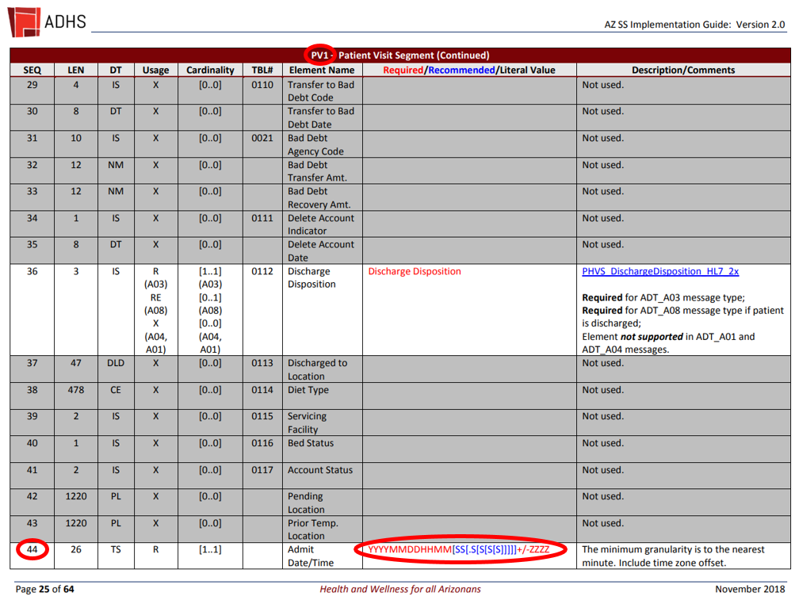
“Required” means that part of the message must always be sent. “Recommended” means if the facility has that part of the data they are required to include it, but not if they don’t have it. Read what is in the “Description/Comments” column to get more information about that field and its requirements. Sometimes there is a link (as seen on PV1-36 “Discharge Disposition” in the same table) of possible values that you can refer to as needed.

