CIFOR Chapter 2 Workgroup Call Notes – February 20, 2018
Attendance
- Authors: Paul Cieslak
  - Missing: Joe Russell
- Workgroup Members: Kristin Hold, Susan Lance, Kenny Yeh
  - Missing: Robyn Atkinson-Dunn, Don Sharp, Veronica Burrell, Heather Carleton
- Craig Hedberg present
- CSTE Staff: Thuy Kim
Discussion
- Logistics
  - Can send out word doc and members and put suggestions and thoughts in tracked changes, Thuy will compile and pass it onto Joe and Paul, can then walk through live outline document and walk through which topics to include or which ones for consideration
  - Working primarily off old version – may just be a start. Focusing on general trends rather than nitty gritty
  - Basecamp just for authors – only authors have access to the live edible version
  - Joe & Paul will develop outline and send out
    - Maybe group could take parts of the outline and help draft it, possibly suggest examples
  - Goal: some type of detailed outline to present at March CIFOR meeting. Ideally would like to have next iteration of what we presented today available by March 5
    - Could get something out to people by next week – and then get some compiling of edits and comments
    - Ideas, comments, graphics send to Thuy and will disseminate it from there
  - CIFOR meeting: will go through each chapter – review with comments and see if certain material should be included in each chapter. Want outline finalized to move further in the process
- Fundamental concepts: Title is kind of broad – maybe retitle to be more specific
- Question: Heard Ch. 1 and 2 were saved to be written later based on other chapters. Should we wait or start writing?
  - Ch. 1 is an intentional overview of other chapters, much more dependent on other chapters
  - Ch. 2 doesn’t really require that we wait to see how we see the rest of the chapters are going. Coming out of the CIFOR meeting in March, may have elements that need to incorporate some of the changes, but perfectly reasonable with revising chapter now.
- Should have other things from routine reportable diseases. Other surveillance data available – USDA animal testing, food testing that might be available.
- Contributing factors – things found in NEARS reporting or EHS-Net reporting – to get factors that lead to foodborne disease
- Also get new things for surveillance – reportable disease, dietary stuff might be found in FoodNet population survey, USDA data about consumption patterns, trends in what’s causing outbreaks – online database, contributing factors, importance of routine investigations
- Should capture foodborne surveillance architecture – don’t really establish anywhere else
- Where complaint system stuff should go?
  - Will stay in Ch. 4 (detecting foodborne surveillance in outbreak detection)
- Ch. 2 – changing nature of food system and dynamic of picture of foodborne illness- looking at broadly who players are in foodborne surveillance, scope of activities under that
- USDA FSIS FSRIO Strategic Plan – list where federal agencies play in. Similar graphic could be used for surveillance networks could work together
  - File attachment: 
  - Food Safety Research Information Office (FSRIO)
    - https://fsrio.nal.usda.gov/research-projects-database/food-safety-research-funding-agencies-map
  - Comments: pretty complex, but general idea of graphic would help
  - Regulated items under FSIS vs. FDA vs. etc

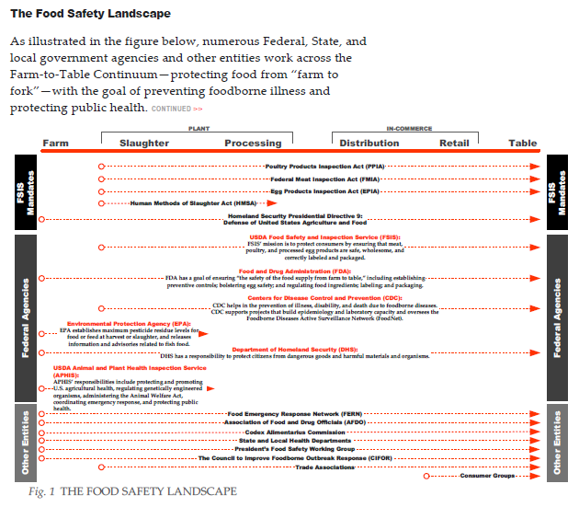
- May start the chapter with trends – grab users’ attention
- Changes of where we get food – key in this chapter. Nice to get specifics of what types of food come to the U.S. at which times of the year.
- Outbreak investigation website
- IFSAC Links:
  - https://www.cdc.gov/foodsafety/ifsac/index.html
  - https://www.cdc.gov/foodsafety/ifsac/research-brief-2015.html
  - https://www.cdc.gov/foodsafety/ifsac/publications.html
Next Call: Tuesday, March 6, 1-2pm EST

