Chapter 5 Cluster and Outbreak Investigation
Chapter Summary Points:
- How a potential outbreak of foodborne illness is initially recognized will determine the first steps taken to investigate (Chapter 4).
- Complaints identifying multiple illnesses associated with a common event or establishment will lead to an investigation to identify the agent and the mode(s) of transmission. While most of these will be local investigations, some will represent sub-clusters of larger, multi-jurisdictional outbreaks (Chapter 7).
- Clusters of cases identified through laboratory-based surveillance at the local or state level will lead to investigations to determine the mode of transmission or source of contamination.
- Multi-state clusters of these cases suggest a commercially distributed food source (Chapter 7).
  - Rapid interviewing with thorough exposure assessment is the key to solving these outbreaks.
  - Product tracing may be needed for successful exposure assessment.
- Identification of a foodborne pathogen in a commercially-distributed food product will lead to a search for illnesses caused by the same organism and an investigation to determine whether the food item was the source of the illness.
- A priority for all of these investigations is to establish the basis for implementing control measures to stop transmission and prevent additional illnesses (Chapter 6).

5.0. Introduction
This chapter is intended to help guide investigators from the process aspect of outbreak investigations to the decision-making aspect; how to collect and analyze data to render a decision on the source of the outbreak and guide necessary control measures (Chapter 6). Because outbreak investigations can help prevent illnesses, speed and accuracy are two key qualities of the investigation.
When a potential foodborne illness outbreak is first detected or reported, investigators will not know whether the illness is foodborne, waterborne, or attributable to other causes. Investigators must keep an open mind in the early stages of the investigation to ensure that potential causes are not prematurely ruled out. Even though these Guidelines focus on foodborne illness, many of the investigation methods described in this chapter apply to a variety of enteric and other illnesses, regardless of source of contamination.
This chapter highlights recent developments in laboratory and epidemiologic methods and their impact on cluster and outbreak investigation methods.
- The development and routine use of whole genome sequencing (WGS) by public health laboratories to characterize foodborne pathogens and identify clusters of cases that warrant investigation (Chapter 4),
- The challenges to cluster identification posed by the growing use of culture-independent diagnostic tests (CIDT), and
- Enhanced use of novel exposure assessment methods to streamline epidemiologic investigations to identify common sources for clusters and determine whether they constitute foodborne outbreaks.
For purposes of outbreak reporting, the National Outbreak Reporting System (NORS) distinguishes the definitions of an outbreak and a cluster as follows:
- An outbreak is two or more cases of similar illness associated with a common exposure.
- A cluster is two or more cases of similar illness that are suspected to be associated with a common exposure, but investigators are unable to identify a shared food, animal, venue, or experience among ill persons.
Various states and programs may differ in their approach to determining when to suspect that a common exposure may exist. WGS will likely lead to more, smaller clusters being investigated. In contrast, CIDTs without reflex culture will limit the ability to link cases by molecular subtype. Special attention will be needed to identify clusters of these cases linked by common exposure on a local level. In this regard, CIDTs will require a blending of approaches used to investigate clusters defined by complaints and those defined by molecular subtype surveillance.
Regardless of how clusters are defined for surveillance purposes, the investigations needed to identify a common exposure include multiple, inter-related epidemiologic, environmental, and laboratory activities. These activities are illustrated in Figure 5.1. It is important to note that while the activities are presented in a sequential manner, many steps may occur simultaneously, and as information is developed, there may be a need to revisit earlier steps. The objectives of these activities and investigative roles are summarized in Table 5.1,
Table 5.1 outlines objectives and investigation activities that can be conducted during epidemiologic, environmental health, and public health laboratory investigations of foodborne illness outbreaks. The table format highlights the major objectives of the investigation to help ensure coordination among epidemiologists, environmental health specialists, and laboratorians in meeting each objective. The assignment of investigation responsibilities to a particular discipline within each table is not intended to be prescriptive. The actual responsibilities for an individual will vary depending on the practices of the jurisdiction responsible for the investigation, roles defined in the outbreak investigation and control team, and resources.
5.1. Initial Outbreak Investigation Procedures
Alert outbreak investigation and control team leaders as soon as the potential outbreak is identified. As noted in Chapter 4, there are several principle ways that outbreaks are detected. However, a common initial approach is to review descriptive features of the outbreak setting and relevant background information about the etiologic agent, establishment, or event:
- Complaints identifying multiple illnesses associated with a common event or establishment will lead to an investigation to identify the agent and the mode(s) of transmission. Most of these will be local investigations requiring co-ordination between epidemiologists, environmental health specialists, and public health laboratorians within the jurisdiction of the event or establishment. Cases need to be rapidly interviewed to confirm illness and exposure details that may suggest a likely etiology and potential source of exposure. Environmental health specialists, guided by available descriptive epidemiology, need to assess food handling practices and food employee health and hygiene habits at the establishment. Public health laboratories need to test clinical specimens to confirm the etiology of the outbreak, based on the description of signs, symptoms and incubation periods (CIFOR Outbreaks of Unknown Etiology [OUE] Guidelines).
- Clusters of cases identified through laboratory-based surveillance at the local or state level will lead to investigations to determine the mode of transmission or source of contamination. Cases need to be rapidly interviewed with a thorough exposure assessment to identify potentially common exposures or likely routes of transmission. Environmental health specialists and food regulators need to be prepared to investigate sub-clusters associated with food establishments and to initiate product tracing for suspected food exposures. Public health laboratories need to rapidly confirm additional cases and food regulatory laboratories need to prepare to rapidly test suspected food products.
- Multi-state clusters of cases suggest a commercially distributed food source (Chapter 7). Product tracing may be needed for successful exposure assessment. Communication and co-ordination of activities between federal, state and local agencies must be established at the onset of the investigation.
- Identification of a foodborne pathogen in a commercially-distributed food product will lead to a search for illnesses caused by the same organism and an investigation to determine whether the food item was the source of the illness. This type of outbreak presentation will likely increase with the use of WGS to link historical food or environmental samples with cases identified through pathogen-specific surveillance. In all instances, this will require multi-jurisdictional investigation to assess the likelihood that the cases are attributable to the suspected food exposure.
Assess the priority of the outbreak investigation. On the basis of the outbreak setting and descriptive epidemiology, outbreak investigation and control team leaders should assess the priority of the outbreak. Give highest priority for investigation to outbreaks that:
- Have a high public health impact:
  - Cause severe or life-threatening illness, such as infection with E. coli O157:H7, hemolytic uremic syndrome (HUS), or botulism;
  - Affect populations at high risk for complications of the illness (e.g., infants or elderly or immunocompromised persons); or
  - Affect a large number of persons.
  - Appear to be ongoing:
  - Outbreak may be associated with food-service establishment in which ill food workers provide a continuing source of infection.
  - Outbreak may be associated with commercially distributed food product that is still being consumed.
  - Outbreak may be associated with adulterated food.

Assemble and brief the outbreak investigation and control team. Open communication between public health and regulatory partners to plan, conduct and evaluate outbreak investigation activities is critical to the success of the investigation.
- On the basis of the priority given the outbreak and on the nature of the outbreak, investigation and control team leaders should assess the availability of staff to conduct the investigation. In particular, the team leader should ensure the presence of adequate staffing to interview cases within 24–48 hours. If sufficient staff are not available, request external assistance to conduct interviews.
- Outbreak investigation staff should be briefed on the outbreak, the members of the outbreak control team, and their individual roles in the investigation.
- For outbreaks involving multiple jurisdictions, the outbreak investigation and control team should include members from all agencies participating in the investigation (Chapter 7).
- Ensure that all members of the investigation team, including epidemiologists, laboratorians, environmental health specialists, and food-safety personnel, are familiar with follow relevant state and federal laws and practices, including the Health Insurance Portability and Accountability Act (HIPAA)
If an agency does not believe it can manage an outbreak (e.g., the scale or complexity is likely to overwhelm agency resources, the nature of the outbreak is beyond the expertise of agency staff), help should be requested as soon as possible (Chapter 3).
Investigation leadership. Leadership of the investigation should reflect the focus of investigation activities and may change over time. During an investigation, the focus of activities may shift among the following:
• Laboratory studies to identify an agent, including microbiologic studies and applied food-safety research;
• Epidemiologic studies to identify transmission routes, exposure sources, or food vehicles and risk factors for disease;
• Regulatory investigations of food-production sources and distribution chains to identify where, during production of the food, contamination occurred and facilitate recall of food items;
• Environmental assessments of food production, processing, and service facilities to identify routes of contamination and contributing factors; and Communication of investigation findings to the public and the food industry to support control and prevention measures.
Communication and coordination. Coordinate activities and set up good lines of communication between individuals and agencies involved in the investigation. Guidelines for coordinating multijurisdictional investigations are summarized in Chapter 7.
Investigations are rarely linear. As depicted in Figure 5.1, although most procedures for investigating outbreaks follow a logical process—from determining whether an outbreak is occurring to identifying and controlling the source—most actual investigations feature multiple concurrent steps. Maintaining close communication and coordination among members of the outbreak investigation team is the best way to ensure concurrent activities do not interfere with each other and important investigation steps are not forgotten.

Establish Goals and Objectives for the Investigation.
• Obtain sufficient information to implement specific interventions that will stop the outbreak.
• Obtain sufficient information to prevent a similar outbreak from occurring in the future.
• Increase our knowledge of the epidemiology and control of foodborne diseases. Unanswered questions about the etiologic agent, the mode of transmission, or contributing factors should be identified and included in the investigation to add to the public health knowledge base.
Define and find cases.
Developing case definitions. Initially, case definitions reflect the cluster recognition methods.
- A cluster of illnesses linked to foodborne illness complaints will likely be defined both by similar features of the illness and common suspected source of exposure. As cases are interviewed, a distinctive clinical profile may emerge that will suggest a likely etiology. If testing of clinical specimens confirms an agent, the features of that agent can be used to establish a clinical case definition.
- Clusters of cases identified by pathogen-specific surveillance, are usually defined by common phenotype or molecular characteristics (serotype, PFGE pattern, WGS), time frame when the cases occurred, and geographic distribution of the cases.
- During the early stages of the investigation, case definitions should be made specific to increase the likelihood that the detected cases share a common exposure. Including unrelated cases in an outbreak investigation will make it harder to recognize a common exposure and will dilute observed measures of association in analytic studies. For example, in an outbreak of salmonellosis, cases may share common symptoms of diarrhea and fever and all be caused by isolates with the same serotype that have a distinctive PFGE pattern and are closely related by WGS. Each of these additional points of identity increases the likelihood that the cases are related, and that the source may be identified.
- After a common source has been identified, it may be necessary or desirable to change the case definition to better assess the magnitude of the outbreak. This may occur when additional pathogens, or strains of a pathogen are linked to the same source. Although outbreaks are detected through "mono-clonal" surveillance for highly defined clusters, many food contamination events are "poly-clonal" and involve multiple strains of pathogenic bacteria. The true nature of these events is usually not discovered until late in the investigation. In addition, after a common source has been identified, accounting for illnesses that occurred following exposure to the source that were not confirmed but had similar clinical characteristics to the confirmed cases can help provide a better estimate of the size, scope and public health impact of the outbreak.

Review current surveillance systems for cases that meet the case definition. Once a case definition has been established, investigators should search for more illnesses related to the outbreak.
- For clusters of illnesses reported through complaints, review complaint logs or databases to find other complaints identifying exposure to the suspected event or establishment. Although many complainants focus on their most recent exposure, reviewing all exposures in a 3-day food history could link unrecognized cases to the outbreak.
In addition, if the confirmed etiology of the complaint-based outbreak is Salmonella, STEC, or other foodborne pathogen for which cases are routinely interviewed, reviewing all exposures for cases interviewed during the likely outbreak period could link unrecognized cases to the outbreak.
- For clusters identified through laboratory-based surveillance, review regular surveillance reports and laboratory reports to PulseNet.
In addition, for restaurants identified in the relevant exposure window, review complaint database to identify potential sub-clusters of cases.
Supplement case-finding activities. Ask local clinical and laboratory professionals to report cases as soon as they suspect the diagnosis, review emergency room records for similar illnesses, alert health officials in surrounding areas to watch for illnesses that might be related, and survey groups that may have been exposed.
5.2. Generating hypotheses about likely sources.
To narrow the focus of an investigation and most effectively use time and resources, investigators should begin to generate hypotheses about potential sources of the outbreak during the earliest stages of the investigation and refine them as they receive information. Key steps in this process include the following:
Review demographic information including age, gender, geographic and temporal distributions of cases. CDC has developed the System for Enteric Disease Response, Investigation, and Coordination (SEDRIC) to help organize and visualize cluster associated data.
Review previous exposure sources linked to the agent. This should include identifying previous vehicles associated with outbreaks, and isolation of the agent from food items or food production environments.
Use standardized data collection forms and compile data from case interviews. A National Hypothesis Generating Questionnaire (NHGQ) has been developed to collect information on a broad range of food and non-food exposures. The NHGQ contains a mix of closed and open-ended questions designed to elicit likely exposure sources. However, the NHGQ cannot capture detailed source information on all possible exposures and supplemental approaches may be needed. A key to identifying the source of an outbreak is to collect detailed information on both the food item and its source as early in the process as possible.
When conducting hypothesis generating interviews, use the following interview techniques to improve food recall:
• Question subjects as soon as possible after reporting.
• Encourage interviewees’ to remember information by asking them to elaborate on where they ate, with whom they ate, and events associated with the meals. Ask interviewees to look at a calendar from the appropriate time periods to jog their memory.
• Enlist the help of those preparing meals during the period of interest
• Ask if the subject keeps cash register or credit card receipts that might indicate where or what they ate.
• If the subject uses a grocery store shopper card, ask permission to get purchase records for a specified time period. Some grocery chains readily cooperate with these requests; others do not.
• Use a structured list of the places where people might get food to get them thinking about exposures other than just restaurants and grocery stores. The list could include food pantries, farmers markets, conferences and meetings, and caterers.

Use a dynamic cluster investigation process to generate hypotheses. In the dynamic cluster investigation model, initial cases within a recognized cluster are interviewed with a detailed exposure history questionnaire. As new exposures are suggested during case interviews, the initial cases are systematically re-interviewed to uniformly assess exposure to the exposures suggested by subsequent patient interviews. For example, an outbreak involving a high proportion of cases among preschool-aged children might suggest exposure to a food product marketed to young children, such as a cereal product or snack food. Identification of a specific product, such as a certain vegetable powder-coated snack, by several cases should prompt re-interview of other cases to identify unrecognized exposures to the product. Newly reported cases also will be asked specifically about these exposures. (Figure 5.2)
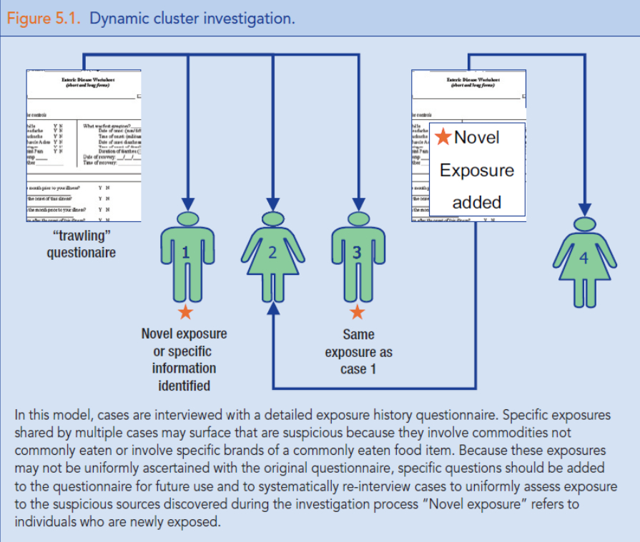
On the basis of this information, investigators can identify possible exposures for further evaluation by epidemiologic, laboratory, or environmental studies. These should include the review specific information about establishments/products of interest:
- Guest lists for common events reported by cases
- Historical information on firms or food items of interest
- Recipe and ingredient lists for common menu items
- Shopper card data to compare grocery store purchases
In practice, the generation and testing of hypotheses is an iterative process, with the hypothesis modified as more information is obtained.
Maintain open communication between public health and regulatory partners to discuss new or updated information on the epidemiological investigation and food/establishment findings

  - . Sub-cluster investigations.
When a group of cases within a cluster identifies exposure to the same individual points of service such as a restaurant, cafeteria, or institution, this group of cases is termed a sub-cluster and represents an invaluable opportunity to solve the outbreak; because the outbreak vehicle was most likely served by the common establishment. Thus, sub-cluster investigations represent a hybrid of hypothesis generating and hypothesis testing approaches, and serve as a useful model of the general approach to outbreak investigations.
All available resources should be committed to rapidly and comprehensively investigate such a sub-cluster because of the high chance for success of the investigation. If resources are not available to conduct an investigation fully and rapidly, assistance should be sought from other agencies.
Ascertain additional cases associated with sub-cluster locations. In their initial interview, all newly identified cluster cases should be asked to identify all dining locations eaten at during the exposure period.

Cases often do not recall eating at some locations outside the home when asked open ended questions on initial interview (e.g., “What restaurants did you eat at?”). All newly identified cluster cases should be asked specifically about the list of dining location named by previous cases.

Once a sub-cluster is identified, cases that were previously interviewed should be re-interviewed, and asked specifically about the sub-cluster establishment. All newly identified cluster cases should be asked specifically about the sub-cluster establishment during their first interview.

- Cases should be asked to check credit/debit card statements to improve recall. It is very important to pinpoint the meal date to the extent feasible (if a receipt or credit card statement is not available, record how confident the case is about the meal date).
- Additional sub-cluster cases may be ascertained by contacting additional patrons of the sub-cluster establishment (e.g., via credit card receipts, on-line orders, or reservations).
Gather detailed food consumption data for sub-cluster cases.
- Sub-cluster cases should be interviewed using the sub-cluster venue’s menu, or a more defined menu if an event cohort with a limited, discrete menu is identified.
- Ask cases about additions or subtractions to the menu item(s) they ordered.
- The establishment manager and/or chef should be interviewed to obtain ingredient lists for menu items.
- A frequency distribution of ingredients consumed by cases should be compiled. Include every ingredient consumed by at least one case.

Conduct an analytical study at the sub-cluster establishment. An ingredient specific case-control study should be conducted. There is no rule as to a minimum # of cases necessary to initiate such a study, but it is reasonable to do so with as few as 3 cases.
Identify additional cases and enroll controls by:
  - Asking cases for meal companions.
  - Getting credit card receipts, reservation lists, take-out orders, and/or lists of workers or students (if a cafeteria) for patrons who dined at the establishment on the implicated meal dates.
Ascertaining additional cases (and increasing the number of controls) increases the likelihood of meaningful results and the confidence you can have in those results.
          - Make the clinical case definition specific for the pathogen of interest (e.g., for Salmonella use “fever and diarrhea” or “diarrhea duration >3 days”). This will minimize the likelihood that unrelated illness will dilute associations.
          - Include every plausible ingredient in the study. Be systematic - don’t focus solely on one or two ingredients that were commonly reported by cases. Some ingredients (e.g., spices, garnishes) may be used in multiple menu items and thus could be overlooked.

Trace back suspected vehicle(s). If there are multiple sub-clusters (i.e., multiple points of service), trace back ingredients implicated in analytic studies or, if analytic studies cannot be done, those that were most frequently consumed by cases. Do not exclude food ingredients from an analytic study based on apparent differences in distributors for ingredients used by the sub-cluster establishments, as commonalities in the source of food items might not occur until farther back in the distribution chain.
Link sub-clusters in multi-state outbreak to look for common distribution links between establishments (possible even if too few cases to do case-control study).
5.4. Testing hypotheses and evaluating evidence.
Much of the work of outbreak investigations involves developing sound hypotheses that explain the patterns of illnesses observed, and point towards effective control measures (Chapter 6). Because the effectiveness of control measures depends on how clearly the source of contamination can be described, detailed exposures are critical. This is important regardless of the choice of analytic study use to test the hypothesis.
Analytic studies; characteristics, use and limitations.
- Cohort study
Cohort studies are limited to outbreaks with defined exposure settings in which exposed persons can be identified without respect to illness status. For example, a banquet with a defined guest list. In cohort studies, persons are interviewed without respect to their illness status. This allows for determination of attack rates that can be used to assess the magnitude of the outbreak and calculation of relative risks for individual exposures. Because many of these settings involve a defined menu and guest list, it may be possible to develop an on-line survey to rapidly collect illness and exposure information.
- Case- community control study
Case-community control studies are a classic staple of outbreak investigations. Comparing food exposures among cases in an outbreak to those among healthy control subjects has great power to identify foods that are associated with the illnesses. For example, in a nationwide outbreak of Salmonella associated with commercially-distributed ice cream, the source was identified based on interviews of 15 cases and 15 community controls. While results of the case-control study implicated an exposure source within three days, regulatory testing to confirm the source of contamination required an additional 10 days.
Having a stringent case definition is important to reduce the likelihood of including unrelated cases in the study. Because unrelated cases would not share the same exposure source, they would reduce the apparent odds ratio, and make it difficult to implicate the exposure source. WGS subtyping allows for very stringent case-definitions. Along with specific case definitions, having detailed exposure source information is critical.

Despite their empirical usefulness, large community-based case-control studies are no longer routinely conducted in outbreak investigations. It is increasingly difficult to recruit suitable controls because of changing demographics of telephone use. Thus, they have become too expensive to conduct, and are too slow to produce actionable results in a timely manner.
Case- case comparison studies
Case- case comparison studies provide many of the same benefits as do case-community control studies, but are logistically easier to conduct. Molecular subtype-specific surveillance based on PFGE, or WGS, makes it possible to compare cases caused by an outbreak-associated strain with cases caused by unrelated strains. Because cases caused by unrelated strains will have many different sources of exposure, they make a very efficient control group. When sporadic cases are routinely interviewed with detailed food exposure questionnaires, case-case comparison studies can be conducted using available data. For example, in the 2011 outbreak of listeriosis identified by the Colorado Department of Public Health and Environment, cantaloupe was implicated by comparing exposures from reported outbreak-associated cases to aggregated exposures of nationally reported cases collected by CDC’s Listeria Initiative.
Case-case comparisons produce the same measures of association as do case-control studies and are interpreted in the same way. The increased stringency of WGS to discriminate outbreak-associated from unrelated cases makes case-case comparisons a desirable alternative to case-control studies when aggregate case exposure data are available.
Case series with binomial exposure assessments
The use of case series with binomial exposure assessments was pioneered by Bill Keene at the Oregon State Health Department, who also developed a simple binomial calculator to test the significance of differences between case and population exposure proportions. Like the other analytic study methods, it requires that outbreak-associated cases are systematically interviewed using a detailed exposure questionnaire. However, instead of comparing case exposure histories to community controls or unrelated cases, the case exposures are compared to an expected value based on population survey data. FoodNet’s Atlas of Exposures has been the most commonly used source of population exposure data. However, the timeliness and geographic representativeness of 2006 Atlas data limits its usefulness. Identifying current, local population exposure data is preferred.
The binomial comparison functions as advanced hypothesis generation. It identifies associations that must be confirmed by product source tracing and corroborated by other investigation findings. Because binomial comparisons emulate very large case-control studies, results must be cautiously interpreted to avoid spuriously significant results that could lead to errors in identifying the source of an outbreak.
For all analytical studies the significance of results is dependent both on the strength of the association and the size of the study. Thus, studies with large numbers of cases are more likely to yield statistically-significant results. However, the goal of outbreak investigations is to rapidly identify the source to prevent additional cases. In this regard WGS will improve the efficiency of these studies by providing very specific case definitions. Increasing the specificity of food exposures will similarly increase the efficiency of the study. However, with WGS, the expected increase in small cluster investigations will limit the usefulness of any of these study designs to produce “significant” results. For clusters involving fewer than 5 cases, product source tracing and corroborating evidence will be needed to confirm the source.

Product Tracing
      - Tracing the source of food items or ingredients through distribution to source of production can be critical to identifying epidemiologic links among cases or ruling them out. For nonbranded commodities, such as produce items, the convergence of multiple cases along a distribution pathway may identify the source of contamination. Once the source is identified, tracing product forward through distribution can help identify additional cases or help remove contaminated product from the market place. Product tracing is an important investigational tool to inform the epidemiological investigation, test the hypothesis, and control the outbreak. There are two types of product tracing tools that can be used to investigate outbreaks. Traceback investigations are used to trace a product suspecting to cause the outbreaks through the supply chain to see if it converges on a common source or supplier. Once a common source or supplier of the contaminated product is identified, traceforward investigations are used to determine other locations that received the contaminated product[IK1] . Both tracefoward and traceback activities can be conducted as informational or regulatory endeavours. Informational product tracing needs to be conducted quickly to be incorporated into the epidemiologic studies. Formal regulatory product tracing may be subsequently needed to confirm the distribution of implicated products.

Traceback Investigations
          - Traceback investigations begin at the point of service where a case was exposed to the product. If two or more cases report the same point of service, important information must be collected from this sub-cluster so a traceback investigation can be initiated.
          - Traceback investigations can be initiated anytime multiple sub-clusters are thought to be related. Ideal sub-clusters to include in a traceback investigation contain four or more confirmed cases with the following information: precise illness onset dates, exposure dates to the product of interest, limited number of exposures to the product of interest, and relative certainty about what foods were eaten prior to illness onset. A sub-cluster that does not contain all ideal information should not be ruled out for traceback as it may provide useful information.
          - Many traceback investigations are initiated after the epidemiological investigation has identified a single vehicle of interest. These regulatory tracebacks allow for detailed record collection and documentation of the product of interest through the supply chain. While this method is an important tool, waiting for the results of the epidemiological investigation prior to initiating the traceback can take time and reduce the speed of the overall investigation. To combat this, traceback investigations are also initiated prior to completion of the epidemiological investigation.(Cite Smith Whitepaper) Informational, or epidemiological, traceback investigations are conducted to help inform the epidemiological investigation and narrow the number of products of interest. Record collection for informational tracebacks may not include the typical documentation and site inspection follow-up performed in regulatory tracebacks. As informational tracebacks progress and a single product of interest is identified, regulatory traceback can be performed if necessary to assist in confirming the vehicle.

          - Once a traceback is initiated, specific information is necessary from both the cases within the subcluster and the point of sale.

As the traceback continues, firm types will change and questions about the handling of the product of interest, timeframes, and available record will need to be amended accordingly.

          - Information collected from each subcluster serves as one “leg” of the overall traceback investigation. Distribution[IK2] chains from multiple traceback legs are documented and compared to identify any commonalities. Convergence of multiple legs of a traceback on a specific facility assist in targeting resources for environmental assessments, inspections, and/or sampling. In addition, information from the traceback are continuously evaluated as part of the evidence for the overall outbreak investigation and convergence reinforces the hypothesis generated by the epidemiological investigation.

          - Traceback investigations continue until the product of interested is followed as far back through the supply chain as possible. Interpretation of the traceback can be challenging, and should not be done without consideration of the epidemiological, laboratory, and environmental information collected during the investigation. If no convergence on a single supplier is identified, evaluation of the hypothesis should be conducted. Tracebacks are challenging and can be limited by poor record-keeping, lack of common product identifiers through the supply chain, co-mingling, and many other factors. Due to these challenges, lack of convergence of a traceback does not singly rule out a vehicle as the source of the outbreak.
Important Information for Traceback Initiation
Subcluster Information
• Exposure dates to product at point of sale
• documentation of purchase of product (credit card, shopper card, etc.)
• Identification of specific menu items or purchases

Point of Sale Information
• List of ingredients in menu items or purchases of interest
• Information on how the product is handled in the facility
• Determine how frequently the product of interest is ordered by the point of sale
• Determine how the point of sale handles shipments and documents receipt of the product of interest
• Identify all suppliers of the product of interest to the point of sale
• Determine the timeframe of interest for distribution record collection by considering case exposure dates, product shelf life, shipment frequency, and any other pertinent factors
• Collect distribution records (invoices, order forms, bills of lading, etc.) for the timeframe of interest that are available at the point of service. Record any gaps or concerns in record keeping

Traceforward Investigations
          - Tracing products forward in the supply chain can determine where contaminated products were distributed and allow for the removal from the supply chain. Chapter 6 (Insert Section) will discuss the utility of traceforward investigations in assisting with the recall of products from the market.
Traceforward investigations are also an important tool to identify additional cases that were exposed to contaminated products. In the hypothesis testing phase of an outbreak investigation, tracing a suspected product forward can identify additional points of sale that received the suspect product. These points of sale can be linked to additional clinical cases, adding further confidence in confirming the suspect source[IK3] .
    - Communication of product tracing information
      - Product tracing efforts are always multijurisdictional and require strong collaboration between public health and regulatory agencies. Predetermined lines of communication should be in place to effectively move information between the necessary parties. Updates on the epidemiological investigation being conducted by the public health agency may greatly impact the traceback being conducted by the regulatory agency, and vice versa.
      - Special considerations need to be given to distribution information collected by regulatory agencies, as it may be protected from disclosure by confidentiality agreements. Investigational partners should have agreements in place to allow for the lawful exchange of the information. Please see Chapters 3 and 7 for[IK4] those considerations.
  - Laboratory Testing of Products and Environments
    - Clinical Sampling Considerations during Outbreak Investigation
      - Laboratory surveillance of clinical pathogens is a powerful tool in identifying clusters and outbreaks for further investigation (see Chapter 4). Pulse-field gel electrophoresis (PFGE) has been the gold standard method for conducting molecular subtyping on bacterial foodborne pathogens since the early 1980s. Presently, public health laboratories across the country have initiated the use of Whole Genome Sequencing (WGS). WGS is an advanced molecular subtyping tool that compares entire bacterial genomes to determine how closely strains are related. This advanced technology has been driving Listeria monocytogenes investigations, allowing for detection of more clusters, but each cluster contains few cases (Reference Jackson paper).

WGS has successfully broken apart or pulled together cluster defined by PFGE. This increased specificity provided by this laboratory method improves cluster investigations in the following ways:
- Epidemiological Investigations
  - Rules out unrelated case that may interfere with analysis of exposure data
- Traceback Investigations
  - Prevents unrelated cases from being included in the traceback investigation
  - Expansive database of bacterial pathogens can assist in generating hypothesis about the geographic source of the contaminated product (Site Hoffman/Allard paper on Barielly)
Performing WGS on clinical samples, especially when PFGE has not provided much clarity, improves the ability to successfully investigate clusters and outbreaks.
      - If surveillance techniques have identified a cluster of illness or outbreak with an unidentified etiology, laboratorians should refer to CIFOR’s OUE tool found at XXXXXX (Insert Link). Information from this table can help begin the process of ruling in and out pathogens, toxins or other potential contaminants.
    - Food and Environmental Sampling during Outbreak Investigations
      - Targeted sampling of food items and environments of interest in the outbreak investigation are a key tool in confirming the food causing illness. Targeted sampling occurs when partners working on the epidemiological and traceback investigations work together to share information products and firms of interest.
Sampling products of interest early in the epidemiological investigation can help quickly bring an investigation together, especially if the products of interest are shelf stable. In 2017, soy nut butter reported by cases associated with an outbreak of E. coli O157:H7 was sampled by local and state authorities. The positive samples generated by that early sampling was used as evidence to suspend the registration of the facility manufacturing the product (Site reference). Not all product sampling occurs at the outset of an investigation. Traceback investigations can identify locations along the supply chain to collect samples, which can then confirm the vehicle[IK5] .
Epidemiological and traceback information also helps inform locations where environmental sampling may be appropriate. Pathogens such as Salmonella spp. and Listeria monocytogens are known to persist in manufacturing and processing environments. Identification of a pathogen in a processing environment that is related to clinical cases provides support for confirmation of the outbreak vehicle.
WGS is also being used to perform molecular subtyping on pathogens recovered from foods and environments impacting foods. The high resolution of WGS increases confidence in the relatedness of pathogens from products and environments to clinical samples. Historical food or environmental samples that are closely related by WGS can launch retrospective outbreak investigations, in which laboratory evidence from the products or environments drives the epidemiological investigation. Retrospective outbreak investigations often lead to the swift identification of the outbreak source[IK6] .
- Finding contamination sources.
  - Introduce and define terminology for EAs and inspections
    - When a food production, food processing, or food service establishment has been identified as being associated with an illness outbreak, environmental health and regulatory officials can conduct environmental assessments or regulatory inspections. Differences between environmental assessments and routine inspections are highlighted in Table XXXXX.
Routine Inspection |  | Environmental Assessment
- Non-Targeted  - Regularly scheduled  - Snapshot of current day  - Code/regulation-based  - Assess current conditions  - Identify violations |  | - Targeted  - In response to an outbreak  - Focuses on the past  - Outbreak information-based  - Examine processes and problems during outbreak period  - Identify system failures  - Identify underlying factors that allowed for the system failure

  - Environmental Assessments
    - An environmental assessment is a systematic, detailed, science-based evaluation of environmental factors that contributed to the introduction and/or transmission of agents that cause a disease in an outbreak. Environmental assessments are conducted in response to an outbreak and address the specific food and process(es) that occurred in the past to identify the cause of the outbreak. The environmental assessment is guided by epidemiologic and laboratory information and examines how the causative agent, host factors, and environmental conditions interacted to result in the system failure and people becoming ill.
    - The goals of an environmental assessment are to identify:
- Contributing factors
  - Factors that introduce or otherwise permit contamination and relate to how the agent got onto or into the food vehicle.
  - Factors that allow proliferation or growth of the agent and relates to how the bacterial agents could increase in numbers and/or produce toxins prior to the vehicle being ingested.
  - Factors that allow survival or fail to inactivate the contaminants and refer to processes or steps that should have eliminated or reduced the microbial agent.
- Environmental antecedents that allowed the system failure to occur
  - Assessing the internal system components (e.g. people, equipment, processes, foods, and economics) and their effect on allowing the system failure to occur
    - There are five main steps in conducting an environmental assessment:
- Planning and Preparation: Members of the outbreak investigation team review epidemiological information, product tracing information, laboratory results, and food facility information. Roles and responsibilities, intended outcomes, sampling plans and ways the team will communicate during the site visit should be determined at this step.
- Site Visit: Observations are made of the facility and practices are evaluated. Records and samples pertinent to the investigation are collected. Information that can be collected as part of the visit includes:
  - Flow diagram of how food moves through the establishment,
  - Policy and procedures in place at the establishments and interviews with responsible parties on execution of policies and procedures,
  - Ill employee records,
  - Sales records for the suspected food item,
  - Employee interviews,
  - Product coding and distribution information if food is suspected to arrive at the facility contaminated.
- Assess Information: Information is reviewed to identify the outbreak's contributing factors and environmental antecedents.
- Recommend Preventive Control Strategies: Control strategies reflect steps that should be taken immediately to stop the outbreak and prevent the further spread of this agent. Longer term strategies are important for reducing the likelihood of any future outbreaks at this type of establishment (see Chapter 6).
- Complete the Report: A summary of the findings is prepared and should include detailed diagrams, descriptions and results. This report should be incorporated into the outbreak investigation report.
    - The timing of an environmental assessment depends largely on the specifics of the outbreak and available information but should be initiated as soon as possible (ideally an initial site visit within 24-48 hours of the identification of the establishment.) Early investigation and collection of food and environmental specimens will best reflect the conditions at the time of the outbreak. In addition, possible food vehicles can be discarded or grow old, and persons involved in the production, processing, storage, transportation, or preparation of the item can change their practices and procedures. If investigators have identified a common location and a profile of symptoms among ill persons that indicates whether the disease agent is likely to be viral, bacterial, toxin, or chemical, they often can begin an environmental assessment based on possible factors more likely to be associated with that disease agent. As more information becomes available, the investigator may need to make additional trips to the establishment to investigate the additional lines on inquiry.
  - Routine Inspections
    - Routine inspections are conducted by regulatory officials and focus on assessing current onsite conditions at a firm against regulatory requirements. Routine inspection activities are typically scripted and follow guidelines outlined by local, state, or federal regulations. While environmental assessments are preferred to routine inspections to identify contributing factors to the outbreak, information from these regulatory based inspections can be useful and necessary to take a regulatory action on a firm.
  - It is important to share results of the inspections and environmental assessments with the outbreak investigation team. This information may change the course of the investigation, or confirm the suspected food item causing the outbreak. Of note, sharing findings on the contributing factors and environmental antecedents that led to contamination with industry partners is key to improving hazard identification and implementing control measures. https://www.foodprotection.org/publications/food-protection-trends/archive/2018-03-leveraging-current-opportunities-to-communicate-lessons-learned-from-root-cause-analysis-to-/

- Coordination of Epidemiological, Traceback, and Sampling Activities
  - Whether the outbreak is restricted to one jurisdiction or involves multiple jurisdictions, notification and updates should be provided to other interested agencies following the Guidelines for Multijurisdictional Investigations.
Arrange for outbreak control team to meet daily and to regularly update the entire outbreak control team. In particular, if the outbreak has gained public attention, the public information officer needs to prepare a daily update for the media.
During investigation of outbreaks involving events or establishments, maintaining close collaboration between epidemiology and environmental health is particularly important. Interview results from persons who attended the event or patronized the establishment will help environmental health specialists focus their environmental assessments by identifying likely agents and food vehicles. Similarly, results of interviews of food workers and reviews of food preparation can identify important differences in exposure potential that should be distinguished in interviews of persons attending the event or patronizing the establishment. For example, environmental health investigators might determine that food items prepared only on certain days or by certain food workers are likely to be risky. These refinements also can help establish the need for or advisability of collecting stool samples from food workers or food and environmental samples from the establishment.
During the earliest stages of the investigation, patrons need to be interviewed rapidly. However, the focus of outbreak activities is likely to shift to interviews of food workers, environmental evaluations of the establishment, and review of food-preparation procedures as the investigation progresses.
During investigation of outbreaks detected by pathogen-specific surveillance, the public health laboratory needs to immediately forward case information to epidemiologists for every new potentially outbreak-associated case they receive. This will ensure rapid enrollment of new cases in the outbreak investigation studies. Similarly, as investigators acquire information from cases about exposures in restaurants and other licensed facilities, they should rapidly forward that information to environmental health specialists to ensure rapid identification of commodity ingredients and their distribution sources.
During the early stages of an investigation, efforts to identify mode of transmission and food vehicle require close coordination of the outbreak team under the leadership of epidemiology. After identification of a likely food vehicle, efforts to identify the source of contamination and contributing factors require engagement of local, state, or federal food-regulatory programs. As the investigation proceeds, the outbreak control team should always consider whether any information indicates the outbreak might be multijurisdictional. See Chapter 7 for information about identifying and responding to multijurisdictional outbreaks.
- Evaluation of Information from Epidemiological, Traceback and Sampling Efforts
  - Compile results of outbreak investigations in a manner that allows comparisons with the original goals for the investigation. State the original goals of the investigation and demonstrate how each goal was achieved; if the goal was not achieved, explain why. For example, in an investigation of an outbreak of vomiting and diarrhea associated with a restaurant, document the steps taken to identify the agent. These could include identifying the number of stool specimens collected, determining the intervals between onset of symptoms and collection of stool and between collection of stool and processing by the public health laboratory, identifying the methods used to culture or test the specimens, and determining the results of the tests.
Prepare epidemic curves, and update them daily to depict the beginning and end of the outbreak. Continued motion of successive epidemic curves, day by day over time, clearly indicates continuation of the outbreak (Box 5.1). Select time scales for the epidemic curve to highlight the agent, mode of transmission, and duration of the outbreak. Notable events, such as changes in food-processing methods or personnel or implementation of control measures, can be noted on the curve. Generating an accompanying timeline of the investigation’s events as they happen often can be helpful. Product tracing diagrams and product/environmental sample tracking sheets should also be updated regulatory and shared across partners in the outbreak investigation. It is important to display information from all lines in a clear, concise way to assist in interpretation of the findings.
Novel questions or opportunities to address fundamental questions about foodborne disease transmission can develop during the outbreak investigation. The opportunity to address these issues might require reevaluation of the investigation’s goals.
b. Interpreting Results
The outbreak investigator’s job is to use all available information to construct a coherent narrative of what happened and why. This begins with the initial detection of the outbreak and formation of hypotheses based on the agent’s ecology, microbiology, and mechanisms of transmission in addition to the descriptive epidemiology of reported cases. Results of subsequent analytic studies (e.g., cohort or case-control study results) must be integrated with results of product tracing, food worker interviews, environmental assessments, and food product and environmental testing. When all of these data elements support and explain the primary hypothesis very strong conclusions can be drawn. Chapter 6 will discuss control measures that are implemented when sources of outbreaks are identified.
Identifying and exploiting less-obvious data sources may require some imagination. Interview questionnaires are a critical starting point, but often do not provide all the answers. For example, when cases are associated with institutional settings or restaurants, it may be necessary to use the institution rather than the case as the unit of observation. Cross-referenced lists of suppliers and food items at different institutions may be more difficult to assess statistically because of their small numbers, but they can help focus commercial product-type investigations. Similarly, relevant restaurant records include much more than menu lists.
Investigators should consider their data critically and question the strength of the association, timing, dose-response, plausibility, and consistency of findings when implicating a food item (Box 5.2). Questionnaire data are often faulty: collected long after the fact, perhaps by proxy, and sometimes tainted by biases known and unknown. Investigators can create or compound errors during transcription, keypunching, or analysis. Records are often incomplete or unavailable. Without a systematic bias, larger data sets tend to be more robust; and minor errors may be cancelled out (or ignored), but the size of the data set is often beyond one’s control. Statistical association between exposure and illness may reflect a causal link but also may reflect confounding, bias, chance, and other factors. If three food items on a questionnaire have a P value <0.05, for example, it does not mean that all three (or indeed, any of them) are “implicated” as a vehicle. Conversely, the failure to achieve a P value <0.05 cannot rule out a causal role for a particular food item. As noted above, observed associations have to be placed in the context of the other investigation results.
Results of the product tracing investigations must be critically evaluated with the epidemiological and laboratory data. Traceback investigations that are not tuned closely into the epidemiological investigation could still find common sources, but of the wrong product. It is important to understand the limitations of the specific traceback investigation being conducted to determine its weight as a tool for confirmation of the vehicle. For instance, in localized outbreak investigations, all sub-clusters included in the traceback may be supplied by a common distribution center. This distribution center would be supplied by the same sources, limiting the ability of the traceback to triangulate a single source. In fact, multiple foods served at the sub-clusters would likely have come from common suppliers. In this instance, it is important to pair the traceback to the epidemiological data and any sampling data to confirm the source of the outbreak.
Although epidemiologists should be open to new developments and new twists to old problems, they should be wary of explanations that depend on implausible scenarios. For example, truly localized outbreaks are unlikely to result from manufacturing defects in nationally distributed products. Outbreaks that differentially affect young children are unlikely to be caused by salad items. Salmonellosis cases are unlikely to become symptomatic within 12 hours of exposure. Minor inconsistencies are common and may be ignored, but large numbers of inconsistencies might indicate that alternate hypotheses need to be considered.
General principles underlie successful investigations; however, no one specific method works best in all situations. Investigators need to be flexible and innovate as circumstances demand. On one point we can agree: investigations that are never begun or that are haphazardly carried out are unlikely to yield satisfactory results. Jurisdictions that cannot commit resources to outbreak investigations themselves should do whatever they can to facilitate follow-up of their cases by other agencies (e.g., counties to states; states to other states or CDC).
Experience reminds us—again and again, unfortunately—that even seemingly well-executed investigations can be inconclusive. Small sample sizes, multivehicle situations, “cryptic” food items, foods with high background rates of consumption are only some of the factors that can reduce the effectiveness of standard epidemiologic methods and make investigations extremely difficult. The decision to stop an investigation depends on the gravity and scope of the outbreak and on the likelihood that it reflects an ongoing public health threat. Before giving up, extraordinary measures, such as home visits and mass testing of leftover products, may be worth considering.

- Investigation Close-Out and Reporting
  - Deciding an Outbreak is Over
Outbreaks end when cases are no longer detected or reported. Outbreak investigations can continue after the outbreak ends given product tracing and observations on practices at suspected firms may take longer to obtain. In addition, control measures need to be evaluated if the source of the outbreak was identified. For outbreaks where the source has not been identified, consideration to the prioritization of resources and expected outcome of the investigation should be considered before continuing investigational activities.
  - Recording data
    - At a minimum, document every outbreak investigation using a standardized form to facilitate inclusion in state and national outbreak databases (e.g., CDC’s form 52.13 or its equivalent).

Summary data should be reported nationally to CDC’s National Outbreak Reporting System (NORS) database. The usefulness of the reports depends on the quality and quantity of information submitted. Make every effort to complete both Part 1: Basic Information, and Part 2: Additional Information, and submit the information as soon as possible.
In addition, investigators are encouraged to submit preliminary reports of outbreaks while the investigation is ongoing. If submission is timely, these reports can help identify potentially related outbreaks occurring simultaneously in multiple places and facilitate further investigation of the outbreaks.

Routinely review and summarize data from these reports (e.g., in annual outbreak summaries) at the state and national level.

Larger or more complex investigations or investigations with significance for public health and food-safety practice demand a more complete narrative report and, potentially, publication in a peer-reviewed journal. Written reports should include the following:
- Background, including information about the outbreak setting, timing, and manner of detection, and an explicit statement of the goals of the investigation.
- Methods, including other agencies involved in the investigation, investigation methods, case definition, number of people exposed, number interviewed, number ill, number of stool samples collected, pathogens tested for in stools, and a high-level summary of the laboratory methods used.
- Results, including percentages of cases with fever, diarrhea, vomiting, and bloody diarrhea; median and range of incubation period and duration of illness; results of stool testing; food items or events associated with illness and odds ratio(s) or relative risks and confidence intervals for implicated food(s); all relevant findings from environmental investigations of establishments and food-preparation reviews; results of food worker interviews; and food worker stool culture results.
- Conclusions, including etiologic agent, discussion of transmission route, contributing factors, justifications for conclusions, and limitations of the study.
- Recommendations, including all specific recommendations for abatement of this outbreak and prevention of similar outbreaks. Summarizing events
  - Sharing Reporting Information
    - Make copies of the report available to all persons involved with the investigation, including:
- Investigation team members and their supervisors;
- Health department officials and press officers;
- Food-safety and regulatory agency officials and press officers;
- Health-care providers who reported cases; and
- Laboratorians who performed tests.

Also, distribute copies of the report to persons responsible for implementing control measures, including:
- Owners and managers of establishments identified as the source of the outbreak;
- Program staff who might oversee implementation of control measures or provide technical assistance; and
- Organizations or regulatory agencies that might develop or implement policies and regulations for which the investigation might have implications.
The report is a public record and should also be made available to members of the public who request it.
  - Conducting Post-Outbreak Debriefs
    - Encourage a post-outbreak meeting among investigators to assess lessons learned and compare notes on ultimate findings. These meetings are sometimes called a “hotwash” or “after-action review.” This is particularly important for multiagency investigations but also is important for single-agency investigations.
The post-outbreak meeting can be used to discuss what went right during the investigation, what went wrong, and potential investigational process improvements. In addition, the meeting can be used to discuss the contributing factors to the outbreak and if there are control measures, guidance or policy that should be reviewed to prevent similar outbreaks in the future.
Outcomes from the post-outbreak meeting should be documented and action items should be assigned. If long-term improvements are deemed appropriate, it is important to coordinate follow through of the item to ensure an agreed upon solution is implemented.

- References

[IK1]I’d like to add a figure/diagram showing the difference between traceforward and traceback.
[IK2]I’d like to include a generic representation of a traceback diagram.
[IK3]Optional: I can include an example of this.

In the 2011 Salmonella Barielly outbreak, three of the four restaurant clusters that were traced back converged on a common Indian tuna supplier. The connection to the fourth restaurant cluster wasn’t identified until a traceforward investigation was conducted and presented new information that was not previously available.
[IK4]Insert appropriate chapter references here.
[IK5]Optional example of S. Barielly outbreak and tuna sampling.
[IK6]Not sure how much Chapter 4 is going to discuss this, but wanted to mention here just in case.

Table 5.1
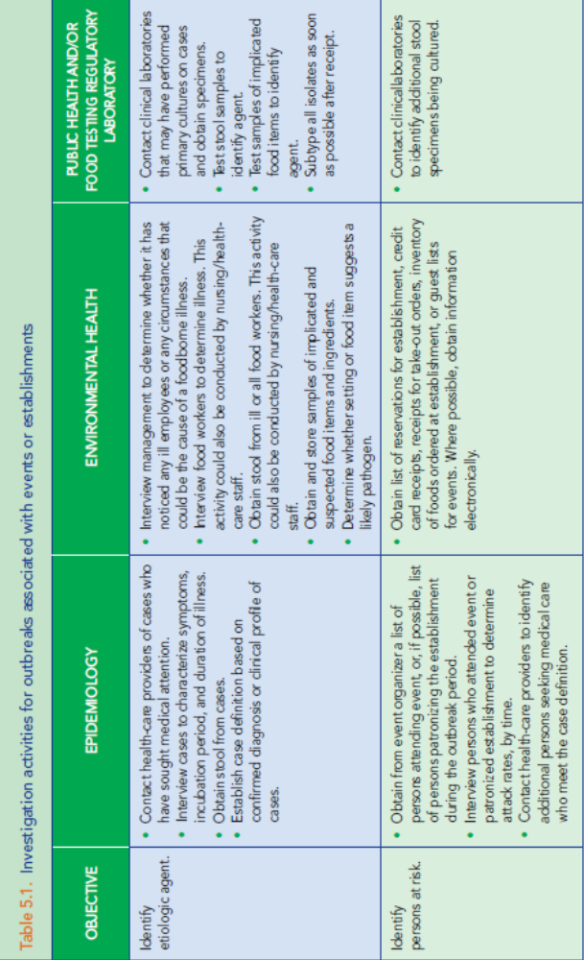
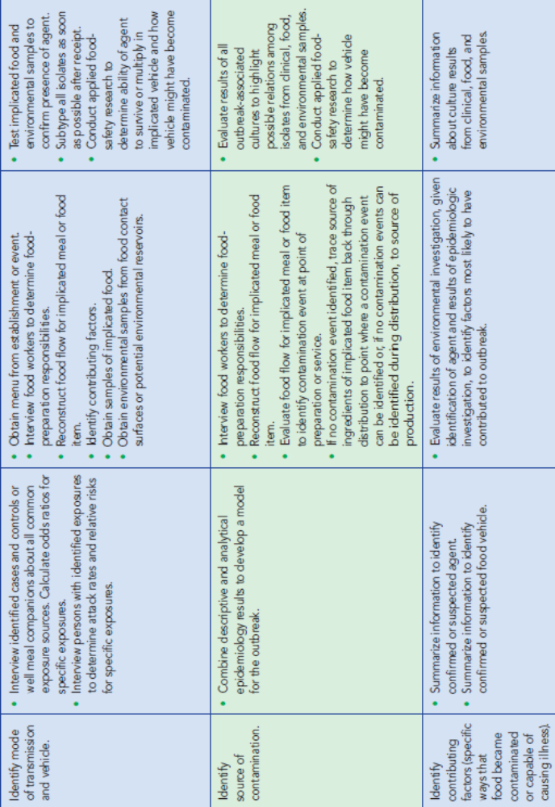
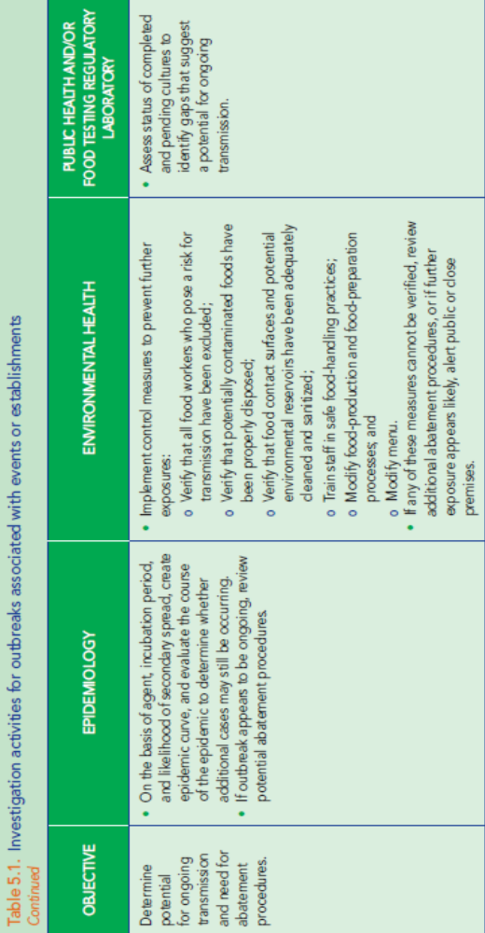
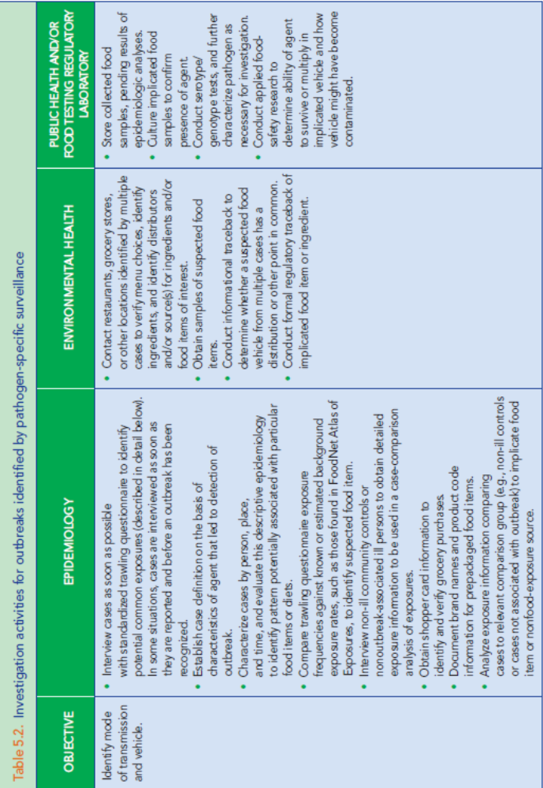
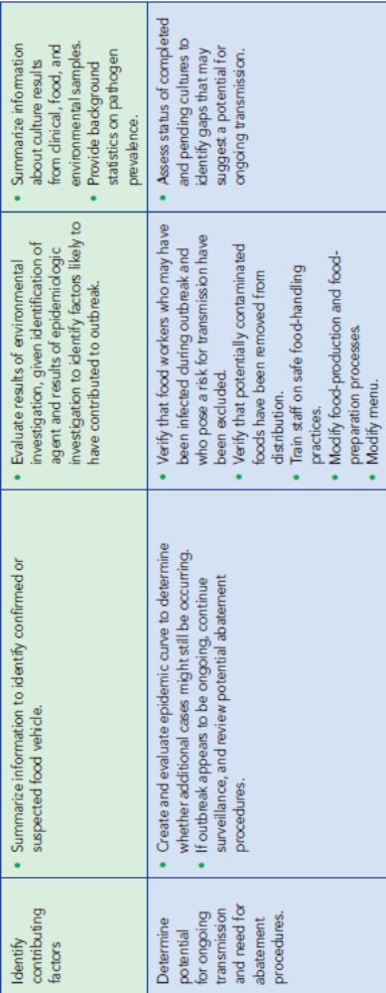

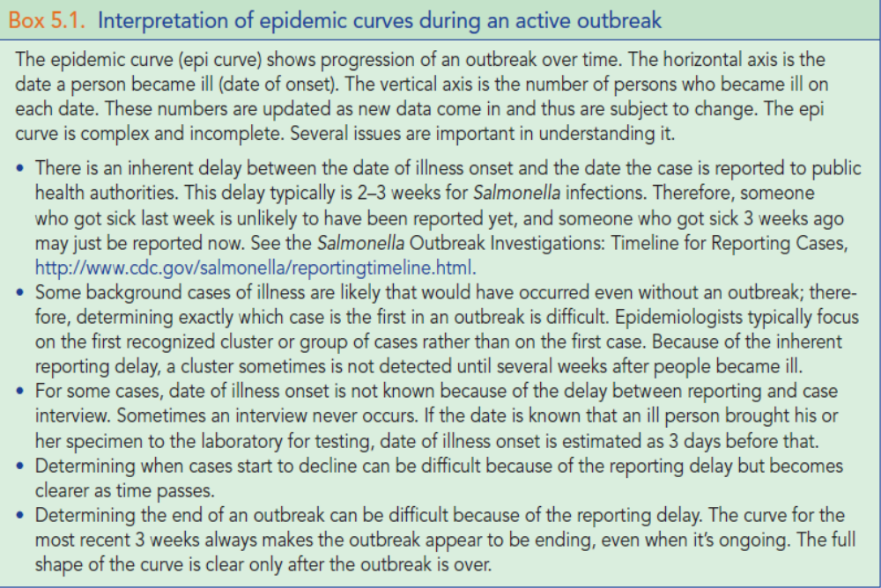

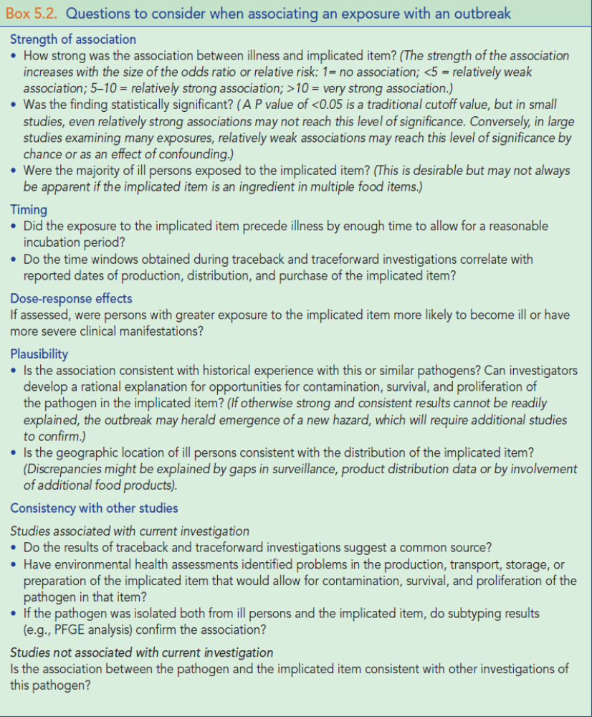

5.3. Multijurisdictional Considerations for Outbreak Investigations
Increased reliance of the United States on large-scale food distribution systems and international food sources has increased the likelihood of outbreaks in multiple jurisdictions. Local and state health agencies always need to be sensitive to the potential for rapid escalation of any outbreak to a regional or national event. (See Chapter 7).
5.4. Indicators/Measures
Key indicators and measures to assist in assessing investigation processes and the overall success of outbreak investigations can be found in Chapter 8.
Investigation leadership
Leadership of the investigation should reflect the focus of investigation activities and may change over time.
During an investigation, the focus of activities may shift among the following:
• Laboratory studies to identify an agent, including microbiologic studies and applied food-safety research;
• Epidemiologic studies to identify transmission routes, exposure sources, or food vehicles and risk factors for disease;
• Regulatory investigations of food-production sources and distribution chains to identify where, during production of the food, contamination occurred and facilitate recall of food items;
• Environmental evaluations of food production, processing, and service facilities to identify routes of contamination and contributing factors; and Communication of investigation findings to the public and the food industry to support control and prevention measures.

Consider moving to chapter 1 or 3
5.1.1. Importance of Speed and Accuracy
Speed and accuracy are the two key qualities of all outbreak investigations. The investigation team cannot afford to sacrifice one for the other. The team motto should be Fast and Right. The importance of speed and accuracy are illustrated below.
• “Removing the pump handle.”
Stopping an outbreak in its tracks and preventing illnesses are the most obvious goals of outbreak investigations. From this perspective, there are 3 types of outbreaks.
o A localized one-time event, such as a specific food-
preparation error or ill food worker at a food-service establishment. By the time these outbreaks are recognized, the event may be over. However, ensuring an ill worker does not continue to spread disease or preventing secondary spread of cases might be possible.
o Widespread distribution of a perishable
commodity, such as spinach or tomatoes. Because product may still be in the marketplace when the outbreak is detected, the faster the source can be identified, the more likely illness from exposure to that source will be prevented. Given the large quantities of contaminated product often involved in these events, even a limited recall could significantly benefit public health.
o Contamination of shelf-stable commodities,
such as canned or frozen foods or peanut butter, or persistent environmental contamination at a farm, food-processing facility, or restaurant. The speed with which the source is identified and the effectiveness of a recall are directly related to the number of people exposed to the contaminated commodity and the ultimate size of the outbreak.
• Preventing future outbreaks by identifying
the circumstances that led to contamination.
Without a prompt, complete, and accurate investigation, the circumstances that led to contamination may not be identified, and the opportunity to prevent future outbreaks will be lost.
• Identifying new hazards.
Outbreak investigations identify new agents, new food vehicles, new agent–food interactions, and other unsuspected gaps in the food-safety system. Prompt and thorough investigations while memories are fresh and specimens are available are much more likely to successfully rule out known hazards and identify new hazards. Presenting the information to the sector of the food industry involved can be critical for encouraging changes in procedures.
• Maintaining the public’s confidence.
Foodborne disease outbreaks undermine the public’s confidence in the food supply and in the public health system established to ensure food safety. Rapidly identifying outbreaks, determining their source, and limiting their scope are critical to restoring confidence in the food supply and food-safety system. On the other hand, inaccurate conclusions about the source undermine public confidence and harm food producers not involved in the cause of the outbreak. For example, strawberries from California were implicated as the source of a multistate outbreak of cyclosporiasis that actually was caused by raspberries from Guatemala. Media reports based on the erroneous conclusions led to millions of dollars in lost strawberry sales, even though the error was rapidly corrected. This situation probably could have been avoided if investigators had considered results from simultaneous investigations in other localities. Maintaining close communication and coordination among members of the investigation team and with other public health officials is the best way to avoid this type of error without delaying the investigation. See section 6.6.1 for additional discussion about the importance of collecting sufficient information before taking action.

• Empowering the public.
Even though releasing premature and incorrect conclusions to the public can be disastrous, and alerting the public about food-safety concerns too often can lead to warning fatigue, withholding or delaying the release of information the public may need to protect itself is inadvisable. Public health agencies are obligated to inform the public or others who need to know as quickly as possible. Generally, ask yourself,
o “Will the release of this information allow consumers to take steps to protect themselves?”
o “If the wrong product is identified, what will the negative impact be on public health, as well as on the industry and consumer confidence?”
and ultimately
o “Would I want my mother or grandmother to know about this hazard?”
5.1.2. Principles of Investigation
5.1.2.1. Outbreak detection
Outbreaks typically are detected through three general methods: pathogen-specific surveillance, notification/complaint systems, and syndromic surveillance (see Chapter 4). After receipt of a suspicious foodborne illness complaint associated with a particular event or establishment or the detection of an unusual cluster of isolates through pathogen-specific surveillance, conduct a preliminary investigation to determine whether the reported illnesses may be part of an outbreak. Preliminary investigations need to assess the epidemiologic context of the reported illnesses to determine whether they might be part of an outbreak.
5.1.2.2. Investigation leadership
Leadership of the investigation should reflect the focus of investigation activities and may change over time.
During an investigation, the focus of activities may shift among the following:
• Laboratory studies to identify an agent, including microbiologic studies and applied food-safety research;
• Epidemiologic studies to identify transmission routes, exposure sources, or food vehicles and risk factors for disease;
• Regulatory investigations of food-production sources and distribution chains to identify where, during production of the food, contamination occurred and facilitate recall of food items;
• Environmental evaluations of food production, processing, and service facilities to identify routes of contamination and contributing factors; and Communication of investigation findings to the public and the food industry to support control and prevention measures.
5.1.2.3. Communication and coordination
Coordinate activities and set up good lines of communication between individuals and agencies involved in the investigation. Guidelines for coordinating multijurisdictional investigations are summarized in Chapter 7. Investigations are rarely linear. Although most procedures for investigating outbreaks follow a logical process—from determining whether an outbreak is occurring to identifying and controlling the source—most actual investigations feature multiple concurrent steps. Maintaining close communication and coordination among members of the outbreak investigation team is the best way to ensure concurrent activities do not interfere with each other and important investigation steps are not forgotten.

Consider moving to Chapter 4
5.2.1. Conduct a Preliminary Investigation
5.2.1.1. For complaints of illness attributed to a particular event or establishment, the following questions should be answered:
• Are the incubation period and symptoms (or specific agent, if one or more cases has been diagnosed) consistent with an illness resulting from the reported exposure?
• Are multiple cases being attributed to the same exposure?
• Are all of the illnesses similar (suggesting all are the same disease)?
• Could these illnesses be reasonably explained by other common exposures?
If multiple cases of illness have incubation period and symptoms consistent with an illness resulting from the reported exposure, the complaints may represent an outbreak and need to be investigated.
5.2.1.2. For case clusters identified through pathogen-specific surveillance, the following questions should be answered:
• Is the number of cases with the cluster characteristics clearly more than should be expected during this time frame?
• Does the distribution of cases by demographics (e.g., age, sex, and ethnicity) or geography suggest a common source of exposure?
• Do cases share any unusual exposures?
• Do new cases continue to be detected, suggesting the potential for ongoing transmission and the need for abatement procedures?
If the number of cases in a cluster clearly exceeds an expected value, if the demographic features or known exposures of cases suggest a common source, or if new cases continue to be detected, the cluster may represent an outbreak and needs to be investigated. (See model practices for cluster investigation, below).

Whether the outbreak is restricted to one jurisdiction or involves multiple jurisdictions, notification and updates should be provided to other interested agencies following the Guidelines for Multijurisdictional Investigations.
Arrange for outbreak control team to meet daily and to regularly update the entire outbreak control team. In particular, if the outbreak has gained public attention, the public information officer needs to prepare a daily update for the media.
During investigation of outbreaks involving events or establishments, maintaining close collaboration between epidemiology and environmental health is particularly important. Interview results from persons who attended the event or patronized the establishment will help environmental health specialists focus their environmental assessments by identifying likely agents and food vehicles. Similarly, results of interviews of food workers and reviews of food preparation can identify important differences in exposure potential that should be distinguished in interviews of persons attending the event or patronizing the establishment. For example, environmental health investigators might determine that food items prepared only on certain days or by certain food workers are likely to be risky. These refinements also can help establish the need for or advisability of collecting stool samples from food workers or food and environmental samples from the establishment.
During the earliest stages of the investigation, patrons need to be interviewed rapidly. However, the focus of outbreak activities is likely to shift to interviews of food workers, environmental evaluations of the establishment, and review of food-preparation procedures as the investigation progresses.
During investigation of outbreaks detected by pathogen-specific surveillance, the public health laboratory needs to immediately forward case information to epidemiologists for every new potentially outbreak-associated case they receive. This will ensure rapid enrollment of new cases in the outbreak investigation studies. Similarly, as investigators acquire information from cases about exposures in restaurants and other licensed facilities, they should rapidly forward that information to environmental health specialists to ensure rapid identification of commodity ingredients and their distribution sources.
During the early stages of an investigation, efforts to identify mode of transmission and food vehicle require close coordination of the outbreak team under the leadership of epidemiology. After identification of a likely food vehicle, efforts to identify the source of contamination and contributing factors require engagement of local, state, or federal food-regulatory programs. As the investigation proceeds, the outbreak control team should always consider whether any information indicates the outbreak might be multijurisdictional. See Chapter 7 for information about identifying and responding to multijurisdictional outbreaks.
5.2.6. Compile Results and Reevaluate Goals for Investigation (see also Chapter 6, Control Measures)
Compile results of outbreak investigations in a manner that allows comparisons with the original goals for the investigation. State the original goals of the investigation and demonstrate how each goal was achieved; if the goal was not achieved, explain why. For example, in an investigation of an outbreak of vomiting and diarrhea associated with a restaurant, document the steps taken to identify the agent. These could include identifying the number of stool specimens collected, determining the intervals between onset of symptoms and collection of stool and between collection of stool and processing by the public health laboratory, identifying the methods used to culture or test the specimens, and determining the results of the tests.
Prepare epidemic curves, and update them daily to depict the beginning and end of the outbreak. Continued motion of successive epidemic curves, day by day over time, clearly indicates continuation of the outbreak (Box 5.1). Select time scales for the epidemic curve to highlight the agent, mode of transmission, and duration of the outbreak. Notable events, such as changes in food-processing methods or personnel or implementation of control measures, can be noted on the curve. Generating an accompanying timeline of the investigation’s events as they happen often can be helpful.
Novel questions or opportunities to address fundamental questions about foodborne disease transmission can develop during the outbreak investigation. The opportunity to address these issues might require reevaluation of the investigation’s goals.
5.1.2.6. Privacy of individuals, patients and their families.
All outbreak investigations involve collection of private information, such as names and symptoms that must be protected from public disclosure to the extent allowed by law. All members of the investigation team, including epidemiologists, laboratorians, environmental health specialists, and food-safety personnel, need to be familiar with and to follow relevant state and federal laws and practices, including the Health Insurance Portability and Accountability Act (HIPAA).

