Chapter 5 Cluster and Outbreak Investigation
Chapter Summary Points:
- Outbreak investigations are conducted to rapidly identify the source of contamination and take action to prevent additional illnesses. This requires effective and timely integration of three types of data:
  - Epidemiologic data that describes illness distributions and analyzes common exposures
  - Traceback and environmental assessment data that identifies common contamination points in the distribution chain
  - Food and environmental testing data that identifies outbreak-associated strains in implicated foods or in environmental samples linked to the foods
- How a potential outbreak of foodborne illness is initially recognized will determine approaches taken to investigate (see Chapter 4).
  - Complaints identifying multiple illnesses associated with a common event or establishment will lead to an investigation to identify the agent and the mode(s) of transmission.
    - While most of these will be local investigations, some will represent sub-clusters of larger, multi-jurisdictional outbreaks (see Chapter 7).
  - Clusters of cases identified through laboratory-based surveillance at the local or state level will lead to investigations to determine the mode of transmission or source of contamination.
    - Multi-state clusters of these cases suggest a commercially distributed food source (see Chapter 7).
  - Identification of a foodborne pathogen in a commercially-distributed food product will lead to a search for illnesses caused by the same organism and an investigation to determine whether the food item was the source of the illness.
- A priority for all investigations is to establish the basis for implementing control measures to stop transmission and prevent additional illnesses (see Chapter 6).

5.0 Introduction
5.0.1 Because outbreak investigations can help prevent illnesses, this chapter is intended to help guide investigators through the various steps of an investigation with speed and accuracy.
Briefly, these include (see Figure 5.1):
- Detecting a possible outbreak (see Chapter 4)
- Defining and finding cases
- Generating hypotheses about likely sources
- Testing hypotheses and evaluating evidence
- Finding contamination sources
- Controlling the outbreak (see Chapter 6)
It is important to note that outbreak investigations are dynamic. This means that multiple steps may happen at the same time. In addition, as the outbreak investigation progresses, steps may need to be repeated.
When a potential foodborne illness outbreak is first detected or reported, investigators will not know whether the illness is foodborne, waterborne, or attributable to other causes. Investigators must keep an open mind in the early stages of the investigation to ensure that potential causes are not prematurely ruled out. Even though these Guidelines focus on foodborne illness, many of the investigation methods described in this chapter apply to a variety of enteric and other illnesses, regardless of source of contamination.
5.0.2 This chapter highlights recent developments in laboratory and epidemiologic methods and their impact on cluster and outbreak investigation methods.
- Whole genome sequencing (WGS) used by public health laboratories increases the specificity of pathogen-specific surveillance, making it more likely that cases with the same DNA fingerprint share a common source (see Chapter 4). In addition, WGS will increase confidence in the relationships between pathogens isolated from food/environments and historical samples. This provides better opportunities to identify outbreaks through food and environmental surveillance sampling. However, WGS may increase the timeline for public health laboratories to characterize foodborne pathogens and identify clusters of cases that warrant investigation.
- Culture-independent diagnostic tests (CIDT) used by clinical laboratories provide rapid test results but require reflex culture to produce an isolate for WGS. CIDTs may increase the number of cases reported and decrease the timeline from onset of illness to report, but also reduce the proportion of isolates available for WGS and increase the timeline for conducting WGS. CIDTs used by public health agencies may enhance additional case finding in an outbreak investigation by providing rapid identification of the agent in stools from suspected cases.
- Enhanced use of novel exposure assessment methods streamline epidemiologic investigations to identify common sources for clusters and determine whether they constitute foodborne outbreaks.
For purposes of outbreak reporting, the National Outbreak Reporting System (NORS) distinguishes the definitions of an outbreak and a cluster as follows:
- An outbreak is two or more cases of similar illness associated with a common exposure. This is generally applied to cases from multiple households.
- A cluster is two or more cases of similar illness that are suspected to be associated with a common exposure, but investigators are unable to identify a shared food, animal, venue, or experience among ill persons. Individual states vary in how they define a cluster.
Regardless of how clusters are defined for surveillance purposes, the investigations needed to identify a common exposure include multiple, inter-related epidemiologic, environmental, and laboratory activities (see Figure 5.1). The objectives of these activities and investigative roles are summarized in Table 5.1.
Table 5.1 outlines objectives and investigation activities that can be conducted during epidemiologic, environmental health, and public health laboratory investigations of foodborne illness outbreaks. The table format highlights the major objectives of the investigation to help ensure coordination among epidemiologists, environmental health specialists, and laboratorians in meeting each objective. The assignment of investigation responsibilities to a particular discipline within each table is not intended to be prescriptive. The actual responsibilities for an individual will vary depending on the practices of the jurisdiction responsible for the investigation, roles defined in the outbreak investigation and control team, and resources.
5.1 Outbreak Detection
5.1.1 Alert outbreak investigation and control team leaders as soon as the potential outbreak is identified. As noted in Chapter 4, there are several principle ways that outbreaks are detected. However, a common initial approach is to review descriptive features of the outbreak setting and relevant background information about the etiologic agent, establishment, or event:
- Most local investigations require co-ordination between epidemiologists, environmental health specialists, and public health laboratorians within the jurisdiction of the cases, event or establishment.
- Multi-state clusters of cases also require communication and co-ordination of activities between federal, state and local agencies (see Chapter 7).
5.1.2 Assess the priority of the outbreak investigation. Although all outbreaks may warrant investigation, give highest priority for investigation to outbreaks that:
- Have a high public health impact:
  - Cause severe or life-threatening illness, such as infection with E. coli O157:H7, hemolytic uremic syndrome (HUS), Listeria monocytogenes, or botulism;

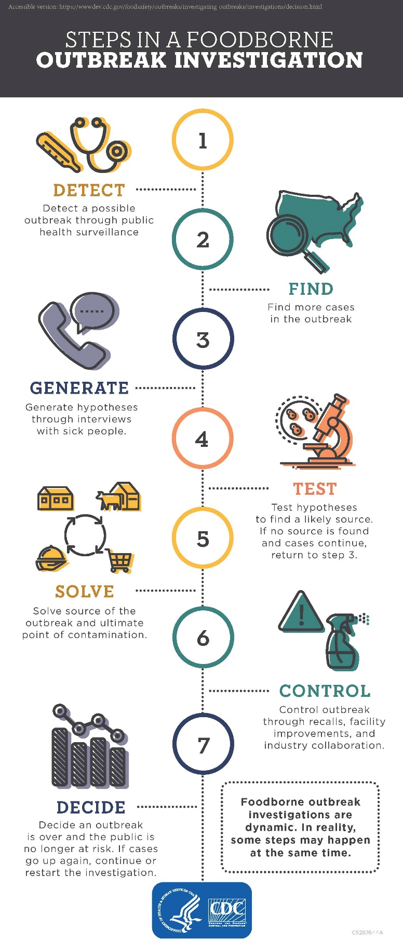
Figure 5.1 Steps in a Foodborne Outbreak Investigation

  - Affect populations at high risk for complications of the illness (e.g., infants or elderly or immunocompromised persons); or
  - Affect a large number of persons.
  - Appear to be ongoing:
  - Outbreak may be associated with food-service establishment in which ill food workers provide a continuing source of infection.
  - Outbreak may be associated with commercially distributed food product that is still being consumed.

If an agency does not believe it can manage an outbreak (e.g., the scale or complexity is likely to overwhelm agency resources, the nature of the outbreak is beyond the expertise of agency staff), help should be requested as soon as possible (see Chapter 3).

5.1.3 Assemble and brief the outbreak investigation and control team. Open communication between investigation members to plan, conduct and evaluate outbreak investigation activities is critical to the success of the investigation.
- Investigation and control team leaders should assess the availability of staff to conduct the investigation. In particular, the team leader should ensure the presence of adequate staffing to interview cases within 24–48 hours. If sufficient staff are not available, request external assistance to conduct interviews.
- Outbreak investigation staff should be briefed on the outbreak, the members of the outbreak control team, and their individual roles in the investigation. Ensure that all members of the of the investigation team, including epidemiologists, laboratorians, environmental health specialists, and food-safety personnel, are familiar with and follow relevant state and federal laws and data handling practices.
- For outbreaks involving multiple jurisdictions, the outbreak investigation and control team should include members from all agencies participating in the investigation (Chapter 7).

5.1.4 Investigation leadership. Leadership of the investigation should reflect the focus of investigation activities and may change over time. During an investigation, the focus of activities may shift among the following:
• Laboratory studies to identify an agent, including microbiologic studies and applied food-safety research;
• Epidemiologic studies to identify transmission routes, exposure sources, or food vehicles and risk factors for disease;
• Regulatory investigations of food-production sources and distribution chains to identify where, during production of the food, contamination occurred and facilitate recall of food items;
• Environmental assessments of food production, processing, and service facilities to identify routes of contamination and contributing factors; and communication of investigation findings to the public and the food industry to support control and prevention measures.
5.1.5 Communication and coordination. Coordinate activities and set up good lines of communication between individuals and agencies involved in the investigation (see Chapter 3). Guidelines for coordinating multijurisdictional investigations are summarized in Chapter 7.
Investigations are rarely linear. As depicted in Figure 5.1, although the steps for investigating outbreaks follow a logical process—from determining whether an outbreak is occurring to identifying and controlling the source—most actual investigations feature multiple concurrent steps.
Maintaining close communication and coordination among members of the outbreak investigation team is the best way to ensure concurrent activities do not interfere with each other and important investigation steps are not forgotten.

    - Establish goals and objectives for the investigation. The primary goal for most investigations is to obtain sufficient information to implement specific interventions that will stop the outbreak. This should also provide information to prevent a similar outbreak from occurring in the future. Secondary goals are to increase our knowledge of the epidemiology and control of foodborne diseases. Unanswered questions about the etiologic agent, the mode of transmission, or contributing factors should be identified and included in the investigation to add to the public health knowledge base.
Objectives for meeting these goals vary by type of outbreak:
- Complaints identifying multiple illnesses associated with a common event or establishment will lead to an investigation to identify the agent and the mode(s) of transmission. Most of these will be local investigations requiring co-ordination between epidemiologists, environmental health specialists, and public health laboratorians within the jurisdiction of the event or establishment. Cases need to be rapidly interviewed to confirm illness and exposure details that may suggest a likely etiology and potential source of exposure. Environmental health specialists, guided by available descriptive epidemiology, need to assess food handling practices and food employee health and hygiene habits at the establishment. Public health laboratories need to test clinical specimens to confirm the etiology of the outbreak, based on the description of signs, symptoms and incubation periods (CIFOR Outbreaks of Unknown Etiology [OUE] Guidelines). If it is determined that the source of contamination was upstream from the establishment, the outbreak could involve multiple locations and require a multi-jurisdictional investigation (see Chapter 7).
- Clusters of cases identified through laboratory-based surveillance at the local or state level will lead to investigations to determine the mode of transmission or source of contamination. Cases need to be rapidly interviewed with a thorough exposure assessment to identify potentially common exposures or likely routes of transmission. Environmental health specialists and food regulators need to be prepared to investigate sub-clusters associated with food establishments and to initiate product tracing for suspected food exposures. Public health laboratories need to rapidly confirm additional cases and food regulatory laboratories need to prepare to rapidly test suspected food products.
- Multi-state clusters of cases suggest a commercially distributed food source (see Chapter 7). Product tracing may be needed for successful exposure assessment. Communication and co-ordination of activities between federal, state and local agencies must be established at the onset of the investigation.
- Identification of a foodborne pathogen in a commercially-distributed food product will lead to a search for illnesses caused by the same organism and an investigation to determine whether the food item was the source of the illness. This type of outbreak presentation will likely increase with the use of WGS to link historical food or environmental samples with cases identified through pathogen-specific surveillance. In all instances, this will require multi-jurisdictional investigation to assess the likelihood that the cases are attributable to the suspected food exposure.
5.2 Define and Find Cases
5.2.1 Developing case definitions. Initially, case definitions reflect the cluster recognition methods.
- A cluster of illnesses linked to foodborne illness complaints will likely be defined both by similar features of the illness and common suspected source of exposure. As cases are interviewed, a distinctive clinical profile may emerge that will suggest a likely etiology. If testing of clinical specimens confirms an agent, the features of that agent can be used to establish a clinical case definition.
- Clusters of cases identified by pathogen-specific surveillance, are usually defined by common phenotype or molecular characteristics (serotype, PFGE pattern, WGS), time frame when the cases occurred, and geographic distribution of the cases. CIDTs represent a challenge to this approach. While the initial CIDT-positive result may be available within a few days of onset of illness, the need to perform reflex culture, and then subtype the isolate means that some cases will not be subtyped, and the timeline will be increased for those that are.
- During the early stages of the investigation, case definitions should be made specific to increase the likelihood that the detected cases share a common exposure. Including unrelated cases in an outbreak investigation will make it harder to recognize a common exposure and will dilute observed measures of association in analytic studies. For example, in an outbreak of salmonellosis, cases may share common symptoms of diarrhea and fever and all be caused by isolates with the same serotype that have a distinctive PFGE pattern and are closely related by WGS. Each of these additional points of identity increases the likelihood that the cases are related, and that the source may be identified.
- After a common source has been identified, it may be necessary or desirable to change the case definition to better assess the magnitude of the outbreak. This may occur when additional pathogens, or strains of a pathogen are linked to the same source. Although outbreaks are detected through "mono-clonal" surveillance for highly defined clusters, many food contamination events are "poly-clonal" and involve multiple strains of pathogenic bacteria. The true nature of these events is usually not discovered until late in the investigation. In addition, after a common source has been identified, accounting for illnesses that occurred following exposure to the source that were not confirmed but had similar clinical characteristics to the confirmed cases can help provide a better estimate of the size, scope and public health impact of the outbreak.

5.2.2 Review current surveillance systems for cases that meet the case definition. Once a case definition has been established, investigators should search for more illnesses related to the outbreak.

- For clusters of illnesses reported through complaints, review complaint logs or databases to find other complaints identifying exposure to the suspected event or establishment. Although many complainants focus on their most recent exposure, reviewing all exposures in a 3-day food history could link unrecognized cases to the outbreak.
In addition, if the confirmed etiology of the complaint-based outbreak is Salmonella, STEC, or other foodborne pathogen for which cases are routinely interviewed, reviewing all exposures for cases interviewed during the likely outbreak period could link unrecognized cases to the outbreak.
- For clusters identified through laboratory-based surveillance, review regular surveillance reports and laboratory reports.
In addition, for restaurants and retailers identified in the relevant exposure window, review complaint database to identify potential sub-clusters of cases.
5.2.3 Supplement case-finding activities. Ask local clinical and laboratory professionals to report cases as soon as they suspect the diagnosis, review emergency room records for similar illnesses, alert health officials in surrounding areas to watch for illnesses that might be related, and survey groups that may have been exposed.
5.2.4 Plot cases on an epidemic curve to track illnesses over time.
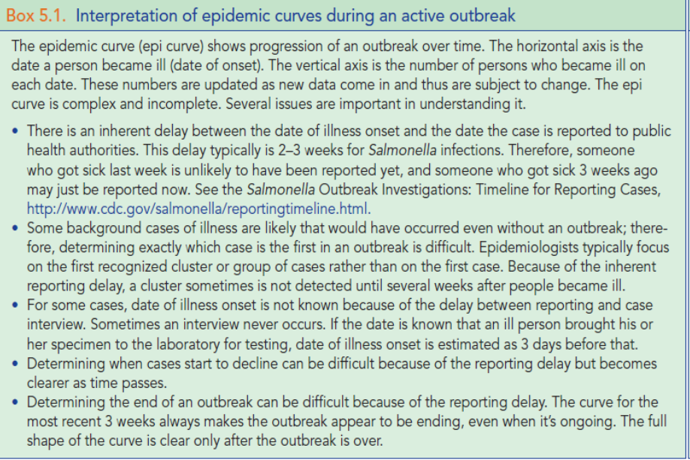
5.3 Generate Hypotheses about Likely Sources
To narrow the focus of an investigation and most effectively use time and resources, investigators should begin to generate hypotheses about potential sources of the outbreak during the earliest stages of the investigation and refine them as they receive information. Hypotheses may emerge from common case characteristics, shared exposures, or historical information about the agent. Key steps in this process include the following:
5.3.1 Review demographic information including age, gender, geographic and temporal distributions of cases. CDC has developed the System for Enteric Disease Response, Investigation, and Coordination (SEDRIC) to help organize and visualize cluster associated data. Patterns in the distributions of these characteristics may suggest possible sources.

5.3.2 Review previous exposure sources linked to the agent. This should include identifying previous vehicles associated with outbreaks, and isolation of the agent from food items or food production environments. However, investigators should avoid only focusing on historic sources since they may miss a new or previously unknown source.

5.3.3 Use standardized data collection forms and compile data from case interviews. A National Hypothesis Generating Questionnaire (NHGQ) has been developed to collect information on a broad range of food and non-food exposures (http://cifor.us/downloads/clearinghouse/NHGQ_v2_OMB0920_0997.pdf).
The NHGQ contains a mix of closed and open-ended questions designed to elicit likely exposure sources. However, the NHGQ cannot capture detailed source information on all possible exposures and supplemental approaches may be needed. A key to identifying the source of an outbreak is to collect detailed information on both the food item and its source as early in the process as possible.
When conducting hypothesis generating interviews, use the following interview techniques to improve food recall:
• Question subjects as soon as possible after reporting.
• Encourage interviewees to remember information by asking them to elaborate on where they ate, with whom they ate, and events associated with the meals. Ask interviewees to look at a calendar from the appropriate time periods to jog their memory.
• Enlist the help of those preparing meals during the period of interest
• Ask if the subject keeps cash register or credit card receipts, or review on-line banking or bank statements to indicate where or what they ate. Purchase receipts can often be reproduced if the case paid with a credit card.
• If the subject uses a grocery store shopper card, ask permission to get purchase records for a specified time period. Some grocery chains readily cooperate with these requests; others do not.
• Use a structured list of the places where people might get food to get them thinking about exposures other than just restaurants and grocery stores. The list could include food pantries, farmers markets, conferences and meetings, and caterers.
5.3.4 Use a dynamic cluster investigation process to generate and develop hypotheses. In the dynamic cluster investigation model, initial cases within a recognized cluster are interviewed with a detailed exposure history questionnaire. As new exposures are suggested during case interviews, the initial cases are systematically re-interviewed to uniformly assess exposure to the exposures suggested by subsequent patient interviews. Newly reported cases also will be asked specifically about these exposures. (Figure 5.2)

On the basis of this information, investigators can identify possible exposures for further evaluation by epidemiologic, laboratory, or environmental studies. These should include the review specific information about establishments/products of interest:
- Guest lists for common events reported by cases
- Historical information on firms or food items of interest
- Recipe and ingredient lists for common menu items
- Shopper card data to compare grocery store purchases
In practice, the generation and testing of hypotheses is an iterative process, with the hypothesis modified as more information is obtained.
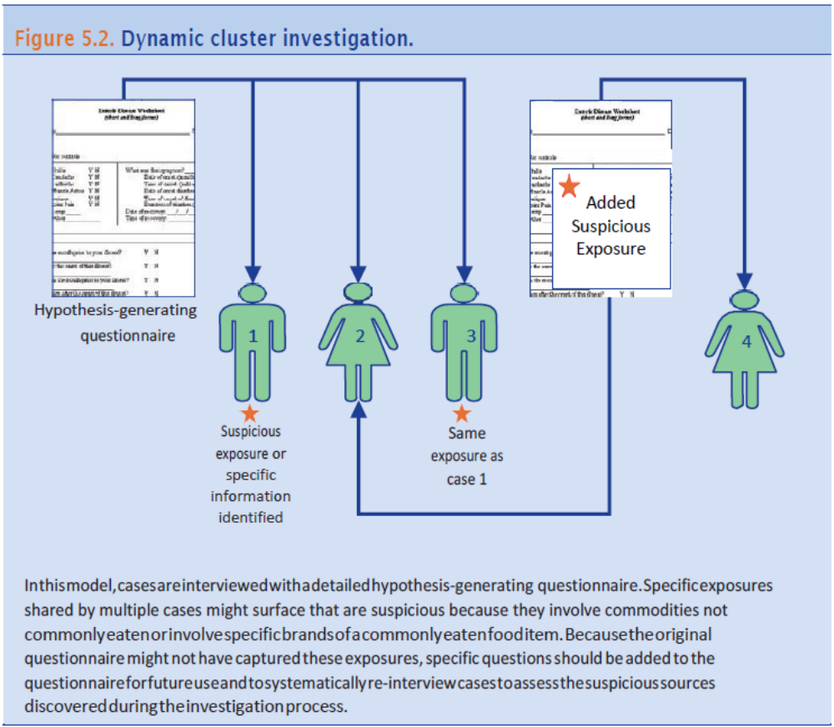
5.3.5 Conduct sub-cluster investigations. When a group of cases within a cluster identifies exposure to the same individual points of service such as a restaurant, cafeteria, grocery store or institution, this group of cases is termed a sub-cluster and represents an invaluable opportunity to solve the outbreak; because the outbreak vehicle was most likely served by the common establishment. Thus, sub-cluster investigations represent a hybrid of hypothesis generating and hypothesis testing approaches, and serve as a useful model of the general approach to outbreak investigations.
- All available resources should be committed to rapidly and comprehensively investigate such a sub-cluster because of the high chance for success of the investigation. If resources are not available to conduct an investigation fully and rapidly, assistance should be sought from other agencies.
- Ascertain additional cases associated with sub-cluster locations. In their initial interview, all newly identified cluster cases should be asked to identify all dining locations eaten at during the exposure period. Cases often do not recall eating at some locations outside the home when asked open ended questions on initial interview (e.g., “What restaurants did you eat at?”). All newly identified cluster cases should be asked specifically about the list of dining location named by previous cases. Additional sub-cluster cases may be ascertained by contacting additional patrons of the sub-cluster establishment (e.g., via credit card receipts, on-line orders, or reservations).
- Once a sub-cluster is identified, cases that were previously interviewed should be re-interviewed, and asked specifically about the sub-cluster establishment. All newly identified cluster cases should be asked specifically about the sub-cluster establishment during their first interview. Cases should be asked to check credit/debit card statements to improve recall. Shopper card records for cases linked to common grocery store chains should be obtained and analyzed. It is very important to pinpoint the purchase date and meal date to the extent feasible (if a receipt or credit card statement is not available, record how confident the case is about the purchase or meal date).
- Gather detailed food consumption data for sub-cluster cases. Sub-cluster cases should be interviewed using the sub-cluster venue’s menu, or a more defined menu if an event cohort with a limited, discrete menu is identified.
  - Ask cases about additions or subtractions to the menu item(s) they ordered.
  - The establishment manager and/or chef should be interviewed to obtain ingredient lists for menu items.
  - A frequency distribution of ingredients consumed by cases should be compiled. Include every ingredient consumed by at least one case.
- Conduct an analytical study at the sub-cluster establishment. An ingredient specific case-control study should be conducted. There is no rule as to a minimum number of cases necessary to initiate such a study, but it is reasonable to do so with as few as 3 cases.
  - Identify additional cases and enroll controls by:
    - Asking cases for meal companions.
    - Getting credit card receipts, reservation lists, take-out orders, and/or lists of workers or students (if a cafeteria) for patrons who dined at the establishment on the implicated meal dates.
  - Ascertaining additional cases (and increasing the number of controls) increases the likelihood of meaningful results and the confidence you can have in those results.
        - Make the clinical case definition specific for the pathogen of interest (e.g., for Salmonella use “fever and diarrhea” or “diarrhea duration >3 days”). This will minimize the likelihood that unrelated illness will dilute associations.
        - Include every plausible ingredient in the study. Be systematic - don’t focus solely on one or two ingredients that were commonly reported by cases. Some ingredients (e.g., spices, garnishes) may be used in multiple menu items and thus could be overlooked.
    - Trace back suspected vehicle(s). If there are multiple sub-clusters (i.e., multiple points of service), trace back ingredients implicated in analytic studies or, if analytic studies cannot be done, those that were most frequently consumed by cases. Do not exclude food ingredients from an analytic study based on apparent differences in distributors for ingredients used by the sub-cluster establishments, as commonalities in the source of food items might not occur until farther back in the distribution chain.
    - Link sub-clusters in multi-state outbreak to look for common distribution links between establishments (possible even if too few cases to do case-control study).
5.3.6 Maintain open communication between public health and regulatory partners to discuss new or updated information on the epidemiological investigation and food/establishment findings

5.4. Test Hypotheses
Much of the work of outbreak investigations involves developing sound hypotheses that explain the patterns of illnesses observed. Testing these hypotheses requires epidemiologic analysis of common exposures combined with traceback and environmental assessment data that identifies common contamination points in the distribution chain, and food and environmental testing data that identifies outbreak-associated strains in implicated foods or in environmental samples linked to the foods.
5.4.1 Analytic studies; characteristics, use and limitations. Epidemiologic studies to analyze the association between illness and exposures may take different forms depending on the setting of the outbreak, the number of cases reported, and the available public health resources available. In recent years there has been an evolution in the approaches to using these study methods. This has resulted in fewer large, community case-control studies being conducted in favor of case-aggregation methods with comparisons to reference data, or in the case of a very specific product identification (e.g., Garden of Life Raw Meal), direct intervention.
- Cohort study. Cohort studies are limited to outbreaks with defined exposure settings in which exposed persons can be identified without respect to illness status. For example, a banquet with a defined guest list. In cohort studies, persons are interviewed without respect to their illness status. This allows for determination of attack rates that can be used to assess the magnitude of the outbreak and calculation of relative risks for individual exposures. Because many of these settings involve a defined menu and guest list, it may be possible to develop an on-line survey to rapidly collect illness and exposure information.
- Establishment-specific case-control study. In defined setting outbreaks where it is more feasible to identify cases rather than groups of exposed persons, an establishment specific case-control study (similar to the sub-cluster study described above) should be conducted.
- Community case-control study. Community case-control studies are a classic staple of outbreak investigations. Comparing food exposures among cases in an outbreak to those among healthy control subjects has great power to identify foods that are associated with the illnesses. For example, in a nationwide outbreak of Salmonella associated with commercially-distributed ice cream, the source was identified based on interviews of 15 cases and 15 community controls. While results of the case-control study implicated an exposure source within 3 days, regulatory testing to confirm the source of contamination required an additional 10 days.
  - Having a stringent case definition is important to reduce the likelihood of including unrelated cases in the study. Because unrelated cases would not share the same exposure source, they would reduce the apparent odds ratio, and make it difficult to implicate the exposure source. WGS subtyping allows for very stringent case-definitions. Along with specific case definitions, having detailed exposure source information is critical.
Despite their empirical usefulness, large community-based case-control studies are no longer routinely conducted in outbreak investigations. It is increasingly difficult to recruit suitable controls because of changing demographics of telephone use. Thus, they have become too expensive to conduct, and are too slow to produce actionable results in a timely manner.
- Case-case comparison studies. Case-case comparison studies provide many of the same benefits as do community case-control studies, but are logistically easier to conduct. Molecular subtype-specific surveillance based on PFGE, or WGS, makes it possible to compare cases caused by an outbreak-associated strain with cases caused by unrelated strains. Because cases caused by unrelated strains will have many different sources of exposure, they make a very efficient control group. When sporadic cases are routinely interviewed with detailed food exposure questionnaires, case-case comparison studies can be conducted using available data. For example, in the 2011 outbreak of listeriosis identified by the Colorado Department of Public Health and Environment, cantaloupe was implicated by comparing exposures from reported outbreak-associated cases to aggregated exposures of nationally reported cases collected by CDC’s Listeria Initiative.
Case-case comparisons produce the same measures of association as do case-control studies and are interpreted in the same way. The increased stringency of WGS to discriminate outbreak-associated from unrelated cases makes case-case comparisons a desirable alternative to case-control studies when aggregate case exposure data are available.
- Case series with binomial exposure assessments. The use of case series with binomial exposure assessments was pioneered by Bill Keene at the Oregon State Health Department, who also developed a simple binomial calculator to test the significance of differences between case and population exposure proportions. Like the other analytic study methods, it requires that outbreak-associated cases are systematically interviewed using a detailed exposure questionnaire. However, instead of comparing case exposure histories to community controls or unrelated cases, the case exposures are compared to an expected value based on population survey data. FoodNet’s Atlas of Exposures has been the most commonly used source of population exposure data. However, the timeliness and geographic representativeness of 2006 Atlas data limits its usefulness. Identifying current, local population exposure data is preferred. The Oregon Department of Health has complied multi-state sporadic Salmonella case exposure data known as Project Hg, for case-case binomial comparisons.

The binomial comparison functions as advanced hypothesis generation. It identifies associations that must be confirmed by product source tracing and corroborated by other investigation findings. Statistically, binomial comparisons emulate very large case-control studies. Results must be cautiously interpreted to avoid spuriously significant results that could lead to errors in identifying the source of an outbreak.
For all analytical studies the significance of results is dependent both on the strength of the association and the size of the study. Thus, studies with large numbers of cases are more likely to yield statistically-significant results. However, the goal of outbreak investigations is to rapidly identify the source to prevent additional cases. In this regard WGS will improve the efficiency of these studies by providing very specific case definitions. Increasing the specificity of food exposures will similarly increase the efficiency of the study. However, with WGS, the expected increase in small cluster investigations will limit the usefulness of any of these study designs to produce “significant” results. For clusters involving fewer than 5 cases, product source tracing and corroborating evidence will be needed to confirm the source.

    - Product tracing. Tracing the source of food items or ingredients through distribution to source of production can be critical to identifying epidemiologic links among cases or ruling them out. For non-branded commodities, such as produce items, the convergence of multiple cases along a distribution pathway may identify the source of contamination. Once the source is identified, tracing product forward through distribution can help identify additional cases or help remove contaminated product from the market place. Product tracing is an important investigational tool to inform the epidemiological investigation, test the hypothesis, and control the outbreak. There are two types of product tracing tools that can be used to investigate outbreaks. Traceback investigations are used to trace a product suspected to cause the outbreak through the supply chain to see if it converges on a common source or supplier. Once a common source or supplier of the contaminated product is identified, traceforward investigations are used to determine other locations that received the contaminated product. Both traceback and tracefoward activities can be conducted as informational or regulatory endeavours. Informational product tracing needs to be conducted quickly to be incorporated into the epidemiologic studies. Formal regulatory product tracing may be subsequently needed to confirm the distribution of implicated products.

- Traceback Investigations. Traceback investigations begin at the point of service where a case was exposed to the product. Informational, or epidemiological, traceback investigations are conducted to help inform the epidemiological investigation and narrow the number of products of interest. Record collection for informational tracebacks may not include the typical documentation and site inspection follow-up performed in regulatory tracebacks (see Smith Whitepaper).
- If two or more cases report the same point of service, important information must be collected from this sub-cluster so a traceback investigation can be initiated.
- Ideal sub-clusters contain cases with the following information: precise illness onset dates, exposure dates to the product of interest, and relative certainty about what foods were eaten prior to illness onset.
- Traceback of individual cases can also provide important information to corroborate sub-cluster data.
- As informational tracebacks progress and a single product of interest is identified, regulatory traceback can be performed if necessary to assist in confirming the vehicle. These regulatory tracebacks allow for detailed record collection and documentation of the product of interest through the supply chain.
- Once a traceback is initiated, specific information is necessary from both the cases within the subcluster and the point of sale. As the traceback continues, firm types will change and questions about the handling of the product of interest, timeframes, and available record will need to be amended accordingly.

Information collected from each subcluster serves as one “leg” of the overall traceback investigation. Distribution chains from multiple traceback legs are documented and compared to identify any commonalities. Convergence of multiple legs of a traceback on a specific facility assists in targeting resources for environmental assessments, inspections, and/or sampling. In addition, information from the traceback is continuously evaluated as part of the evidence for the overall outbreak investigation and convergence reinforces the hypothesis generated by the epidemiological investigation.
Traceback investigations continue until the product of interest is followed as far back through the supply chain as possible. Interpretation of the traceback can be challenging, and should not be done without consideration of the epidemiological, laboratory, and environmental information collected during the investigation. If no convergence on a single supplier is identified, evaluation of the hypothesis should be conducted. Tracebacks are challenging and can be limited by poor record-keeping, lack of common product identifiers through the supply chain, co-mingling, and many other factors. Due to these challenges, lack of convergence of a traceback does not singly rule out a vehicle as the source of the outbreak.
Important information for traceback initiation:
Subcluster information
• Exposure dates to product at point of sale
• Identification of specific menu items or purchases
• Documentation of purchase of product (credit card, shopper card, etc.)

Point of sale information
• List of ingredients in menu items or purchases of interest
• Timeframe of interest for distribution record collection (determined by considering case exposure dates, product shelf life, shipment frequency, and any other pertinent factors)
• Identity of all suppliers of the product of interest to the point of sale
• How frequently the product of interest is ordered by the point of sale
• How the point of sale handles shipments and documents receipt of the product of interest
• Distribution records (invoices, order forms, bills of lading, etc.) for the timeframe of interest that are available at the point of service. Any gaps or concerns in record keeping should be noted.
• How the product is handled in the facility

- Traceforward investigations. Tracing products forward in the supply chain can determine where contaminated products were distributed and allow for the removal from the supply chain (see Chapter 6). Traceforward investigations are also an important tool to identify additional cases that were exposed to contaminated products. In the hypothesis testing phase of an outbreak investigation, tracing a suspected product forward can identify additional points of sale that received the suspect product. These points of sale can be linked to additional clinical cases, adding further confidence in confirming the suspect source.

- Communication of product tracing information. Product tracing efforts are always multijurisdictional and require strong collaboration between public health and regulatory agencies. Predetermined lines of communication should be in place to effectively move information between the necessary parties. Updates on the epidemiological investigation being conducted by the public health agency may greatly impact the traceback being conducted by the regulatory agency, and vice versa.
  - Special considerations need to be given to distribution information collected by regulatory agencies, as it may be protected from disclosure by confidentiality agreements. Investigational partners should have agreements in place to allow for the lawful exchange of the information (see Chapters 3 and 7 for those considerations).

    - Environmental assessments. When a food production, food processing, or food service establishment has been identified as being associated with an illness outbreak, environmental health and regulatory officials can conduct environmental assessments or regulatory inspections. Differences between environmental assessments and routine inspections are highlighted in Table 5.2.
Table 5.2 Differences between routine inspections and environmental assessments.
Routine Inspection |  | Environmental Assessment
- Non-Targeted  - Regularly scheduled  - Snapshot of current day  - Code/regulation-based  - Assess current conditions  - Identify violations |  | - Targeted  - In response to an outbreak  - Focuses on the past  - Outbreak information-based  - Examine processes and problems during outbreak period  - Identify system failures  - Identify underlying factors that allowed for the system failure

An environmental assessment is a systematic, detailed, science-based evaluation of environmental factors that contributed to the introduction and/or transmission of agents that cause a disease in an outbreak. Environmental assessments are conducted in response to an outbreak and address the specific food and process(es) that occurred in the past to identify the cause of the outbreak. The environmental assessment is guided by epidemiologic and laboratory information and examines how the causative agent, host factors, and environmental conditions interacted to result in the system failure and people becoming ill.
Goals of an environmental assessment:
- Identify contributing factors
  - Factors that introduce or otherwise permit contamination and relate to how the agent got onto or into the food vehicle.
  - Factors that allow proliferation or growth of the agent and relates to how the bacterial agents could increase in numbers and/or produce toxins prior to the vehicle being ingested.
  - Factors that allow survival or fail to inactivate the contaminants and refer to processes or steps that should have eliminated or reduced the microbial agent.
- Identify environmental antecedents that allowed the system failure to occur
  - Assessing the internal system components (e.g. people, equipment, processes, foods, and economics) and their effect on allowing the system failure to occur
Five main steps in conducting an environmental assessment:
- Planning and preparation: Members of the outbreak investigation team review epidemiological information, product tracing information, laboratory results, and food facility information. Roles and responsibilities, intended outcomes, sampling plans and ways the team will communicate during the site visit should be determined at this step.
- Site visit: Observations are made of the facility and practices are evaluated. Records and samples pertinent to the investigation are collected. Information that can be collected as part of the visit includes:
  - Flow diagram of how food moves through the establishment,
  - Policy and procedures in place at the establishments and interviews with responsible parties on execution of policies and procedures,
  - Ill employee records,
  - Sales records for the suspected food item,
  - Employee interviews,
  - Product coding and distribution information if food is suspected to arrive at the facility contaminated.
- Assess information: Information is reviewed to identify the outbreak's contributing factors and environmental antecedents.
- Recommend preventive control strategies: Control strategies reflect steps that should be taken immediately to stop the outbreak and prevent the further spread of this agent. Longer term strategies are important for reducing the likelihood of any future outbreaks at this type of establishment (see Chapter 6).
- Complete the report: A summary of the findings is prepared and should include detailed diagrams, descriptions and results. This report should be incorporated into the outbreak investigation report.
The timing of an environmental assessment depends largely on the specifics of the outbreak and available information but should be initiated as soon as possible (ideally an initial site visit within 24-48 hours of the identification of the establishment.) Early investigation and collection of food and environmental specimens will best reflect the conditions at the time of the outbreak. In addition, possible food vehicles can be discarded or grow old, and persons involved in the production, processing, storage, transportation, or preparation of the item can change their practices and procedures. If investigators have identified a common location and a profile of symptoms among ill persons that indicates whether the disease agent is likely to be viral, bacterial, toxin, or chemical, they often can begin an environmental assessment based on possible factors more likely to be associated with that disease agent. As more information becomes available, the investigator may need to make additional trips to the establishment to investigate the additional lines on inquiry.
Communication of environmental assessment findings. It is important to share results of the inspections and environmental assessments with the outbreak investigation team. This information may change the course of the investigation, or confirm the suspected food item causing the outbreak. Of note, sharing findings on the contributing factors and environmental antecedents that led to contamination with industry partners is key to improving hazard identification and implementing control measures. (see https://www.foodprotection.org/publications/food-protection-trends/archive/2018-03-leveraging-current-opportunities-to-communicate-lessons-learned-from-root-cause-analysis-to-/ )

5.4.4 Laboratory testing of food products and environments. Targeted sampling of food items and environments of interest in the outbreak investigation are a key tool in confirming the food causing illness. Targeted sampling occurs when partners working on the epidemiological and traceback investigations work together to share information products and firms of interest.
- Sampling products of interest early in the epidemiological investigation can help quickly bring an investigation together, especially if the products of interest are shelf stable. In 2017, soy nut butter reported by cases associated with an outbreak of E. coli O157:H7 was sampled by local and state authorities. The positive samples generated by that early sampling was used as evidence to suspend the registration of the facility manufacturing the product. Not all product sampling occurs at the outset of an investigation. Traceback investigations can identify locations along the supply chain to collect samples.
- Food and environmental sampling allows investigators to directly test hypotheses generated during investigation, often picking up where analytic studies leave off. By gathering information about items of interest, such as food items or ingredients commonly consumed at a restaurant in question, animals to which cases were exposed prior to illness, or other less common environmental exposures like contaminated milk crates, investigators can target very specific items or areas to sample for microbiologic testing at a laboratory. When combined with the case series with binomial exposure assessments, such testing can quickly hone a list of suspected products to a single source.
- Sampling can also be used to elucidate the root cause of product contamination, especially when done in partnership with the grower or product manufacturer. Pathogens such as Salmonella spp. and Listeria monocytogenes are known to persist in manufacturing and processing environments. Identification of a pathogen in a processing environment that was linked by epidemiological and traceback information to clinical cases provides support for confirmation of the outbreak vehicle.
- WGS is also being used to perform molecular subtyping on pathogens recovered from foods and environments impacting foods. The high resolution of WGS increases confidence in the relatedness of pathogens from products and environments to clinical samples. Historical food or environmental samples that are closely related by WGS can launch retrospective outbreak investigations, in which laboratory evidence from the products or environments drives the epidemiological investigation. Retrospective outbreak investigations often lead to the swift identification of the outbreak source.
5.4.5 Coordination of epidemiological, traceback, and sampling activities. Whether the outbreak is restricted to one jurisdiction or involves multiple jurisdictions, notification and updates should be provided to other interested agencies following the Guidelines for Multijurisdictional Investigations (see Chapter 7).
- Arrange for outbreak control team to meet daily and to regularly update the entire outbreak control team. In particular, if the outbreak has gained public attention, the public information officer needs to prepare a daily update for the media.
- During investigation of outbreaks involving events or establishments, maintaining close collaboration between epidemiology and environmental health is particularly important. Interview results from persons who attended the event or patronized the establishment will help environmental health specialists focus their environmental assessments by identifying likely agents and food vehicles. Similarly, results of interviews of food workers and reviews of food preparation can identify important differences in exposure potential that should be distinguished in interviews of persons attending the event or patronizing the establishment. For example, environmental health investigators might determine that food items prepared only on certain days or by certain food workers are likely to be risky. These refinements also can help establish the need for or advisability of collecting stool samples from food workers or food and environmental samples from the establishment.
- During the earliest stages of the investigation, patrons need to be interviewed rapidly. However, the focus of outbreak activities is likely to shift to interviews of food workers, environmental assessments of the establishment, and review of food-preparation procedures as the investigation progresses.
- During investigation of outbreaks detected by pathogen-specific surveillance, the public health laboratory needs to immediately forward case information to epidemiologists for every new potentially outbreak-associated case they receive. This will ensure rapid enrollment of new cases in the outbreak investigation studies. Similarly, as investigators acquire information from cases about exposures in restaurants and other licensed facilities, they should rapidly forward that information to environmental health specialists to ensure rapid identification of commodity ingredients and their distribution sources.
- During the early stages of an investigation, efforts to identify mode of transmission and food vehicle require close coordination of the outbreak team under the leadership of epidemiology. After identification of a likely food vehicle, efforts to identify the source of contamination and contributing factors require engagement of local, state, or federal food-regulatory programs. As the investigation proceeds, the outbreak control team should always consider whether any information indicates the outbreak might be multijurisdictional. See Chapter 7 for information about identifying and responding to multijurisdictional outbreaks.
5.5 Evaluate Evidence to Solve Point of Contamination and Source of the Food
5.5.1 Evaluate evidence. Identifying the source of contamination and taking action to prevent additional illnesses requires effective and timely integration of three types of data:
- Epidemiologic data that describes illness distributions and analyzes common exposures.
- Traceback and environmental assessment data that identifies common contamination points in the distribution chain.
- Food and environmental testing data that identifies outbreak-associated strains in implicated foods or in environmental samples linked to the foods.

Evidence from each of these pillars of the outbreak investigation is evaluated in concert to determine if the data support the conclusion that a suspected food or other exposure is the outbreak cause. Investigators typically determine that they have identified the likely source of the outbreak when they have clear and convincing evidence from two pillars. In rare instances, data from one pillar alone might be sufficient to determine the likely source of and outbreak (e.g., complaints or point source clusters linked to a meal or single event). In investigations of products with a short shelf life (e.g., unpasteurized milk or leafy greens), conducting testing on products during the likely period of contamination might be impossible and investigators must rely on evidence from the other pillars to determine the likely source of the outbreak.
5.5.2 Solve point of contamination and source of the food. The outbreak investigator’s job is to use all available information to construct a coherent narrative of what happened and why. This begins with the initial detection of the outbreak and formation of hypotheses based on the agent’s ecology, microbiology, and mechanisms of transmission in addition to the descriptive epidemiology of reported cases. Results of subsequent analytic studies (e.g., cohort or case-control study results) must be integrated with results of product tracing, food worker interviews, environmental assessments, and food product and environmental testing. When all of these data elements support and explain the primary hypothesis very strong conclusions can be drawn (see Box 2).
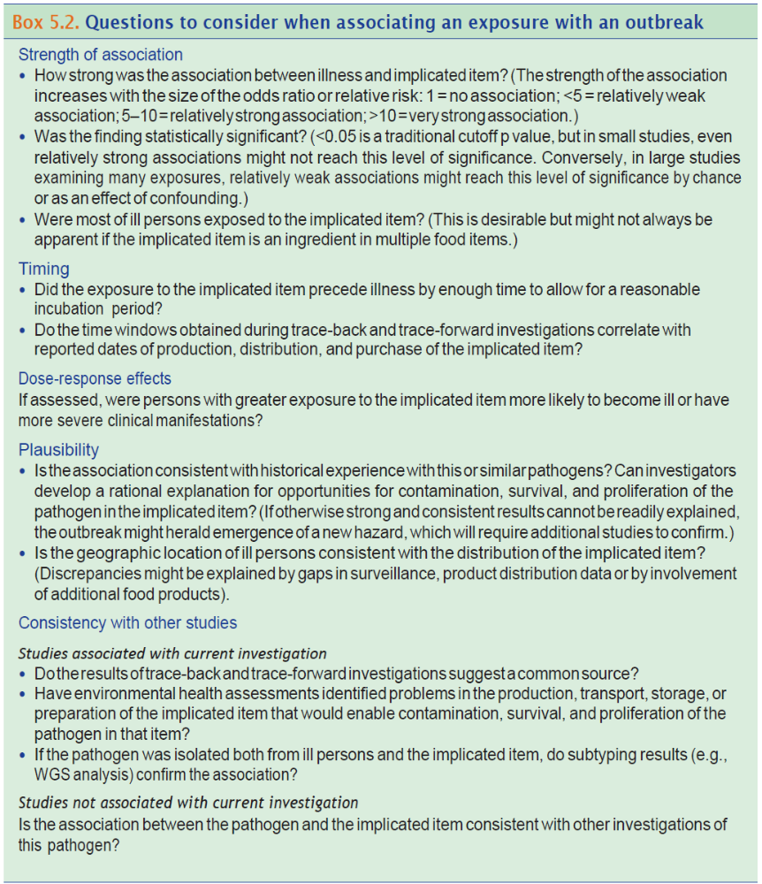
Outbreak investigators should be open to new developments and new twists to old problems. New hazards are frequently identified through outbreak investigations. However, they should be wary of explanations that depend on implausible scenarios.
  - Implement Control Measures, Investigation Close-Out and Reporting
5.6.1 Deciding an outbreak is over (see Chapter 6) Outbreaks end when cases are no longer detected or reported. Outbreak investigations can continue after the outbreak ends given product tracing and observations on practices at suspected firms may take longer to obtain. In addition, control measures need to be evaluated if the source of the outbreak was identified. For outbreaks where the source has not been identified, consideration to the prioritization of resources and expected outcome of the investigation should be considered before continuing investigational activities. Experience reminds us—again and again, unfortunately—that even seemingly well-executed investigations can be inconclusive. Small sample sizes, multivehicle situations, “cryptic” food items, foods with high background rates of consumption are only some of the factors that can reduce the effectiveness of standard epidemiologic methods and make investigations extremely difficult.

Table 5.1. Outbreak investigation activities by objective and role
OBJECTIVE | EPIDEMIOLOGY | ENVIRONMENTAL HEALTH | PUBLIC HEALTH AND/OR FOOD TESTING REGULATORY LABORATORY
Identify etiologic agent. | If outbreak associate with event or establishment:
Identify etiologic agent. | - Contact health-care providers of cases who have sought medical attention.  - Interview cases to characterize symptoms, incubation period, and duration of illness.  - Obtain stool specimens from cases.  - Determine whether symptoms, incubation period, or duration of illness suggest a likely pathogen.  - Establish case definition based on confirmed diagnosis or clinical profile of cases. | - Interview management to determine whether it has noticed any ill employees or any circumstances that could cause a foodborne illness.  - Interview food workers to determine illness. This activity also could be conducted by nursing/health- care staff.  - Obtain stool specimens from ill or all food workers. This activity could also be conducted by nursing/ health-care staff.  - Obtain and store samples of implicated and suspected food items and ingredients.  - Determine whether setting or food item suggests a likely pathogen. | - Contact clinical laboratories that might have performed primary cultures on cases, and obtain specimens.  - Test stool samples to identify agent.  - Test samples of implicated food items to identify agent.  - Subtype all isolates as soon as possible after receipt.
Identify etiologic agent. | If outbreak identified by pathogen-specific surveillance: Agent is known.

OBJECTIVE | EPIDEMIOLOGY | ENVIRONMENTAL HEALTH | PUBLIC HEALTH AND/OR FOOD TESTING REGULATORY LABORATORY
Identify persons at risk and determine size and scope of outbreak. | If outbreak associate with event or establishment:
 | - Obtain from event organizer a list of persons attending event, or, if possible, list of persons patronizing the establishment during the outbreak period.  - Interview persons who attended event or patronized establishment to determine attack rates, by time.  - Contact health-care providers to identify additional persons seeking medical care whose illnesses meet the case definition.  - If identified agent is reportable, review recently reported cases to identify possible exposures to event or establishment. | - Obtain list of reservations for establishment, credit card receipts, receipts for take-out orders, inventory of foods ordered at establishment, or guest lists for events. Where possible, obtain information electronically. | - Contact clinical laboratories to identify additional stool specimens being cultured.
 | If outbreak identified by pathogen-specific surveillance:
 | - Alert health-care providers of possible outbreak to identify additional persons seeking medical care, and review laboratory reports and medical charts at hospitals or physicians’ offices to identify possible cases.  - Ask cases if they know of others who are similarly ill.  - Depending on nature of outbreak, take additional steps as warranted. Examples include reviewing employee or school absences, reviewing death certificates, surveying population affected, or directly asking members of the public to contact the health department if they have the illness under investigation. | - Review foodborne illness complaints to identify undiagnosed cases that could be linked to outbreak.  - Contact restaurants, grocery stores, or other points of final service visited by multiple cases to identify employee illnesses or foodborne illness complaints from patrons. | - Contact clinical laboratories to identify additional stool specimens being cultured.  - Speed up referral and subtyping of outbreak pathogen.

OBJECTIVE | EPIDEMIOLOGY |  | ENVIRONMENTAL HEALTH | PUBLIC HEALTH AND/OR FOOD TESTING REGULATORY LABORATORY
Identify mode of transmission and vehicle. | If outbreak associate with event or establishment:
Identify mode of transmission and vehicle. | - Interview identified cases and controls or well meal companions about all common exposure sources. Calculate odds ratios for specific exposures.  - Interview persons with identified exposures to determine attack rates and relative risks for specific exposures. |  | - Obtain menu from establishment or event.  - Interview food workers to determine food- preparation responsibilities.  - Reconstruct food flow for implicated meal or food item.  - Identify contributing factors and environmental antecedents.  - Obtain samples of implicated food.  - Obtain environmental samples from food contact surfaces or possible environmental reservoirs. | - Test implicated food and environmental samples to confirm presence of agent.  - Subtype all isolates as soon as possible after receipt.  - Conduct applied food- safety research to determine ability of agent to survive or multiply in implicated vehicle and how vehicle might have become contaminated.
Identify mode of transmission and vehicle. | If outbreak identified by pathogen-specific surveillance:
Identify mode of transmission and vehicle. | - Interview cases as soon as possible with standardized detailed exposure history questionnaire to identify possible common exposures.  - Establish case definition on the basis of characteristics of agent that led to detection of outbreak.  - Characterize cases by person, place, and time, and evaluate this descriptive epidemiology to identify pattern possibly associated with particular food items or diets.  - Compare detailed exposure history questionnaire frequencies against known or estimated background exposure rates, to identify suspected food item.  - Interview non-ill community controls or non–outbreak- associated ill persons to obtain detailed exposure information to be used in a case-comparison analysis of exposures.  - Obtain shopper card information to identify and verify grocery purchases and possibly determine background rates of purchase of item.  - Document brand names and product code information for prepackaged food items.  - Analyze exposure information comparing cases to relevant comparison group (e.g., non-ill controls or cases not associated with outbreak) to implicate food item or nonfood-exposure source. |  | - Contact restaurants, grocery stores, or other locations identified by multiple cases to verify menu choices, identify ingredients, and identify distributors and/or source(s) for ingredients and/or food items of interest.  - Obtain samples of suspected food items. Work with appropriate regulatory authority to ensure that food samples are collected and maintained with appropriate chain of custody. This will help the regulatory authority to take appropriate regulatory action,  - Conduct an investigational traceback to determine whether a suspected food vehicle from multiple cases has a distribution or other point in common.  - If specific food item or ingredient is implicated, conduct formal regulatory traceback. | - Store collected food samples, pending results of epidemiologic analyses.  - Culture implicated food samples to confirm presence of agent.  - Conduct WGS to further characterize pathogen as necessary for investigation.  - Conduct applied food- safety research to determine ability of agent to survive or multiply in implicated vehicle and how vehicle might have become contaminated.
OBJECTIVE |  | EPIDEMIOLOGY | ENVIRONMENTAL HEALTH | PUBLIC HEALTH AND/OR FOOD TESTING REGULATORY LABORATORY
Identify source of  contamination. |  | If outbreak associate with event or establishment:
 |  | - Combine descriptive and analytical epidemiology results to develop a model for the outbreak. | - Interview food workers to determine food- preparation responsibilities.  - Reconstruct food flow for implicated meal or food item.  - Evaluate food flow for implicated meal or food item to identify contamination event at point of preparation or service.  - If no contamination event identified, trace source of ingredients of implicated food item back through distribution to point where a contamination event can be identified or, if no contamination events can be identified during distribution, to source of production. | - Evaluate results of all outbreak-associated cultures to highlight possible relations among isolates from clinical, food, and environmental samples.  - Conduct applied food- safety research to determine how vehicle might have become contaminated.
 |  | If outbreak identified by pathogen-specific surveillance:
 |  | - Combine descriptive and analytical epidemiology results to develop a model for outbreak. | - Trace source of implicated food item or ingredients through distribution to point where a contamination event can be identified or to source of production if no contamination events can be identified during distribution.  - Conduct environmental assessment of likely source of contamination, including  - Reconstruct food flow for implicated food item.  - Interview food workers to determine food-preparation responsibilities and practices before exposure.  - Obtain samples of implicated food or ingredients.  - Obtain environmental samples from food contact surfaces or potential environmental reservoirs. | - Evaluate results to highlight possible relations among isolates from clinical, food, and environmental samples.  - Conduct applied food- safety research to examine likely sources of contamination.  - Work with appropriate regulatory authority to ensure that food samples are collected and maintained with appropriate chain of custody. This will help the regulatory authority to take  appropriate regulatory action.

OBJECTIVE | EPIDEMIOLOGY | ENVIRONMENTAL HEALTH | PUBLIC HEALTH AND/OR FOOD TESTING REGULATORY LABORATORY
Identify contributing factors and antecedents | If outbreak associate with event or establishment:
Identify contributing factors and antecedents | - Summarize information to identify confirmed or suspected agent.  - Summarize information to identify confirmed or suspected food vehicle. | - Evaluate results of environmental assessment, given identification of agent and results of epidemiologic investigation, to identify factors most likely to have contributed to outbreak and their environmental antecedents. | - Summarize information about culture results from clinical, food, and environmental samples.
Identify contributing factors and antecedents | If outbreak identified by pathogen-specific surveillance:
Identify contributing factors and antecedents | - Summarize information to identify confirmed or suspected food vehicle. | - Evaluate results of environmental assessment, given identification of agent and results of epidemiologic investigation, to identify contributing factors and antecedents. | - Summarize information about culture results from clinical, food, and environmental samples.  - Provide background statistics on pathogen prevalence.

OBJECTIVE | EPIDEMIOLOGY | ENVIRONMENTAL HEALTH | PUBLIC HEALTH AND/OR FOOD TESTING REGULATORY LABORATORY
Determine potential for ongoing transmission and need for abatement procedures  . | If outbreak associate with event or establishment:
 | - On the basis of agent, incubation period, and likelihood of secondary spread, create epidemic curve, and evaluate the course of the epidemic to determine whether additional cases may still be occurring.  - If outbreak appears to be ongoing, review possible control measures in collaboration with environmental health specialists. | - Implement control measures to prevent further exposures:  - Verify that all food workers who pose a risk for transmission have been excluded or restricted, as needed;  - Verify that potentially contaminated foods have been properly disposed;  - Verify that food contact surfaces and potential environmental reservoirs have been adequately cleaned and sanitized;  - Train staff in safe food-preparation practices;  - Modify food-production and food-preparation processes with appropriate preventive controls; and  - Modify menu.  - If any of these measures cannot be verified, review additional control measures, or if further exposure appears likely, alert public or close premises. | - Assess status of completed and pending cultures to identify gaps that suggest a potential for ongoing transmission.
 | If outbreak identified by pathogen-specific surveillance:
 | - Create and evaluate epidemic curve to determine whether additional cases might still be occurring.  - If outbreak appears to be ongoing, continue surveillance, and review potential abatement procedures. | - Verify that food workers who might have been infected during outbreak and who pose a risk for transmission have been excluded or restricted, as needed.  - Verify that potentially contaminated foods have been removed from distribution.  - Train staff on safe food-preparation practices.  - Modify food-production and food-preparation processes by implementing appropriate preventive controls.  - Modify menu. | - Assess status of completed and pending cultures to identify gaps that may suggest a potential for ongoing transmission.

