For use by CIFOR organizations to announce CIFOR Toolkit and Law Project via social media in February

Social media to promote CIFOR Toolkit and Law Project

Facebook (max 250 characters)  CIFOR Toolkit | CIFOR Toolkit is ‘essential framework’ to improve how Minnesota responds to foodborne illness, says Kirk Smith of state Center of Excellence. CIFOR is a multidisciplinary collaboration of national associations and federal agencies who work to improve how local, state, and federal officials investigate, control, and prevent foodborne disease outbreaks. http://cifor.us/products/toolkit  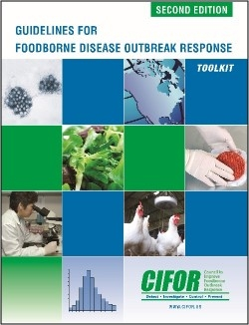
Twitter: max 110 characters  CIFOR Toolkit  Use CIFOR hashtag, and #foodsafety | CIFOR Toolkit is ‘essential framework’ to improve Minnesota’s response to foodborne illness, says Kirk Smith of state Center of Excellence. http://cifor.us/products/toolkit #CIFORUS #foodsafety
Facebook: max 250 characters  CIFOR Toolkit: more testimonials  Facebook: max 250 characters  Law Project | - In Boulder County, CO, the public health food safety program uses CIFOR Toolkit to improve the way it handles foodborne illness outbreaks, says Gina Bare.  - Investigating foodborne illness is not easy, but CIFOR Toolkit breaks it down for state and local health departments, labs, and government agencies. It is ‘thorough, systematic, well written, clear and easy to understand,’ says Mark Buxton of MO.  - Reducing foodborne illness CIFOR’s goal, and CIFOR Toolkit shows how it’s done, step by step.  - CIFOR, which works to reduce foodborne illness, analyzed surveillance and investigation laws in select states. Read about it at http://cifor.us/products/law-project  - Tools to help agencies improve their legal preparedness to conduct surveillance for foodborne illness outbreaks at http://cifor.us/products/law-project  For image, use a screenshot of http://cifor.us/products/law-project
Twitter: max 110 characters  Law Project  Use #ciforfood and #foodsafety  Link to http://cifor.us/products/law-project | - Do you investigate foodborne illness? Find tools and info on legal aspects at http://cifor.us/products/law-project #ciforfood #foodsafety  - CIFOR tools help state and local public health agencies improve legal preparedness to respond to foodborne illness. http://cifor.us/products/law-project #ciforfood #foodsafety  For image use a gavel or CIFOR logo  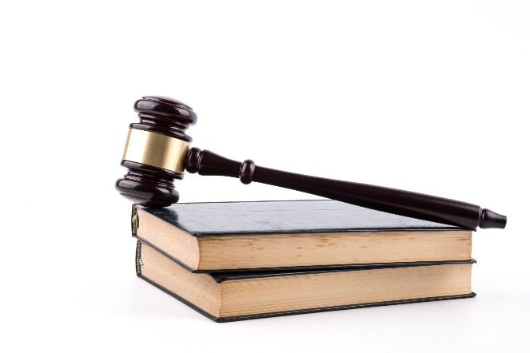  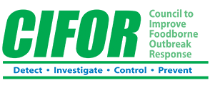

- The Law Project (later in Feb)
- Promote Law docs
- #ciforfood
- Target audiences: NACCHO’s Law workgroup, CDC, Network for PHL, each org to promote
- Please insert a picture for use

Approved CIFOR Testimonials – November 2017
Minnesota COE – Kirk Smith
“The CIFOR Toolkit has been a prominent and indispensable tool used by the Minnesota Integrated Food Safety Center of Excellence (CoE). Specifically, Minnesota CoE staff have facilitated CIFOR Toolkit exercises in three states to bring together laboratorians, epidemiologists, public health nurses, and environmental health specialists to critically evaluate and plan improvements to their surveillance and response efforts. The CIFOR Toolkit was the essential framework that guided these discussions.”
Boulder County Public Health – Gina Bare
“Boulder County Public Health’s Food Safety Program is enrolled in the FDA’s Voluntary National Retail Food Regulatory Program Standards, which directs programs to have a “systematic approach in place for the detection, investigation, response, documentation and analysis of alleged food-related incidents.” For that reason, our program has relied heavily on the CIFOR Guidelines for the development of our policies and procedures. We are pleased to say that we successfully met that Program Standard in 2012 and continue to look to the CIFOR Guidelines to see how we can improve our program.”
Missouri Rapid Response Team – Mark Buxton
“I think the most important things about CIFOR are that it is thorough, systematic, well written, clear and easy to understand. It takes a very complex problem—foodborne illness and contamination, and shows how we can organize to break down the complexity and tackle a tough problem as a team. We included CIFOR guidelines in our Communicable Disease Investigation Reference Manual and referenced CIFOR in our Environmental Health Operational Guidelines. The Missouri Rapid Response Team (MRRT) subcommittee on CIFOR will also be looking into making sure we systematically incorporate CIFOR into all our work.”
Lincoln-Lancaster County Health Department – Scott Holmes
“The work completed at our CIFOR Toolkit Workshop will improve Nebraska’s ability to respond quickly to foodborne outbreaks, thereby reducing the number of cases of foodborne illnesses. Specifically, the Lincoln-Lancaster County Health Department developed ten recommendations for action items, timelines and staff responsible for each. One participant described the Workshop as ‘super valuable,’ attributing it to generating ‘more communication and coordination than the state has had in recent history.’ Our progress is a solid indicator of the workshop’s success because that is what CIFOR is all about – reducing the disease burden caused by foodborne illness.”

