January social media messages for CIFOR
For use by CIFOR organizations to promote CIFOR and the Clearinghouse tool.

Social media to promote CIFOR website and clearinghouse

Facebook (max 250 characters) | We work to reduce foodborne illness as a proud member of the Council to Improve Foodborne Outbreak Response (CIFOR). CIFOR is a multidisciplinary collaboration of national associations and federal agencies whose goal is to improve methods at the local, state, and federal levels to detect, investigate, control, and prevent foodborne disease outbreaks. http://cifor.us/  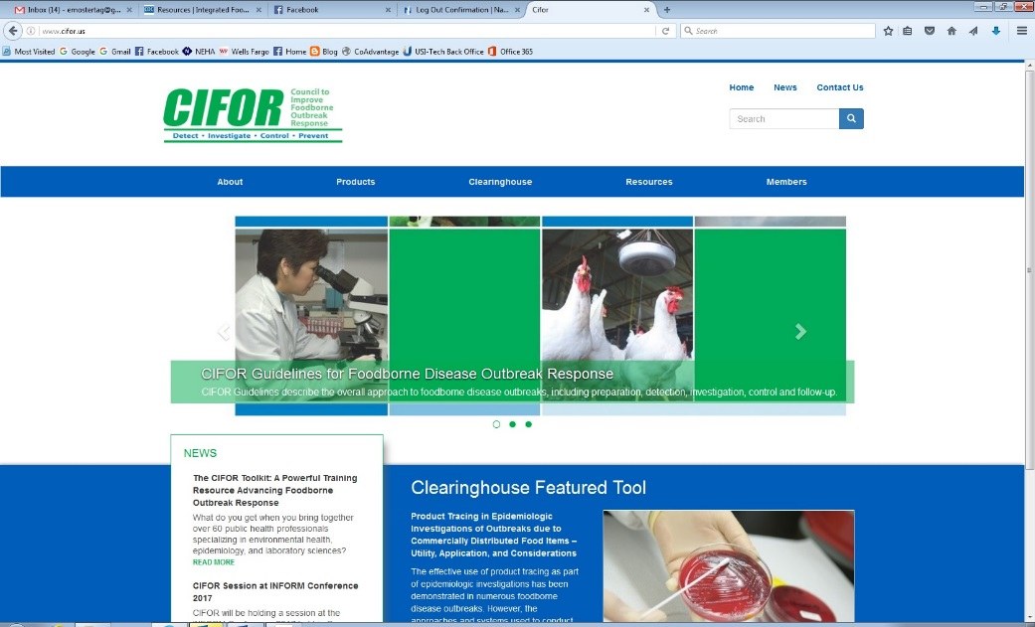
Twitter: max 110 characters  Use CIFOR hashtag, and #foodsafety | We are on the Council to Improve Foodborne Outbreak Response (CIFOR). Learn how CIFOR works to reduce foodborne Illnesses. #CIFORfood #FoodSafety http://cifor.us/  add link to organization webpage on CIFOR.
Twitter: max 110 characters  Use CIFOR hashtag and #foodsafety  Link to clearinghouse. | Looking for free #FoodSafety resources you can download? Go to CIFOR's Food Safety Clearinghouse. #CIFORfood http://cifor.us/clearinghouse  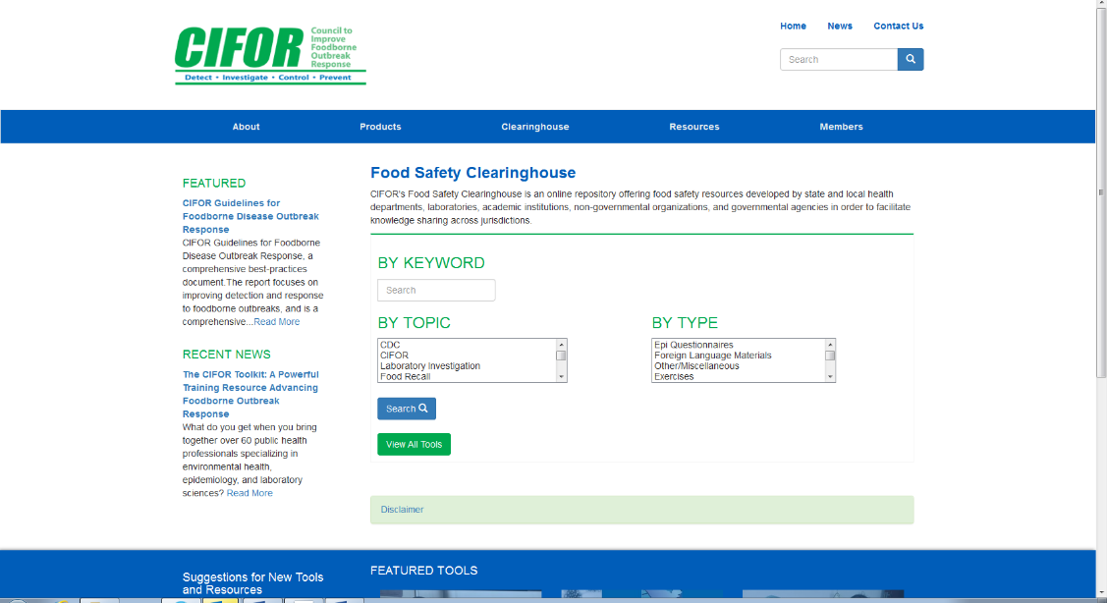
Facebook: max 250 characters | Investigating a foodborne illness outbreak? Download free tools, developed by state and local health departments, laboratories, academic institutions, non-governmental organizations, and governmental agencies. Tools available at CIFOR’s Food Safety Clearinghouse. http://cifor.us/clearinghouse

Background info:
Twitter
Possible images to use with Twitter posts
- Screenshot of new website homepage
- Photos from basecamp’s image library (resize for Twitter)
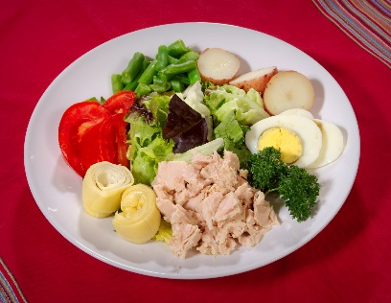
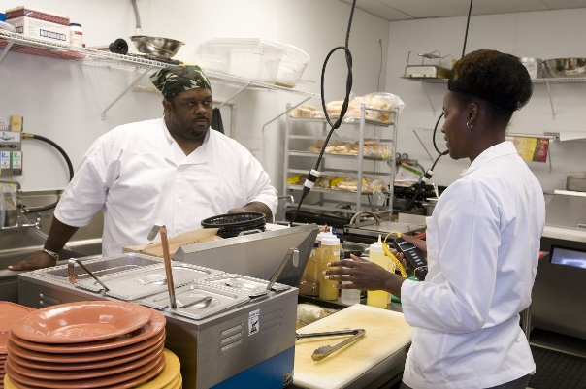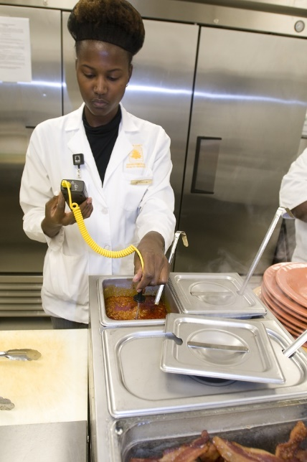

- Do you investigate foodborne outbreaks? Helpful tools on new CIFOR website www.cifor.us #CIFORfood

- CIFOR has a new website with tools to help you investigate foodborne outbreaks. #CIFORfood
http://cifor.us/products

- Find tools and resources to investigate foodborne illness on revamped CIFOR website. www.cifor.us #CIFORfood

Facebook
Possible images to use with Facebook posts (use the above pics) . Must be sized for Facebook.
- Screenshot of new website homepage
- Photos from basecamp’s image library

- The Council to Improve Foodborne Outbreak Response (CIFOR) has a new website, with updated information for local, state and federal health departments, scientists, and industry who collaborate to improve the detection, investigation, control and prevention of foodborne disease in the United States. www.cifor.us

- The Council to Improve Foodborne Outbreak Response's (CIFOR) redesigned, updated website has information for local, state and federal health departments, scientists, and industry who collaborate to improve the detection, investigation, control and prevention of foodborne disease in the United States. www.cifor.us

- Find resources and tools to investigate foodborne illness at CIFOR’s new website. www.cifor.us

