CIFOR Guidelines Toolkit

Document I:
Toolkit Tips for Facilitators

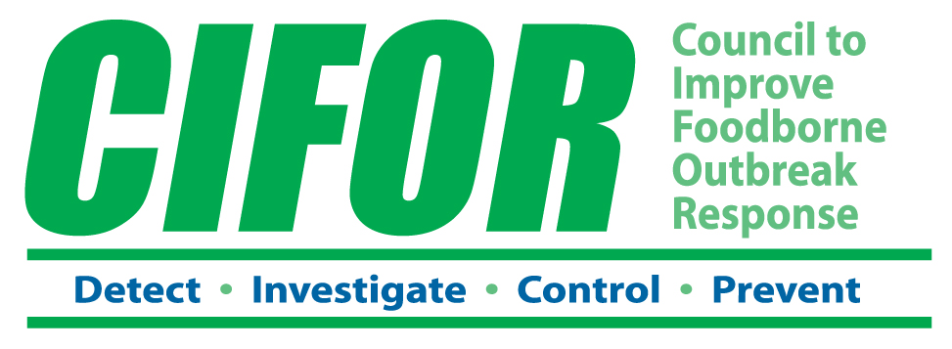

Facilitator role
Assist workgroups of local or state staff responsible for responding to foodborne disease outbreaks with assessing their current outbreak response capabilities and determining where and how to make improvements.

Facilitator experience
- Familiarity with the CIFOR Guidelines;
- Extensive experience in surveillance and outbreak detection, investigation, and control;
- Knowledge of local and state resources available to help implement and carry out surveillance, investigation, and control activities; and
- Familiarity with the CIFOR Toolkit materials and process.

Facilitation tips
- Read through the “Toolkit User Instructions” (Document B) and examine the worksheets before assembling the workgroup. Think about how these materials could help your outbreak response team prevent foodborne illnesses and deaths through more effective disease surveillance and response efforts.
- Be clear about the scope and intended goals for your agency’s or jurisdiction’s Toolkit process so that subsequent discussions can be scaled up or down according to available time and intended goals.
- Identify the local and state agencies in your jurisdiction that are involved in foodborne disease outbreak response.
- Identify who will participate in the workgroup. Remember to include representatives with different types of expertise, including epidemiology, environmental health, food regulation, laboratory science, health education, and communication as well as knowledge of the agency or jurisdiction and to include staff from other agencies, such as State officials.
- Make sure that the workgroup has access to all necessary materials including the entire CIFOR Guidelines, written agency protocols, after-action reports from recent foodborne disease outbreaks or exercises, data from pathogen-specific surveillance and foodborne disease complaint systems, and information on other quality improvement initiatives in which your agency might be involved.
- Before starting, ask participants to identify their agency’s objectives for the workgroup, potential opportunities that will aid implementation of CIFOR recommendations, and any constraints workgroup members should be aware of.
- Help motivate workgroup members by sharing information on the occurrence of foodborne diseases in their jurisdiction and the agency’s past performance in outbreak response. Be honest but stay positive. Do not blame or appear condescending.
- Walk the workgroup through the Toolkit process, step by step, using the “Toolkit User Instructions (Cheat Sheet for Facilitators)” (Document C).
- Describe the general layout of the worksheets for the 11 Focus Areas so they do not look so intimidating to workgroup members.
- Help the workgroup identify their high priority Focus Areas. Remind them to keep the goals of any capacity development or quality assurance initiatives in mind. If different agencies or units are involved in the process, anticipate that their representatives might identify areas of interest primarily to their agency as well as areas of shared interest.
- If workgroup members are having difficulty identifying areas of shared interest, use standard facilitation techniques such as having each person vote on his/her top three priorities for collaboration.

- Do not overplay the selection of priority Focus Areas, however, since most agencies and jurisdictions will benefit from improvements in a number of different (if not all) Focus Areas.
- Workgroups might want to focus initially on “Relationships with Relevant Agencies and Organizations” as a first step since that Focus Area will be relevant to all agencies and likely has broader-reaching ramifications due to its impact on multijurisdictional outbreaks. Remember that industry groups are among the relevant organizations with whom to develop working relationships.
- Keep the workgroup moving. Working through the materials for a Focus Area (e.g., viewing the keys to success and related CIFOR recommendations) alone will help workgroup members become more familiar with the CIFOR Guidelines as a resource.
- In selecting actions to address a particular target for improvement, help the workgroup focus on a few realistic goals as opposed to developing detailed expansive plans. Focusing efforts and energies on a few actions might allow the workgroup to demonstrate more immediate results that will fuel continued efforts toward improvement.
- Encourage all members of the workgroup to participate. Consider calling on individual members of the group, or otherwise encouraging quiet members to provide their input.
- Assure that the workgroup’s findings and recommendations are accurately and concisely recorded.
- Assure that each specialty is reflected in workgroup recommendations (e.g., don’t let all of the recommendations focus on just epidemiology or just environmental health).
- Assure that the workgroup develops an action plan for their recommendations, with the timeframe for implementation and assigned responsibilities.
- Identify how the recommended action plan will be coordinated with the right decision-makers to obtain the high-level support needed for implementation.
- Before the meeting is over, assure that specific plans have been developed for addressing any priorities that were not analyzed during this work session (e.g., setting a date for a subsequent meeting).

