CIFOR Guidelines Toolkit

Document J:
Participant Evaluation Form

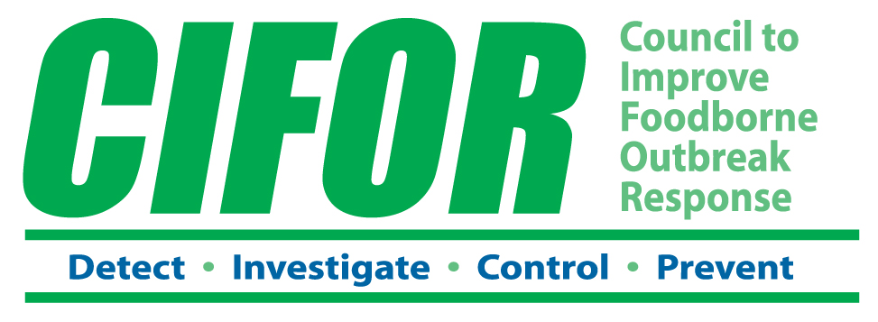

PARTICIPANT EVALUATION

Please take a moment to give us your feedback about the CIFOR Guidelines Toolkit. You can also submit your thoughts about the Toolkit by going to www.CIFOR.us.

Which of the following best describes your agency?
□ Local public health agency □ State environmental health agency
□ Local environmental health agency □ State public health laboratory
□ Local public health laboratory □ State agricultural agency
□ State public health agency □ Other (specify: _________________________)

Which of the following best describes your program area?
□ Agriculture □ Environmental health □ Laboratory
□ Communication □ Food regulation □ Public health nursing
□ Epidemiology □ Health education □ Other (specify: ___________________)

How did you use the Toolkit?
□ In a training/informational setting with individuals from multiple jurisdictions in your state or region
□ Primarily with staff from your agency or jurisdiction
□ Other (describe at end)

How much time was spent in this use of the Toolkit?
□ Less than half a day
□ Between a half and a full day
□ More than a day

Which Focus Areas did you address? (Check all that apply.)
□ Relationships with relevant agencies and
organizations
□ Necessary resources
□ Communication
□ Complaint systems
□ Pathogen-specific surveillance
□ Initial steps of an investigation
□ Epidemiology investigation
□ Environmental health investigation
□ Laboratory investigation
□ Control of source and secondary spread
□ Food recall

Please rate your response to the following statements about the CIFOR Toolkit.
 |  | Strongly Agree | Agree | Neither / Undecided | Disagree | Strongly Disagree | N/A
 | The CIFOR Toolkit process was easy to follow.
 | The CIFOR Toolkit process moved at an appropriate pace.
 | The CIFOR Toolkit process supported a meaningful examination of our outbreak response activities and needed changes.
 | The “Focus Areas” used to organize the CIFOR Toolkit process made sense.

 |  | Strongly Agree | Agree | Neither / Undecided | Disagree | Strongly Disagree | N/A
 | The Focus Areas covered most major outbreak response activities.
 | Which outbreak response activities were omitted from the Focus Areas? | Comments:
 | The worksheets made it easy to review outbreak response at our agency/ jurisdiction and identify activities and procedures in need of improvement.
 | The keys to success helped us understand the critical aspects of outbreak response in the different Focus Areas.
 | The worksheets helped us identify CIFOR recommendations to improve outbreak response appropriate for our agency/jurisdiction.
 | The materials included in the CIFOR Toolkit were adequate to undertake the process.
 | What additional materials would have made it easier? | Comments:

Please share any other thoughts or ideas you have to improve the CIFOR Toolkit.

Your thoughts are important to us. Please send completed evaluations to: Dhara Patel, MPH, Senior Research Analyst, Council of State and Territorial Epidemiologists, 2872 Woodcock Blvd., Suite 250, Atlanta, GA 30341 or by fax at 770-458-8516 or by email at dpatel@cste.org.

