Colonization Surveillance WG
Friday, December 6, 2019; 1:00 – 2:00 PM ET
Participants
Brooke Beaulieu, Scott Troppy, Marion Tseng, DJ Shannon, Caitlin Pedati, Erin Grogan, Ben Chan, Nicole Kosacz, Meredith Lichtenstein, Megan Irving
Agenda:
- Roll
- Quick recap of 11/22 call
- Attempt at reworking CP-CRE in the style of C. auris (separating out colonized vs clinical)
  - Using specimen source to determine intent of testing, separate colonized vs clinical cases
  - Identifying gaps in applying the C. auris approach to CP-CRE, gauging if this approach is generalizable
- At a glance: draft abstract for submission to CSTE 2020
  - Draft abstract attached
  - Discuss review and submission timeline
- Adjourn

Recap of 11/22 Call
- C. auris position statement review
  - No clinical criteria or epi linkage attached to case ascertainment (epi linkage was included in case definition)
    - Would not expect clinical criteria for a screening case
    - Does this mean clinical criteria has to be ruled out to be able to call something a colonization case?
  - Does it make sense to have a case definition for clinical cases and one for screening cases (in the same position statement)?
    - Agreement that this would be helpful
  - Specimen source can be used to estimate intent of testing
    - Certain sites are associated with screening, others with clinical
    - Estimated intent of testing can then inform if colonization or clinical case
    - How can this be applied to CPOs and implemented from program standpoint
- CSTE 2020 abstract, revised Brief scope
- DHQP will be joining future call(s) to give CDC perspective

Simplified Logic Flow Chart
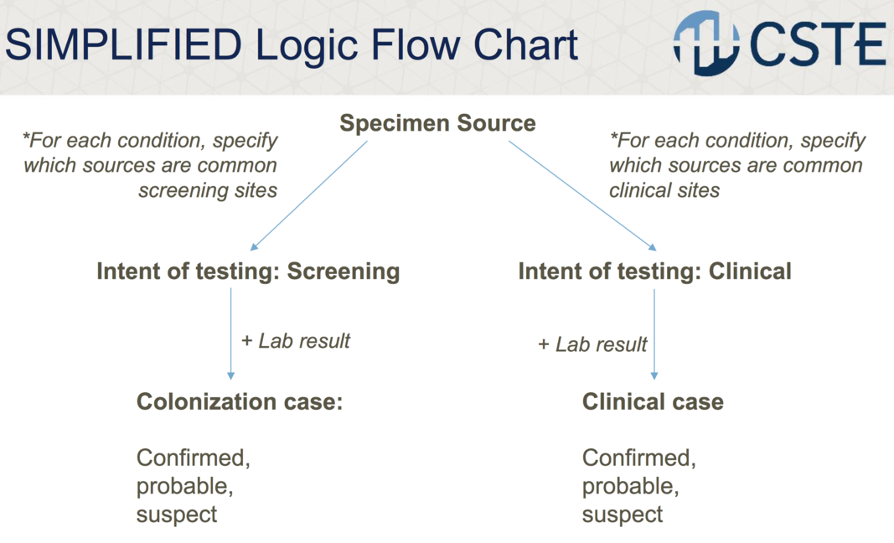

Logic Flow Chart Applied to C. auris
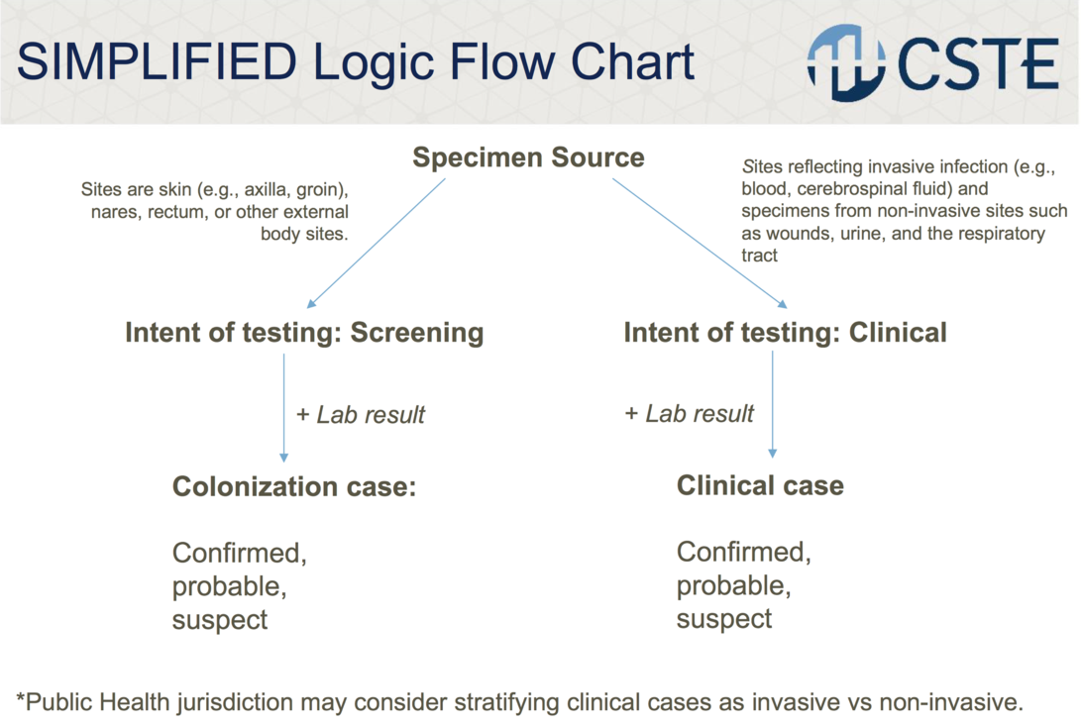
Confirmed, probable, suspect classification for C. auris is dependent on type of lab test and epi linkage

Attempt at reworking CP-CRE as an example of applicability
- Currently position statement does not differentiate between colonization and clinical cases
- There are only confirmed cases
CP-CRE work-through: Separating out colonization vs clinical
(language from position statement) *Screening tests should generally be limited to rectal, peri-rectal or stool cultures. Cultures from such sites can be assumed to be for screening unless specifically noted otherwise. Laboratory may also note screening culture for other sites (e.g., wounds, tracheostomy or central line sites).
Specimen Source
Clinical case
Confirmed
Any other site? Any sites that would be helpful to specifically spell out?
+ Lab result
+ Lab result
Colonization case:
Confirmed

Rectal, peri-rectal, stool cultures, or other sites specifically noted as screening cultures

*offshoot for mechanism-only? Potentially in the future for a CPO position statement

Intent of testing: Screening
Intent of testing: Clinical

** Add in layers for organism known vs unknown, type of testing, how to factor in clinical info (not currently specified in case ascertainment)

CURRENT TABLE 7: ALL NNC
Criterion | CONFIRMED CP-CRE  Klebsiella spp. | CONFIRMED CP-CRE  E. coli | CONFIRMED CP-CRE  Enterobacter spp.
Laboratory Evidence
ETC. (specimen source not specified)
ETC. (specimen source not specified)

POTENTIAL TABLE 7: (Separating out colonization and clinical) – Which would be NNC?
Criterion | CONFIRMED COLONIZATION  Klebsiella spp. | CONFIRMED COLONIZATION  E. coli | CONFIRMED COLONIZATION  Enterobacter spp. | CONFIRMED CLINICAL  Klebsiella spp. | CONFIRMED CLINICAL  E. coli | CONFIRMED CLINICAL  Enterobacter spp.
Laboratory Evidence
ETC. (specify source/intent of testing
ETC. (specify source/intent of testing

Discussion Questions:
  - Which sites would indicate clinical testing?
  - Typically, what is the typical quality/completeness of specimen source data?
  - What are the benefits of this approach? Limitations?
  - Is this approach feasible for broad implementation?
  - Future item: what does this look like in real life?

- Thoughts:
  - What would be nationally notifiable?
    - With C. auris, colonized cases are not, clinical cases are
  - Does this change if we are thinking about a mechanism and not a species?
    - This scheme may only apply to mechanisms that have organism
    - Include a branch for mechanism only that leads to colonization case?
    - Potential in future for a CPO position statement?
  - Add layers to the flow chart for organism known vs unknown, type of testing, how to factor in clinical info (nor currently specified in case ascertainment)
  - Note that there has been some email discussion related to whether colonization cases for CP-CRE should have a probable and confirmed case classification vs just confirmed. We will explore this discussion more on the next call.
- Goal: To have a draft brief written by the 2020 CSTE conference that has gone through some preliminary commenting/revision. We will use the roundtable to further vet our thoughts.

Draft of roundtable abstract for CSTE 2020 (draft was sent via email on 12/6/19)
- Suggestion to give a more specific title
- Need to target the programmatic epis but also reach out to the State Epis to encourage them to come to this meeting/roundtable
- Please submit feedback by 12/20!
- If you would like to be listed as an author (can have 2), please let Brooke know

Next Call: Friday, January 3 at 1:00 PM ET
- Anticipate DHQP will be on next call
- Further discuss flow chart and applicability to various conditions
- Review revised Brief outline, begin to determine approach/assign sections to continue development

