CORHA Spring Meeting

Emory Conference Center Hotel
1615 Clifton Road, NE

Atlanta, GA 30329

May 4 and 5, 2017

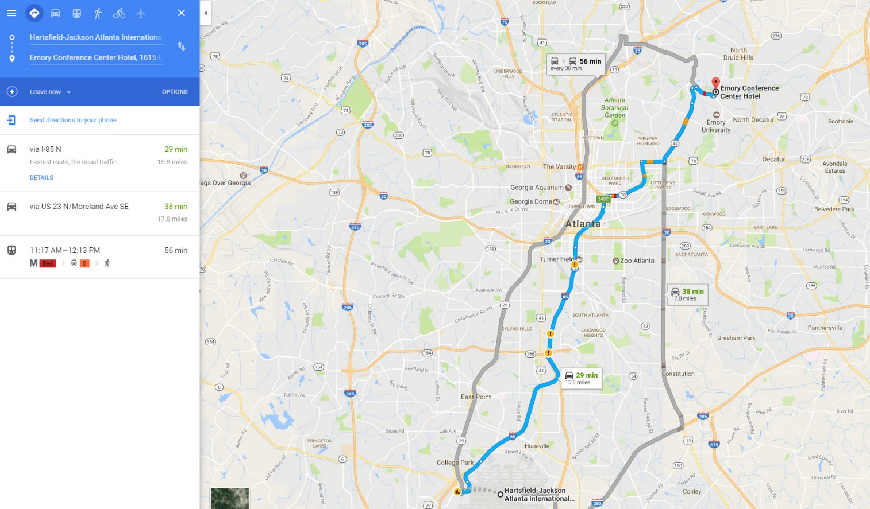

Airport Shuttle
Airport Transportation is available from Atlanta Superior Shuttle. Please visit the Atlanta Superior Shuttle website for rate information and reservations. Shuttle service from Airport departs from Ground Transportation Center.

Driving Directions

*Ground transportation to and from the airport will be reimbursed.

85 South to North Druid Hills Road (Exit 89)
- At the end of the ramp, turn left onto North Druid Hills Road.
- At the second traffic light, turn right onto Briarcliff Road.
- At the 6th traffic light, turn left onto Clifton Road. The conference center is approximately (1) mile on the left at 1615 Clifton Road.

85 North (From the airport)
- Take I-85 north to Exit 248C (Freedom Parkway).
- Follow the signs to the Carter Center and bear right on 42 east until it dead ends.
- Go left on Moreland Avenue; Moreland becomes Briarcliff.
- Stay on Briarcliff and go approximately three miles.
- Turn right on Clifton Road.
- At the 5th traffic light, make a left into the Emory Conference Center Hotel.

I-85 North to North Druid Hill Road South (Exit 89)
- At the end of the ramp, turn right onto North Druid Hills Road.
- At the 3rd traffic light, turn right onto Briarcliff Road.
- At the 6th traffic light, turn left onto Clifton Road.
- The conference center is approximately 1 mile on the left at 1615 Clifton Road.

75 North
- Drive from 75 North to 85 North.
- Follow directions from 85 North.

75 South
- Follow signs to I-85 North (left exit).
- Follow I-85 North to Exit #89 North Druid Hills. At end of ramp turn right.
- At the second light, turn right on Briarcliff Road.
- At the sixth light, turn left on Clifton Road.
- The Emory Conference Center Hotel will be on the left approx 1 mile down Clifton.

I 20 East or West
- Exit on Moreland Avenue North (Exit 60-B).
- Head north on Moreland Avenue for 4 ½ miles (note: Moreland Avenue turns into Briarcliff Road after 2 miles).
- Turn right onto Clifton Road.
- The conference center is approximately 1 mile on the left.

HWY 78
- Take HWY 78 West to Scott Boulevard.
- Traveling south on Scott Boulevard turn right onto North Decatur Road.
- Turn right onto Clifton Road.
- The conference center is approximately 1 mile on the right.

400 South
- 400 South to Piedmont Road/Sydney Marcus Boulevard Exit.
- At end of ramp, go left onto Sydney Marcus Boulevard.
- At the next light, go left onto Buford Highway.
- At the next light, turn right onto Cheshire Bridge Road.
- At the 4th traffic light, turn left onto LaVista Road.
- At the 2nd traffic light turn right onto Briarcliff Road.
- At the 3rd traffic light, turn left onto Clifton Road.
- The conference center is approximately 1 mile on the left.

Public Transportation
MARTA serves the Emory Conference Center Hotel. From Hartsfield International Airport take MARTA to the Lindbergh Station. From Lindbergh take the #6 bus directly to the hotel. Visit MARTA. Emory Cliff Busses serve the University Monday through Friday from 5:30 AM until 7 PM. This transportation is complimentary.

