CORHA Laboratory Workgroup Kick-off Conference Call
October 01, 2019 (9 – 10 am) EST
Members: Jafar Razeq (Co-Chair; APHL, CT), Dan Diekema (Co-Chair; UoI), Rita Parke Stainback (ACLA, LabCorp), Kaede Ota Sullivan (SHEA, TU), Kamal Singh (ASM, Northshore), Dawn Seivert (CDC), Monica Schroeder (CSTE), Martha Ngoh (ASTHO), Kate Heyer (ASTHO)

Liaisons & Staff: Kelly Wroblewski (APHL), Angela Fritzinger (APHL), Puja Shah (CSTE), Wendy Bamberg (CSTE)

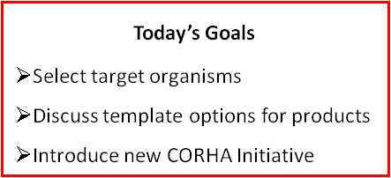
https://aphl.zoom.us//j/967894726
Phone: 646-876-9923
Meeting ID: 967 894 726

Agenda:
- Roll Call and Introductions (Angela)
- Review Laboratory Workgroup Purpose and Objectives (Jafar)

- Logistics (Angela)
- Call frequency
- Ground rules for conference calls:
- Everyone has a voice
- Be respectful of others
- Be engaged
- Identify yourself when speaking
- Any others?
- Platforms to share information
  - Sharepoint: working drafts of documents and other products
  - Basecamp: meeting agendas and minutes; finalized documents and other products
- Target organisms (Dan)
- Product templates (Jafar)
- New CORHA initiative (Wendy)
- Action Items (Angela)
- Schedule Next Call (Angela)

