CORHA Overview (2019)
Audience - By Year:
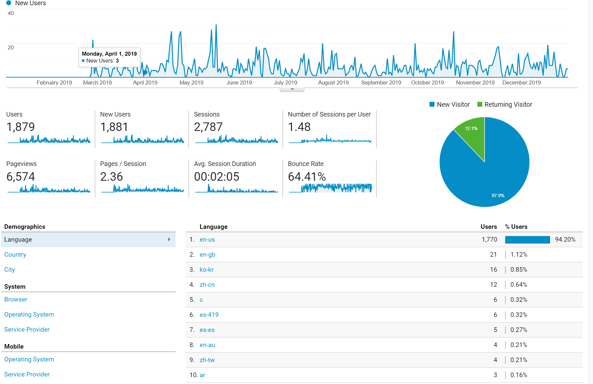
2019 Yearly Stats:
- Users: 1,879
- Session: 2,787
- Pageviews: 6,574
Audience - By Month:
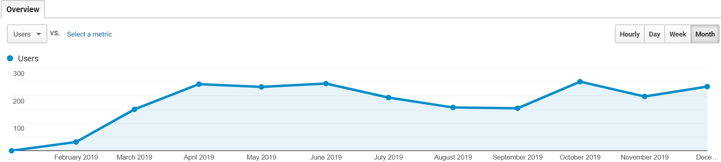
2019 Monthly Stats:
Months with the highest visitors:
- October 2019 – 252 users
- June 2019 – 245 users
- April 2019 – 243 users
- December 2019 – 234 users
Months with the lowest visitors:
- February 2019 – 32 users
- March 2019 – 151 users
- September 2019 – 155 users

Top Pages on CORHA.org by Pageview:
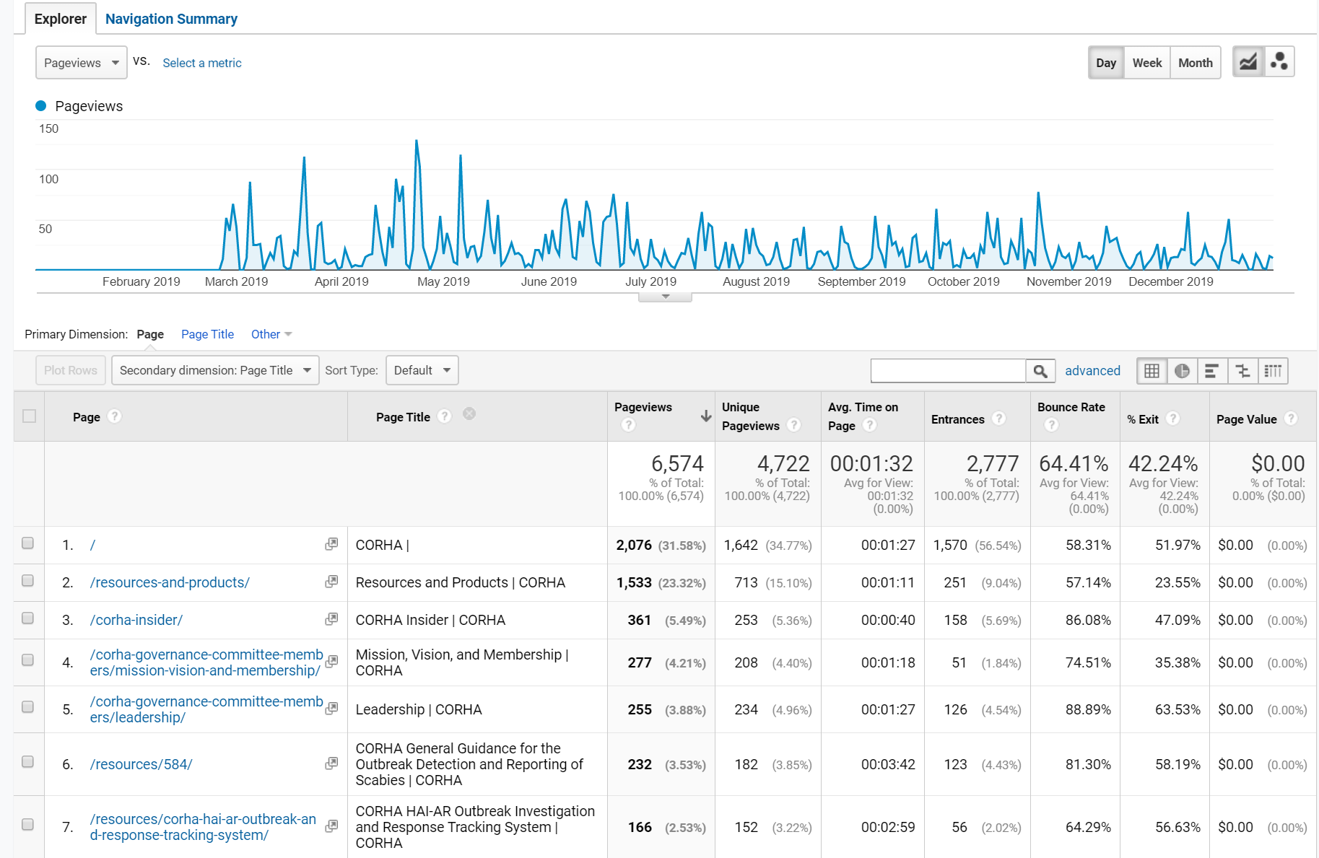
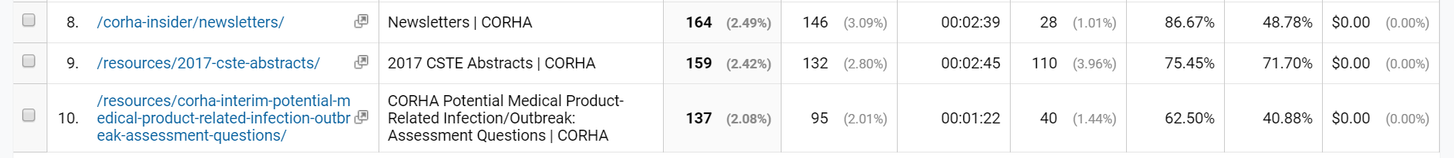
- CORHA Homepage
- Resources and Products
- CORHA Insider
- Mission, Vision, and Membership
- Leadership
- CORHA General Guidelines for the Outbreak Detection and Reporting of Scabies
- CORHA HAI-AR Outbreak Investigation and Response Tracking System
- Newsletters
- 2017 CSTE Abstracts
- CORHA Potential Medical Product-Related Infection/Outbreak Assessment Questions
How Traffic Comes to CORHA.org:
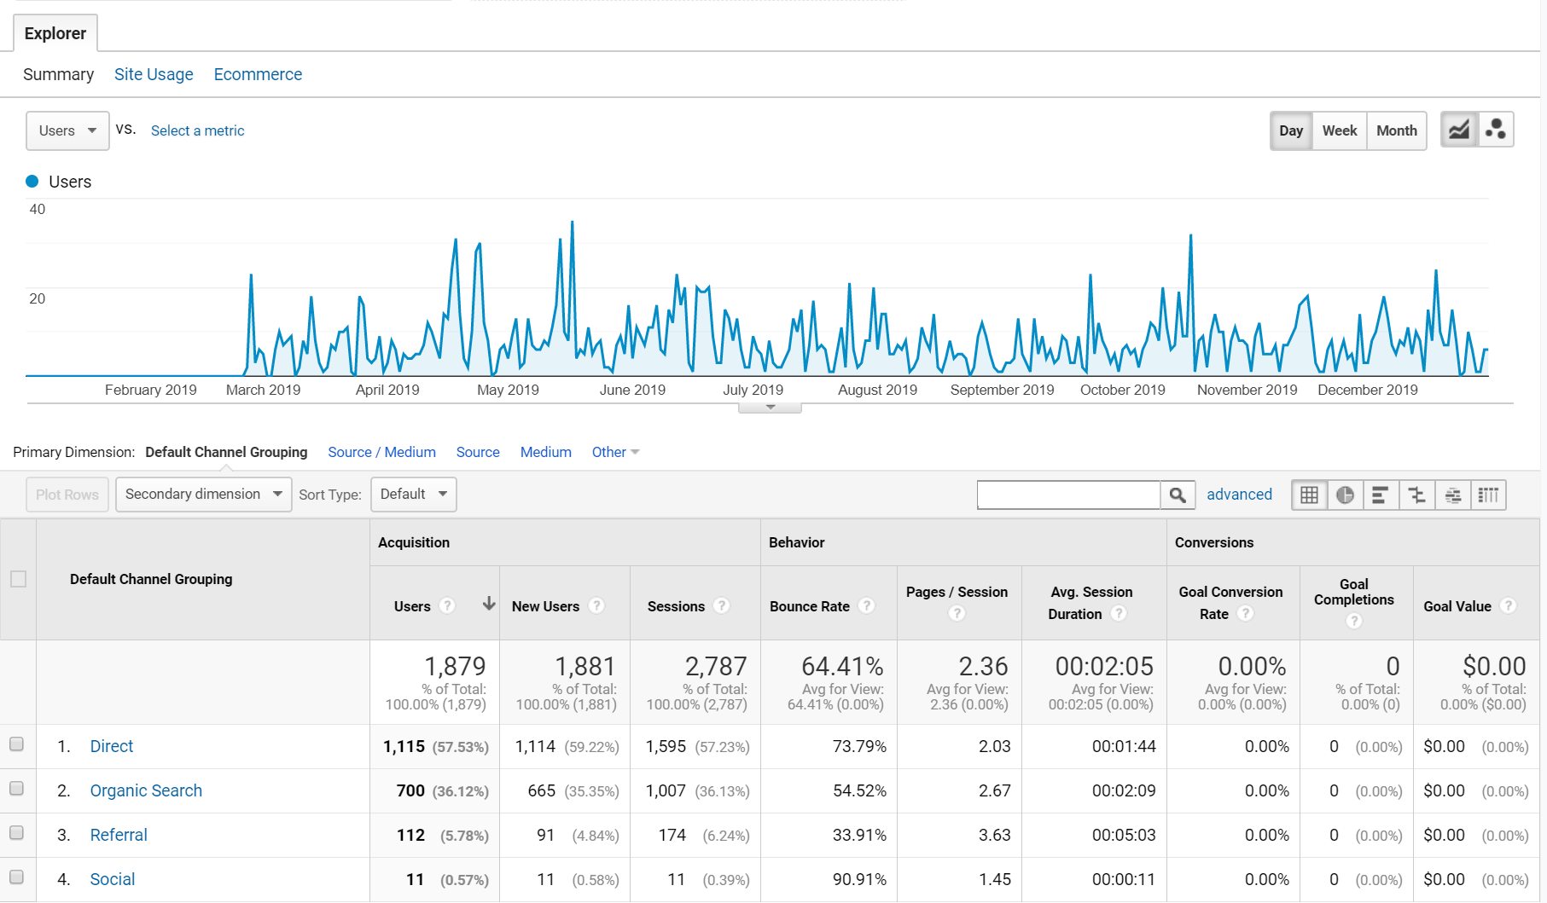
Traffic coming to the site.
- Direct (traffic that comes directly to the site via bookmarks, etc., incognito views and/or other ways to remove tracking)
- Organic Search (traffic coming from search engines such as google, bing, etc.)
- Referral (traffic with tracking code coming from astho.org, Informz (newsletter), etc.)
- Social (Facebook and Twitter)

