

Council for Outbreak Response: Healthcare-Associated Infections and

Antibiotic-Resistant Pathogens

Spring 2018 Meeting | May 23-24, 2018

Emory Conference Center, Atlanta, GA

Starvine I Room

Conference Call Line: 1-866-740-1260 | Passcode 5273136

Meeting Objectives: To review progress made towards meeting CORHA and workgroup strategic goals and objectives and continue development of CORHA’s product offerings.

Meeting Agenda
Wednesday, May 23
Time | Activity | Location
8:00 AM | Breakfast | Starvine Foyer
8:30 AM | Introductions and Orientation to the Meeting  - Introductions of meeting participants  - Review of meeting materials  - Review of CORHA’s Strategic Map and implementation priorities  - Updates from the Governance Committee  - Presentations from Workgroup A and B Leads | Starvine I
9:30 AM | CORHA High-Level Outbreak Investigation Guidance | Starvine I
10:30 AM | Break | Starvine Foyer
10:45 AM | Medical Product Investigations | Starvine I
11:45 AM | High-Level Outbreak Investigation Guidance Small Group Meetings/Outline Development  - Groups will be split to focus on reviewing and developing outlines for upcoming chapters  - Outbreak Planning and Preparation --------------------------------->  - Outbreak Detection and Surveillance ------------------------------->  - Investigation of Clusters and Outbreaks ----------------------------> | Starvine I  Starvine II  Peachtree
12:45 PM | Working Lunch | Emory Conference Center Dining Room
2:00 PM | Workgroup Meetings  - Workgroup A  - Workgroup B | Workgroup A: Starvine II  Workgroup B:  Peachtree
3:45 PM | Break | Starvine Foyer
4:00 PM | Workgroup Meetings  - Laboratory Workgroup  - Policy Workgroup | Lab: Starvine II  Policy: Peachtree
5:00 PM | Full Council Discussion and Report-Back | Starvine I
5:30 PM | Adjourn
6:00 PM | Optional Group Dinner | Tin Lizzy’s

Thursday, May 24
Time | Activity | Location
8:00 AM | Breakfast | Starvine Foyer
8:30 AM | Welcome and Overview of the Day | Starvine I
8:45 AM | Workgroup Meetings | Workgroup A: Starvine II  Workgroup B:  Peachtree
10:45 AM | Break
11:00 AM | - Communications and Website  - Prioritization of Future Activities  - Report Outs | Starvine I
12:30 PM | Next Steps and Wrap Up | Starvine I
12:50 PM | Adjourn
1:00 PM | Governance Committee Business Meeting

Contents
Meeting Agenda 1
Meeting Participants 4
Council Strategic Map 7
CORHA Development Process for High-Level Guidance on HAI/AR Outbreak Detection, Reporting, Investigation and Control: Roadmap (Draft) 8
Medical Product Investigations 12
CORHA Laboratory Workgroup Charge (Draft) 16
CORHA Policy Workgroup Charge (Draft) 17
CORHA Activities At-A-Glance 19
Appendix A: CORHA High-Level Guidance Chapter on Investigation of HAI/AR Outbreaks (Draft) 20
Appendix B: CORHA Background and Overview 34

Meeting Participants

Meredith Allen, DrPH, MS  Association of State and Territorial Health Officials  mallen@astho.org | Kristen Ehresmann, RN, MPH  CORHA Voting Member  Association of State and Territorial Health Officials  Minnesota Department of Health  kristen.ehresmann@state.mn.us
Michael Anderson, MPH  Council of State and Territorial Epidemiologists  manderson@cste.org | Jeff Engel, MD  Council of State and Territorial Epidemiologists  JEngel@cste.org
Wendy Bamberg, MD  CORHA Voting Member  Council of State and Territorial Epidemiologists  Colorado Department of Public Health and Environment  wendy.bamberg@state.co.us | Erin Epson, MD  CORHA Voting Member  Council of State and Territorial Epidemiologists  California Department of Public Health  erin.epson@cdph.ca.gov
Isaac Benowitz, MD  Centers for Disease Control and Prevention  Key6@cdc.gov | Andrea Flinchum, MPH  Council of State and Territorial Epidemiologists  Kentucky Department for Public Health  Andrea.Flinchum@ky.gov
James Blumenstock, MA  Association of State and Territorial Health Officials  jblumenstock@astho.org | Steven Franklin, MPH  Centers for Disease Control and Prevention  yom9@cdc.gov
Gerd Clabaugh, MPA  CORHA Governance Committee Co-Chair  Association of State and Territorial Health Officials  Iowa Department of Public Health  gerd.clabaugh@idph.iowa.gov | Linda Greene, RN, MPS, CIC  CORHA Voting Member  Association for Professionals in Infection Control and Epidemiology  Highland Hospital-University of Rochester Medical Center  Linda_Greene@URMC.Rochester.edu
Matthew Crist, MD, MPH  Centers for Disease Control and Prevention  cwu0@cdc.gov | Cal Ham, MD, MPH  Centers for Disease Control and Prevention  ink4@cdc.gov
Valerie Deloney, MBA  Society for Healthcare Epidemiology of America  vdeloney@shea-online.org | Bonnie Herring  Centers for Disease Control and Prevention  lte4@cdc.gov

Kate Heyer, MPH  Association of State and Territorial Health Officials  kheyer@astho.org | Elizabeth Mothershed, MS  CORHA Voting Member  Centers for Disease Control and Prevention  ekm9@cdc.gov
Carissa Holmes, MPH  Centers for Disease Control and Prevention  ipz3@cdc.gov | Allyn Nakashima, MD  CORHA Voting Member (Representing Joe Miner)  Association of State and Territorial Health Officials  Utah Department of Health  anakashima@utah.gov
Waleed Javaid, MD  CORHA Voting Member  Society for Healthcare Epidemiology of America  SUNY Upstate Medical University  javaidw@upstate.edu | Martha Ngoh, MPH  Association of State and Territorial Health Officials  mngoh@astho.org
Marion Kainer, MD, MPH  CORHA Governance Committee Co-Chair  Council of State and Territorial Epidemiologists  Tennessee Department of Health  marion.kainer@tn.gov | Priti Patel, MD, MPH  Centers for Disease Control and Prevention  pgp0@cdc.gov
Lilly Kan, MPH  National Association of County and City Health Officials  lkan@naccho.org | Joseph Perz, DrPH, MA  CORHA Governance Committee Member  Centers for Disease Control and Prevention  bzp4@cdc.gov
Preeta Kutty, MD, MPH  Centers for Disease Control and Prevention  chz6@cdc.gov | Marcus Plescia, MD, MPH  Association of State and Territorial Health Officials  mplescia@astho.org
Mary Alice Lavin, RN  Association of Professionals in Infection Control and Epidemiology  alavin@att.net | Krista Powell, MD, MPH  Centers for Disease Control and Prevention  duf8@cdc.gov
Ruth Link-Gelles, PhD, MPH  Centers for Disease Control and Prevention  hzt7@cdc.gov | Aftin Ross, PhD  Food and Drug Administration  aftin.ross@fda.hhs.gov
Lisa McGiffert  Consumers Union  lmcgiffert@consumer.org | Dhara Shah, MPH  Council of State and Territorial Epidemiologists  dshah@cste.org

Rachel Stricof, MPH
Council of State and Territorial Epidemiologists
HAI Consultant
rstricof@gmail.com

Dawn Terashita, MD, MPH
CORHA Governance Committee Member
National Association of County and City Health Officials
Los Angeles County Department of Public Health
dterashita@ph.lacounty.gov

Maureen Tierney, MD, MSc
Council of State and Territorial Epidemiologists
Nebraska Department of Health and Human Services
Maureen.Tierney@nebraska.gov

Mark Weng, MD, MSc
Centers for Disease Control and Prevention
lyo4@cdc.gov

Richard Wild, MD, JD, MBA
CORHA Voting Member (Representing Patti Meier)
Centers for Medicare & Medicaid Services
Richard.Wild@cms.hhs.gov

Kelly Wroblewski, MPH
Association of Public Health Laboratories (APHL)
kelly.wroblewski@aphl.org

Council Strategic Map

Council for Outbreak Response: Healthcare-Associated Infections and Antibiotic-Resistant Pathogens
Strategic Map: 2016-2018

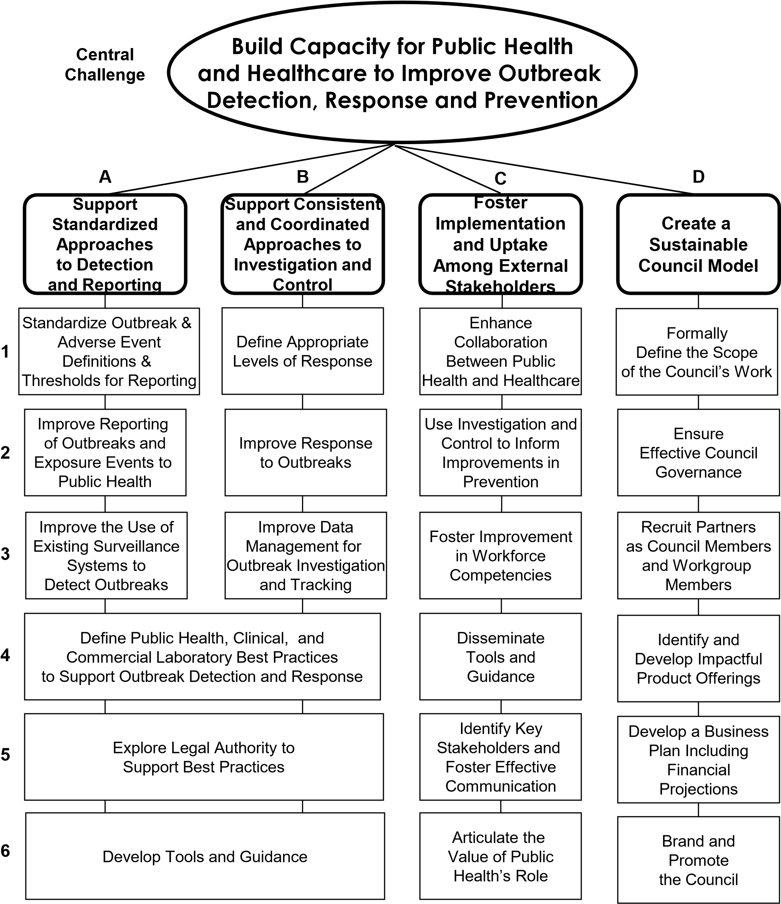

CORHA Development Process for High-Level Guidance on HAI/AR Outbreak Detection, Reporting, Investigation and Control: Roadmap (Draft)

Background
This document outlines the purpose, content, status and future plans for the development of the CORHA’s High-Level Guidance (HLG).
Description
The CORHA HLG is intended as a comprehensive reference containing information specific to HAI/AR outbreak detection, reporting, investigation and control. The document covers key areas that are applicable to settings across the public health and healthcare continuum.
Rationale for a CORHA HLG
The CORHA HLG aims to equip public health, healthcare and other stakeholders with information on a series of HAI/AR outbreak response topics and will serve as a resource for users who are trying to build, standardize or improve capacities and practices related to HAI/AR outbreak detection, reporting, investigation and control.
Additionally, the completed HLG will serve as the principal CORHA product offering and a highly visible means to advance our mission and vision, solidify CORHA’s brand, and establish the Council’s presence as a leader in efforts to improve HAI/AR outbreak detection, reporting, investigation and control.
HLG Format
The organization of chapters in the HLG, when fully assembled, will provide a comprehensive overview of HAI/AR response, following a logical sequence from planning to performance measurement and progressing from basic issues to more advanced topics. Content in the HLG will be formatted to accommodate several print, web and digital platforms to address unique users’ needs. Utilization of digital platforms will allow for a “living document” approach in which links to newly developed CORHA resources or external content can be added as these become available.

Chapters will be developed in a phased manner and will not always follow the exact order in which proposed chapters appear in the overall HLG outline. Chapters in the HLG will also be subject to separate review, approval and publishing schedules.

Future and Proposed Chapters for Development
The following draft outline reflects discussion by CORHA members and partners (e.g., at the November 2017 in-person meeting in Atlanta, GA), in addition to chapter topics modeled after the CIFOR guidance:
- Chapter 1: Overview of the CORHA HLG
- Chapter 2: Fundamental Concepts of HAI/AR Outbreak Response
- Chapter 3: Planning and Preparation for HAI/AR Outbreak Response– In development
- Chapter 4: HAI/AR Outbreak Detection and Reporting – In development (outline stage)
- Chapter 5: Investigation of HAI/AR Outbreaks – In development (review stage)
- Chapter 6: Laboratory Best Practices in Support of HAI/AR Outbreak Response
- Chapter 7: Special Consideration for Multi-Jurisdictional Outbreaks
- Chapter 8: Performance Indicators for HAI/AR Outbreak Response
- Chapter 9: Legal Considerations for Reporting, Investigation and Control of HAI/AR Outbreaks
- Supplement: Communications, Media, Public Reporting, Notification and Disclosure
- Supplement: Medical Product Investigations [Q: stand-alone vs. Ch. 7]
- Supplement: Infection Control Breach Investigations

Participants in the Development of the HLG
Roles and Responsibilities related to HLG content development are as follows:
- Council member(s) at-large: Will contribute ideas and advice regarding the overall HLG content and format, as well as the content and outline for material contained and organized within individual chapters. Note that CORHA voting members will also be asked for their approval on final chapter drafts.
- Chapter/Module Writing Team: Will be responsible for drafting the chapter/module manuscript. The team will consist of one or two Leads. These persons may be individuals with technical writer-editor skills and/or a subject-matter expert on the topic of interest, who is also a participant in CORHA and familiar with its workgroups and strategic objectives. The Writing Team Lead(s) may be nominated or identified by CORHA members and will be vetted by CORHA’s Governance Committee. Additional persons may be drafted as part of the Writing Team based on relevant CORHA workgroup membership and/or subject matter expertise. These individuals will contribute to the actual drafting of the chapter/module.
- Chapter/Module Review Team: Will review and comment on the chapter/module draft from the Writing Team. The Chapter/Module Reviewers may be subject-matter experts and should be familiar with CORHA’s mission, vision, and activities. Reviewers may be nominated by CORHA member organizations to serve on the Team. Review Team Members will be vetted by CORHA’s Governance Committee.
- Series Editor(s): TBD—determine who will perform the final review and standardization of chapters, using a pre-determined CORHA style guide.

Proposed Next Steps for the HLG
Proposed next steps for the HLG are as follows:
- Current Chapters in Development: The HLG materials that are currently in development will require review by the Governance Committee and CORHA voting members. These chapters will be subject to steps D through F of the review process outlined below.
- Future Chapters for Development: For those chapters/modules not yet under development, the Governance Committee, with support from CORHA staff, will be charged with:
- Mapping out and vetting the list of chapters for development
- Identifying chapter/module Writing Team members
- Identifying chapter/module Review Team members
- Communicating updates on HLG chapter/module development to CORHA Membership on All-CORHA calls and at in-person meetings.

HLG Development and Review Process

- Chapter Selection and Prioritization
The CORHA Governance Committee will arrange discussion of HLG organization, including chapter selection, prioritization and outlines; for example, at in-person Council meetings. In addition, CORHA voting members may propose, in writing, content to be developed and included in the HLG. Content must be connected to the CORHA Strategic Map and related to current or future CORHA Workgroup activities and/or products. Proposals to include content in the HLG must contain a discussion of the issue, suggestions on potential substantive content, and a recommendation for authors and taskforce members to be charged with the content development.

- Chapter Planning and Outline
Following the above steps, the Writing Team, with guidance from the Governance Committee and input from the Review Team will be tasked with developing the outline for the accepted chapter. The chapter outline will contain a breakdown of the content, format, suggested models and frameworks to be used.

- Chapter Development and Writing
Following approval of the chapter outline, the Writing Team will be tasked with drafting the chapter. Throughout the development process, authors are encouraged to solicit information, resources and support from the Review Team as well as other CORHA members and representatives via email, on conference calls and at in-person meetings.

- Periodic Chapter Review and Edits
Throughout the development process, members of the Review Team will be tasked with periodic reviews of the chapter drafts. CORHA staff will arrange and coordinate conference calls with the Writing Team and Review Team members. During these periods of review, Review Team members will have the opportunity to provide detailed feedback (suggested edits/additions/deletions). Writing Team members will strive to edit the content to address the feedback to the mutual satisfaction of both Teams.

- Leadership Review
Upon the completion of the draft chapter, the CORHA Governance Committee will receive the draft for review and comments. During this review period, GC members may submit comments to the both the Writing Team and Review Team.

- Final Review and Approval
Following step E, the final draft will be shared with CORHA voting members for review and a vote. The final CORHA member-approved chapter will then be branded and posted to the CORHA website.

Medical Product Investigations

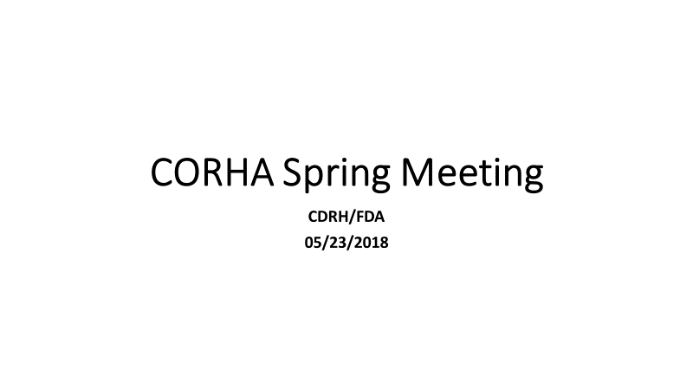

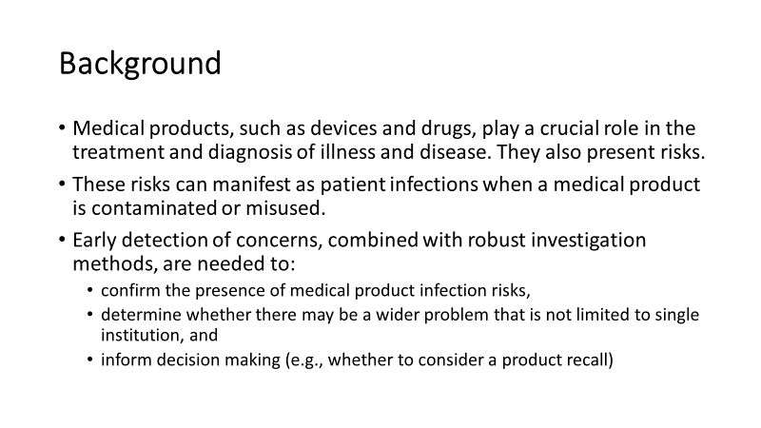
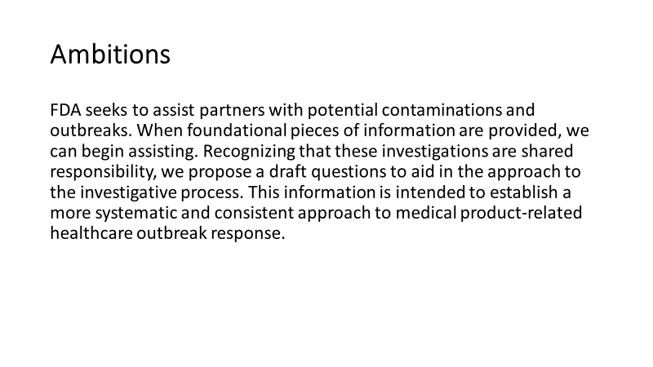

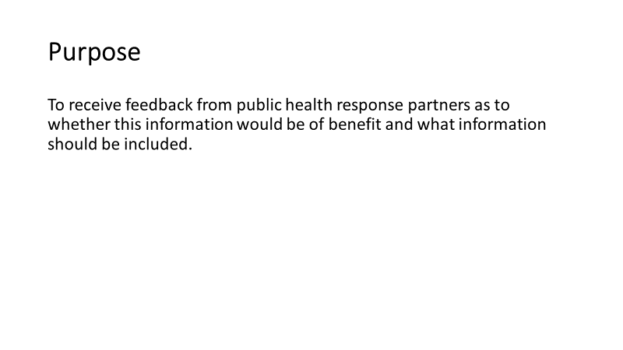

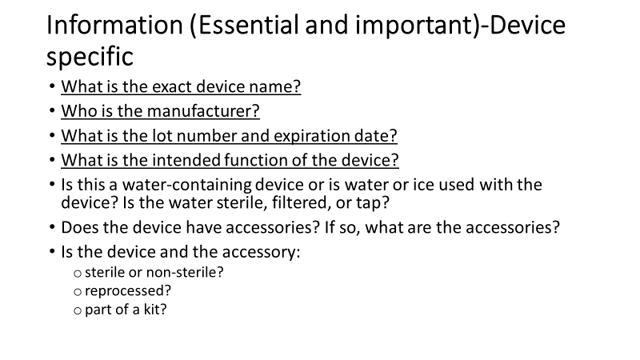

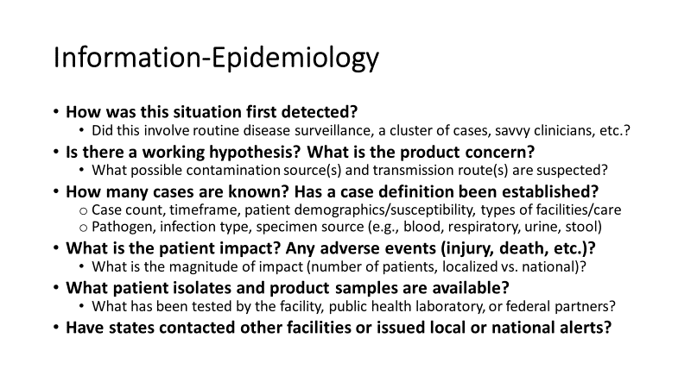

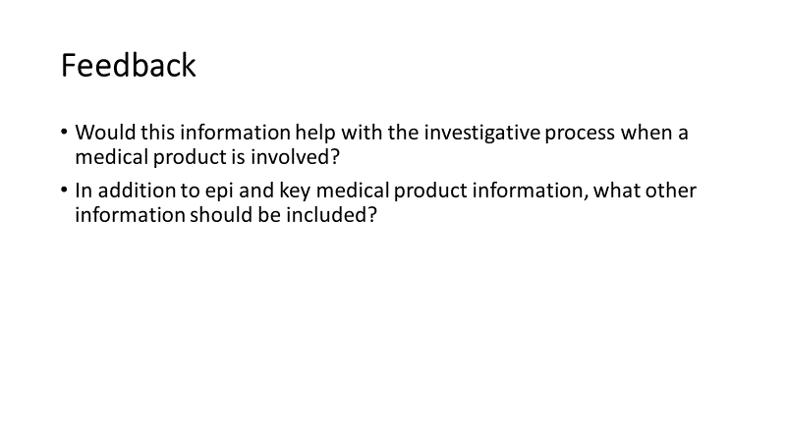



CORHA Laboratory Workgroup Charge (Draft)

Workgroup purpose:
The Laboratory Workgroup of CORHA seeks to promote and support improvement of laboratory response to healthcare-associated infection outbreaks. The primary objective is to define public health, clinical, and commercial laboratory best practices to support outbreak detection and response. The workgroup will assist laboratorians as well as public health and clinical partners by developing guidance, identifying best practices, and improving collaborations with healthcare facilities and state/local public health departments.

The workgroup is tasked with the following activities:

- Contribute knowledge and support activities that lead to improving laboratory test methods in support of HAI/AR outbreak response activities. The workgroup will:
  - Promote implementation of techniques to detect specific pathogen strains (e.g. CP-CRE) helpful for outbreak response.
  - Determine what laboratory test methods are practical for HAI/AR outbreak response

- Identify and promote best practices for laboratory data collection and data sharing in relation to HAI/AR outbreak response. The workgroup will:
  - Determine what laboratory data would be most valuable for outbreak identification/investigation.
  - Make recommendations on reporting roles and methods for different types of laboratories, including clinical, commercial, research, and public health laboratories, to relevant stakeholders.

- Support effective interactions between laboratories, healthcare facilities, and state/local health departments in the context of HAI/AR response activities. The workgroup will:
  - Identify best practices for how laboratories can assist epidemiologists and other partners with identifying potential outbreaks and investigating routes of transmission.
  - Identify best practices for outbreak response from a laboratory perspective and determine the roles of each stakeholder during an investigation.
  - Foster relationships with laboratory stakeholders

CORHA Policy Workgroup Charge (Draft)

Workgroup purpose:
The CORHA Policy Workgroup seeks to address the legal and policy considerations related to outbreaks of healthcare-associated infection (HAI), including those caused by antimicrobial-resistant (AR) pathogens, and make recommendations to policy makers at all levels to improve the detection, reporting, investigation, control and prevention of HAI/AR outbreaks.

To address these priorities, the Workgroup will work in sequence to address the following focus areas:

- Improve reporting of HAI/AR outbreaks and exposure events
Outbreak Reporting, Notification, and Disclosure.
For the purposes of this workgroup, outbreak reporting is defined as activities that occur when a facility reports a possible outbreak to public health, notification occurs when patients potentially affected by an outbreak are informed, and disclosure is defined as activities that occur to inform individuals beyond the patients potentially affected by an outbreak.

To address outbreak reporting, notification, and disclosure, Policy Workgroup members will conduct the following activities in Phase I:
  - Assess current state laws relating to HAI outbreak reporting, notification, and disclosure practices;
  - Assess current federal requirements relating to HAI outbreak reporting, notification, and disclosure practices;
  - Explore and describe common HAI outbreak reporting, notification, and disclosure burdens;
  - Define and describe levels of HAI outbreak public disclosure;
  - Describe ethical and legal issues related to HAI outbreak reporting, including but not limited to timeliness of reporting, notification and disclosure;
  - Highlight examples of promising or effective tools for HAI outbreak public reporting and disclosure practices; and
  - Identify key resources to improve and support standardized approaches to HAI outbreak reporting, notification, and disclosure to public health and relevant stakeholders.

- Explore options to enhance legal authority and policy options to support best practices
To address the legal authorities and other policy options associated with HAI outbreak reporting, notification, and disclosure, Policy Workgroup members will conduct the following activities in Phase II:
  - Describe and codify best practices for HAI outbreak reporting, notification, and disclosure options, as identified through the Phase I activities described above;
  - Describe legal issues related to HAI outbreak reporting, notification and disclosure;
  - Promote best practices, supporting examples, and recommendations on legal issues and policy options relating to HAI outbreak reporting, notification, and disclosure; and
  - Develop or promote model legislation or policy language to support best practices for HAI outbreak reporting, notification, and disclosure.

All Policy Workgroup activities will occur in coordination with CORHA workgroups focused on promoting standardized approaches on outbreak detection and reporting, and investigation and control.

Priority Pathogens for the Policy Workgroup include:
TBD

Policy Workgroup Members should consider representation from the following perspectives:
1) Experts on state law relating to reporting and disclosure practices (attorneys general, health department legal counsel, etc.), 2) ad-hoc contributors from federal and/or accreditation agencies with knowledge of their respective agency HAI outbreak reporting requirements 3) IC staff at the state and local levels, 3) communication staff, 4) hospital and facility staff knowledgeable of day-to-day workflow, data collection and reporting effort, 5) experts who are able to speak to ethical issues relating to HAI outbreak reporting, notification, and disclosure, 6) patient advocates, 7) persons knowledgeable of optimal pathogen-specific intervention timelines to guide discussion of timeliness of reporting.

Indicate that a future phase may focus more specifically on legal authorities related to investigation activities.

CORHA Activities At-A-Glance
Green = Completed; Yellow = In Progress; Red = Not Started; Blue = Ongoing
Activities | Status | Completed/Expected | Notes
A: Detection and Reporting
Outbreak Definitions
Candida auris |  | Q2 2018 | Completed; Pending review process
Clostridium difficile |  | Q2 2018 | In progress
CRE |  | Q2 2018 | Completed; Under review
MDRO Gram Negatives |  | TBD
NTM (extra-pulmonary) |  | Q2 2018 | In progress
Scabies |  | Q4 2017 | Available on the CORHA website
Assessment to Healthcare Facilities |  | Q3 2018 | Distributed through SHEA and APIC channels
Assessment to Public Health |  | Q4 2017 | Completed; Analysis in progress
A4: Laboratory
Workgroup charge |  | Q1 2018 | Finalized
Workgroup member identification |  | Q3 2018 | Workgroup lead identified
A5: Policy
Workgroup charge |  | Q2 2018 | Finalized
Workgroup member identification |  | Q3 2018
B: Investigation and Control
Response Activity Tracking System |  | Q4 2017 | Available on the CORHA Website
Sample Tracking System Data Dictionary |  | Q4 2017 | Available on the CORHA Website
Candida auris |  | Q3 2018 | Completed; Pending review process
Clostridium difficile |  | Q3 2018 | Near completion; Awaiting WG A product
CRE |  | Q4 2018
AB6: External Resource Reviews (Inv and Control)
Candida auris |  | Q3 2018
Clostridium difficile |  | Q3 2018
CRE |  | Q2 2018 | In progress
MDRO Gram Negatives |  | TBD
NTM (extra-pulmonary) |  | TBD
Scabies |  | Q1 2018 | Pending final round of SME reviews
ABCD: High-Level Guidance
Chapter 3: Planning and Preparation for HAI/AR Outbreak Response |  | Q3 2018 | In development
Chapter 4: HAI/AR Outbreak Detection and Reporting |  | Q4 2018 | In development (outline stage)
Chapter 5: Investigation of HAI/AR Outbreaks |  | Q2 2018 | Pending review process
CD: Communications and Marketing
CORHA Website |  |  | Website live; Ongoing
CORHA Branding |  |  | Materials developed; Ongoing
CORHA Outreach and Promotion |  |  | Ongoing

Appendix A: CORHA High-Level Guidance Chapter on Investigation of HAI/AR Outbreaks (Draft)
Draft Copy for Discussion Purposes Only. Do not Distribute.

NOTE: This is a “living document” so, as CORHA materials are developed, links will be inserted where appropriate.

Responding to Possible Healthcare-Associated Infection or Antibiotic-Resistant Organism (HAI-AR) Outbreaks

Introduction
This guidance was developed to inform the investigation and control of possible HAI-AR outbreaks by public health and healthcare system partners. We use the term response to describe efforts to assess and investigate specific, acute HAI-AR risks, which may take the form of (1) a serious breach in infection control practice, (2) a sentinel case of public health significance (e.g., an unusual HAI or emerging AR threat of public health significance), or (3) a possible or confirmed outbreak.
The type of investigation and appropriate level of response will vary depending on several factors, including the nature of the initial report. Possible HAI outbreaks can be identified by routine, laboratory-based surveillance; routine infection surveillance; or reports from individual healthcare personnel who detect unusual events.
A systematic approach is necessary to examine the nature and scope of the problem, identify the etiologic agent, define the population at risk, establish the existence of an outbreak, determine risk factors and routes of transmission, implement appropriate control measures and develop strategies to prevent future occurrences.
While hospitals and other healthcare facilities are responsible for prevention and control practices on their premises, public health officials are responsible for ensuring the health and safety of the population within their jurisdiction, including residents and visitors alike. In this capacity, public health authorities may provide healthcare facilities assistance with epidemiological analyses, laboratory testing, environmental assessments, and other tasks necessary for disease control. Public health partners for HAI-AR response often include state or local health departments, as well as federal agencies such as the Centers for Disease Control and Prevention (CDC) or the Food and Drug Administration (FDA).
This chapter reviews the key elements and steps involved in an HAI-AR response. The content is geared toward situations involving unexplained clusters of infections (i.e., a potential outbreak). For guidance pertaining to the investigation of serious infection control breaches or sentinel cases of emerging pathogens and AR threats, please refer to the www.CDC.gov and www.CORHA.org websites.

Key Elements to Successfully Conduct Outbreak Investigations
Overview of Activities
During an investigation, activities may involve:
• Case finding, including efforts to identify potentially at-risk patients and ascertain their status with regard to signs, symptoms or laboratory evidence of infection;
• Assessments of healthcare practices to identify breaks in infection control;
• Epidemiologic studies to evaluate potential sources of exposure, routes of transmission, and disease risk factors;
• Laboratory studies to identify and characterize the etiologic agent (e.g., determine its drug-resistance profile) and the patients’ infection/colonization status;
• Laboratory studies to establish the relatedness of strains obtained from patients, healthcare personnel, medical products, or the healthcare environment;
• Environmental studies that incorporate sampling and testing to identify possible microbial reservoirs, evaluate possible routes of transmission, and inform control measures;
• The quarantine or collection of potentially contaminated medical products (e.g., devices, medications, etc.), if indicated;
• Implementation and monitoring of control measures to correct deficient practices and stop the spread of the infectious agent;
and
• Communication with regulatory partners (e.g., the FDA, accreditation agencies, state survey agencies, professional licensing boards, etc.) to relate findings that might prompt regulatory action to improve the safety of medical products or to remedy lapses in patient care (see Table I); and
• Communication with healthcare providers, healthcare administrators, patients, and others, as necessary to ensure appropriate awareness of investigation findings;

Table I: Regulatory Partners*
Type of Event | Agency
Potentially contaminated medical product or device | Food and Drug Administration and product manufacturer
Infection control breach in licensed health care setting | State regulatory agency and public health agency
Infection control breach in private practice setting | Professional licensure board and public health agency
Drug diversion (e.g., theft or tampering) | Professional licensure board, public health agency, and law enforcement agency
*State and local laws differ, and additional notifications may be applicable.

Communication and Coordination
Although most steps in an outbreak investigation follow a logical process—from determining whether an outbreak exists to identifying and controlling the source—multiple steps may occur concurrently. Maintaining close communication and coordination among members of the outbreak investigation team is the best way to ensure concurrent activities are synergistic, to maximize the use of resources, to avoid duplicating or omitting critical activities, and to hasten implementation of appropriate control measures.
Multijurisdictional Considerations for Outbreak Investigations
Increased reliance on large-scale manufacturing and the global distribution of medical products (devices, medications, etc.) has increased the likelihood of outbreaks affecting multiple jurisdictions. Local and state health agencies must be sensitive to potential regional or national implications of any local outbreak, especially those due to a potentially contaminated product or defect in a medical device.
Preliminary Assessment
Investigators should begin by establishing the existence of an outbreak and generating hypotheses about potential sources of infection. These hypotheses will be refined in an iterative process as additional information becomes available. Key steps in this process include the following:
• Obtain background rates of infection for the facility, community or specific patient population, if available.
• Determine how the implicated agent was identified and request that specimens or microbial isolates be saved and made available for further testing, if necessary.
• Consult available reference tools, guides, peer-reviewed literature, or subject matter experts to identify the most likely host, agent, exposure pathways and environmental factors associated with the infection or condition.
• Consider the need for instituting immediate corrective actions or other preliminary control measures.
• Examine the descriptive epidemiology of cases to identify patient, locational, or temporal characteristics that might suggest a particular exposure.
• Interview facility staff (e.g., clinical team members, laboratorians, infection control staff, etc.) to identify potential commonalities among cases and potential exposures.
Based on this information, investigators can identify possible exposures for further evaluation by epidemiologic, laboratory, or environmental studies.
Standardized Data Collection Forms
The use of standardized data collection forms ensures that pertinent information is collected from all patients, medical records and other sources for subsequent systematic analysis. In addition, the use of standardized data elements (e.g., same variable names and attributes) will enhance data sharing and comparisons of exposures between cases and controls and/or within different healthcare facilities/jurisdictions, if indicated.
The Council for Outbreak Response: Healthcare-associated Infections and Antimicrobial Resistance (CORHA) provides examples of questionnaires used by various health departments to collect exposure information for different pathogens and infection types. These may be used “as is” or adapted to meet the needs of a specific investigation.
Privacy of Individuals, Patients and Their Families
All outbreak investigations involve collections of private information, such as patient names and medical records, that must be protected from public disclosure. All members of the investigation team—epidemiologists, laboratorians, environmental health specialists, and healthcare personnel—must follow data security practices and comply with relevant state and federal laws, including the Health Insurance Portability and Accountability Act (HIPAA).
Cluster and Outbreak Investigation Procedures
Establishing the Existence of an Outbreak
For reports of infection related to a specific microorganism, procedure, device, clinical setting, and/or clinical service, the following questions should be answered:
• What is the background rate of infection for the specific organism or site of infection?
• When was the first case detected (date of disease onset or date of specimen collection)?
• How many cases have been identified to date and what methods of detection were used? Are there efforts underway to expand case finding activities?
• What symptoms or sites of infection have been involved?
• What is the severity of illness (colonization, infection, hospitalization/readmission, re-operation, death, etc.) associated with the cases?
• How many patients were likely to be exposed during the timeframe in which the cases occurred? (If indicated, numbers of personnel or visitors should be assessed as well.)
If the number of cases exceeds what would be expected for the patient population in a given timeframe, or if the facility reports a previously unrecognized pathogen/type of infection, further investigation is warranted. A single case may constitute an outbreak. Likewise, if concerning infection control deficiencies are identified as part of the initial report or preliminary assessment, the investigation should continue.
Assemble and Brief the Investigation Team
The urgency and intensity of the investigation should be based upon the potential for ongoing transmission and harm, which, in turn, is based on infection type, illness severity, and populations likely to be affected (e.g., infants, elderly persons, pregnant women, immunocompromised persons, etc.).
Members of the investigation team should be introduced to one another, assigned roles and receive regular briefings on current developments in the investigation. In the event of a large, complex or lengthy investigation, the investigation team should assess the availability of additional staff to assist with its work and consider implementing an incident command structure to formalize roles and communications. Consider the roles and responsibilities of the affected healthcare facility(ies) and their staff; communicate essential details of the investigation team’s approach and expectations regarding the facility(ies) contributions to the investigation.
For outbreaks involving multiple facilities or jurisdictions, the investigation team should include members from all agencies participating in the investigation and designate one individual as the team lead.
For outbreaks that may involve a contaminated drug or medical device, the investigation team should notify and engage appropriate regulatory partners (e.g., US FDA, state pharmacy board).
If the investigation cannot be managed with local resources due to its scale, complexity or limited agency expertise, help should be requested as soon as possible from local, state, or federal agencies.
Verify the Diagnosis
The facility’s laboratory should be involved in the investigation as soon as a cluster, outbreak, or unusual event is suspected. Any clinical specimens, microbial isolates or environmental samples should be secured in a manner that facilitates further evaluation and laboratory safety.
If an unusual microorganism is suspected in the outbreak, it is essential to confirm laboratory test results. This may be achieved via a review of test methods or additional testing at either the same laboratory or a reference laboratory, such as the state public health laboratory.
Previous laboratory records should be reviewed to identify any possible, earlier unidentified cases.
Establish Case Definition and Classification Criteria
A case definition describes the clinical and/or laboratory-based criteria for deciding whether an individual patient should be included in the investigation. When drafting the definition, it is better to begin with broad criteria that err on the side of sensitivity and then to refine the case definition over time as additional evidence accumulates.

Investigators often create different subcategories within a case definition, such as a confirmed case, probable case, and possible or suspected case. Confirmed cases usually require laboratory verification. A probable case usually has typical clinical features of the disease without laboratory confirmation. A possible or suspected case usually has fewer of the typical clinical features than a probable case and has no laboratory confirmation.
Patients may move from one category to another as additional information becomes available. Thus, for example, a case might be temporarily classified as probable or possible while laboratory results are pending. Alternatively, a case may be permanently classified as probable or possible if it is not possible to obtain specimens or if testing is prohibitively expensive, difficult to obtain, or unnecessary to inform patient management.
Line List or Database
Information from questionnaires and case reports should be maintained in a consistent format and with appropriate security safeguards. Although a paper tool will suffice when few cases are involved, the development and use of a readily accessible electronic database can be invaluable to ensure all critical team members have timely and salient information during a large or complex investigation.
INSERT LINKS TO TEMPLATES

Identification of Cases
Depending upon preliminary findings, it may be important to seek additional cases to determine the extent of the outbreak, identify prevention and control measures, and monitor for ongoing transmission. In addition, consider the need to collect information on potentially exposed individuals or healthcare personnel, in addition to case-patients.
Pathogen-specific outbreaks may occur as a result of a common exposure source or through direct or indirect person-to-person contact via the hands of facility personnel, contaminated medical products (devices, medications, equipment or supplies), or tainted food, water, or air. The laboratory is often the primary source of information about pathogen-specific outbreaks. Laboratory partners can assist with timely recognition of an outbreak or additional outbreak cases and provision of essential information on microbial characteristics, such as drug-susceptibility profiles, appropriate methods of specimen collection, windows for detection via laboratory testing, and likely environmental reservoirs.
Laboratory reports should be reviewed retrospectively to determine when the outbreak or cluster began, to search for additional potential cases, and to establish background rates if applicable.
Laboratory staff should be questioned to determine if there have been changes in laboratory methods that could explain the unusual rates of detection and to ensure appropriate methods of detection were used. If the laboratory findings/reports are not consistent with the clinical presentation or evidence of infection, consideration should be given to possible contamination during specimen collection, handling, or processing. An investigation of all steps in specimen handling and processing should be conducted to rule-out a pseudo-outbreak due to contamination of specimens following their collection from patients.
Laboratory staff should be trained to immediately alert the investigation team of any possible new cases and to store clinical specimens or isolates appropriately to ensure further testing can be performed. Specimen retention is increasingly important in the face of widespread use of culture-independent methods to detect specific microorganisms and/or drug-resistant genes.
Depending upon the clinical syndrome, additional sources of information may be needed to investigate cases. For example, histopathology laboratory results may be necessary to identify invasive fungal infections, such as aspergillosis. Similarly, operating room logs may be necessary to identify patients that return to the operating room for surgical site infections. Other sources may include occupational health records, pharmacy records, radiology reports, admission/discharge records, etc.
Data Collection and Analysis
Descriptive Epidemiology
The analytic approach used in any situation depends on a host of factors, including the circumstances specific to the outbreak (e.g., the pathogen, number and distribution of cases), staff expertise, structure of the investigating agency, and agency resources. Investigators are encouraged to use a combination of analytical approaches, as appropriate to the specific outbreak.
Descriptive epidemiology is the first stage in an epidemiologic study and is focused on two activities: (1) accumulating data to characterize the outbreak and to inform response activities, and (2) generating hypotheses to account for the data.
Medical records—including laboratory, radiology, and surgical records—often serve as the basis for data collection. As stated earlier, a standardized data collection tool will ensure that consistent, complete information is collected on all outbreak cases. If a case-control study is begun to test various hypotheses, the same tool can also be used to collect information on control patients.
The data collection tool usually comprises the following components:
- Patient identifying information, such as name, medical record number, admission date, admission status [admitted from emergency department, home, another facility (name of facility), etc.], discharge date and discharge status (discharged to home, transferred to another facility, deceased, etc.).
- Demographic information, including age, gender, room location, etc.
- Clinical information focused on simple, objective criteria to the extent possible. Disease signs and symptoms allow investigators to verify that the case definition has been met. Date of illness onset or specimen collection is needed to chart the time course of the outbreak and, when applicable, the incubation period. Supplementary clinical information, such as illness duration and re-hospitalizations or patient death, help characterize the spectrum of illness.
- Risk factor information should be tailored to the specific disease and situation under investigation. For example, underlying diseases, surgical procedures (including date and type of procedure, duration, surgical team, operating room, devices used, etc.) and other medical interventions (e.g., medications administered) may be associated with risk of exposure or transmission.

The CORHA website has examples of tools that can be used or adapted for the following conditions:
INSERT LIST WITH LINKS
In many outbreak investigations, it is helpful to prepare an epidemic curve (i.e., a histogram). Update the epidemic curve regularly to depict the status of the outbreak. Select time scales for the epidemic curve to highlight the agent, type of infection, mode of transmission, and outbreak duration. Notable events, such as implementation of control measures, can also be indicated.
The epidemic curve is used to:
- Depict the magnitude of the outbreak over time—and potentially correlated events—in a simple, easily understood visual format.
- Help distinguish epidemic from endemic disease.
- Provide clues, based on the shape of the curve, about the pattern of spread in the population (e.g., point source versus propagated transmission).
- Identify the current phase of the epidemic—i.e., on the upswing, on the downward slope, or post-epidemic—to help predict the magnitude of expected cases in the near future.
- Evaluate the effectiveness of control measures.
- Identify outliers (i.e., cases that don't fit into the body of the curve), which may yield important clues.
- Deduce a probable time of exposure—if the disease and disease incubation period are known. This information, in turn, can inform development of the data collection tool, which should focus on the identified timeframe.

Descriptive epidemiology provides a critical assessment of the status of the outbreak and often serves as the basis for determining further actions, such as implementing specific prevention and control measures, initiating environmental assessments, and conducting analytic studies to test specific hypotheses.
After an explanatory outbreak hypothesis has been developed, the next step is to evaluate its plausibility, typically using a combination of epidemiology, laboratory, and environmental evidence. From the epidemiologic point-of-view, hypotheses are evaluated by either (1) comparing the hypotheses with established facts or (2) using analytic epidemiology to quantify relationships and assess the role of chance.
The first method, simple comparisons, is likely to be sufficient when the leading hypothesis is supported by accumulated evidence in an obvious manner and to a degree that formal hypothesis testing is unnecessary. When this is not the case, analytic epidemiology often comes into play.
Analytic Epidemiology

The key feature of analytic epidemiology is a comparison group, which enables epidemiologists to contrast the observed patterns (e.g., incidence rates and odds ratios) among case-patients or exposed persons with those among non-cases or unexposed persons. Do key statistics differ substantially from what should be expected? If so, by what degree?

This exercise quantifies the relationships between exposures and disease and also enables hypothesis testing with regard to the likelihood of those relationships being due to chance. The two most common types of analytic epidemiology studies used in field investigations are retrospective cohort studies and case-control studies. A prerequisite to the conduct of an analytic study is having a sufficient sample of cases to power the statistical analyses. Additional information about each comprises Appendix A.

Infection Control Assessment

Assessment of infection control practices can reveal safety breaches potentially linked to disease transmission. Such an assessment should be based upon the population affected and common patient exposures or other identified risk factors. The following is a partial list of tools developed for various healthcare settings and devices and available from CDC:
- Infection Control Assessment Tool for Acute Care Hospitals [PDF – 433 KB]
- Infection Control Assessment Tool for Long-term Care Facilities [PDF – 104 KB]
- Infection Control Assessment Tool for Outpatient Settings [PDF – 337 KB]
- Infection Control Assessment Tool for Hemodialysis Facilities [PDF – 278 KB]
- Acute Care Facility Multidrug-resistant Organisms Control Activity Assessment Tool [PDF – 402 KB]
- Checklist for Prevention of Central Line Associated Bloodstream Infections https://www.cdc.gov/hai/pdfs/bsi/checklist-for-CLABSI.pdf
Implement Prevention and Control Measures
If appropriate disease control measures are known and available, they should be initiated even before an epidemiologic investigation is launched. In general, such measures are directed against one or more segments in the chain of transmission that are susceptible to intervention—agent, source, mode of transmission, portal of entry, host. If appropriate interventions are not immediately obvious, they should be implemented as soon as the evidence base permits.

Environmental Assessment

An environmental assessment is a systematic evaluation of environmental factors that may contribute to transmission in an outbreak, as revealed by the initial epidemiological investigation.
The overall goal of the assessment is to pinpoint the conditions that allowed the outbreak to happen, such as:
• Possible points of contamination and contact between the disease agent and vulnerable persons.
• Environmental conditions conducive to microbial survival and/or growth.

Environmental cultures are infrequently warranted and should only be obtained once a potential microbial source or reservoir has been identified and epidemiologically linked to outbreak cases. Since clinical laboratories may not be licensed or able to perform environmental testing, health authorities may require further consultation and additional resources to obtain such testing, if warranted.
Coordinate Investigation Activities
Timely communication and collaboration are critical throughout the course of the investigation among all investigative partners.
Arrange for the core outbreak control team to meet daily and for regular updates for the entire, extended team. For example, the public information officer will need to be briefed before any scheduled press briefings.
Assure that pathogen-specific surveillance—by the healthcare facility and public health laboratories engaged in the investigation—continues unabated, with information on any potential new outbreak-associated cases forwarded to epidemiologists in real time to ensure rapid enrollment of these cases in outbreak investigation studies. Similarly, as investigators acquire information about case-patient exposures in other facilities or case-patient transfers to or from other facilities or across state lines, they should rapidly update the appropriate health authorities and consider whether any information indicates the outbreak might be multi-jurisdictional.
Finally, the scope of the investigation or the need to identify the source of any product contamination may require engagement of local, state, or federal agencies.
Monitor the Status of all Investigation Components on an Ongoing Basis.
Ongoing review of investigation findings—including current case-patient lists, new laboratory data, updated epidemic curves, recent environmental assessment findings, etc.—can raise novel questions or help to answer existing questions related to an outbreak. This information, in turn, may lead investigators to modify existing prevention and control strategies or to adopt new strategies.
Interpreting Results
The outbreak investigator’s job is to use all available information to construct a coherent narrative of what happened and why. This begins with the initial detection of the outbreak and formation of hypotheses based on the agent’s ecology, microbiology, and mechanisms of transmission in healthcare settings, in addition to the descriptive epidemiology of reported cases. Results of subsequent analytic studies (e.g., cohort or case-control study results) should be interpreted within the context of all investigation findings. When all of these data elements support the primary hypothesis, strong conclusions can be drawn.
Investigators should consider their data critically and question the strength of causal associations, in light of timing, dose-response, plausibility, and consistency of findings. Statistical association between exposure and illness may reflect a causal link, but also may reflect confounding, bias or chance. Conversely, failure to achieve a p-value <0.05 due to a small number of cases, faulty sampling method, inappropriate selection of controls, or other factors cannot rule out an association with a potential source or exposure.
Even well-executed investigations can be inconclusive. Small sample sizes, confounders, common procedures and events can reduce the effectiveness of standard epidemiologic methods. The decision to end an investigation depends on the gravity and scope of the outbreak and on the likelihood that it reflects an ongoing public health threat.
The most successful investigations are rigorous and evidence-based, but also adaptable, with investigators able to innovate as circumstances demand. Haphazard investigations are unlikely to yield meaningful results. Facilities or jurisdictions that cannot commit resources to conduct outbreak investigations themselves should do whatever they can to facilitate follow-up of case-patients by other agencies (e.g., counties to states; states to other states or CDC).
Debrief After the Investigation Ends
Conduct a post-outbreak meeting among investigators to assess lessons learned and to compare notes on ultimate findings. This is particularly important for multiagency investigations.
Summarize Investigation Findings, Conclusions, and Recommendations
Investigations that are large, complex or highly consequential for public health and patient-safety demand a more complete narrative report and, potentially, publication in a peer-reviewed journal. Written reports should include the following:
• Background, including information about the outbreak setting, timing, and manner of detection.
• Methods, including agencies involved in the investigation, case definition, details of investigative procedures (e.g., record reviews, patient interviews, environmental assessments, etc.), number of patient specimens and environmental samples collected and tested, and a high-level summary of laboratory test methods and target analytes.
• Results, including number of persons exposed, sickened, hospitalized and deceased; key clinical findings; key laboratory findings; key environmental findings; and epidemiologic statistics, such as odds ratios or relative risks and confidence intervals for risk factors. Include the epidemic histogram and, if possible, timing and impact of control measures.
• Conclusions, including etiologic agent, transmission route(s), contributing factors, justifications for conclusions, and study limitations.
• Recommendations for (1) abatement of the outbreak under investigation, (2) enhanced surveillance (if appropriate) and (3) prevention of similar outbreaks.
Distribute Report
Make copies of the report available to all persons involved with the investigation, including
• Investigation team members and their supervisors.
• Health department officials and press officers.
• Regulatory agency officials and press officers.
• Healthcare facility administrators and providers who reported cases.
• Laboratorians who performed tests.
Also distribute copies of the report to persons responsible for implementing control measures, including
• Healthcare facility CEO and/or director.
• Program staff who might oversee implementation of control measures or provide technical assistance.
• Accreditation organizations or regulatory agencies for which the investigation might have policy or regulatory implications.
Appendix A

Retrospective cohort studies
A retrospective cohort study—in which the investigator calculates incidence rates for the exposed and the unexposed—is the study of choice for an outbreak in a small, well-defined population. Generally, an exposure is considered a strong suspect if it meets the following criteria:
- The incidence rate is high among those exposed.
- The incidence rate is low among those not exposed, so the difference, or ratio, between incidence for the exposed and unexposed is high.
- Most case-patients were exposed, so the exposure could “explain” or account for most, if not all, cases.
Relative risk. Commonly, the investigator calculates the relative risk (a.k.a. risk ratio) by dividing the incidence of disease in the exposed group by the incidence of disease in the unexposed group. When the two incidence rates are the same, the relative risk equals 1.0, and the exposure is not associated with disease. The larger the relative risk, the stronger the association between exposure and disease.
Statistical significance testing. When an exposure is found to have a relative risk different from 1.0, many investigators perform a chi-square or other test of statistical significance to determine the probability of finding an association as large or larger based on chance alone. This probability is called the p-value, and the smaller the p-value, the less likely it is that the observed association is due to chance. (A purely chance association is considered the “null hypothesis,” which must be disproved to demonstrate causality.) Generally, an acceptable p-value—commonly 0.05 or a 5% probability of a chance association—is specified in advance.
The chi-square test works well if the number of study participants is greater than about 30. For smaller studies, the Fisher Exact Test may be more appropriate. Although this statistic is tedious to calculate manually, it—like all of the statistical tests described here—can be calculated electronically via Epi Info or another computer program.
Confidence intervals. An alternative to the p-value is a confidence interval, a statistic that combines an interval estimate (i.e., the range of values estimated to contain the true value), with a probability statement that specifies the uncertainty associated with the interval estimate (i.e., the uncertainty associated with the investigator’s sampling methods). The typical 95% confidence interval for a calculated relative risk, for example, indicates that use of the same sampling method to select different case-patients and controls will yield a confidence interval that contains the true relative risk 95% of the time. Less variable data and larger sample sizes will tend to yield narrower confidence intervals and thus more precise estimates of the true relative risk.
Because a confidence interval provides more information than a p-value, many medical and epidemiologic journals prefer confidence intervals to p-value. However, in the outbreak setting, the difference may be irrelevant. If the objective of an outbreak investigation is to identify the source of pathogenic exposure, a relative risk and p-value may serve as well as a relative risk and confidence interval.
Case-control studies
In a case-control study, the investigator compares the exposure status of case-patients with a comparable group of persons without the disease under study ("controls").
Choosing controls. When designing a case-control study, one of the most important tasks is selecting the individuals who will comprise the control group. As mentioned above, the controls must not have the disease under study, but should otherwise represent the population in which the cases occurred.
Common control groups consist of:
- Random patients admitted to the same hospital unit within the same timeframe.
- Patients undergoing the same medical procedure.
- Patients with the same underlying diagnosis that prompted hospital admittance (but without, of course, the HAI under study).
If the control group differs systematically from the case group, a true association between exposure and disease may be missed or a spurious association may be observed between a non-causal exposure and disease.
When designing a case-control study, other considerations include the number of controls to select per case and potential confounding due to factors associated with both the exposure and disease outcome that cause a spurious association. Sample size formulas are available to help determine the number of controls per case. Confounding can be controlled by matching cases and controls on the confounding factor during the selection process or during data analysis.
Often, the number of case-patients that can be enrolled in a study is limited by the size of the outbreak. For example, in a hospital, four or five cases may constitute an outbreak. Fortunately, potential controls are usually plentiful. In an outbreak of 50 or more cases, one control per case will usually suffice. In smaller outbreaks, two, three, or four controls per case may be feasible. However, including more than four controls per case is rarely worth the effort in terms of increased statistical power.
Odds ratios. In most case-control studies, the population is not well defined, and the total number of people exposed (or unexposed) to a suspected vehicle or source is not known. Without a proper denominator, incidence rates cannot be calculated.
Thus, for a case-control study, the odds ratio is the preeminent measure of association. Fortunately, for rare events, such as HAIs and most other outbreak-associated diseases, the odds ratio from a case-control study approximates the relative risk that would have been found if a cohort study had been feasible.
The odds ratio—the ratio of the odds of exposure among cases to that among controls—is calculated as a/c ÷ b/d where:
a = the number of individuals who are both exposed and have the disease.
b = the number who are exposed and do not have the disease.
c = the number who are unexposed and have the disease
d = the number who are both unexposed and without the disease.
To test the statistical significance of the odds ratio, a chi-square test can be computed. However, it is important to remember that statistical significance is not proof of causality, as the observed result may be due to chance, bias or confounding.

Appendix B: CORHA Background and Overview

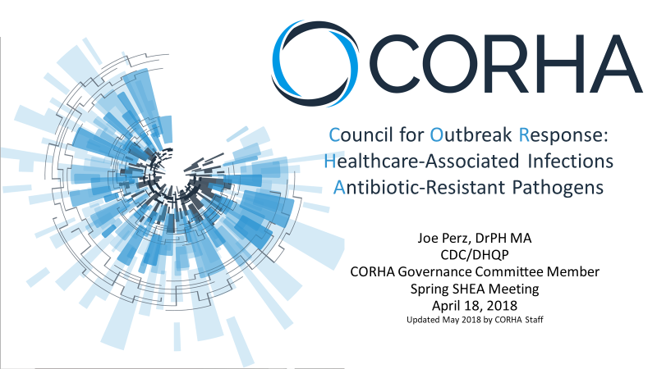

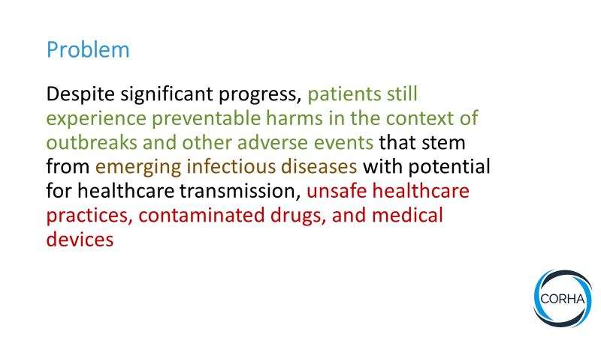

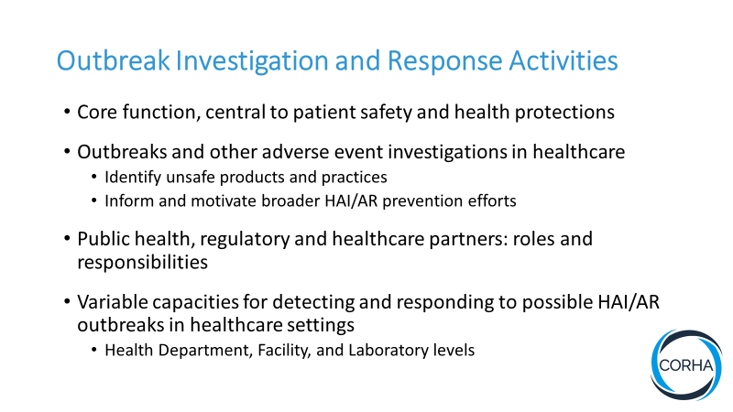

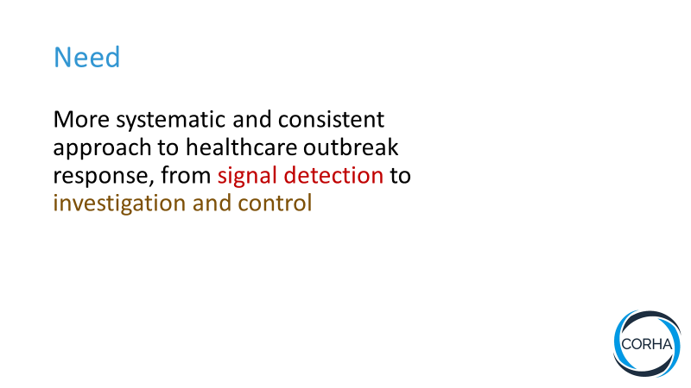

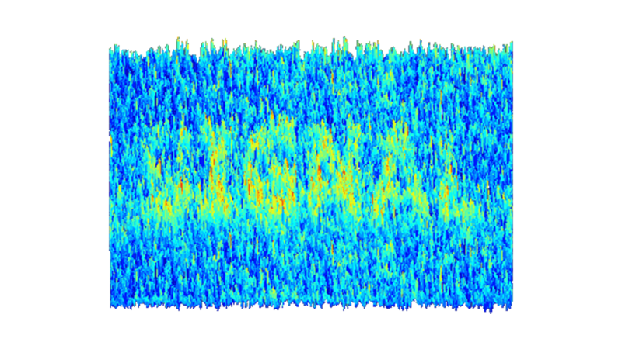

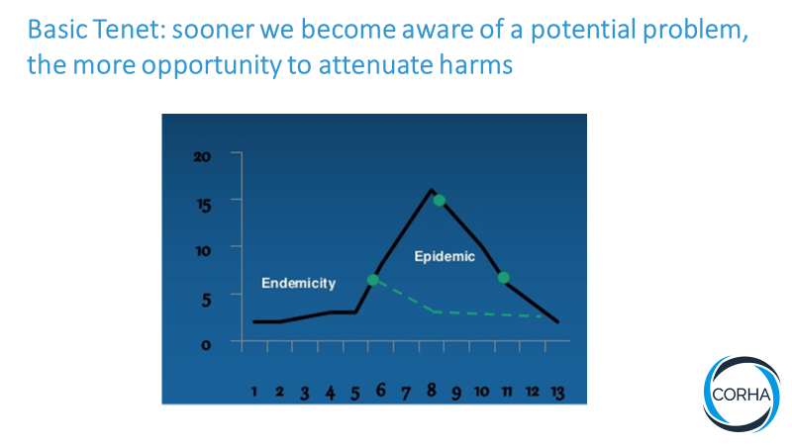

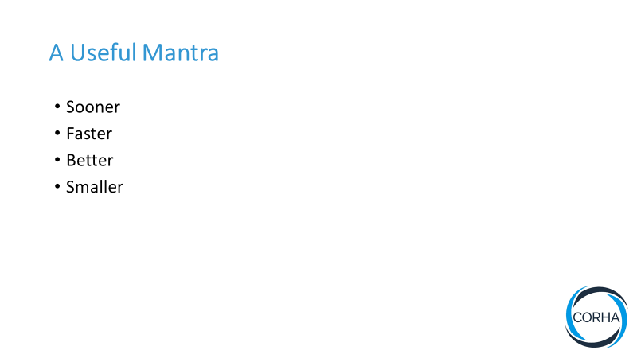

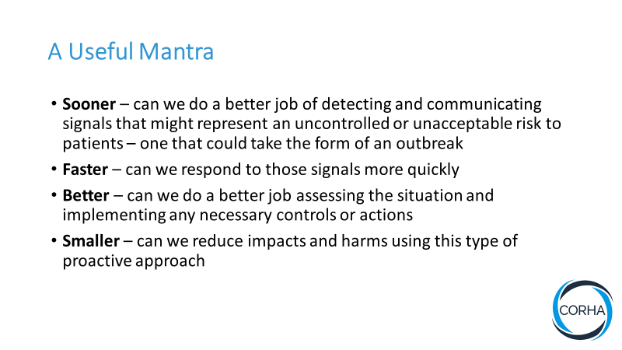

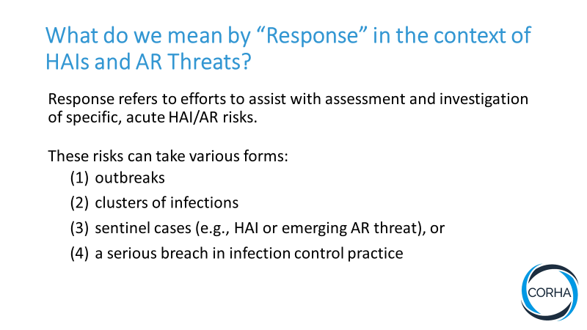

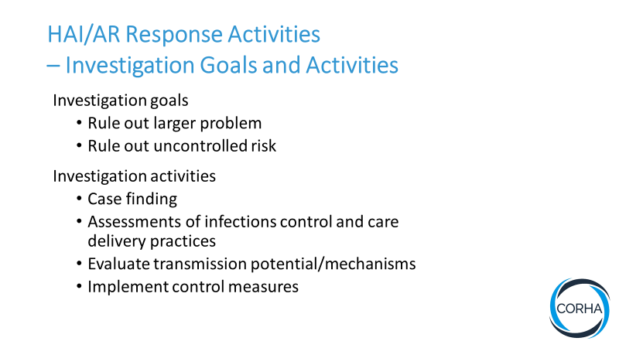

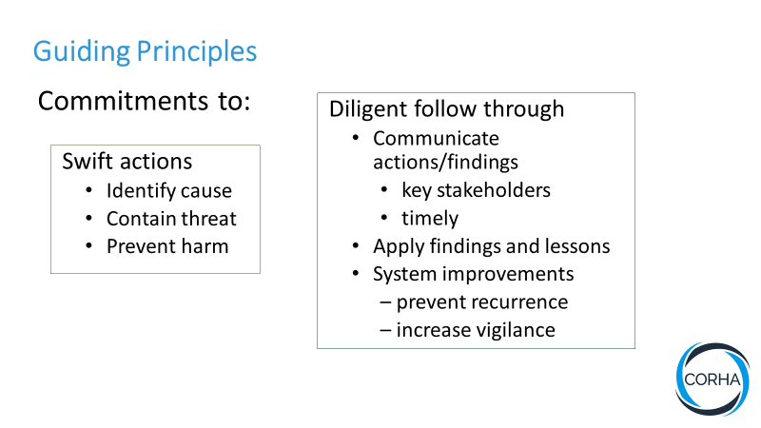

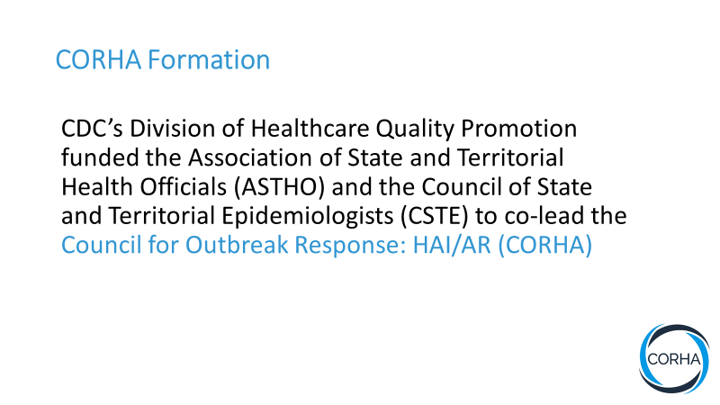

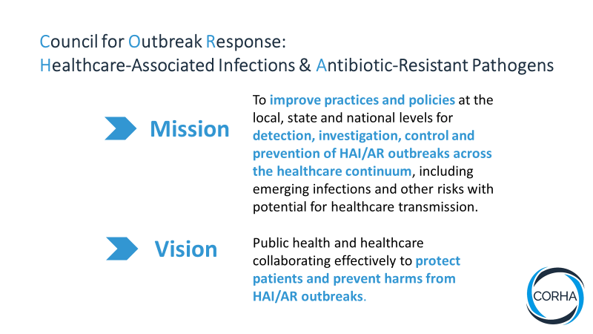

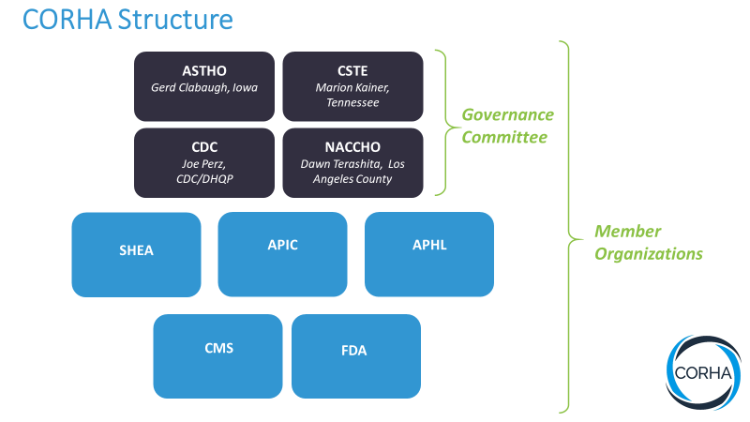

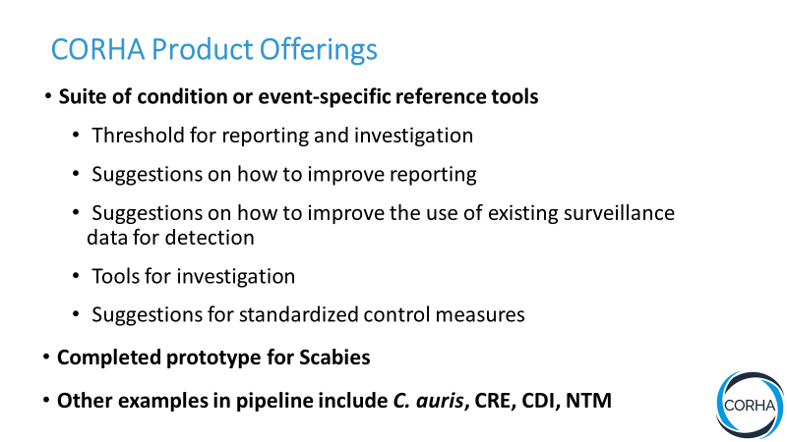

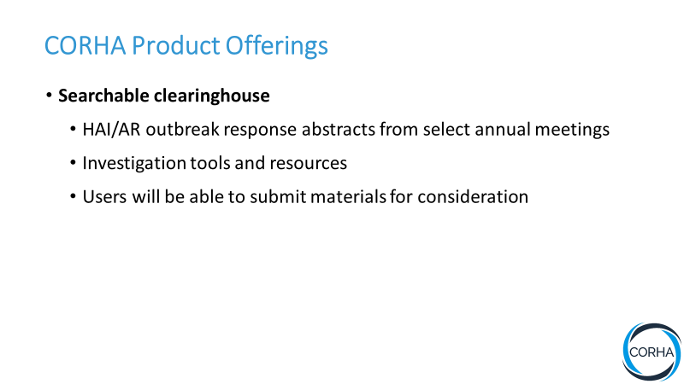

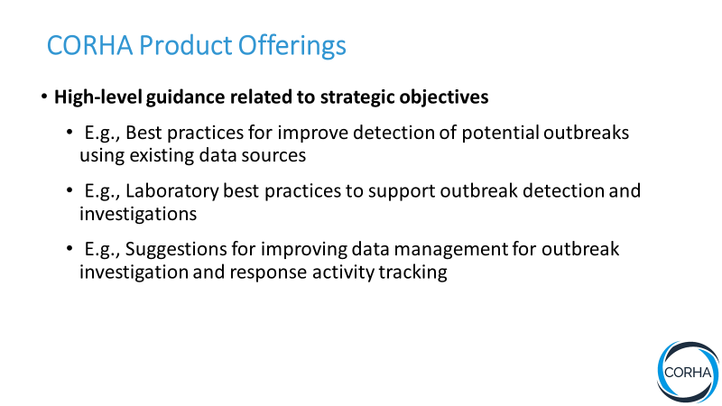

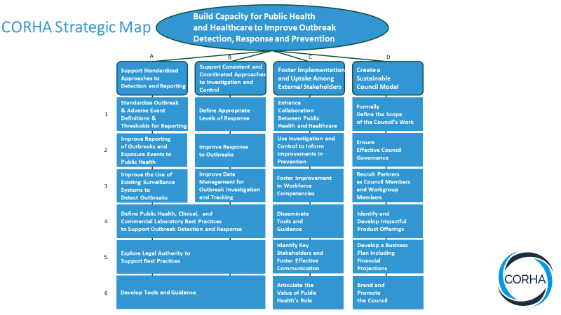

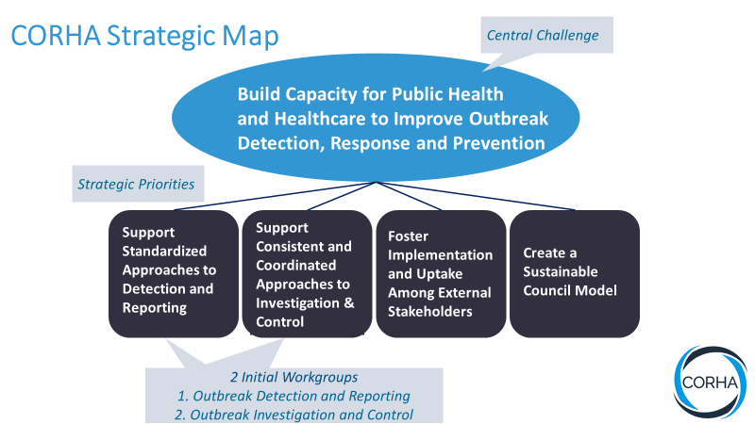

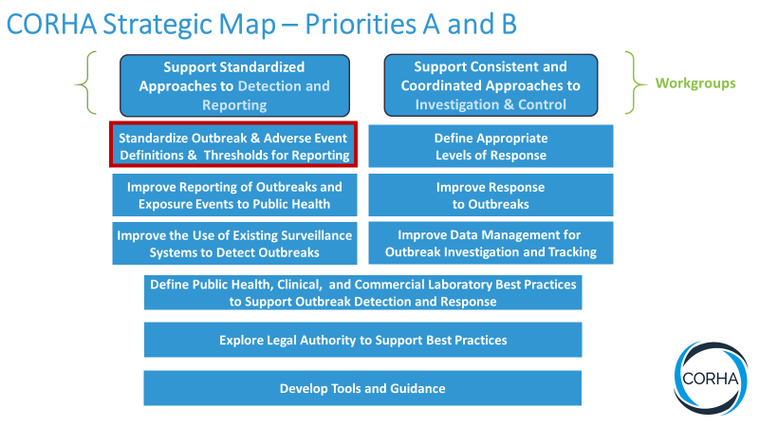

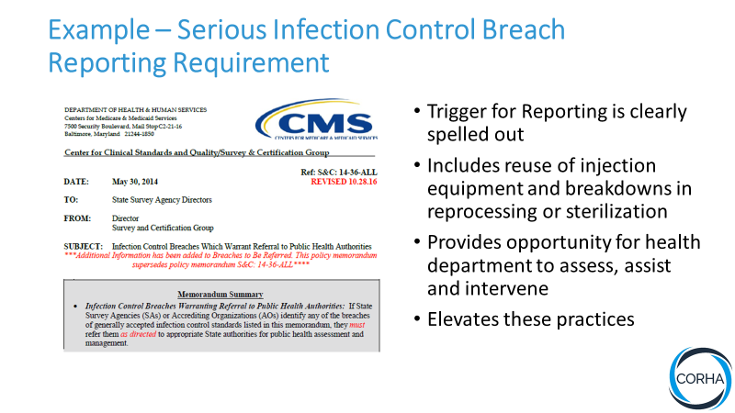

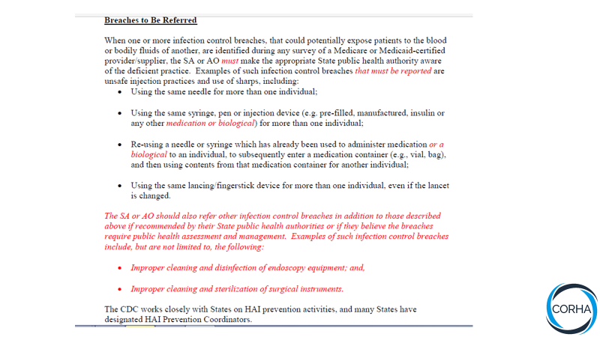

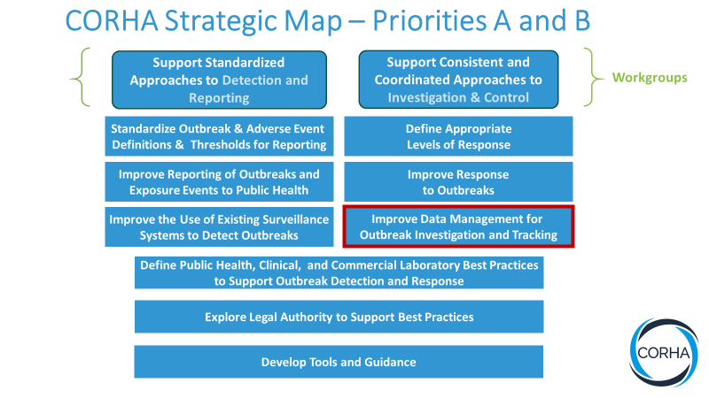

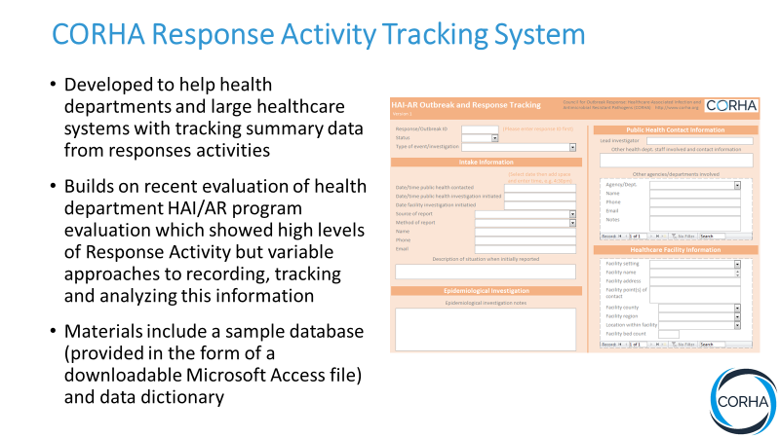

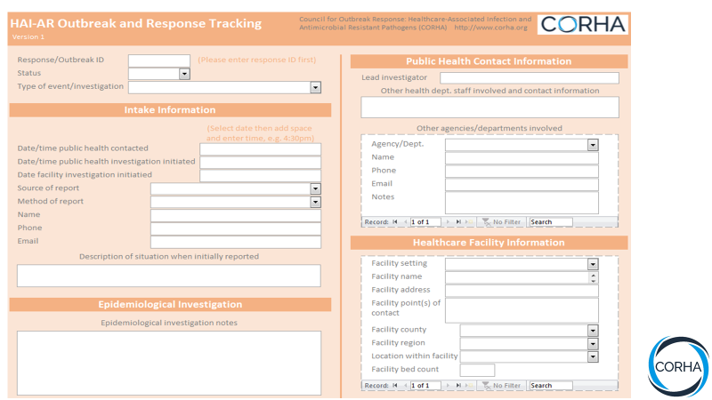
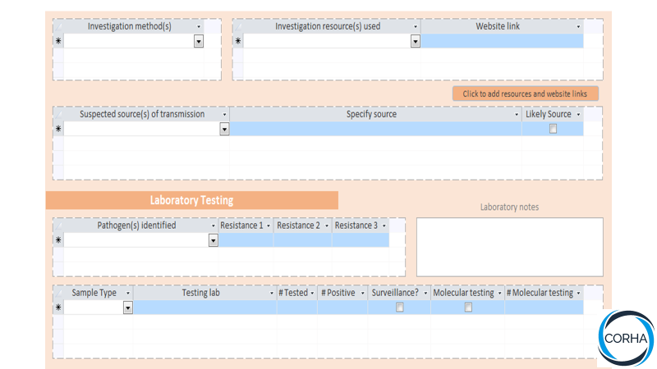
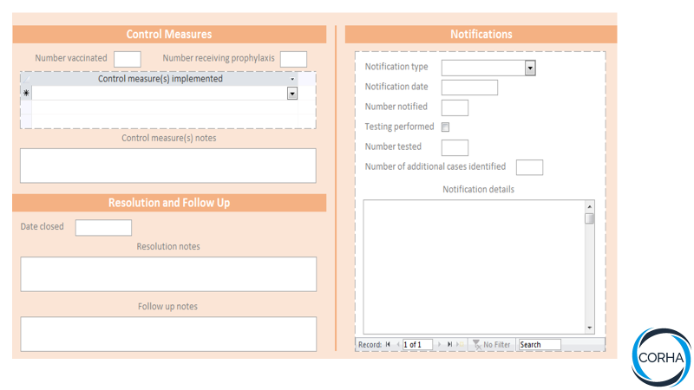

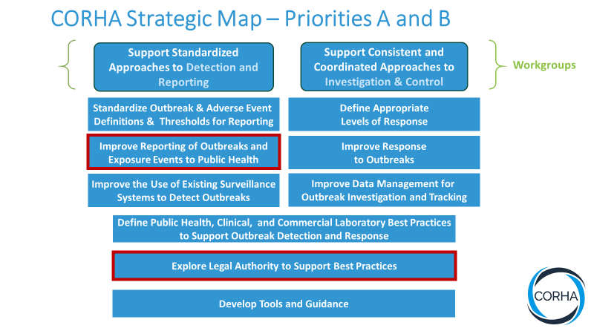

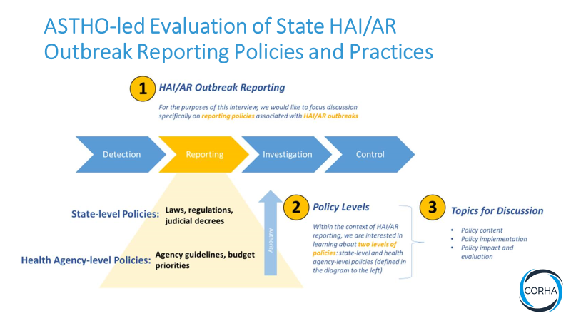

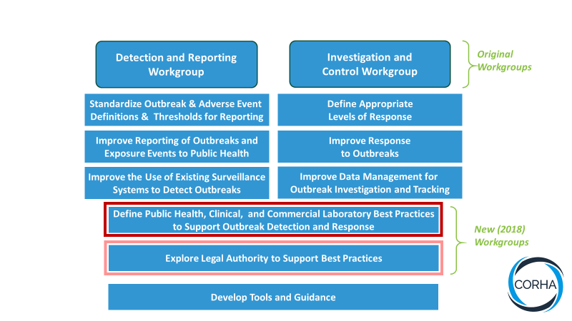

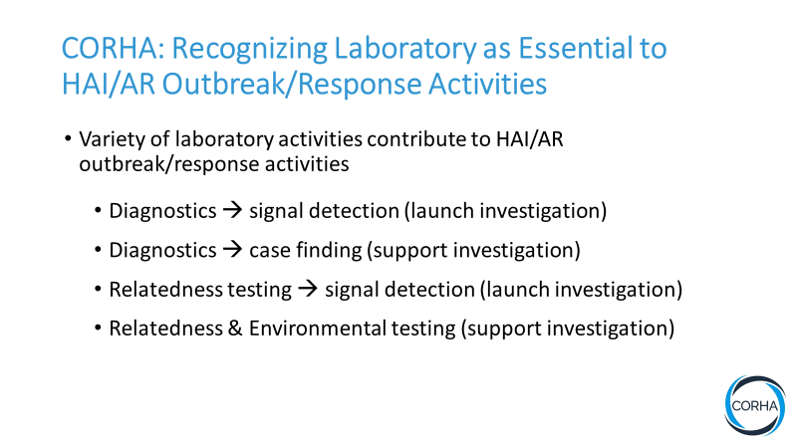

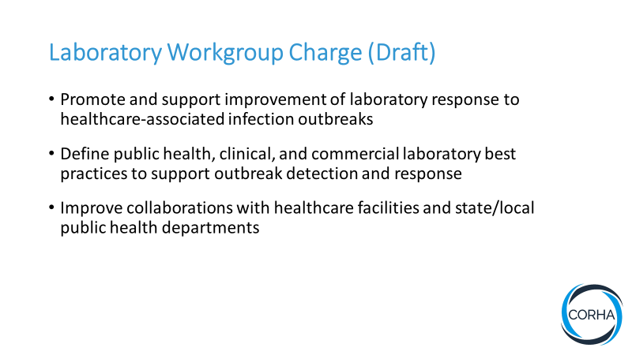

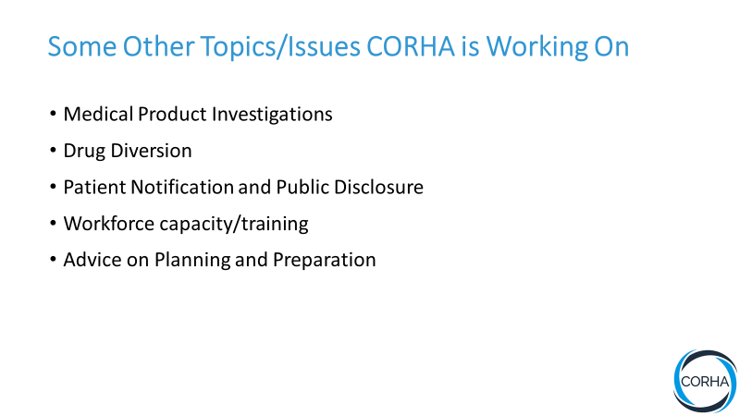

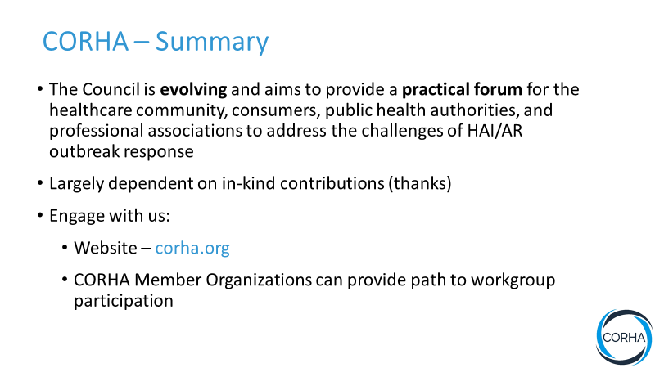



Interference by a third variable that distorts the association between cases and exposures.
Any action that systematically distorts findings.
A random, unpredictable occurrence that is not due to human intervention.

