Contents
Full Meeting Agenda 2
Workgroup A: Detection & Reporting Agenda 4
Workgroup B: Investigation & Control Agenda 5
Policy Workgroup Breakout Agenda 6
Meeting Participants 7
Strategic Map 9
CORHA Bylaws 10
Workgroup A: Outbreak detection & Reporting Charge 14
Workgroup B: Outbreak Investigation & Control Charge 16
Laboratory Workgroup charge 18
Laboratory Workgroup Product outline 20
Medical Product Investigation guidance (Draft) 22
CORHA Activities At-A-Glance 25
parking map 26
walking map 27
Transportation 28

Council for Outbreak Response: Healthcare-Associated Infections and Antibiotic-Resistant Pathogens (CORHA)

Fall 2018 In-person Meeting | November 28-30, 2018

CSTE National Office
2635 Century Parkway, Atlanta, GA 30345
Conference Rooms 1 & 7, Huddles 1 & 2

Meeting Objectives: To review progress made towards meeting CORHA and workgroup strategic goals and objectives and continue development of CORHA’s product offerings.
Wednesday, November 28, 2018
Time | Activity | Groups |  | Location
CORHA Governance Committee Meeting
8:30 AM | Governance Committee Meeting | GC |  | Conference Room, Flr 7
9:45 AM | Break—refreshments provided (15 minutes) | GC |  | Catering Galley, Flr 7
10:00 AM | Governance Committee Meeting | GC |  | Conference Room, Flr 7
12:00 PM | Lunch (On your own) | GC |  | Century Center Café/Fooda
CORHA Workgroup Meetings
1:00 PM | Workgroup Breakout Sessions | A |  | See workgroup-specific agendas
1:00 PM | Workgroup Breakout Sessions | B |  | See workgroup-specific agendas
1:00 PM | Workgroup Breakout Sessions | Policy |  | See workgroup-specific agendas
3:00 PM | Break—refreshments provided (15 minutes) | All |  | Catering Galley/Reception, Flr 7
5:00 PM | Adjourn | All
6:30 PM | Optional Group Dinner – Central Rail Kitchen & Bar | All |  | Atlanta Marriott Century Center
Thursday, November 29, 2018
Time | Activity |  | Groups | Location
All Council Business Meeting
8:30 AM | Introductions & Housekeeping |  | All | Conference Room, Flr 1
8:45 AM | CORHA Updates:  - Updates from the Governance Committee  - Presentations from Workgroup Leads  - Updates from Communications Taskforce  - Updates from ARSTF |  | All | Conference Room, Flr 1
9:30 AM | Medical Product Investigation |  | All | Conference Room, Flr 1
10:15 AM | Break—refreshments provided (15 minutes) |  | All | Catering Galley, Flr 1
10:30 AM | CORHA Bylaws: Overview of Updates |  | All | Conference Room, Flr 1
11:00 AM | Strategic Map & Implementation of Priorities:  - Strategic Map overview  - Accomplishments & activities  - Addressing new priorities:  - Policy Workgroup  - Laboratory Workgroup |  | All | Conference Room, Flr 1
12:00 PM | Lunch (Provided) |  | All | Catering Galley, Flr 7
1:00 PM | Strategic Map & Implementation of Priorities  - Future Planning & Evaluation |  | All | Conference Room, Flr 1
2:00 PM | Adjourn - All Council Business Meeting
CORHA Workgroup Meetings
2:15 PM | Workgroup Breakout Sessions |  | A | See workgroup-specific agendas
2:15 PM |  |  | B | See workgroup-specific agendas
2:15 PM |  |  | Policy | See workgroup-specific agendas
3:30 PM | Break—refreshments provided (15 minutes) |  | All | Catering Galley, Flr 7
3:45 PM | Cross-Cutting Workgroup Breakout Sessions |  | A | See workgroup-specific agendas
3:45 PM |  |  | B | See workgroup-specific agendas
3:45 PM |  |  | Policy | See workgroup-specific agendas
5:00 PM | Full Council discussion and Report Back |  | All | Conference Room, Flr 1
5:30 PM | Adjourn |  | All
Friday, November 30, 2018
Time | Activity |  | Groups | Location
CORHA Workgroup Meetings
8:00 AM | Workgroup Breakout Sessions (A & B) |  | A | See workgroup-specific agendas
8:00 AM |  |  | B | See workgroup-specific agendas
10:30 AM | Break—refreshments provided (15 minutes) |  | All | Catering Galley, Flr 7
10:45 AM | Workgroup Breakout Sessions (A & B) |  | A | See workgroup-specific agendas
10:45 AM |  |  | B | See workgroup-specific agendas
12:00 PM | Report Outs and Prioritization of Future Activities |  | All | Conference Room, Flr 1
12:30 PM | Adjourn |  | All | Conference Room, Flr 1

All Council Business Meeting Remote Participation*:
Date: Thursday, November 29, 2018, 8:00 am, Eastern Standard Time (New York, GMT-05:00)
Phone: 1-877-668-4490
Session Number: 791 262 086
-------------------------------------------------------
To join the webinar
-------------------------------------------------------
1. Go to https://cste.webex.com/cste/k2/j.php?MTID=t14a129940edb25a61e6a6f7e081727cb
2. Enter your name and email address.
3. Enter the session password: corha18
4. Click "Join Now".
5. Follow the instructions that appear on your screen.4. Follow the instructions that appear on your screen.

*See workgroup agendas for their remote participation call information

Workgroup A: Detection & Reporting Agenda

Wednesday, November 28, 2018
Time | Activity | Location
Workgroup A Breakout Session
1:00 PM | Review Strategic Map & Priority Setting | Conference Room, Flr 7
1:30 PM | NTM Definitions & Thresholds | Conference Room, Flr 7
~3:15 PM | Break—refreshments provided (15 minutes) | Catering Galley, Flr 7
3:30 PM | CDI Definitions & Thresholds | Conference Room, Flr 7
5:00 PM | Adjourn
Thursday, November 29, 2018
Time | Activity | Location
Workgroup A Breakout Session
2:00 PM | Medical Product Investigation | Conference Room, Flr 7
2:45 PM | NICU S. aureus Definitions & Thresholds | Conference Room, Flr 7
3:30 PM | Break—refreshments provided (15 minutes) | Catering Galley, Flr 7
Cross-Cutting Workgroup A & B Breakout Session
3:45 PM | Product Pilot Strategy & Assessment | Conference Room, Flr 1
4:30 PM | Additional Cross-Cutting Priorities (CRE, NTM) | Conference Room, Flr 1
4:45 PM | Finalize C. auris Products | Conference Room, Flr 1
5:00 PM | Full Council Discussion and Report Back | Conference Room, Flr 1
5:30 PM | Adjourn
Friday, November 30, 2018
Time | Activity | Location
Workgroup A Breakout Session
8:00 AM | Priority Setting | Conference Room, Flr 7
8:30 AM | CDI Definitions & Thresholds | Conference Room, Flr 7
10:00 AM | Break—refreshments provided (15 minutes) | Catering Galley, Flr 7
10:15 AM | CDI Definitions & Thresholds | Conference Room, Flr 7
11:00 AM | High Level Guidance (Surveillance & Detection) | Conference Room, Flr 7
11:30 AM | Review Workgroup Charge & Future Priorities | Conference Room, Flr 7
12:00 PM | Report Out | Conference Room, Flr 1
12:30 PM | Adjourn

Remote Participation Information:
Phone Number: (773) 231 9226
Participant Code: 148-012-1201
https://meetings.ringcentral.com/j/1480121201

Workgroup B: Investigation & Control Agenda

Wednesday, November 28, 2018
Time | Activity | Location
Workgroup B Breakout Session
1:00 PM | Review Strategic Map & Priority Setting | Huddle 1, Flr 7
1:30 PM | CRE Investigation & Control Guidance | Huddle 1, Flr 7
~3:15 PM | Break—refreshments provided (15 minutes) | Catering Galley, Flr 7
3:30 PM | NTM Investigation & Control Guidance | Huddle 1, Flr 7
5:00 PM | Adjourn
Thursday, November 29, 2018
Time | Activity | Location
Workgroup B Breakout Session
2:00 PM | CRE & NTM Investigation & Control Guidance | Huddle 1, Flr 7
3:30 PM | Break—refreshments provided (15 minutes) | Catering Galley, Flr 7
Cross-Cutting Workgroup A & B Breakout Session
3:45 PM | Product Pilot Strategy & Assessment | Conference Room, Flr 1
4:30 PM | Additional Cross-Cutting Priorities (CRE, NTM) | Conference Room, Flr 1
4:45 PM | Finalize C. auris Products | Conference Room, Flr 1
5:00 PM | Full Council Discussion and Report Back | Conference Room, Flr 1
5:30 PM | Adjourn
Friday, November 30, 2018
Time | Activity | Location
Workgroup B Breakout Session
8:00 AM | Priority Setting | Huddle 1, Flr 7
8:30 AM | CRE & NTM Investigation & Control Guidance | Huddle 1, Flr 7
10:00 AM | Break—refreshments provided (15 minutes) | Catering Galley, Flr 7
10:15 AM | Product Pilot Strategy & Assessment (WG specific) | Huddle 1, Flr 7
11:00 AM | High Level Guidance: Outbreak Investigation | Huddle 1, Flr 7
11:30 AM | Review Workgroup Charge & Future Priorities | Huddle 1, Flr 7
12:00 PM | Report Out | Conference Room, Flr 1
12:30 PM | Adjourn

Remote Participation Information:
Phone Number: (773) 231 9226
Participant Code: 149-001-4772
https://meetings.ringcentral.com/j/1480014772

Policy Workgroup Breakout Agenda

Wednesday, November 28, 2018
Time | Activity | Location
Policy Workgroup Breakout Session
1:00 p.m. | Introductions and Workgroup Overview | Conference Room, Flr 1
1:20 p.m. | Summary of Resources | Conference Room, Flr 1
1:30 p.m. | Reporting, Investigation, Notification and Disclosure Definitions | Conference Room, Flr 1
2:45 p.m. | Break—refreshments provided (15 minutes) | Catering Galley, Flr 7
3:00 p.m. | Reporting, Investigation, Notification and Disclosure Definitions Wrap-up | Conference Room, Flr 1
3:30 p.m. | Assessment of State HAI Outbreak Reporting Policies | Conference Room, Flr 1
4:45 p.m. | Plans for Thursday’s Breakout | Conference Room, Flr 1
5:00 p.m. | Adjourn | Conference Room, Flr 1

Thursday, November 29, 2018
Time | Activity | Location
Policy Workgroup Breakout Session
2:00 p.m. | Wednesday Recap | Conference Room, Flr 1
2:15 p.m. | Finalize Reporting, Investigation, Notification and Disclosure Definitions  Discuss Product Format | Conference Room, Flr 1
3:00 p.m. | Assessment of State HAI Outbreak Reporting Policies | Conference Room, Flr 1
3:30 p.m. | Break—refreshments provided (15 minutes) | Catering Galley, Flr 7
3:45 p.m. | Discussion of Other Charge Items | Conference Room, Flr 1
4:45 p.m. | Prioritization of Future Activities  Crosscutting Activities with Other CORHA Workgroups | Conference Room, Flr 1
5:00 p.m. | Report out | Conference Room, Flr 1
5:30 p.m. | Adjourn | Conference Room, Flr 1

Remote Participation Information:
Phone Number: (773) 231 9226
Participant Code: 149-040-6547
https://meetings.ringcentral.com/j/1497594277

Meeting Participants

First Name | Last Name | Credentials | Council Organization | Email
Meredith | Allen | DrPH, MS | ASTHO | mallen@astho.org
Michael | Anderson | MPH | CSTE | manderson@cste.org
Wendy | Bamberg | MD | CSTE | wendy.bamberg@state.co.us
Brooke | Beaulieu | MPH | CSTE | brooke@cste.org
Isaac | Benowitz | MD | CDC | key6@cdc.gov
Stephanie | Black | MD, MSc | NACCHO | stephanie.black@cityofchicago.org
Jim | Blumenstock | MA | ASTHO | jblumenstock@astho.org
Gerd | Clabaugh | MPA | ASTHO | gerd.clabaugh@idph.iowa.gov
Matthew | Crist | MD, MPH | CDC | cwu0@cdc.gov
Valerie | Deloney | MBA | SHEA | vdeloney@shea-online.org
Kristin(Kris) | Ehresmann | MPH, RN | ASTHO | kristen.ehresmann@state.mn.us
Jeff | Engel | MD | CSTE | jengel@cste.org
Erin | Epson | MD |  | erin.epson@cdph.ca.gov
Andrea | Flinchum | MPH | CSTE | Andrea.Flinchum@ky.gov
Katie | Forsberg | MPH | CDC | lnv6@cdc.gov
Steven | Franklin | MPH | CDC | yom9@cdc.gov
Janet | Glowicz | PhD, RN, MPH, CIC, FAPIC | CDC | kvi1@cdc.gov
Linda | Greene | RnN, MPS, CIC | APIC | Linda_Greene@URMC.Rochester.edu
Cal | Ham | MD, MPH | CDC | ink4@cdc.gov
Hillary | Hanson | MPH, MS, CPH | NACCHO | hhanson@flathead.mt.gov
Bonnie | Herring |  | CDC | lte4@cdc.gov
*Kate | Heyer | MPH | ASTHO | kheyer@astho.org
Waleed | Javaid | MD | SHEA | waleedjavaid@gmail.com
Marion | Kainer | MD, MPH | CSTE | marion.kainer@tn.gov
Lilly | Kan | MPH | NACCHO | lkan@naccho.org
Moon | Kim | MD | NACCHO | mokim@ph.lacounty.gov
Preeta | Kutty | MD, MPH | CDC | chz6@cdc.gov
Mary Alice | Lavin | RN, MJ, CIC, FAPIC | APIC | alavin@att.net
Jennifer | Lemmings | MPH | CSTE | jlemmings@cste.org
Julie | Marders | MS, RN | FDA | Julia.Marders@fda.hhs.gov
Elizabeth | Mothershed | MS | CDC | ekm9@cdc.gov
Martha | Ngoh | MPH | ASTHO | mngoh@astho.org
Kiran | Perkins | MD, MPH | CDC | guu9@cdc.gov
Joe | Perz | DrPH | CDC | bzp4@cdc.gov
*Jafar | Razeq | MD | APHL | jafar.razeq@ct.gov
Heidi | Satter |  | ASTHO | hsatter@astho.org
Dhara | Shah | MPH | CSTE | dshah@cste.org
Geeta | Sood | MD | SHEA | gsood1@jhmi.edu
Dawn | Terashita | MD, MPH | NACCHO | dterashita@ph.lacounty.gov
Maureen | Tierney | MD, MsC | CSTE | Maureen.Tierney@nebraska.gov
Maroya | Walters | PhD, ScM | CDC | vii0@cdc.gov
Richard | Wild | MD, JD, MBA, FACEP | CMS | Richard.Wild@cms.hhs.gov
Taitainia | Willamson |  | CDC | kmy8@cdc.gov
Jean | Williams |  | CMS | jean.moodywilliams@cms.hhs.gov
*Kelly | Wroblewski | MPH, MT(ASCP) | APHL | kelly.wroblewski@aphl.org
*Remote Participation
Governance Committee
Marion Kainer  Co-chair  CSTE | Gerd Clabaugh  Co-chair  ASTHO
Joe Perz  CDC | Dawn Terashita  Workgroup B & Policy Lead  NACCHO
Council Members
Wendy Bamberg  Workgroup A Lead  CSTE | Erin Epson  CSTE
Kristen Ehresmann  ASTHO | Joe Miner  ASTHO
Elizabeth Mothershed  CDC | Hillary Hanson  NACCHO
Jafar Razeq  Laboratory Workgroup Lead  APHL | Waleed Javaid  Workgroup A Lead  SHEA
Linda Greene  Workgroup A Lead  APIC | Julia Marders (non-voting)  FDA
Patti Meier, Richard Wild (substitute)
CMS
CORHA Member Organization Support Staff
Kate Heyer  ASTHO | Martha Ngoh  ASTHO
Michael Anderson
CSTE

Council Strategic Map
Council for Outbreak Response: Healthcare-Associated Infections and Antibiotic-Resistant Pathogens
Strategic Map: 2016-2019

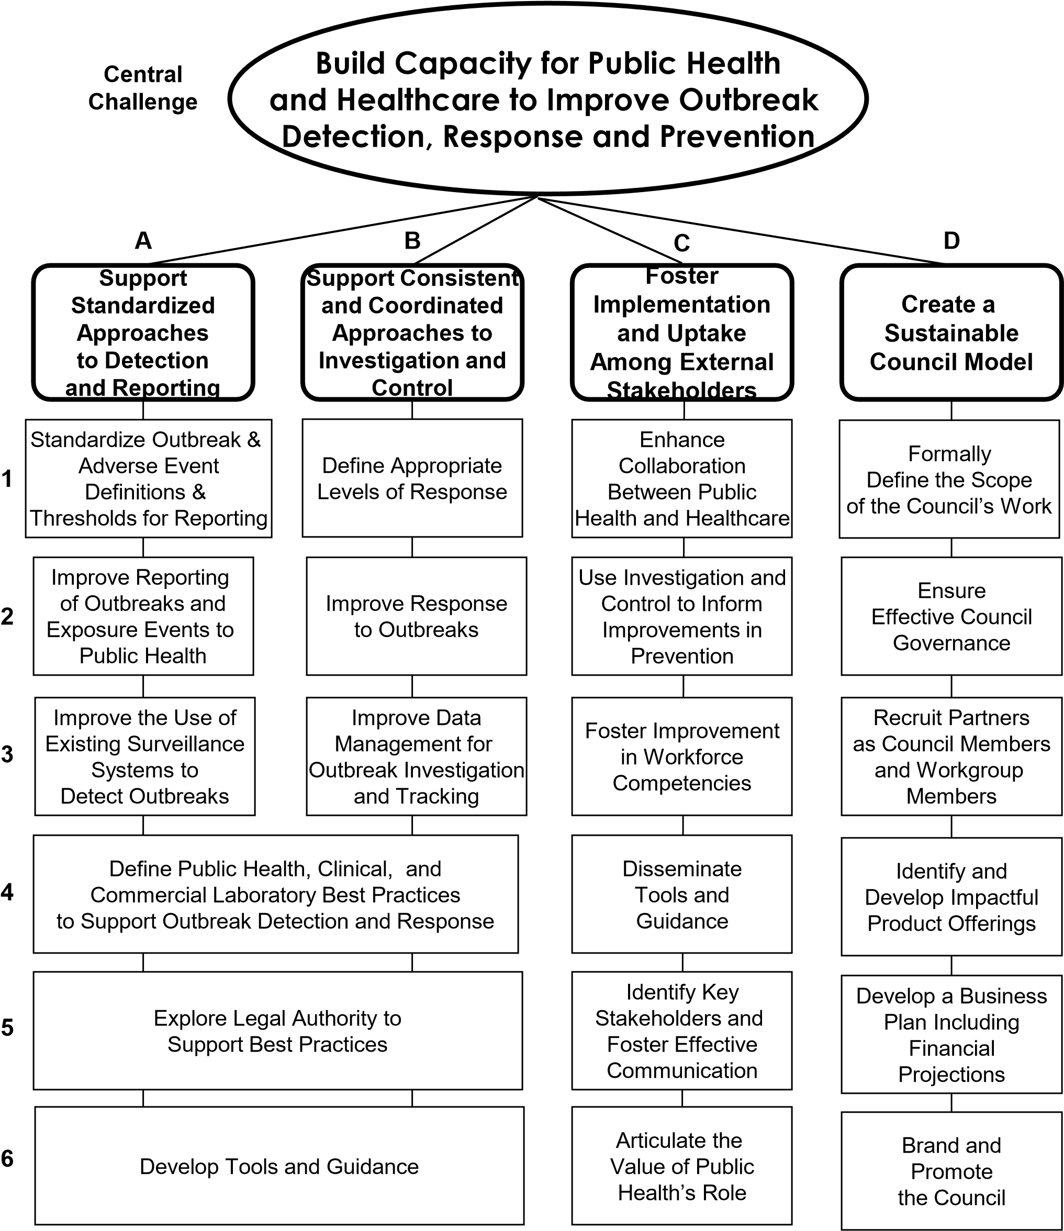
CORHA Bylaws
(Proposed Revisions)

- History and Purpose
In 2015, CDC’s Division of Healthcare Quality Promotion funded the Association of State and Territorial Health Officials (ASTHO) and the Council of State and Territorial Epidemiologists (CSTE) to create and co-lead the Council for Outbreak Response: HAI/AR (CORHA) and serve as Founding Members. Healthcare-associated Infections (HAIs) including antimicrobial-resistant (AR) pathogens cause hundreds of thousands of illnesses and deaths among U.S. patients each year. Consistent and coordinated approaches are needed to speed up detection of new threats, develop tools to support outbreak investigation, stop outbreaks from spreading, and better inform prevention activities. The Council will work to ‘Build Capacity for Public Health and Healthcare to Improve Outbreak Detection, Response and Prevention.’

- Mission
To improve practices and policies at the local, state and national levels for detection, investigation, control, and prevention of HAI/AR outbreaks across the healthcare continuum, including emerging infections and other risks with potential for healthcare transmission.

- Vision
Public health and healthcare collaborating effectively to protect patients and prevent harms from HAI/AR outbreaks.

- Organizational Structure
CORHA is comprised of several interacting components: 1) The Governance Committee, 2) Member Organizations, and 3) Workgroups. Together, these entities constitute the full Council (i.e., CORHA).

- CORHA Member Organization Categories
CORHA Member Organizations include organizations, professional associations, and other agencies that have an active interest in delivering safe healthcare and promoting patient safety.

- CORHA Member Organizations include organizations, professional associations, and other agencies that have an active interest in delivering safe healthcare and promoting patient safety.
- Founding Member Organizations: are those membership organizations that were originally brought together to form CORHA. They include CDC’s Division of Healthcare Quality Promotion (DHQP), the Association of State and Territorial Health Officials (ASTHO), the Council of State and Territorial Epidemiologists (CSTE), and the National Association of County and City Health Officials (NACCHO). Founding member organizations form the CORHA Governance Committee and do not have membership term limits.
- Stakeholder Member Organizations: include organizations that join CORHA after the Founding Member organizations. Stakeholder member organizations serve four-year terms on CORHA and the Governance Committee votes to renew the four-year term of each member organization.
- Federal Liaison Member Organizations: include federal agencies invited to participate on CORHA in a non-voting member capacity. Federal liaison member organizations serve four-year terms on CORHA and the Governance Committee votes to renew the four-year term of their membership.

- CORHA Voting Members
Each CORHA Stakeholder Member Organization designates one representative to serve as a voting member on CORHA. The following exceptions apply:
- CORHA Co-Chair organizations (ASTHO and CSTE) will each have three voting representatives on the Council, one of whom will be designated to serve as Co-Chair on the Governance Committee.
- Founding Member organizations that are not co-chairs (NACCHO and CDC (DHQP)) will each have two voting representatives on the Council, one of whom will be designated to serve on the Governance Committee.

- CORHA Voting Member Responsibilities
- Support and implement the decisions of the Governance Committee.
- Approve and vote on modifications to the CORHA Bylaws.
- Approve and vote on addition of new stakeholder member organizations to CORHA.
- Approve and vote on changes to the vision, mission or Strategic Map of CORHA.
- Participate in and/or provide support and guidance to CORHA workgroups.
- Participate in in-person meetings and quarterly voting member conference calls.
- Provide feedback on CORHA initiatives.
- Review, approve and vote on CORHA-developed products.
- Disseminate and promote final and approved CORHA products.

- Stakeholder Organization Representatives: are staff from CORHA member organizations that are involved in CORHA activities, but do not have voting privileges on CORHA.

- Stakeholder Organization Representative Responsibilities:
- Provide support to CORHA members representing their organizations.
- Facilitate communication between CORHA staff, their organizations’ voting members and their organizations.
- Lead, participate in, and/or provide support and guidance to CORHA workgroups and other activities.

- CORHA Governance Committee
The CORHA Governance Committee is responsible for providing overall guidance for CORHA. One representative from each of the four Founding organizations Member (ASTHO, CDC (DHQP), CSTE, NACCHO) serves on the Governance Committee. Governance Committee members are appointed by the organizations they represent. If a Governance Committee member is no longer able to serve on the Governance Committee, the sponsoring organization will present another candidate for consideration to the Governance Committee to vet and approve.

The Governance Committee strives to make decisions by consensus, but when consensus is not clear, a vote will be conducted. Each Governance Committee member will have one vote and a decision must be approved by at least three-fourths of Governance Committee members.

- Governance Committee Responsibilities
- Approve changes to CORHA’s vision, mission and Strategic Map.
- Provide strategic direction for CORHA.
- Introduce, prioritize and maintain a list of proposed CORHA projects for consideration.
- Review and approve new CORHA processes and all internal and external-facing documents bearing the CORHA logo.
- Provide guidance on policy, legal, and financial matters of CORHA.
- Approve the creation, scope, and goals of workgroups.
- Provide guidance to CORHA workgroups, committees and other initiatives.
- Identify and/or approve CORHA voting and workgroup members.
- Suggest, vet, and approve member organizations to be voted upon by CORHA.
- Approve four-year term renewals for additional member organizations.
- Vote on replacement voting members when a voting member resigns from CORHA or leaves their member organization.
- Approve federal liaison member organizations.
- Attend CORHA meetings and conference calls.
- Identify and invite participants to CORHA meetings and conference calls.
- Promote and represent CORHA at public events.
- Respond to media requests for CORHA.
- Grant permission to persons and organizations who wish to make presentations, announcements to or on behalf of CORHA.
- Provide resolution if conflicts arise with member organizations.
- Advocate for CORHA.

- Voting
CORHA voting members will review and vote on the following CORHA products, activities and initiatives:
- Changes to CORHA Bylaws and Strategic Map.
- The addition of new Member Organizations, voting members and workgroups.
All CORHA-developed products from CORHA workgroups and writing teams. A quorum must be established with a simple majority of voting members, each of which may cast one vote. If a voting member knows in advance that he/she will not be present for a vote, that member may designate a proxy (from the same member organization) to vote on his or her behalf.

CORHA-developed products requiring approval and a vote will follow the processes and guidelines outlined in the CORHA Workgroup to Website process. CORHA members will be responsible for obtaining the appropriate level of input from their respective organization during open review periods.

- Meeting Attendance and Participation
The Council will meet in person twice per year—typically, once in the spring and once in the fall, and quarterly via video or teleconference. The hosting organization (ASTHO or CSTE), with direction from the Governance Committee will be responsible for identifying and inviting voting members, their alternates, selected stakeholder organization representatives or Subject Matter Experts to the meeting.
If a CORHA voting member is unable to represent their organization at a given meeting or conference call, voting members or their member organizations may propose an alternate. Notification of all proposed alternates must be sent to the Council Co-Chairs and the meeting planning staff as soon as possible prior to the meeting or call. Alternates should have a strong scientific background, knowledge of HAI outbreak and response, extensive knowledge of their member organization, understanding of HAI outbreak lab, policy and legal issues, and CORHA. If there are concerns about the suitability of a proposed alternate, the Governance Committee will make the final decision.
- CORHA Workgroups and Committees
CORHA Workgroups and Committees will be formed to address specific short or long-term projects as approved by the CORHA Governance Committee. CORHA workgroups will be led by a Chair and a Co-Chair, one of whom should be a current CORHA voting member. If CORHA members do not volunteer to serve in these roles, the Governance Committee will consider an alternate designee with appropriate interest and subject matter expertise to serve as Workgroup Chair and/or Co-Chair.

Workgroup members may be identified and recommended by CORHA voting members and the Governance Committee. Workgroup members will have a strong scientific background, knowledge of HAI outbreak and response, extensive knowledge of their Member Organization, understanding of policy and legal issues, and be dedicated to the mission and vision of CORHA.

- Processes and Guidance Documents
The following process documents were developed to operationalize these Bylaws and other CORHA activities:
- The CORHA Operating Guidance (Basecamp)
- The CORHA Workgroup to Website Process (Basecamp)
- The CORHA Workgroup Product Development Process (Basecamp)
- High-Level Guidance Roadmap (Basecamp)

Workgroup A Charge: Detection and Reporting

* A Detection and Reporting Workgroup of CORHA is developed for the purpose of identifying standardized approaches to detection and reporting of infectious disease outbreaks and exposure events within healthcare facilities and in various ambulatory settings. Settings of interest include the following: acute care hospitals, long term care facilities, dialysis, ambulatory surgery centers, long term acute care hospitals, and provider clinical offices. Outbreaks of interest for 2016-2017 include those resulting from the following pathogens or infection types:

Antimicrobial Resistant Pathogens
- CRE
- MDR Gram-negatives
- Clostridium difficile
- Bacterial/other (e.g., Staphylococcus aureus)
- Nontuberculosis Mycobacteria (extrapulmonary)
- Candida auris

The workgroup is tasked with the following activities:

1. Create standard definitions for outbreaks and exposure events and thresholds for reporting. The workgroup will:
* Evaluate existing standards and best practices in place from across the country with regard to the number of cases needed to constitute an outbreak for each pathogen or infection type, by setting.
* Articulate recommended thresholds: number of cases (by setting) that constitute an outbreak.
2. Improve reporting of outbreaks and exposure events to public health. The workgroup will:
* Identify a standard set of qualitative and quantitative data elements to be included in the reporting response to the public health agency of jurisdiction to facilitate timely and accurate response to the outbreak.
* Evaluate existing best practices in place throughout the country which lead to thorough, timely, and accurate reporting of outbreaks from various clinical settings to public health agencies
* Understand clearly the qualitative and quantitative reporting requirements of public health agencies necessary to evaluate and respond to each pathogen or infection type, by setting
* Understand clearly the resource and informational limitations in each healthcare setting, for each infection type, which affect the thorough, timely and accurate reporting of outbreaks.
* Articulate recommended standards to guide the thorough, timely and accurate reporting of outbreaks from various healthcare settings and provider types to public health agencies.
* Evaluate, identify, or develop if necessary, training materials aimed at improving the practice of healthcare settings/providers to the thorough, timely and accurate reporting of outbreaks to public health agencies.
3. Improve the use of existing surveillance systems to detect outbreaks. The workgroup will:
* Identify and evaluate existing reporting systems in use which are intended to facilitate the exchange of thorough, timely and accurate information for purpose of reporting outbreaks.
* Understand clearly and evaluate the workflow processes and performance of public health agencies' use of these systems for outbreak identification. From this, identify best practices in use of these systems which ensure timely and accurate response to information these surveillance systems provide.
* Evaluate, identify, or develop if necessary, training materials aimed at improving public health agencies' use of surveillance systems to ensure timely and accurate response to information provided through existing systems.

Additional pathogens for future consideration:
- Emerging infectious diseases
- MRSA
- Bloodborne pathogens
- Group A Streptococcus
- Device-associated infections
  - CLABSI
  - CAUTI
  - SSI
  - VAP
- Respiratory
  - Influenza
  - Legionella
  - Tuberculosis
- Mycotics (non- Candida auris)
- Enterics
  - Norovirus
- Events
  - Infection control breaches
  - Drug diversion
  - Drug contamination
  - Product contamination
- Toxic Anterior Segment Syndrome
  - Other non-infectious outbreaks

Workgroup B Charge: Investigation and Control

* An Investigation and Control Workgroup of CORHA is developed for the purpose of identifying consistent and coordinated approaches to investigation and control of infectious disease outbreaks and exposure events within healthcare facilities and in various ambulatory settings. Settings of interest include the following: acute care hospitals, long term care facilities, dialysis, ambulatory surgery centers, long term acute care hospitals, and provider clinical offices. Outbreaks of interest for 2016-2017 includes those resulting from the following pathogens or infection types:

Antimicrobial Resistant Pathogens
- CRE
- MDR Gram-negatives
- Clostridium difficile
- Bacterial/other (e.g., Staphylococcus aureus)
- Nontuberculosis Mycobacteria (extrapulmonary)
- Candida auris

The workgroup is tasked with the following activities:

1. Define appropriate levels of response. The workgroup will:
1.1 Evaluate existing standards and best practices in place from across the country with regard to the levels of response needed for infection and exposure events for each pathogen or infection type, by setting.
1.2 Articulate recommended thresholds: number of cases (by setting) that warrant investigation and control for a suspected outbreak.
1.3 Identify a standard set of qualitative and quantitative data elements to be assessed in the investigation and control of a suspected outbreak.
2. Improve response to investigation and control of outbreaks to public health. The workgroup will:
2.1 Evaluate existing best practices in place throughout the country which lead to thorough, timely, and accurate investigation and control of outbreaks from various clinical settings to public health agencies.
2.2 Understand clearly the qualitative and quantitative information requirements of public health agencies necessary to investigate and control outbreaks for each pathogen or infection type, by setting.
2.3 Understand clearly the resource and informational limitations in each healthcare setting, for each infection type, which affect the thorough, timely and accurate investigation of suspected outbreaks.
2.4 Articulate recommended standards to guide the thorough, timely and accurate investigation and control reporting of outbreaks from various healthcare settings.
2.5 Evaluate, identify, or develop if necessary, resources and training materials aimed at improving the practice of healthcare settings for the thorough, timely and accurate investigation and control of suspected outbreaks.
3. Improve data management for outbreak investigation and tracking. The workgroup will:
3.1 Identify and evaluate existing data management systems in use which are intended to facilitate the management of outbreak investigation and tracking.
3.2 Understand clearly and evaluate the workflow processes and performance of public health agencies' use of data management systems for outbreak investigation and control. From this, identify best practices in use of these systems which ensure timely and accurate investigation of suspected outbreaks in response to information these surveillance systems provide.
3.3 Evaluate, identify, or develop if necessary, training materials aimed at improving public health agencies' use of surveillance systems to ensure timely and accurate response to information provided through existing systems.

Additional pathogens for future consideration:
- Emerging infectious diseases
- MRSA
- Bloodborne pathogens
- Group A Streptococcus
- Device-associated infections
  - CLABSI
  - CAUTI
  - SSI
  - VAP
- Respiratory
  - Influenza
  - Legionella
  - Tuberculosis
- Mycotics (non-Candida auris)
- Enterics
  - Norovirus
- Events
  - Infection control breaches
  - Drug diversion
  - Drug contamination
  - Product contamination
- Toxic Anterior Segment Syndrome
  - Other non-infectious outbreaks

CORHA Laboratory Workgroup Charge

Workgroup Mission:
The CORHA Laboratory Workgroup seeks to describe and promote public health, clinical, and commercial laboratory best practices to support HAI/AR outbreak detection and response. The workgroup will assist laboratorians as well as public health and clinical partners by developing guidance, identifying best practices, and improving laboratory partner collaborations with healthcare facilities and state/local public health departments.

To achieve its mission, the Laboratory Workgroup is tasked with addressing the following high-level objectives:

- Contribute knowledge and support activities to optimize laboratory practices in support of identifying and investigating possible HAI/AR outbreaks. The workgroup will:
  - Select target organisms/conditions, beginning with AR and non-AR examples already under the consideration of the Identification & Reporting Workgroup and the Investigation & Control Workgroup.
  - For each targeted organism/condition, describe the laboratory practices that best support outbreak identification/investigation, including activities such as case finding, environmental assessments and relatedness testing.
  - Promote best practices for environmental assessments, including when it is appropriate, techniques in sample collection and processing, and expertise required.
  - As deemed appropriate, promote implementation of techniques to detect specific pathogen strains (e.g. CP-CRE) helpful for outbreak detection and response.
  - Identify and promote best practices for laboratory data collection and data sharing in relation to HAI/AR outbreak response.

- Support effective interactions among laboratory partners and between laboratories, healthcare facilities, and state/local health departments in the context of HAI/AR response activities. The workgroup will:
  - Make recommendations on reporting roles and methods for different types of laboratories, including clinical, commercial, research, and public health laboratories, to relevant stakeholders.
  - Identify best practices for how laboratories can assist epidemiologists and other partners with identifying potential outbreaks and investigating routes of transmission.
  - Identify best practices for outbreak response from a laboratory perspective and describe the roles of each stakeholder during an investigation.
  - Foster relationships with laboratory stakeholders.

Coordination and Consultation. All Laboratory Workgroup activities will occur in coordination with other CORHA workgroups and activities focused on promoting standardized approaches on outbreak detection and reporting, and investigation and control. The Laboratory Workgroup will be available to provide consultation within CORHA for issues that intersect with its scope and objectives (e.g., automated cluster detections; data management; medical product investigations). The Laboratory Workgroup will also be informed by (and strive to complement) the efforts of the CSTE/CDC/APHL Antimicrobial Resistance Surveillance Task Force.

Priority Pathogens/Conditions for the Laboratory Workgroup may include:
- Candida auris (AR)
  - Echinocandins: Anidulafungin, Caspofungin, Micafungin
- Carbapenem Resistant Enterobacteriaeceae (CRE) (AR)
  - Polymyxins, Fosfomycin, and Aminoglycosides
- Clostridium difficile (AR)
- Nontuberculous mycobacteria (NTM) (non-AR)
- Multidrug-resistant Gram-negative bacteria including Acinetobacter

Laboratory Workgroup Structure and Support. The Workgroup will be comprised of a combination of qualified individuals with either long term or short term appointments. Leadership will be provided by a CORHA-appointed chairperson or co-chairs, with assistance from CORHA staff and the Governance Committee, especially during the initial phases of Workgroup activity. Long term members should be limited in number (less than or equal to ten individuals including the chairperson[s]) and function as a steering group, helping to guide the workgroup activities and product development. On-boarding of long term members should occur in a phased manner to help provide a stable launch. Short term members will be engaged on an ad hoc basis, to bring expertise to the development of specific workgroup products.

Consider long-term workgroup representation from the following perspectives:
1) State Public Health Laboratory (to include a chairperson representing APHL), 2) Commercial, Clinical, Hospital, and/or Academic Laboratories (e.g., via ASM, ACLA), State/Local health departments (e.g., via CSTE, NACCHO) 3) federal public health agency (e.g., CDC), 4) hospital-based infection control and/or epidemiology experts (e.g., via SHEA or APIC).

Initial Workgroup Products and Activities (two descriptions follow below)

I. Sample (pathogen/condition-specific) product outline (e.g., apply to C. auris or NTM).

Consider various audiences. State and Local health departments. Commercial/clinical labs. Other types of labs. Perform a gap analysis regarding existing guidance from CDC and others.

1. Background

- Use workgroup A (detection/reporting) product to summarize thresholds for reporting and investigating potential outbreaks for the organism/condition in question (referred to below as “X”). Provide general sense of what to be on the lookout for as a laboratorian.

2. Lab roles in outbreak detection: initial identification and reporting

- Address the different types of labs that are likely to receive samples or isolates for diagnosis or characterization of “X”. Consider whether “X” is represented on Reportable Condition list for the applicable state (e.g., patient residence or submitting healthcare facility?). Describe recommended communication pathways for single case vs. cluster (2 or more cases with some characteristic).

- Are there characteristics beyond species ID that should be considered in determining whether there is evidence of a sentinel case or cluster (e.g., strain type, resistance pattern or mechanism); address lab type as part of this.

- Describe sample & isolate retention/submission practices.

3. Lab roles in outbreak investigation

- Provide overview of the different types of labs that might be involved in Diagnostics in support of Case Finding. Coordination with epi to (a) assure appropriate parameters are applied for retrospective case finding (i.e., micro or other record review); and (b) appropriate sample collection and test ordering as part of prospective case finding. For cases identified retrospectively, what additional testing might be needed and how to pursue this.

- Environmental sampling: when is this is appropriate and advisable; what (e.g., surfaces, water, equipment, medical products) should be targeted; what sample collection methods s/b used; what qualifications does a lab need to receive/analyze samples, including advice on recommended assays/methods to employ; how to interpret and communicate results.

- Relatedness testing. Describe recommended methods and approaches specific for “X” including the analysis of isolates that are patient-derived versus environmental. Include discussion of when more sophisticated or expensive techniques (e.g., WGS) are warranted accounting for cost, timeliness and other factors; how to interpret and communicate results.

4. Summary (could take form of table listing key points for the different stakeholders) [END]

II. General guidance for labs and stakeholders (e.g., state health department)
- Another workgroup product type, to supplement the condition/organism specific products; it is likely this would take the form of a chapter in the CORHA High Level Guidance
- Outline TBD but could follow general structure shown above for condition-specific
- Some assorted key points that have come up in discussions to date:
- Inform laboratory-based stakeholders about the roles and responsibilities of epidemiology partners in the context of HAI/AR response
- SPHL to loop in epidemiology partners if receiving request for typing multiple isolates from a healthcare facility/provider for an apparent cluster/outbreak investigation
- SPHL/SHD to address issues such as sample/isolate retention and reporting of potential outbreaks by commercial/private/academic labs, in-state and out-of-state (incorporating these into guidance or administrative codes)
- SPHL/SHD to develop/maintain inventory of which tests (e.g., AST, resistance mechanisms, relatedness x organism) are available at which labs; provide advice (e.g., for LHDs, hospitals or other healthcare facilities) on how to access these services (suggestion from May 2018 in person meeting to adapt approach or language from PulseNet guidance);
- Academic or reference labs to recognize obligations to report potential outbreaks (e.g., in context of request for typing clusters) directly or to remind the requestor
- Commercial/clinical labs to be knowledgeable of state reporting requirements
- Explore best practices in developing and sharing antibiograms (e.g., data that are timely and relevant within specific regions, localities, patient populations or facility types) in parallel with the CSTE/CDC/APHL Antimicrobial Resistance Surveillance Task Force.

Medical Product Investigation Principles – DRAFT
DRAFT DOCUMENT: Guiding principles and questions for use when investigating a medical product that is suspected of being involved in a contamination or outbreak
BACKGROUND
Medical products, such as devices and drugs, play a crucial role in the treatment and diagnosis of illness and disease. They also present risks. For example, patient infections can occur when a medical product is contaminated or misused.
Early detection of safety signals combined with robust investigation methods are needed to:
- Confirm the presence of medical product infection risks,
- Determine whether there may be a wider problem that is not limited to single institution, and
- Inform decision making (e.g., whether to institute a product recall)
High level Goal- Establish a more systematic and consistent approach to medical product-related healthcare outbreak response activities, from signal detection and reporting to investigation and control
Guiding principles and commitments:
- Swift actions to identify cause, contain threat, and prevent harm
- Timely communication of actions, findings and recommendations, to key stakeholders
- Apply findings and lessons to prevent recurrence, increase vigilance, and drive improvements
FRAMEWORK FOR INFORMATION GATHERING AND COORDINATED INVESTIGATION
High Level Questions
- How was the situation detected and brought to light? To whom were the concerns reported and when?
- Which parties are currently involved in this investigation?
- What information is needed to support timely decision making (e.g., whether to institute a product recall)?
- What are the most effective ways of gathering and sharing this information?
- How can we best organize ourselves to assess the situation and make sure that any necessary controls or actions get implemented?
- Who is leading the investigation from the medical product perspective? From the epidemiologic or public health perspective? From the laboratory perspective? From the healthcare facility or providers perspective? Are there any stakeholders missing and if so what are the plans to engage them?
- What steps are needed to assure a timely and coordinated response from this point forward? Is there a need for an Incident Command Structure (ICS) at a local, state or federal level?
- Are the goals of the investigation clear? Have short and longer term goals been identified and placed in a timetable?
- Have the key stakeholders agreed upon the primary objectives and roles/responsibilities for collecting and sharing information? What are the immediate next steps and deliverables?
Key Questions – Descriptive Epidemiology and Investigational Approach
- What is/are the specific product concern(s)?
- Have any adverse events been identified?
  - Infections, serious complications/injuries, deaths
  - What is/are the primary clinical outcome(s) or presentation(s) of concern
  - Have specific pathogens been identified; if so, from what specimen source(s)
- What is the magnitude of impact as currently understood in terms of the numbers of patients currently affected and the number/location of facilities that are reporting adverse events?
- Describe the setting, the primary affected patient population and others with potential exposure; does this include children, pregnant women, the elderly or immunocompromised?
- Is there a working hypothesis?
- What other possible source(s) of contamination and possible route(s) of transmission require evaluation?
- Has a case definition been established? Are there criteria available to classify cases as suspect, possible, or confirmed?
- Is there a need for additional case finding (consider person-place-time)? How should this be organized and who will implement and lead this?
- What information needs to be collected as part of case finding activities (e.g., patient characteristics, healthcare exposures, laboratory findings)? Has there been a ‘call for cases’? If so, what was the message and how was it delivered?
- Has any testing been performed on patient or product samples? If so, what are the preliminary findings? What types of testing are still needed to inform decision-making?

Product-related questions
- What is the exact product name?
- Who is the manufacturer?
- What is the lot number and expiration date?
- Can you share pictures of the product, brochures, IFU, etc.?
- Has a MedWatch report been filed?
- For devices,
  - What is the intended function of the device? Is it still working properly?
  - Can a Unique Device Identifier be located?
  - Is the device:
    - Sterile or non-sterile?
    - Part of a kit?
  - Does the device have accessories? If so:
    - What are the accessories?
    - Are any of these components sterile, reprocessed or part of a kit?
  - Is this a water-containing device or is water or ice used with the device? Is the water (or ice) sterile, filtered, or tap?
  - Is this a single use device?
  - Does the device require reprocessing? If so, explain how, where, and by whom.
  - Does the device require maintenance? If so, what is the schedule? When was maintenance last performed? By whom?
  - When was the device acquired and first put into use? What is the vendor’s role?
  - What is the current status (i.e., still in use, removed from service) of the potentially implicated device?
  - What steps have been taken to evaluate use of the device with regards to:
    - Routine handling (including adherence with IFUs and any applicable infection control practices)?
    - Reprocessing and/or maintenance?

- For drugs,
  - What is/are the clinical indications/applications? How is/are the drugs in question being administered and for what purpose?
    - Are the drugs labeled as sterile or non-sterile?
    - Were they supplied as part of a kit?
    - How were the drugs acquired?
    - In what form were the drugs supplied (e.g., vial, bag, syringe)?
      - For manufactured drugs, provide the National Drug Code (NDC) or, if applicable, the Investigational New Drug Application (IND) identifier
      - For drugs supplied by a compounder, provide pharmacy information
    - In what manner have the drugs been stored prior to being administered? Under what conditions?
    - In what manner have the drugs been manipulated after receiving them at your facility and prior to being administered? Under what conditions? By whom?
    - Did multiple patients receive drug from a single medication container? Explain.
    - If any of the drugs in question are controlled substances, how is security maintained?
  - What is the current status (i.e., still in use, removed from service) of the potentially implicated drug(s)?
  - What steps have been taken to evaluate use of the drug with regards to:
    - Storage, handling, preparation and administration (including adherence with IFUs and applicable infection control practices or pharmacy standards)?
    - Evaluation of potential for abuse, mishandling or tampering?

CORHA Activities At-A-Glance
Updated November 2018
Green = Completed; Yellow = In Progress; Red = Not Started; Blue = Ongoing
Activities | Status | Completed/Expected | Notes
A: Detection and Reporting
Outbreak Definitions
Candida auris |  | Q4 2018 | In progress
Clostridium difficile |  | TBD | In progress
CRE |  | Q2 2018 | Completed and approved. Awaiting website posting
MDRO Gram Negatives |  | TBD
NTM (extra-pulmonary) |  | Q2 2019 | In progress
Scabies |  | Q4 2017 | Available on the CORHA website
Assessment to Healthcare Facilities |  | Q3 2018
Assessment to Public Health |  | TBD | Completed; Workgroup to review and plan next steps
A4: Laboratory
Workgroup charge |  | Q1 2018 | Finalized
Workgroup member identification |  | Q4 2018 | Workgroup lead identified; members to be invited
A5: Policy
Workgroup charge |  | Q2 2018 | Finalized
Workgroup member identification |  | Q3 2018 | Completed
Workgroup product development |  | TBD
B: Investigation and Control
Response Activity Tracking System |  | Q4 2017 | Available on the CORHA Website
Sample Tracking System Data Dictionary |  | Q4 2017 | Available on the CORHA Website
Candida auris |  | Q1 2019 | In progress
Clostridium difficile |  | Q3 2018 | Completed and approved. Awaiting website posting
CRE |  | TBD
AB6: External Resource Reviews (Inv and Control)
Candida auris |  | TBD
Clostridium difficile |  | TBD
CRE |  | Q4 2018 | In progress
MDRO Gram Negatives |  | TBD
NTM (extra-pulmonary) |  | TBD
Scabies |  | Q1 2018 | Completed
C: Foster Implementation and Uptake Among External Stakeholders |  |  | Ongoing
D: Foster Implementation and Uptake Among External Stakeholders |  |  | Ongoing
ABCD: High-Level Guidance
Chapter 3: Planning and Preparation for HAI/AR Outbreak Response |  | TBD | In development
Chapter 4: HAI/AR Outbreak Detection and Reporting |  | TBD | In development (outline stage)
Chapter 5: Investigation of HAI/AR Outbreaks |  | TBD | Pending review process
CD: Communications and Marketing
CORHA Website |  |  | Website live; Ongoing
CORHA Branding and Product Design |  |  | Materials developed; Ongoing
CORHA Outreach and Promotion |  |  | Ongoing
CORHA Newsletter |  |  | Ongoing

2018 CORHA Fall In-Person Meeting
Parking Map
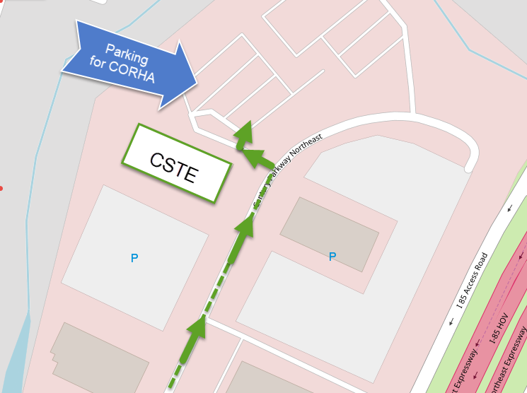
Where to Park:
Going North on Century Center Parkway, take the last Left-hand turn to park in front of the building. Once you enter the building- pass the elevators and the meeting room is on your right through the glass doors.
CORHA Meeting Room Address:
2635 Century Parkway NE
1st Floor
Atlanta, GA 30345

*Please be make sure you sign in at the registration counter to get your ID*
CSTE National Office- Walking Map
2635 Century Parkway NE, Atlanta Ga 30345
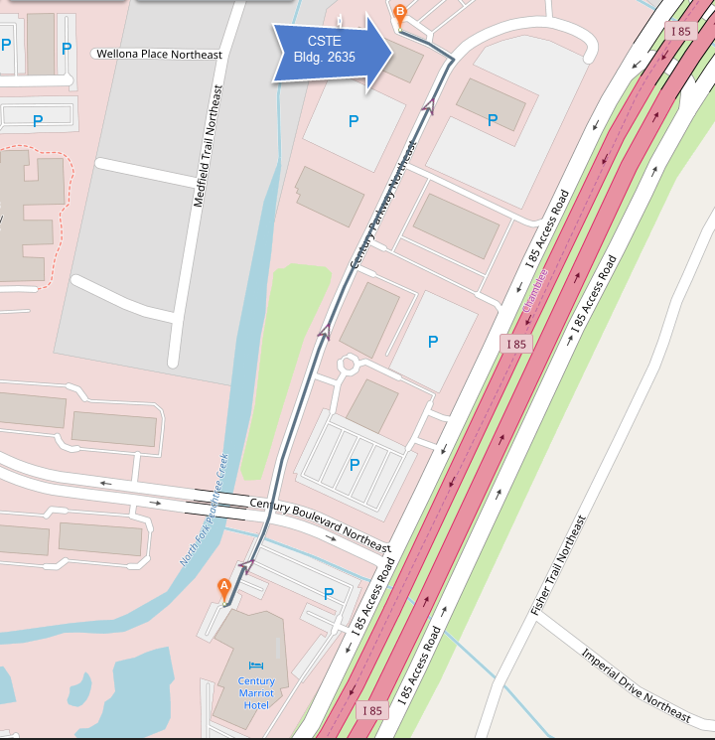
Directions from The Marriott Century Center Hotel:
- Head Northeast from the hotel and cross over “Century Boulevard” to “Century Parkway, NE” (Cross to the left-hand sidewalk).
- Keep walking on “Century Parkway, NE” (you will pass the park, other office building and parking deck on the left) We are the last building on the left-hand side, 2635 Century Parkway (there is signage.).
- Take the last left-hand turn (parking lot) and you will see the building entrance.
- Once inside, walk past the security desk and the elevators- the meeting is in the last room on the right (through the glass doors). CSTE staff will be there to greet you with ID badge and meeting materials.
MARTA and Hotel Shuttle Information:
Taking Marta:

From the Airport:
Follow signs in the airport to “Ground Transportation” You will see signage directing you to the MARTA train line. MARTA tickets and passes are sold at kiosks in the train terminal. Once you have your ticket look for signs directing you to the Gold Line- “Northbound” train. Take the Northbound train line and get off at the “Brookhaven” station. When you arrive at the station call the Marriott Century Center at 404-325-0000 to arrange shuttle pickup from the station.

To the Airport:
Please call the front desk for complimentary hotel shuttle service to the Brookhaven MARTA Station. MARTA tickets and passes are sold at automated kiosks in the train terminal. Take the Southbound train to the airport (final stop on the line).

Marriott Century Center Hotel Shuttle:
Hotel Shuttle:
The Marriott has a complementary shuttle with service to the CORHA meeting as well as to local area restaurants and shopping within a three-mile radius of the hotel. Contact the front desk for the day’s shuttle schedule and to arrange a drop off or pickup. Please note: The hotel shuttle does not offer service to Hartsfield International Airport.
Daily Shuttle Schedule:
- One Shuttle to CSTE Wednesday morning, 8:15 AM.
- One Shuttle to CSTE Wednesday Afternoon, 12:30 PM.
- Two Shuttles from CSTE Wednesday evening, 5:15 PM.
- Two Shuttles to CSTE Thursday morning, 8:15 AM.
- Two Shuttles from CSTE Thursday evening, 5:30 PM.
- Two Shuttles to CSTE Friday morning, 8:15 AM.

