Responding to Possible HAI-AR Outbreaks
All tables need to be revised for HAIs
This is a “living document” so, as CORHA materials are developed, links will be inserted where appropriate.
Introduction
The following material was developed to help health departments and healthcare systems improve their approaches to the investigation and control of possible HAI-AR outbreaks. The type of investigation and appropriate level of response vary depending on a variety of factors, including the nature of the initial report. In general, the term “response” refers to efforts to assist with the assessment and investigation of specific, acute HAI-AR risks, which may take the form of (1) outbreaks, (2) clusters of infections, (3) sentinel cases (e.g., HAI or emerging AR threat of public health interest), or (4) a serious breach in infection control practice.
Possible outbreaks of healthcare-associated infections (HAIs) can be identified by various methods including routine surveillance activities, assessment of laboratory reports, patient complaints or astute healthcare personnel who detect and report unusual events. The distribution of cases by person, place and time can provide important clues as to whether cases are likely to represent a random cluster, outbreak due to a common source or transmission, or pseudo-outbreak due to contamination. A systematic approach is necessary to establish the existence of an outbreak, identify the etiologic agent, define the population at risk, determine risk factors and routes of transmission, implement appropriate control measures and develop strategies to prevent future occurrences. This chapter provides the key elements and steps to systematically evaluate clusters, outbreaks, or unusual events.
Although the facility is responsible for prevention and control within the facility, public health is responsible for ensuring the health and safety of all residents within their jurisdiction, including patients, visitors, staff, and volunteers. Public health agencies often provide assistance with epidemiology, laboratory, environmental assessment, and resources to support the investigation.
Key Elements to Successfully Conduct Outbreak Investigations
Overview
During an investigation, activities may involve:
• Case finding, including efforts to identify potentially at-risk patients and ascertain their status with regard to signs, symptoms or laboratory evidence of infection;
• Assessments of healthcare practices and other observations aimed at identifying possible breaks in infection control;
• Epidemiologic studies to evaluate potential sources of exposure, routes of transmission, and risk factors for disease;
• Laboratory studies to determine the etiologic agent, screening cultures/assays to determine the patients’ infection/colonization status;
• Environmental studies that incorporate sampling and testing to help identify possible reservoirs, evaluate possible routes of transmission, and inform control measures;
• Molecular typing for establishing the relatedness of strains obtained from patients, healthcare personnel, medical products, or the environment;
• Implementation of control measures to correct deficient practices, prevent additional exposures, and contain the spread of the infectious agent or resistant pathogen;
• Engaging regulatory partners (e.g., the FDA, accreditation agencies, state survey agencies, professional licensing) on an as needed basis to communicate findings that intersect with their responsibilities to provide oversight regarding the safety of medical products or patient care;
• Communicating with healthcare providers, healthcare facilities, or patients to ensure appropriate levels of awareness of the investigation and its findings; and
• Monitoring the effectiveness of control measures, which may include observations of care practices and heightened surveillance.
Communication and Coordination
Although most steps in an outbreak investigation follow a logical process—from determining whether an outbreak exists to identifying and controlling the source—most investigations involve multiple concurrent steps. Maintaining close communication and coordination among members of the outbreak investigation team is the best way to ensure concurrent activities are synergistic, maximize the use of resources, ensure important steps in the investigation are not overlooked, and improve the likelihood of implementing timely and appropriate control measures.
Multijurisdictional Considerations for Outbreak Investigations
Increased reliance of the United States on large-scale distribution systems has increased the likelihood of outbreaks in multiple jurisdictions. Local and state health agencies always need to be sensitive to the potential for regional or national implications of any outbreak, especially those due to a potentially contaminated product or defect in a medical device.
Preliminary Assessment
To narrow the focus of an investigation and most effectively use time and resources, investigators should begin by establishing the existence of an outbreak and generating hypotheses about potential sources of infection during the earliest stages of the investigation and refine them as they receive information. Key steps in this process include the following:
• Obtain background rates of infection for the facility or affected patients, if available;
• Determine how the specific agent was identified, request that isolates be saved and made available for further testing, if necessary;
• Consult available reference tools, guides, peer-reviewed literature, or subject matter experts to identify the most likely host, agent, exposure pathways and environmental factors associated with the infection or condition;
• Examine the descriptive epidemiology of cases to identify person, place, or time characteristics that might suggest a particular exposure;
• Interview facility staff (e.g., clinical team, laboratory, infection prevention and control) to identify potential exposures or commonalities among cases; and
• Consider the need for instituting immediate corrective actions or other preliminary control measures.
Based on this information, investigators can identify possible exposures for further evaluation by epidemiologic, laboratory, or environmental studies. In practice, the generation and testing of hypotheses is an iterative process, with the hypothesis modified as more information is obtained.
Standardized data collection forms
The use of standardized data collection forms ensures that pertinent information is collected from all patients or medical records and the results can be systematically analyzed. In addition, the use of standardized data elements (e.g., same variable names and attributes) will enhance data sharing and comparisons of exposures between cases and controls and/or within different healthcare facilities/jurisdictions, if indicated.
CORHA provides examples of questionnaires used by various health departments to collect exposure information for different pathogens or infection types and may be useful in the development of tools during a specific investigation.
Privacy of individuals, patients and their families
All outbreak investigations involve collection of private information, such as names, contact information, and underlying diseases that must be protected from public disclosure. All members of the investigation team, including epidemiologists, laboratorians, environmental health specialists, and healthcare personnel, must protect confidential information, follow safe data security practices, and comply with relevant state and federal laws, including the Health Insurance Portability and Accountability Act (HIPAA).
Cluster and Outbreak Investigation Procedures
Establishing the Existence of an Outbreak
For reports of infection related to a specific microorganism, procedure, device, clinical setting, and/or clinical service, the following questions should be answered:
• What is the background rate of infection for the specific organism or site of infection?
• When was the first case detected (date of onset or date of positive laboratory finding)?
• How many cases have been identified to date?
• What symptoms or sites of infection have been involved?
• What is the severity of illness (colonization, infection, hospitalization/readmission, re-operation, death, etc.) associated with the cases?
• How many patients (if indicated, numbers of personnel or visitors should be assessed as well) were likely to be exposed during the timeframe in which the cases occurred?
If the number of cases is clearly more than would be expected for the patient population in a given timeframe or if the facility is reporting a previously unrecognized pathogen/type of infection, then further investigation is warranted. Likewise, if concerning infection control deficiencies are identified as part of the initial report or preliminary assessment, the investigation should continue.
Assemble and brief the outbreak investigation and control team
The urgency and intensity of the investigation should be based upon the potential for ongoing transmission, infection type, illness severity, and population affected (infants, elderly, immunocompromised persons, etc.).
The investigation and control team should assess the availability of staff to assist with the investigation. Large, complex, or lengthy investigations should consider the implementation of an incident command structure to establish roles and formalize communications.
Outbreak investigation staff should be briefed on the outbreak, introduced to other members of the team and define their roles.
For outbreaks involving multiple jurisdictions, the outbreak investigation and control team should include members from all agencies participating in the investigation and assign responsibility to one individual as the team lead.
For outbreaks having potential involvement of a widely distributed medical product (drug or device), take steps to involve representatives from regulatory partners (e.g., FDA, state pharmacy board).
If the investigation cannot be managed given local resources (e.g., the scale or complexity is likely to overwhelm agency resources, the nature of the outbreak is beyond the expertise of agency staff), help should be requested as soon as possible from local, state, or federal agencies.
Verify the Diagnosis
The facility’s laboratory should be involved in the investigation as soon as a cluster, outbreak, or unusual event is identified. Any clinical or environmental samples or isolates should be secured in a manner that facilitates further evaluation.
If an unusual microorganism is suspected or involved in the outbreak, it is essential to confirm the laboratory test results. Confirmation may include a review of the microbiologic testing methods, performing additional tests and/or sending the isolates to a reference laboratory for further study.
Previous laboratory records should be reviewed to determine when and if there were other previously unidentified cases.
Establish Case Definition and Classification Criteria
A case definition is a standard set of criteria for deciding whether an individual should be classified as having the health condition of interest and is based upon clinical and laboratory findings. It is better to err on the side of sensitivity (use a broad definition) at the start of the investigation and refine the case definition over time as evidence is accumulated.

Investigators often create different categories of a case definition, such as confirmed, probable, and possible or suspect, that allow for uncertainty. To be classified as confirmed, a case usually must have laboratory verification. A case classified as probable usually has typical clinical features of the disease without laboratory confirmation. A case classified as possible usually has fewer of the typical clinical features.
Patients may move from one category to another as additional information is made available. A case might be temporarily classified as probable or possible while laboratory results are pending. Alternatively, a case may be permanently classified as probable or possible if it is not possible to obtain specimens or if tests are expensive, difficult to obtain, or unnecessary.
Line List or Database
Information from collection forms and case reports should be maintained in a systematic and secure form. Consider the need to assemble information on potentially exposed individuals or healthcare personnel, in addition to case-patients. Although a paper tool will suffice in a small cluster or outbreak investigation, the development and use of a readily accessible electronic database can be invaluable to ensure all critical team members have up-to-date and salient information during a large or complex investigation. Ensuring data security is critical in the development and maintenance of any database, but especially those involving identifiable clinical, epidemiologic, and laboratory data.
Identification of Cases
Depending upon the preliminary findings, it is important to seek additional cases to determine the extent of the outbreak, identify prevention and control measures, and monitor for ongoing transmission.
Pathogen-specific outbreaks may occur as a result of a common source, reservoir, or through direct or indirect person-to-person contact via the hands of personnel, contaminated equipment/supplies, food, water, or air. The laboratory is often the primary source of information for pathogen-specific outbreaks (except scabies, lice, etc.). Laboratory partners can assist with timely recognition of an outbreak or additional cases, provide essential information on growth characteristics of the microorganism, and assist in identifying reservoirs for infection.
Laboratory reports should be reviewed retrospectively to determine when the outbreak or cluster began, to search for additional potential cases, and to establish background rates if applicable.
Laboratory staff should be questioned to determine if there have been concomitant changes in laboratory methods that could explain the unusual rates of detection and to ensure appropriate methods of detection were used. If the laboratory findings/reports are not consistent with the clinical presentation or evidence of infection, consideration should be given to possible contamination during specimen collection, handling, or processing. An investigation of all steps in specimen handling and processing should be conducted to rule-out a pseudo-outbreak due to contamination.
Laboratory staff should be trained to immediately alert the investigation team of any possible new cases and store clinical specimens or isolates to ensure further testing can be performed. This is becoming increasingly important as non-culture methods are being used to detect specific microorganisms and/or the organisms’ level of resistance to antimicrobial agents.
Depending upon the clinical syndrome, additional sources of information may be used. For example, histopathology laboratory results may be necessary to identify invasive fungal infection such as aspergillosis. Operating room logs may be necessary to identify patients that return to the operating room for deep or organ space surgical site infections. Other sources may include occupational health records, pharmacy records, radiology reports, admission/discharge records, etc.
Data collection and analysis
The analytic approach used in any particular situation depend on a host of factors including the circumstances specific to the outbreak (e.g., the pathogen, number and distribution of cases), staff expertise, structure of the investigating agency, and the agency’s resources. Investigators are encouraged to use a combination of these practices as is appropriate to the specific outbreak.
- Descriptive epidemiology
During HAI/AR outbreak investigations, medical records, including laboratory, radiology, and surgical records, often serve as the basis for data collection. A standardized data collection tool is used to ensure consistent, complete information is collected on all cases. The information is collected and used to describe the outbreak in terms of person, place and time. In addition, the same tool is often used to review the medical records of control patients if and when an analytic study is undertaken to test various hypotheses.
The data collection tool is usually comprised of the following components:
- Identifying information may include name, medical record number, admission date and status [admitted from ED, home, another facility (name of facility), etc.], discharge date and status.
- Demographic information including age, gender, room location, etc.
- Clinical information using simple, objective criteria to the extent possible. Signs and symptoms allow investigators to verify that the case definition has been met. Date of onset and/or date of culture is needed to chart the time course of the outbreak and when applicable, the incubation period. Supplementary clinical information, such as duration of illness and whether re-hospitalization or death occurred, helps characterize the spectrum of illness.
- Risk factor information should be tailored to the specific disease and situation under investigation. For example, underlying diseases, surgical procedures (including date and type of procedure, duration, surgical team, operating room, etc.), medical interventions, medications administered, etc. may be associated with risk of exposure or transmission.

The CORHA website has examples of tools that can be used or adapted for the following conditions:
INSERT LIST WITH LINKS
Prepare an epidemic curve (i.e., a histogram), and update daily to depict the status of the outbreak. Select time scales for the epidemic curve to highlight the agent, type of infection, mode of transmission, and duration of the outbreak. Notable events, such as implementation of control measures, can be indicated on the curve.
The epidemic curve provides essential information regarding the status of the outbreak. It is used to:
- Depict the magnitude of the outbreak over time in a simple, easily understood visual. It permits the investigator to distinguish epidemic from endemic disease. Potentially correlated events can be noted on the graph.
- The shape of the epidemic curve may provide clues about the pattern of spread in the population, e.g., point source versus intermittent source versus propagated.
- The curve shows where you are during the epidemic — still on the upswing, on the down slope, or after the epidemic has ended. This information forms the basis for predicting whether more or fewer cases will occur in the near future.
- The curve can be used in evaluating the effectiveness of control measures.
- Outliers — cases that don't fit into the body of the curve —may provide important clues.
- If the disease and its incubation period are known, the epi curve can be used to deduce a probable time of exposure and help develop a questionnaire focused on that timeframe.

Need to modify table:
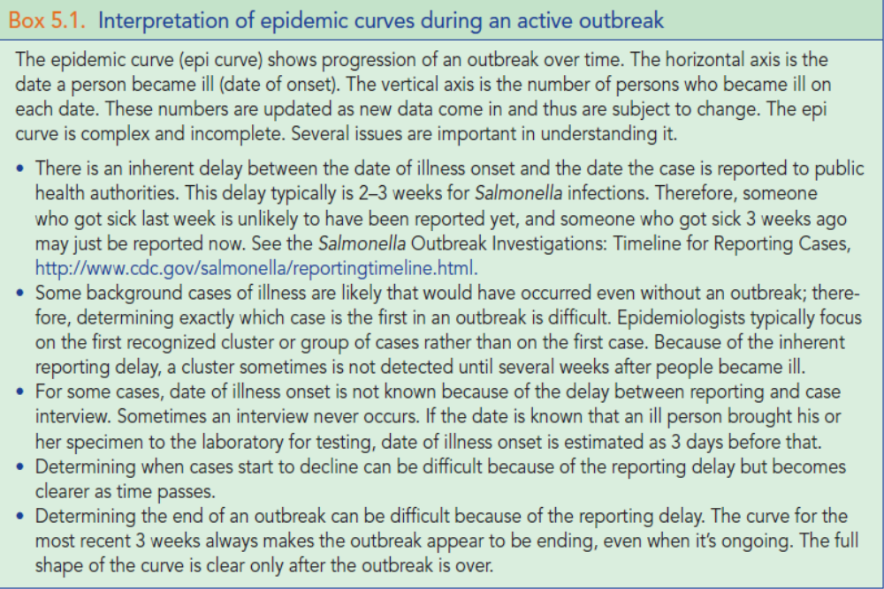

Descriptive epidemiology offers a critical assessment of the status of the outbreak and often serves as the foundation for determining further actions including: implementing prevention and control measures, targeting environmental assessments should they be necessary, and conducting analytic studies to test various hypotheses.
After an explanatory outbreak hypothesis has been developed, the next step is to evaluate the plausibility of that hypothesis. Typically, hypotheses in a field investigation are evaluated using a combination of epidemiology, laboratory, and environmental evidence. From an epidemiologic point of view, hypotheses are evaluated one of two ways:
- Compare the hypotheses with the established facts.
- Use analytic epidemiology to quantify relationships and assess the role of chance.
The first method is likely to be used when the clinical, laboratory, environmental, and/or epidemiologic evidence so obviously supports the hypotheses that formal hypothesis testing is unnecessary. In many other investigations, however, the circumstances are not as straightforward, and information from the series of cases is not sufficiently compelling or convincing. In such investigations, epidemiologists use analytic epidemiology to test their hypotheses.
- Analytic Epidemiology

The key feature of analytic epidemiology is a comparison group. The comparison group allows epidemiologists to compare the observed pattern among case-patients or a group of exposed persons with the expected pattern among non-cases or unexposed persons. By comparing the observed with expected patterns, epidemiologists can determine whether the observed pattern differs substantially from what should be expected and, if so, by what degree. In other words, epidemiologists can use analytic epidemiology with its hallmark comparison group to quantify relationships between exposures and disease, and to test hypotheses about causal relationships. The two most common types of analytic epidemiology studies used in field investigations are retrospective cohort studies and case-control studies.

Retrospective cohort studies
A retrospective cohort study is the study of choice for an outbreak in a small, well-defined population. The investigator calculates an incidence rate for those exposed and those who were not exposed. Generally, an exposure that has the following three characteristics or criteria is considered a strong suspect:
- The incidence rate is high among those exposed.
- The incidence rate is low among those not exposed, so the difference or ratio between incidence rates is high.
- Most of the case-patients were exposed, so that the exposure could “explain” or account for most, if not all, of the cases.
Commonly, the investigator compares the incidence rate in the exposed group to the incidence rate in the unexposed group to measure the association between the exposure and disease. This is called the risk ratio or the relative risk. When the rate for the exposed group is the same as the incidence rate for the unexposed group, the relative risk is equal to 1.0, and the exposure is said not to be associated with disease. The greater the difference in incidence rates between the exposed and unexposed groups, the larger the relative risk, and the stronger the association between exposure and disease.
Statistical significance testing. When an exposure is found to have a relative risk different from 1.0, many investigators calculate a chi-square or other test of statistical significance to determine the likelihood of finding an association as large or larger based on chance alone. A detailed description of statistical testing is beyond the scope of this lesson, but the following text presents some key features and formulas.
To test an association for statistical significance, assume first that the exposure is not related to disease, i.e., the relative risk (RR) equals 1.0. This assumption is known as the null hypothesis. The alternative hypothesis, which will be adopted if the null hypothesis proves to be implausible, is that exposure is associated with disease. Next, compute a measure of association, such as a risk ratio or odds ratio. Then calculate a chi-square or other statistical test. This test indicates the probability of finding an association as strong as or stronger than the one you have observed if the null hypothesis were really true, that is, if in reality the exposure being tested was not related to the disease. This probability is called the p-value. A very small p-value means that the observed association occurs only rarely if the null hypothesis is true. If the p-value is smaller than some cutoff that has been specified in advance, commonly 0.05 or 5%, you discard or reject the null hypothesis in favor of the alternative hypothesis.
The chi-square test works well if the number of people in the study is greater than about 30. For smaller studies, a test called the Fisher Exact Test may be more appropriate. Because the Fisher Exact Test is tedious to calculate, let Epi Info or another computer program perform the calculations for you.
Confidence intervals. An alternative to calculating a p-value is calculating a confidence interval. A 95% confidence interval, the interval used most commonly by epidemiologists, corresponds to a p=0.05 cut-off. In non-technical terms, a confidence interval for a risk ratio is the range of values of the risk ratio consistent with the data in a study. A wide confidence interval indicates that the study is consistent with a wide range of values, i.e., the study is not very precise in describing the strength of the association (risk ratio) between exposure and disease. A narrow confidence interval indicates that the risk ratio is fairly precise.
Because a confidence interval provides more information than a p-value does, many medical and epidemiologic journals now prefer confidence intervals to p-values. However, in the outbreak setting, the difference may be irrelevant. If the objective of an outbreak investigation is to identify the culprit such as a specific medical device, medication, or person associated with an outbreak, a relative risk and p-value may do just as well as a relative risk and confidence interval.

Case-control studies
In a case-control study, the investigator compares case-patients and a comparison group of persons without disease ("controls") about their exposures. Using the information about disease and exposure status, the investigator then calculates an odds ratio to quantify the relationship between exposure and disease. Finally, a p-value or confidence interval is calculated to assess statistical significance.
Choosing controls. When designing a case-control study, one of the most important decisions is deciding who the controls should be. The controls must not have the disease being studied, but should represent the population in which the cases occurred. In other words, they should be similar to the cases except that they don't have the disease. The controls provide the level of exposure you would expect to find among the case-patients if the null hypothesis was true. If exposure is much more common among the case-patients than among the controls, i.e., the observed exposure among case-patients is greater than expected exposure provided by the controls, then exposure is said to be associated with illness.
In practice, choosing the most appropriate control group may be quite difficult. Investigators must consider logistical issues, such as ensuring that they are free of disease, and obtain appropriate exposure data from them.
Other common control groups consist of:
- Random patients admitted to the same unit or in the same timeframe,
- Patients undergoing the same procedure, or
- Patients with the same underlying diagnosis.

If the control group is systematically different from the case group, a true association between exposure and disease may be missed or a spurious association may be observed between a non-causal exposure and disease. A systematic difference between cases and controls that results in a mistaken estimate of the association between exposure and disease is called a bias.
When designing a case-control study, other considerations include the number of controls to select per case and potential confounding (factors associated with both the exposure and disease outcome causing a spurious association). Sample size formulas are available to help determine the number of controls per case. Confounding can be controlled by matching cases and controls on the confounding factor during the selection process or during the analysis of the data.
Often, the number of case-patients that can be enrolled in a study is limited by the size of the outbreak. For example, in a hospital, four or five cases may constitute an outbreak. Fortunately, potential controls are usually plentiful. In an outbreak of 50 or more cases, one control per case will usually suffice. In smaller outbreaks, you might use two, three, or four controls per case. Including more than four controls per case is rarely worth the effort in terms of increasing the statistical power of your investigation.
Odds ratios. In most case-control studies, the population is not well defined, and the total number of people exposed (or unexposed) to a suspected vehicle or source is not known. Without a proper denominator, incidence rates cannot be calculated.

For a case-control study, the measure of association of choice is the odds ratio. Fortunately, for rare events such as HAIs and most other outbreak-associated diseases, the odds ratio from a case-control study approximates the relative risk that would have been found if a cohort study had been feasible. To test the statistical significance of this finding, a chi-square test can be computed. It is important to remember that statistical significance is not proof of causality. The observed results may be due chance, bias or confounding.

Environmental assessment

An environmental assessment is a systematic, evaluation of environmental factors that contributed to transmission in an outbreak. An environmental assessment should be guided by the initial epidemiological investigation.
The goals of an environmental assessment are to identify:
• Possible points of contamination and contact with the disease agent,
• Whether conditions were conducive for organism survival and/or growth, and
• Conditions that allowed the outbreak to happen.

Environmental cultures may be warranted to identify reservoirs for the agent. Please note that clinical laboratories may not be licensed or able to appropriately perform environmental testing. If, based upon the initial epidemiological and environmental assessments, environmental cultures are necessary then further consultation and additional resources may be necessary.

Implement prevention and control measures
In most outbreak investigations, the primary goal is control of the outbreak and prevention of additional cases. If appropriate control measures are known and available, they should be initiated even before an epidemiologic investigation is launched.
In general, control measures are usually directed against one or more segments in the chain of transmission (agent, source, mode of transmission, portal of entry, or host) that are susceptible to intervention.
Coordinate Investigation Activities
Arrange for outbreak control team to meet daily and to regularly update the entire outbreak control team. In particular, if the outbreak has gained public attention, the public information officer needs to prepare a daily update for the media.
During investigation of outbreaks detected by pathogen-specific surveillance, the facility and public health laboratories need to immediately forward case information to epidemiologists for every new potentially outbreak-associated case they receive. This will ensure rapid enrollment of new cases in the outbreak investigation studies. Similarly, as investigators acquire information from cases about exposures in other facilities or patients that are from or have been transferred to other facilities or states, they should rapidly forward that information to the other facilities and/or states. Timely communication and collaboration are critical for prevention and control of outbreaks or new/emerging pathogens.
During the early stages of an investigation, efforts to identify the source of exposure and mode of transmission require close coordination of the outbreak team. After identification, efforts to identify the source of contamination and contributing factors may require engagement of local, state, or federal agencies. As the investigation proceeds, the outbreak control team should always consider whether any information indicates the outbreak might be multi-jurisdictional.
Monitor the status of all components in the investigation on an ongoing basis.
- Review laboratory findings.
- Maintain and review the list of cases.
- Maintain and update the epidemic curve.
Novel questions or opportunities to address fundamental questions about disease transmission can develop during the outbreak investigation. The opportunity to address these issues might require adapting or adopting new strategies during the investigation. Ongoing review and adaptation is often necessary during outbreak investigations.
Interpreting Results
The outbreak investigator’s job is to use all available information to construct a coherent narrative of what happened and why. This begins with the initial detection of the outbreak and formation of hypotheses based on the agent’s ecology, microbiology, and mechanisms of transmission in addition to the descriptive epidemiology of reported cases. Results of subsequent analytic studies (e.g., cohort or case-control study results) should be integrated into the overall context of the investigation. When all of these data elements support and explain the primary hypothesis very strong conclusions can be drawn.
Investigators should consider their data critically and question the strength of the association, timing, dose-response, plausibility, and consistency of findings when implicating a potential source or mode of transmission. Statistical association between exposure and illness may reflect a causal link but also may reflect confounding, bias, chance, and other factors. Conversely, the failure to achieve a P value <0.05 cannot rule out an association for a potential source or exposure due to small number of cases, sampling method, inappropriate selection of controls, or other factors. As noted above, observed associations need to be placed in the context of the other investigation results.
Even well-executed investigations can be inconclusive. Small sample sizes, confounders, common procedures and events can reduce the effectiveness of standard epidemiologic methods and make investigations extremely difficult. The decision to stop an investigation depends on the gravity and scope of the outbreak and on the likelihood that it reflects an ongoing public health threat.
General principles underlie successful investigations; however, no one specific method works best in all situations. Investigators need to be flexible and innovate as circumstances demand. Investigations that are haphazardly carried out are unlikely to yield meaningful results. Facilities or jurisdictions that cannot commit resources to outbreak investigations themselves should do whatever they can to facilitate follow-up of their cases by other agencies (e.g., counties to states; states to other states or CDC).

Need to modify table:

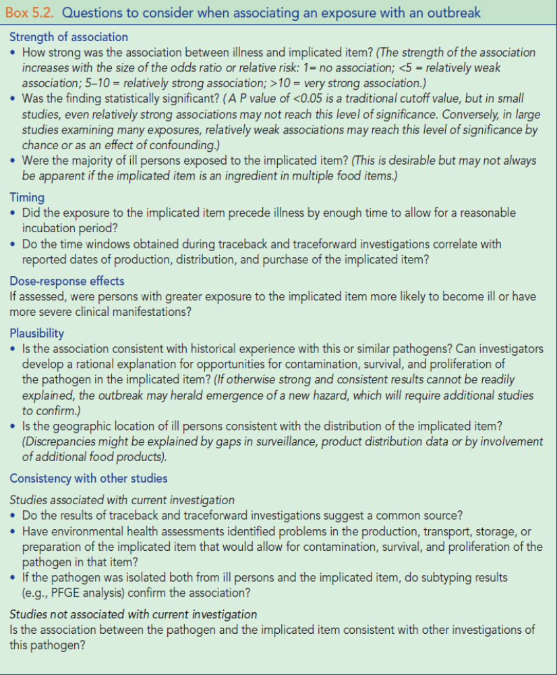

Conduct a Debriefing at End of Investigation
Conduct a post-outbreak meeting among investigators to assess lessons learned and compare notes on ultimate findings. This is particularly important for multiagency investigations but also is important for single-agency investigations.
Summarize Investigation Findings, Conclusions, and Recommendations
Larger or more complex investigations or investigations with significance for public health and patient-safety demand a more complete narrative report and, potentially, publication in a peer-reviewed journal. Written reports should include the following:
• Background, including information about the outbreak setting, timing, and manner of detection of the investigation.
• Methods, including other agencies involved in the investigation, investigation methods, case definition, number of people exposed, number of records reviewed, number ill, number of samples collected, pathogens tested, and a high-level summary of the laboratory methods used.
• Results, including number of persons affected, clinical findings, laboratory findings, odds ratio(s) or relative risks and confidence intervals for risk factors, and relevant findings from environmental investigations. Include the epidemic histogram and if possible, timing and impact of control measures.
• Conclusions, including etiologic agent, discussion of transmission route, contributing factors, justifications for conclusions, and limitations of the study.
• Recommendations, including all specific recommendations for abatement of this outbreak and prevention of similar outbreaks.
Distribute Report
Make copies of the report available to all persons involved with the investigation, including
• Investigation team members and their supervisors;
• Health department officials and press officers;
• Regulatory agency officials and press officers;
• Health-care facility and providers who reported cases; and
• Laboratorians who performed tests.
Also distribute copies of the report to persons responsible for implementing control measures, including
• Healthcare facility CEO and/or Director;
• Program staff who might oversee implementation of control measures or provide technical assistance; and
• Accreditation organizations or regulatory agencies that might develop or implement policies and regulations for which the investigation might have implications.

Notes regarding content of this chapter for reviewers’ consideration:
Legal and ethical issues are not discussed in this chapter including when, if and how to conduct patient notifications and release of information.
Drug diversion and infection control breaches will be included in the list of condition-specific issues with appropriate links.

