

Council for Outbreak REsponse:
Healthcare-Associated Infections and Antiobiotic-Resistant Pathogens (CORHA)
Implementation Planning Meeting Summary

June 7-8, 2016

920 farmington avenue, ste. 100
west hartford, ct 06107
860.232.3667
www.theclariongroup.com
Table of Contents

Introduction 1
Orientation and Review 1
Overview of Strategic Effectiveness 1
Review of the Council’s 2016-2018 Strategic Map 2
Keys to Successful Implementation 4
CORHA’s First Year Implementation Priorities/Tracks of Work 5
Developing Preliminary Implementation Plans 5
Inward-Facing Tracks of Work 5
Outward-Facing Tracks of Work 7
Guidance for Strategic Priorities A and B Workgroups 8
Draft Matrix 9
Prioritization Criteria 9
Year 1 Product Brainstorming 9
Next Steps 10

Council for Outbreak Response: Healthcare-Associated

Infections and Antibiotic-Resistant Pathogens (CORHA)

Implementation Planning Session

Meeting Summary: June 7-8, 2016

Introduction
Marion Kainer and Gerd Clabaugh, Co-Chairs of the Council for Outbreak Response: Healthcare-Associated Infections and Antibiotic-Resistant Pathogens (CORHA), welcomed participants to the implementation planning session. Gerd made the following opening remarks.
- We’ve had a busy six months since we met last December as a new Council.
- CDC has been actively working on the Council, and has convened meetings at which we received great feedback to the organization and its goals.
- We welcome our new members, APIC and SHEA.
- We will continue to define the role of this Council in reimagining how our systems operate.
Marion and Gerd welcomed Laurie Schulte of The Clarion Group and invited her to facilitate the session.

Laurie outlined the agenda for the session:
- Conduct an orientation and review of the Council’s strategy formulation work that took place in December of 2015.
- Develop preliminary implementation plans for the Council’s “inward-facing” first-year implementation priorities.
- Begin implementation planning for the Council’s “outward-facing” first-year implementation priorities.
The first year of implementation of the Council’s strategic plan is aligned with its grant cycle, e.g. July 1, 2016 through June 30, 2017.

This document provides highlights of the implementation planning workshop.

Orientation and Review

Overview of Strategic Effectiveness
Laurie Schulte reviewed the definition of strategic effectiveness: an organization’s ability to set the right goals and consistently achieve them.

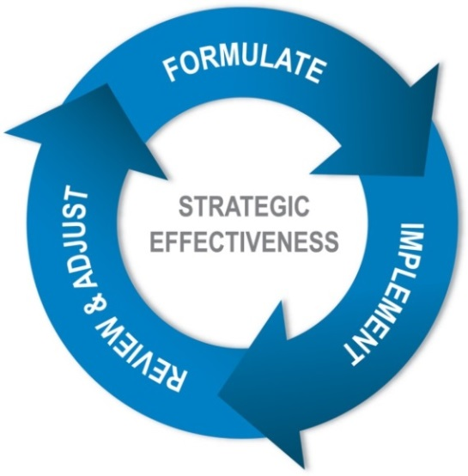

Organizations with high strategic effectiveness:
- Quickly formulate a “good enough” strategic plan.
- Move immediately to implementation – letting implementation teach them the ways that the strategy is on target and ways it needs to be improved.
- Review progress on implementation regularly with honesty and candor.
- Make needed adjustments based on what is working, what isn’t, and how the world has changed.
- Focus on results, not activities.
There are three outcomes of strategic effectiveness, including:
- The right goals
- Consistent goal achievement
- Development of strategic effectiveness as an organizational capability

Review of the Council’s 2016-2018 Strategic Map
Using a one-page graphic representing a strategic map, Laurie Schulte reviewed the concepts of the strategic map: central challenge, strategic priorities, and strategic objectives.
- The oval at the top of the one-page strategic map is the central challenge.
  - It is the focal point for the strategy.
  - It focuses on what the organization needs to do in the next three years to support its mission and vision.
- The central challenge is supported by some number of strategic priorities. Strategic priorities are the few critical things an organization must do in order to meet its central challenge. The number of strategic priorities can vary, but it is never fewer than three or more than six.
- There are two tests of a strategic priority:
  - Is each priority necessary to meet the central challenge?
  - Are the strategic priorities taken together sufficient to meet the challenge?
- The boxes under each strategic priority are strategic objectives. Objectives spell out more specifically “what to do” in order to achieve the strategic priority.
Laurie Schulte then reviewed the strategic map for CORHA, developed at its December 17-18, 2015 strategic planning session. The map is included for reference below. The color coding of selected strategic objectives reflects the priorities/tracks of work the planning group identified at that session for the first 12 months of implementation of the strategic map.
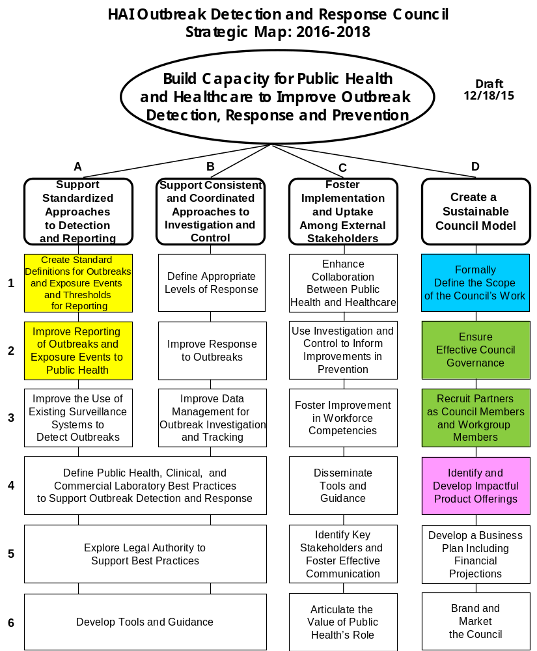

Keys to Successful Implementation
Based on The Clarion Group’s work in providing implementation support to a wide range of organizations, Laurie Schulte outlined the following keys to successful strategy implementation.
- Effective leadership in three critical roles:
  - The executive leader or sponsoring leader is the person or group that makes the “go/no go” decision on implementation and allocates human and financial resources necessary to support effective implementation. (This role is most clearly assumed by the Council’s Governance Committee.)
  - The front line leader is the person or group that has designated responsibility to implement a specific implementation priority or initiative. (This role is most likely assumed by other Council members and key members of their home organizations.)
  - The consultative or supportive leader is the person or group with the responsibility for providing critical support (expertise, coaching, resources, etc.) to the front line leaders. In addition, the supportive leader may have the responsibility for the coordination of all implementation efforts. These leaders often come from key support functions such as human resources, performance management, organizational development or information technology. (In CORHA’s case, this role is most likely to be performed by CSTE and ASTHO staff.)
- Strong teams staffed with the right people
- Clearly defined, result-based implementation plans
- Aligned human and financial resources
- An effective approach to monitoring implementation and making appropriate adjustments
- Well-defined indicators/measures of success
- A clear line of sight that helps each person see “how I make a difference.” An example of what a clear line of sight includes is depicted in the graphic below.

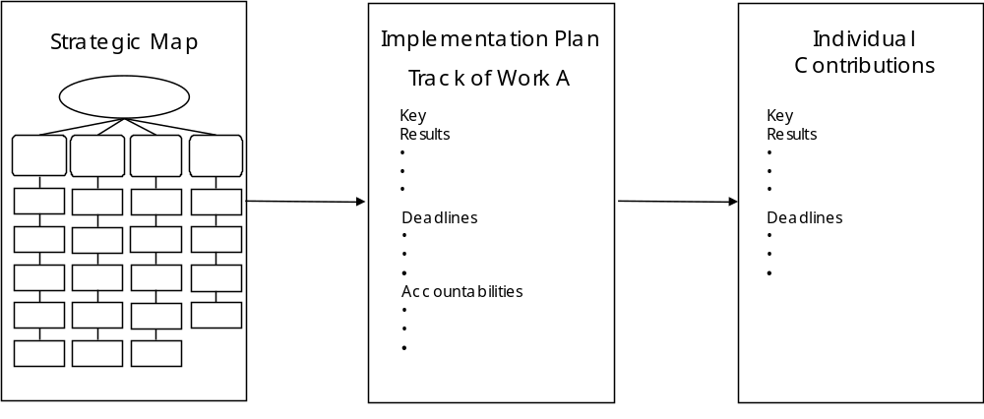

CORHA’s First Year Implementation Priorities/Tracks of Work
Laurie Schulte reminded the group of the first year implementation priorities that were identified at its strategic planning session in December of 2015. Those priorities follow.

Inward-facing

Governance and Membership
- Strategic Objective D-2: Ensure effective Council governance.
- Strategic Objective D-3: Recruit partners as Council members and workgroup members.

Product Offerings
- Strategic Objective D-4: Identify and develop impactful product offerings.

Scope of Work
- Strategic Objective D-1: Formally define the scope of the Council’s work.

Outward-facing
- Strategic Priority A: Support standardized approaches to detection and reporting.
- Strategic Priority B: Support consistent and coordinated approaches to investigation and control.

Developing Preliminary Implementation Plans

Inward-Facing Tracks of Work
Participants met in small groups to begin to draft implementation plans that included the following elements (as reflected in Worksheet 1):
- Key results
- If time allowed, suggested metrics for those results
The three groups also began to develop more detailed elements of their plans that included the following (as reflected in Worksheet 2):
- Tactical steps for each result
- Deadlines for achieving each result
- Accountabilities for achieving each result

A summary of the small group reports follows.

Governance and Membership: Gerd Clabaugh, Dhara Shah, Elizabeth Mothershed, Ryan Fagan, Meredith Allen, Jay Butler, Alexa Limeres
The preliminary implementation plan for the Governance and Membership implementation priority/track of work can be accessed by double-clicking on the icons below.

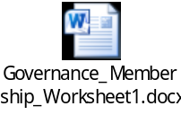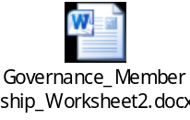

Product Offerings: Wendy Bamberg, Nicole Bryan, Bonnie Herring, Dawn Terashita, Matthew Crist, Srihari Seshadri, Steven Franklin, Kate Heyer, Linda Greene
The preliminary implementation plan for the Product Offerings implementation priority/track of work can be accessed by double-clicking on the icons below.


- A toolkit outline will be developed in Year 1 by the Strategic Priority A and B workgroups (to be empaneled at a later date).
- In Year 2, key results include:
  - The Year 2 plan for product development is in place.
  - Council establishes a “clearinghouse” of resources.

Scope of Work: Marion Kainer, James Blumenstock, Zack Moore, Sara Chang, Waleed Javaid, Joseph Perz, Kathy Seiber, Kristy Weinshel
Prior to developing key results for the Scope of Work track of work, participants considered the following:
- Assumptions for the track of work
- Conditions for Council participation in that work
- Healthcare settings that the Council’s work would impact
- Audiences for the Council’s work

The group began to document this thinking in the document attached below (double click to open). The completion and approval by Council of this document is a next step for CORHA.



The preliminary implementation plan for the Scope of Work implementation priority/track of work can be accessed by double-clicking on the icons below.



Outward-Facing Tracks of Work
Council will designate two workgroups, comprised of members and potential non-members, to implement its outward-facing tracks of work:
- Strategic Priority A: Support standardized approaches to detection and reporting.
- Strategic Priority B: Support consistent and coordinated approaches to investigation and control.
Participants worked in small groups to begin to provide implementation guidance for these workgroups. The small group reports follow.

Group 1: Gerd Clabaugh, Dhara Shah, Elizabeth Mothershed, Ryan Fagan, Meredith Allen, Jay Butler, Alexa Limeres
- Inventory (less value) vs. distillation (more value)
- Goal: scanning available resources among Council
  - Council member organizations perform scan of available resources, based on organizational expertise, of a topic.
  - Detection and Reporting workgroup distills Council scan of resources, reviews, and identifies areas for clarification and standardization.
- Clarifying roles
  - Where they connect
  - Healthcare facility vs. public health
- How do you identify outbreaks at a state health department?
- How do you detect/report at a facility?
- Definitions to be used for the public to help clarify
- Public is defined as:
  - Public health and healthcare
  - Those who work in response
- If definitional purpose is to clarify, need an environmental scan to understand where gaps are
  - For CRE, split how to scan so each piece can start on standardization.
  - While scanning, look for areas that need standardization and clarity.
- Create central repository for CORHA scanning (possible help desk).
- Template submission per member organization
  - Audience
  - Type of source
  - Etc.

Group 2: Wendy Bamberg, Nicole Bryan, Bonnie Herring, Dawn Terashita, Matthew Crist, Srihari Seshadri, Steven Franklin, Kate Heyer, Linda Greene

Goal
- Web page with resources

Steps
- Create resource list as internal process by pathogen condition.
  - First draft: 9/16
    - Proposal to divide into sections and assign: 7/16
    - Create template, including abstract/summary: 7/16
    - Each assignor complete template: 8/16
    - CSTE/ASTHO compile: 9/16
  - Final draft
    - Discuss on call: 9/16
    - E-mail drafts/revisions: 9-12/16
    - CORHA review/approval: 12/16
- If necessary, creation of web pages (very aggressive timing)
  - Web page outline: 9/16
  - Creation of CORHA website: 12/16
  - Consider focusing on certain conditions, to be chosen by 1/17.
  - Web page template with example: 3/17
  - Web page template/mockup with example: 3/17
  - Develop a CORHA logo: 3/17
  - CORHA stamp of approval for each web page: 4/17
  - Final web pages up and running: 6/17

Toolkit for One Condition (Timeline Untenable?)
- Creation of content vs. resource list
- Steps
  - Forum workgroup: 7/16
  - Choose condition: 7/16
  - Environmental scan review: 8/16. Please note that the environmental scan will not be complete by 8/16 according to the Product Offerings timeline.
  - Identify gaps: 8/16
  - Outline of toolkit: 8/16
  - Assign sections: 9/16
  - Write sections: 5/17
  - Compile sections: 6/17
  - CORHA review and approve: 6/17
  - Post on website: 7/17
Once empaneled, the Strategic Priorities A and B workgroups will use the input summarized above to frame their work over the next year.

Guidance for Strategic Priorities A and B Workgroups
In order to provide additional guidance to the Strategic Priorities A and B workgroups, participants:
- Considered an approach to drafting a matrix of healthcare settings and events to be prioritized in the next year
- Drafted prioritization criteria for the A and B workgroups to use in prioritizing those settings/events
- Brainstormed potential CORHA products to be introduced in the next year

A summary of that work follows.

Draft Matrix
The CDC team provided the following for consideration by participants.


Once finalized by the Scope of Work Council team identified in this session, the matrix will be used by Strategic Priority workgroups A and B to help identify the focus of their work over the next year.

Prioritization Criteria
Participants worked as a large group to identify those prioritization criteria that will be used against the matrix referenced above to identify where the outward-facing work of the Council should begin. A summary follows.
- Achievable result within one year
- Alignment of the priority with work that is already funded nationally
  - Emerging national issues that are not yet funded
  - Includes willing partners
- Guidance
  - Gaps in guidance
  - Opportunities for dissemination: guidance exists that hasn’t been disseminated broadly
  - Low uptake
- Burden/impact
  - Potential to affect a large number of people
  - Morbidity/mortality
  - Potential to cross settings/facilities: community-based
  - Pathogen severity
- Settings/conditions that translate more broadly to others

Year 1 Product Brainstorming
The group brainstormed a list of potential CORHA products for the next year. A summary of that brainstorming follows.

For a Prioritized Event/Setting
- Distill existing information (“one stop shop”) into a one-page document or web page with brief summary text including:
  - Threshold for reporting and investigation
  - Suggestions on how to improve reporting
  - Suggestions on how to improve the use of existing surveillance data
  - Tools for investigation
  - Standardized control measures
  - Related links
- Have a suite of these event-specific reference tools.
- An internal result: clarity on gaps in existing guidance

MDRO Guidance for State/Territorial Health Departments
- Aggregate what exists.
- Identify gaps and consider how to develop guidance for them.
- This is an opportunity for CORHA to “be aggressive” in Year 1.

Lab Guidance (Strategic Objectives AB4, AB5)
- What exists, but is hard to find (Council’s Year 1 focus)
- What doesn’t exist and needs to be created (a Year 2 workgroup?)
- Areas include:
  - Surveillance cultures
  - Susceptibility testing
  - Environmental sampling
  - Clinical isolates
  - What test results mean

Next Steps
At the end of the session, the group established the following next steps.
- Laurie Schulte will provide draft Worksheets 1 and 2 to CSTE/ASTHO for distribution to the three ad hoc work groups established at this session (Governance and Membership, Product Offerings and Scope of Work) by June 15th.
- Laurie Schulte will provide the draft internal Scope of Work document and the written summary of highlights from this session by June 23rd.
- The ad hoc work groups will meet virtually to complete their draft plans and distribute to the full Council by June 30th.
- Council will conduct a full Council call at which it will:
  - Consider the three plans together to ensure the results and dates are achievable.
  - Match aggressiveness with the appropriate amount of realism to ensure success with implementation.
  - Develop a master work plan with adjusted deadlines as appropriate.

