

Council for Outbreak REsponse:
Healthcare-Associated Infections and Antiobiotic-Resistant Pathogens (CORHA)
Winter Meeting

November 17-18, 2016

920 farmington avenue, ste. 100
west hartford, ct 06107
860.232.3667
www.theclariongroup.com
Table of Contents

Introduction 1
Orientation and Review 1
Overview of Strategic Effectiveness 1
Review of CORHA’s 2016-2018 Strategic Map 2
Implementation Priorities/Tracks of Work 4
Organizational Updates – Council Members 5
CDC: Feedback from HAI Program Evaluations 5
SHEA Outbreak Response Training Program 5
NACCHO 6
CSTE 6
ASTHO 6
APIC 6
Other 6
Workgroups A and B Updates 7
Operationalizing Workgroup Charges 8
Next Steps 12

Council for Outbreak Response: Healthcare-Associated

Infections and Antibiotic-Resistant Pathogens (CORHA)

Winter Meeting

Meeting Summary: November 17-18, 2016

Introduction
Gerd Clabaugh, Co-Chair of the Council for Outbreak Response: Healthcare-Associated Infections and Antibiotic-Resistant Pathogens (CORHA), welcomed Council members and staff to the CORHA Winter Meeting. Gerd made the following opening remarks:
- I want to congratulate all of you on the work you’ve done in support of CORHA.
- We’ve accomplished much in a year.
- There’s a lot more to do.
- This is an opportunity to build on our momentum.
- I’d also like to thank my colleagues on the Governance Committee, who have been well engaged and meeting regularly.
Marion Kainer, CORHA Co-Chair, echoed Gerd’s welcome and made the following opening remarks:
- We’ve come a long way since the origination of the Council.
- We’ve developed charges for the workgroups.
- We’ve identified pathogens on which to focus.
- We have foundational guidance for CORHA as an organization.
- I’d like to thank all of you, especially CSTE and ASTHO staff.
Marion and Gerd welcomed Laurie Schulte of The Clarion Group and invited her to facilitate the session.

Laurie outlined the agenda for the session, which included:
- A review of CORHA’s strategic map and implementation priorities
- Organizational updates on CORHA-related activities
- Updates on the progress to-date of Workgroup A (Detection and Reporting) and Workgroup B (Investigation and Control)
- Operationalizing the charges of:
  - Workgroup A
  - Workgroup B
  - Branding and marketing the Council
This document provides highlights of the CORHA Winter Meeting.

Orientation and Review

Overview of Strategic Effectiveness
Laurie Schulte reviewed the definition of strategic effectiveness: an organization’s ability to set the right goals and consistently achieve them.

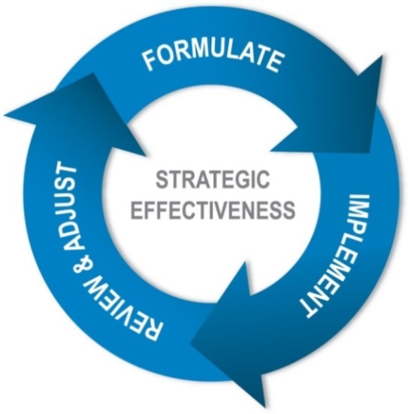

Organizations with high strategic effectiveness:
- Quickly formulate a “good enough” strategic plan.
- Move immediately to implementation – letting implementation teach them the ways that the strategy is on target and the ways it needs to be improved.
- Review progress on implementation regularly with honesty and candor.
- Make needed adjustments based on what is working, what isn’t, and how the world has changed.
- Focus on results, not activities.
There are three outcomes of strategic effectiveness, including:
- The right goals
- Consistent goal achievement
- Development of strategic effectiveness as an organizational capability

Review of CORHA’s 2016-2018 Strategic Map
Using a one-page graphic representing a strategic map, Laurie Schulte reviewed the concepts of the strategic map: central challenge, strategic priorities, and strategic objectives.
- The oval at the top of the one-page strategic map is the central challenge.
  - It is the focal point for the strategy.
  - It focuses CORHA on what it needs to do in the next three years to support its mission and vision.
- The central challenge is supported by some number of strategic priorities. Strategic priorities are the few critical things CORHA must do in order to meet its central challenge. The number of strategic priorities can vary, but it is never fewer than three or more than six.
- There are two tests of a strategic priority:
  - Is each priority necessary to meet the central challenge?
  - Are the strategic priorities taken together sufficient to meet the challenge?
- The boxes under each strategic priority are strategic objectives. Objectives spell out more specifically “what to do” in order to achieve the strategic priority.
Laurie Schulte then reviewed the strategic map for CORHA, developed at its December 17-18, 2015 strategic planning session. The map is included for reference below.

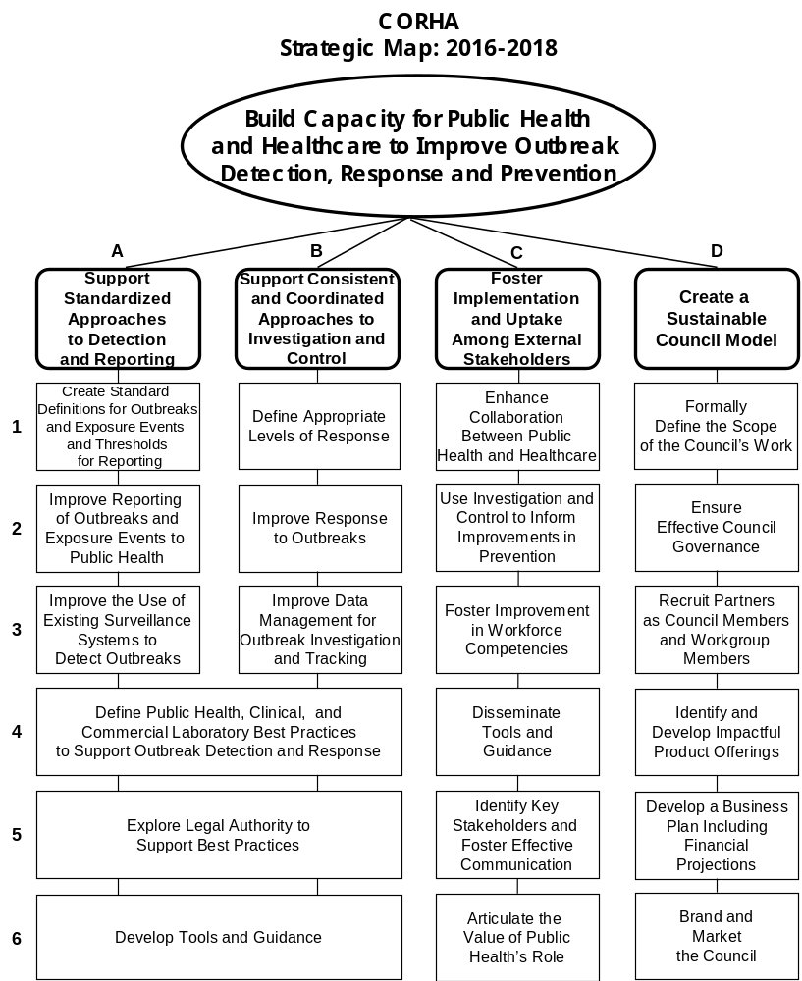

Implementation Priorities/Tracks of Work

First Year Implementation Priorities/Tracks of Work
Laurie Schulte reminded the group of the first year implementation priorities that were identified at its strategic planning session in December of 2015. Those priorities follow, with a status update in red.

Inward-facing

Governance and Membership: ongoing and working well
- Strategic Objective D-2: Ensure effective Council governance.
- Strategic Objective D-3: Recruit partners as Council members and workgroup members.

Product Offerings: now embedded in Workgroups A and B
- Strategic Objective D-4: Identify and develop impactful product offerings.

Scope of Work: complete
- Strategic Objective D-1: Formally define the scope of the Council’s work.

Outward-facing
- Strategic Priority A: Support standardized approaches to detection and reporting: now reflected as Workgroup A (see below).
- Strategic Priority B: Support consistent and coordinated approaches to investigation and control: now reflected as Workgroup B (see below).

Next Year’s Implementation Priorities/Tracks of Work

Workgroup A: Detection and Reporting
- Strategic Objective A-1: Create standard definitions for outbreaks and exposure events and thresholds for reporting.
- Strategic Objective A-2: Improve reporting of outbreaks and exposure events to public health.
- Strategic Objective A-3: Improve the use of existing surveillance systems to detect outbreaks.

Workgroup B: Investigation and Control
- Strategic Objective B-1: Define appropriate levels of response.
- Strategic Objective B-2: Improve response to outbreaks.
- Strategic Objective B-3: Improve data management for outbreak investigation and tracking.

Branding and Marketing
- Strategic Objective D-6: Brand and market the Council.

Organizational Updates – Council Members

CDC: Feedback from HAI Program Evaluations
CDC Council members provided the following preliminary analysis of ICAR Activity A4 HAI outbreak reporting and response.



Discussion included the following points.
- The analysis serves as a starting point to evaluate the capacities of state and major city health departments to detect, report and respond to HAI outbreaks. (Note that territories were not included in the survey.)
- It can provide direction to CORHA as to what health departments need guidance on.
- Given variability by state in sophistication of reporting and compliance, the survey likely significantly under-represents the breadth of HAI outbreaks.
- Where a culture of reporting exists, there is greater openness/willingness of settings to report outbreaks to health departments.
- It would be helpful to understand how the reported dynamics vary between urban and rural areas.
  - Health departments by definition report statewide data.
  - Urban areas are likely to have greater deficiencies and less infrastructure.
  - CDC might consider repeating the analysis with a cadre of local health departments and facilities.

SHEA Outbreak Response Training Program
SHEA is developing an outbreak response training program for hospital epidemiologists. Discussion included the following points.
- In the case of an outbreak or potential outbreak, hospital epidemiologists are forced into roles with which they are unfamiliar.
  - They need clarity on their roles and responsibilities vis a vis public health.
  - SHEA’s new training will help establish standards for hospital epidemiologists.
  - SHEA has established advisory panels to develop a range of trainings, to be launched in 2017.
- SHEA’s training is intended to focus very specifically at the facility level – although practically speaking, there will be overlap with the work of this Council.
  - Ebola funding made possible the launching of various entities with common purposes.
  - The intentions were good; the implementation will require coordination.
  - CORHA’s Governance Committee will work with SHEA leadership to determine an appropriate mechanism for this coordination.
- Other entities with whom CORHA should coordinate include the new CSTE-sponsored Antimicrobial Resistance Surveillance Taskforce.

NACCHO
NAACHO is providing the following to local health departments:
- Grants to support:
  - Response to emerging infections
  - Improved community infection control practices
  - Facilitated regional conversations
- Scholarships for 35 health departments to become certified in infection control
- Guidance documents to local facilities

The Council should consider how to integrate NACCHO’s guidance into its work.

CSTE
CSTE provided a brief overview of the Antimicrobial Resistance Surveillance Taskforce.
- It will provide guidance on roles and responsibilities at the federal, state and local levels, including:
  - An overview of the current state
  - A proposed desired state
  - The path from current to desired
  - Underlying workgroups to achieve the path
- Position statements are in development for approval at CSTE’s annual meeting.
- This group has significant implications for CORHA.

ASTHO
ASTHO shared the 2017 priorities for its Infectious Disease Policy Committee.
- One of these priorities is antimicrobial resistance and healthcare-associated infections, specifically regarding the sharing of state resources.
- This issue is of critical importance to State Health Officials.
- There may be “force multipliers” that can advance CORHA’s work.

ASTHO also shared that Dr. Jay Butler, ASTHO President, will be interviewed by Reuters next week as they launch the second round of investigative reporting into healthcare-associated infections. The group will consider how best to equip Dr. Butler with CORHA talking points later in this session.

APIC
APIC shared its monitoring of pending death certificate legislation emerging across states that would require a death from a healthcare-associated infection to be cited on a person’s death certificate.
- The legislation likely is originating from patient advocacy groups.
- APIC will continue to monitor this closely.

Other
Marion Kainer and Joe Perz will be presenting CORHA at HICPAC’s December meeting. This has potential as a powerful “launching point” and test run of CORHA messaging, to be discussed in more detail later in this session.

Workgroups A and B Updates
Workgroups A and B provided updates on their progress to-date, as represented in the attached documents (double-click to open):



Discussion included the following points.
- Workgroup A is considering APHL and ASM representatives as potential working members of this group.
- CORHA will need an ongoing communication mechanism between Workgroups A and B. This could include:
  - Short updates incorporated into regular workgroup calls
  - Cross-group coordination by ASTHO/CSTE staff
  - Call notes and work plans
  - Coordination between workgroup chairs
  - Basecamp
- CORHA also needs to consider what communications mechanisms to use among/between various other audiences.
  - Basecamp is an internal mechanism.
  - The Council needs to determine how to “push” information out to various stakeholders to build awareness and engagement.
  - It also needs to develop common messaging for use by members.
  - How do we avoid duplication with others, for example, SHEA?
  - The Branding and Marketing small group will consider these issues later in this session.
- The group discussed which organizations might be approached to solicit members for Workgroups A and B. Members could be either “sustained” or “ad hoc.” A list of organizations follows:
  - Increased state health department representation
  - Facilities, including hospitals and nursing homes; at the present time, APIC and SHEA’s participation is considered sufficient
  - APHL
  - Increased participation by NACCHO/local health department representatives
  - ASM
  - Legal experts; the group agreed that standing legal entities at Council member organizations can fill this role
  - ARLM
  - Exploration within Workgroups A and B of representation by other federal agencies, e.g.:
    - FDA
    - CMS
    - Veterans Administration
  - CORHA may be more ready to approach some of these organizations than others.
  - There is a desire to keep the workgroups smaller and more focused in their early stages; “ad hoc” members are an appropriate future consideration.
- At a future meeting, CORHA’s Governance Committee will consider:
  - How it might fill the workgroup member gaps
  - The appropriate pacing of a desired approach
- As outlined in CORHA guidance documents, Workgroups A and B will each have a Chair and Co-Chair.
  - Wendy Bamberg will serve as Chair of Workgroup A.
  - The other positions remain to be filled.
- Workgroups A and B agreed to the following regarding pathogens of interest.
  - Workgroup A is developing a table to frame its work to standardize outbreak and adverse event definitions and thresholds for reporting.
  - Per Workgroup B’s interest, it will add scabies to its definitional table.
    - Workgroup B is interested in investigation and control of scabies, particularly in long-term care facilities.
    - It is useful information for front-line practitioners.
  - Workgroup A is emphasizing CRE and C diff as focus areas in its efforts to improve surveillance and reporting of outbreaks.
  - Workgroup B will consider what its “table” should be and will populate it as a work product.

Operationalizing Workgroup Charges
Participants worked in three small groups aligned with CORHA’s next year implementation priorities to provide guidance for operationalizing the charge for each of these priorities. Groups A and B completed the following assignment:
- Identify a limited number of specific results to be achieved by the Workgroup.
- Identify deadlines and accountabilities for each result:
  - By the CORHA Spring Meeting (May 2017)
  - Within the next year (November 2017)
Workgroups A and B also began to develop more detailed elements of their plans. A summary of the small group reports follows.

Workgroup A: Detection and Reporting (Wendy Bamberg, Marion Kainer, Lisa Tomlinson, Lilly Kan, Kathy Seiber, Ryan Fagan, Nicole Bryan, Elizabeth Ruebush, Alexa Limeres)
The small group output for Workgroup A can be accessed by double-clicking on the icons below.



Workgroup B: Investigation and Control (Joe Perz, Waleed Javaid, Dawn Tarashita, Srihari Seshadri, Jessica Helms, Alyssa Farmer, Steven Franklin, Matthew Crist)
The small group output for Workgroup B can be accessed by double-clicking on the icons below.



The third small group considered branding and marketing the Council. This group considered the following questions:
- What is the purpose of branding/marketing CORHA?
- What do you see as the core elements of the CORHA “brand?” What would you like CORHA to be known for?
- What do you see as the most effective means by which to market/communicate CORHA to/from key stakeholders? What’s our platform?
- What else would you want a communications resource who may help CORHA with branding/marketing to know?
A summary of the small group report follows.

Branding and Marketing: (James Blumenstock, Meredith Allen, Elizabeth Mothershed, Dhara Shah, Sara Chang, Monica Huang, Erin Laird)

Purpose
- What we do, resources, how we’re distinct
- Establishing authority, credibility and legitimacy
- Entities involved, reputation
- Nimble, responsive, guidance timely

Core Elements
- Articulating value-added, uniqueness
- Clearance process? Balancing nimbleness with bureaucracy
  - Organizational level for “big” products
  - Council level for other products
- Collective voice/messaging on behalf of the field
- Advancing national dialogue, federal work
- Convener of partners, coordination, communication
- Platform for community of practice
Questions regarding the above:
- Approval process for guidance, products, standards
- What/who are we advising (not a FACA)?
- Are we “responders?”
- Do we conduct IPRs/AARs?

Means
- Audience: spectrum of public health stakeholders
- Logo and website development, updates and management
- Flyers
- Social media
- Slide deck template
- Present as CORHA, not linked to organizations
- Establish a standing marketing and communications workgroup?
  - Staff
  - Council members
  - Marketing and communications staff from Council member organizations/partners
- Evaluate impact of efforts (hits, etc.) to convey the importance of the work, the degree of implementation.
- Attendance/representation at meetings
- Elevator pitch/messaging
- Not just reaching technical specialists, also communications (like NPHIC)
- Hosting/promoting resources/clearinghouse
- Framing of federal partners, membership
Questions regarding the above:
- Voting in bylaws – what if CDC doesn’t approve, but the Council does?
- To what extent will we review resources/guidance for the clearinghouse?
- What are the criteria for “launching” website/products?
- What are our communications metrics/indicators?
- Who is our audience? Who are we engaging?
- Who will be responsible for communications? Is it a marketing and communications workgroup?
- Dynamic/coordination with national centers
- What is the role, framing and approval of federal involvement?
The group also developed talking points for CORHA representatives as they interact with the media and other audiences.

Talking Points
- There have been dramatic decreases in most infections.
- We have a national plan and are making investments.
- We’re talking about multiple infections across multiple settings.
- There are disparate systems; there’s an opportunity to align data.
- This is not a new problem and we have made progress.
- There is not a national requirement for surveillance.
- There are Healthy People 2020, CARB goals.
- How do we plug in CORHA in this context?
- This is an initiative that will move us further, faster.
- We have the CORHA one-pager as background.
- Add to the one-pager: member organizations and who they serve.
- We have the strategic map as our course of action.
- Convener of partners and levels
  - Local
  - State
  - Federal
- What is unique about CORHA?
- This is a national systems approach – “reconciliation.”
- Inclusion of facilities is part of the web.
  - SHEA
  - APIC
- Mention the impact of these relationships – so what?
- Surveillance for prevention
- Do we understand what an outbreak is?
  - This is what we’re trying to sort out.
  - Is it the word outbreak?
  - Could we get examples?
- We could focus on emerging infections.
- It is also about severity and what is normal.
- Better surveillance equals increased identification until prevention kicks in.
- Need to be balanced with containing infections we do know about
- Examples for where we have made progress are important.
  - CLABSCI
  - CAVITI
  - Etc.
- Correct inaccuracies.
- Acknowledge deficiencies.
- Articulate why CORHA is important.
- Examples of what CORHA has already accomplished
- There was an official CDC response to the first Reuters article.
- This is the first time we’re collaborating and coordinating to address resistance.
- What is unique about CORHA and what is its impact?
- Some things are “never events,” but some aren’t.
- CORHA vision: reducing harm, protecting patients
- Standardization
  - Improving detection
  - Contain
  - Prevent transmission.
- How do we translate this information to:
  - The lay person
  - Patients
- Caring for sick people has risks associated with it; CORHA is addressing this.
- Protect patients and save lives; that’s why we’re here.
- There may be talking points in ASTHO tools, Vital Signs.
- Who speaks publicly for CORHA?
- Do we release member/organization names?

Discussion
- How do we want to engage patients?
  - We had discussed involving them later, but not necessarily as members.
  - HICPAC meetings are public.
  - We are not required to make CORHA public, but why wouldn’t this be transparent?
  - Patient groups could provide input on products.
  - We’re very SME-focused; it could derail conversations with patients.
  - The value is in engagement, learning their concerns.
- We need help finding answers and fostering buy-in; right now, CORHA is focused on finding answers.
- Should we engage Vital Statistics at some point?
- Death could be a form of surveillance, display burden.
- Uncertain on how that would fit in CORHA’s mission
- Hepatitis C deaths are used to calculate:
  - Burden
  - Cost
  - Relevance

Next Steps
At the end of the session, the group established the following next steps.
- Laurie Schulte will provide a written summary of highlights from the meeting to ASTHO/CSTE staff for distribution to Council members.
- The Governance Council will consider whether CORHA operating guidelines need more specificity around communications.
- Inbound requests for communication/information will be funneled through ASTHO/CSTE staff. Staff will engage CORHA Co-Chairs when appropriate.
- CORHA members will be represented on its website by their names and their CORHA organization affiliation (e.g., the six national organizations that comprise CORHA). Member employer information will not be included.
- ASTHO/CSTE staff will develop a membership roster for Workgroups A and B, aligned with CORHA bylaws.
- Staff will bring recommendations/next steps regarding an external marketing/communications resource to the Governance Committee for consideration. In the near term, there will be no CORHA marketing/communications workgroup.
- If additional support staff for CORHA is needed, it should be built into future CDC Cooperative Agreements with ASTHO and CSTE.
  - CORHA should determine these needs, if any, by March of 2017.
  - This will inform the next Cooperative Agreements which run from 7/1/17 through 6/30/18.

