Visit the CORHA website to browse through the resource hub  and sign up to receive updates!  www.CORHA.org  CORHA works to improve practices and policies for the detection, investigation, control and prevention of HAI/AR outbreaks across the healthcare continuum by developing and sharing products and resources that will facilitate effective outbreak response.  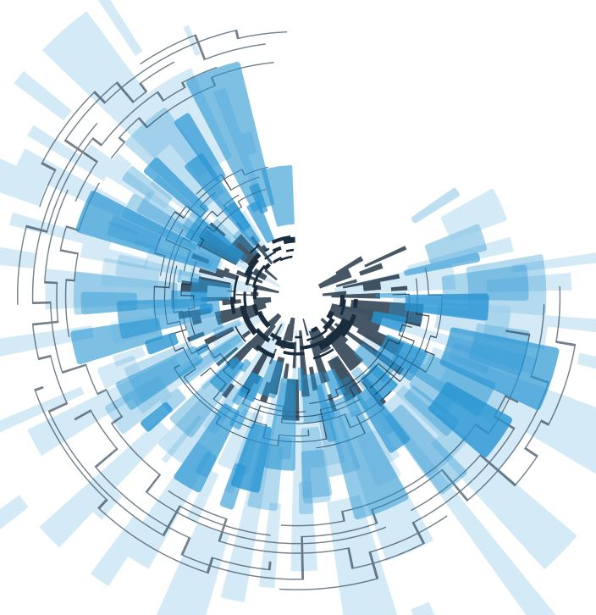   | «Next Record»  Visit the CORHA website to browse through the resource hub  and sign up to receive updates!  www.CORHA.org  CORHA works to improve practices and policies for the detection, investigation, control and prevention of HAI/AR outbreaks across the healthcare continuum by developing and sharing products and resources that will facilitate effective outbreak response.
«Next Record»  Visit the CORHA website to browse through the resource hub  and sign up to receive updates!  www.CORHA.org  CORHA works to improve practices and policies for the detection, investigation, control and prevention of HAI/AR outbreaks across the healthcare continuum by developing and sharing products and resources that will facilitate effective outbreak response. | «Next Record»  Visit the CORHA website to browse through the resource hub  and sign up to receive updates!  www.CORHA.org  CORHA works to improve practices and policies for the detection, investigation, control and prevention of HAI/AR outbreaks across the healthcare continuum by developing and sharing products and resources that will facilitate effective outbreak response.

