Laboratory Workgroup
New Member Packet

Contents
Invitation Letter 1
Council Strategic Map 2
Workgroup Scope of Work (Charge) 3
Workgroup Member Roles and Responsibilities 4
Workgroup Tentative Timeline 4
Workgroup Logistics 4
Workgroup Product Presentation and Council Approval Process 5
Workgroup Confidentiality Agreement 5
Key Resources to Get Started 5

Invitation Letter

To Whom It May Concern:
You are invited to serve as a workgroup member on the Council for Outbreak Response: Healthcare-Associated Infections and Antibiotic-Resistant Pathogens (CORHA) workgroup on Laboratory Response to Healthcare-Associated Infection (HAI) Outbreaks. You were identified and highly recommended by members of the CORHA Governance Committee. This workgroup will be co-led by Jafar Razeq, MD, Directory of the Connecticut Public Health Laboratory, who also serves as the Association of Public Health Laboratories (APHL), representative on CORHA.
CORHA is a public health-healthcare collaborative that works to improving practices and policies at the local, state and national levels for detection, investigation, control and prevention of healthcare-associated and antimicrobial-resistant (AR) infections and outbreaks across the healthcare continuum. CORHA is funded by CDC’s Division of Healthcare Quality Promotion and co-led by the Association of State and Territorial Health Officials (ASTHO) and the Council of State and Territorial Epidemiologists (CSTE).
CORHA has established a strategic map to guide the Council’s activities. There are currently two active workgroups focused on 1) supporting standardized approaches to detection and reporting outbreaks (“Workgroup A”), and 2) supporting consistent and coordinated approaches to investigation and control (“Workgroup B”).
The CORHA Laboratory Workgroup seeks to promote and support improvement of laboratory response to healthcare-associated infection outbreaks. The primary objective is to define public health, clinical, and commercial laboratory best practices to support outbreak detection and response. The workgroup will assist laboratorians as well as public health and clinical partners by developing guidance, identifying best practices, and improving collaborations with healthcare facilities and state/local public health departments.
The Laboratory Workgroup will be tasked with three major focus areas:
- Contribute knowledge and support activities that lead to improving laboratory test methods in support of HAI/AR outbreak response activities.
- Identify and promote best practices for laboratory data collection and data sharing in relation to HAI/AR outbreak response.
- Support effective interactions between laboratories, healthcare facilities, and state/local health departments in the context of HAI/AR response activities
The CORHA Laboratory Workgroup will benefit from your subject-matter expertise. Your input on workgroup discussions and feedback on related activities will help advance the charges listed above and be of value to laboratory and public health practices on HAI outbreak detection, response and prevention.
Attached for your reference are the following workgroup-related materials:
- Council Strategic Map
- Workgroup Scope of Work (Laboratory Workgroup Charge).
- Workgroup Tentative Timeline.
- Workgroup Product Presentation and Council Endorsement Process.
- Workgroup Member Roles and Responsibilities.
- Workgroup Confidentiality Agreement.
- Key Resources to Get Started.
Please review these materials and feel free to request additional information as needed. Should you have additional questions, contact the CORHA staff member listed on page 6 of this packet. We ask that you respond to this invitation no later than Xday, June X, 2018.

Council Strategic Map
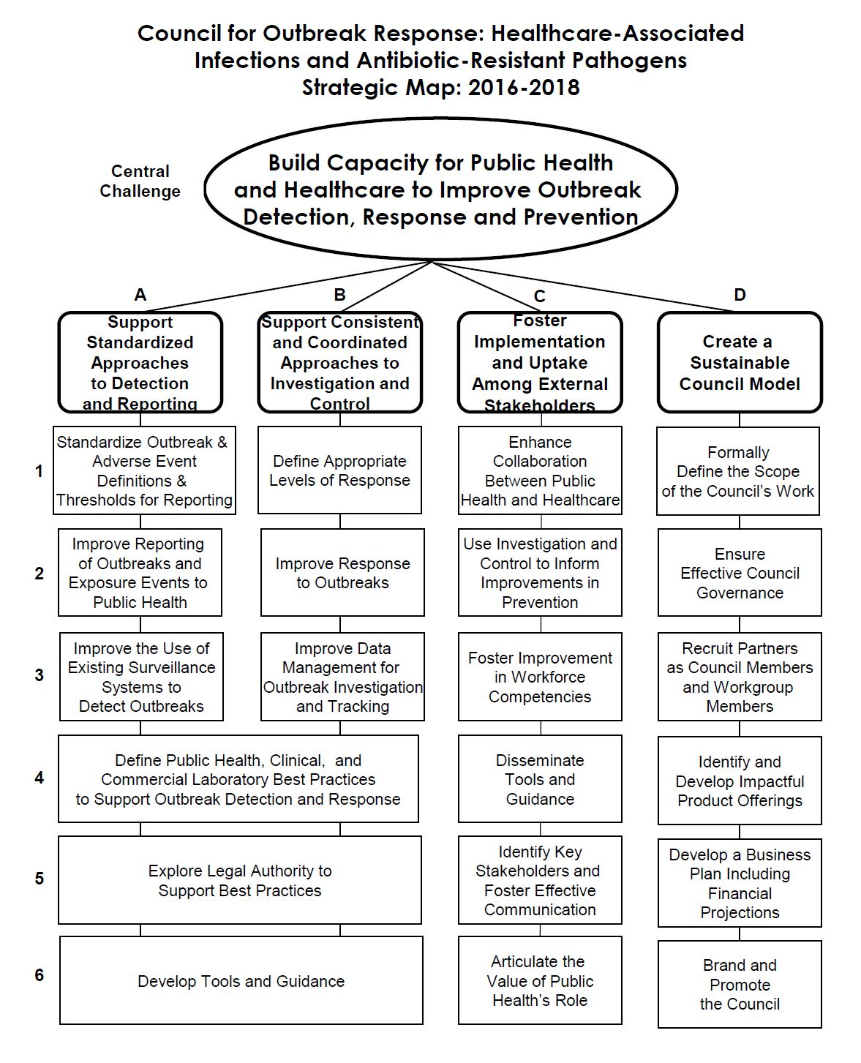

Workgroup Scope of Work (Charge)

CORHA Laboratory Workgroup Charge: Outbreak Detection and Response

Workgroup purpose:
The Laboratory Workgroup of CORHA seeks to promote and support improvement of laboratory response to healthcare-associated infection outbreaks. The primary objective is to define public health, clinical, and commercial laboratory best practices to support outbreak detection and response. The workgroup will assist laboratorians as well as public health and clinical partners by developing guidance, identifying best practices, and improving collaborations with healthcare facilities and state/local public health departments.

The workgroup is tasked with the following activities:

- Contribute knowledge and support activities that lead to improving laboratory test methods in support of HAI/AR outbreak response activities. The workgroup will:
  - Promote implementation of techniques to detect specific pathogen strains (e.g. CP-CRE) helpful for outbreak response.
  - Determine what laboratory test methods are practical for HAI/AR outbreak response

- Identify and promote best practices for laboratory data collection and data sharing in relation to HAI/AR outbreak response. The workgroup will:
  - Determine what laboratory data would be most valuable for outbreak identification/investigation.
  - Make recommendations on reporting roles and methods for different types of laboratories, including clinical, commercial, research, and public health laboratories, to relevant stakeholders.

- Support effective interactions between laboratories, healthcare facilities, and state/local health departments in the context of HAI/AR response activities. The workgroup will:
  - Identify best practices for how laboratories can assist epidemiologists and other partners with identifying potential outbreaks and investigating routes of transmission.
  - Identify best practices for outbreak response from a laboratory perspective and determine the roles of each stakeholder during an investigation.
  - Foster relationships with laboratory stakeholders

Workgroup Member Roles and Responsibilities
CORHA workgroup members are strongly encouraged to:
- Attend and actively participate on workgroup calls and meetings.
- Provide expertise and guidance during the product development process.
- Provide comments and feedback on workgroup materials.
- Identify and suggest resources to inform the development process.
- Support the workgroup co-chairs in guiding workgroup discussions and priorities.
- Present products to the full Council for vote and approval as needed.

Workgroup Tentative Timeline
The development of CORHA workgroup products typically spans 4 to 6 months. The group is expected to convene biweekly via teleconference and at least once, in-person. Please see below for a tentative plan of the workgroup’s activities.
CORHA Laboratory Workgroup Tentative Meeting Plan
Activity | Platform
Introductory and Product Development Call #1 | Teleconference Call
Product Development Call #2 | Teleconference Call
Product Development Call #3 | Teleconference Call
In-person Product Development Meeting | In-person Meeting
Product Completion and Review Call #4 | Teleconference Call
Product Presentation for Council Endorsement | Teleconference Call

Workgroup Logistics
Workgroup teleconference calls are facilitated by the workgroup co-chairs. Workgroup call notes, product drafts, materials, resources and other documents are hosted on Basecamp, a project management platform, to which you will be granted access.
Workgroup members are strongly encouraged to attend CORHA in-person meetings. Travel expenses for all non-federal workgroup members will be supported by the hosting partner organization (ASTHO or CSTE).

Workgroup Product Presentation and Council Approval Process
All CORHA workgroup-developed products are required to undergo a review process by the Governance Committee and the full Council for approval.
- The completed product is sent to the Governance Committee for review and comments.
- The product is sent to voting members for review.
- Workgroup co-chairs or subject-matter experts present the product on a Council call or meeting.
- Voting members provide comments and feedback.
- The workgroup co-chairs determine and lead the revision of the product as needed.
- Voting members review the final product and cast their votes by electronic or other methods.
- The approved product is branded and posted to the CORHA website.

Workgroup Confidentiality Agreement
By accepting to serve as a member of the CORHA laboratory workgroup, you are accepting the following:
- All workgroup call and meeting discussions will be kept confidential.
- Non-approved CORHA materials, drafts or resources will be kept within the confines of the workgroup unless given written permission by the workgroup co-chairs and a member of CORHA’s Governance Committee.

Key Resources to Get Started

