CORHA Governance Committee Call Agenda
August 1, 2018 | 2:00 PM – 3:00 PM ET
Dial-in: 1-866-740-1260; Passcode: 5273136#

Roll Call – 5 minutes

Workgroup A and B Updates – 15 minutes
- Draft workgroup product development process (on page 2 and saved on Basecamp)

Workgroup to Website Process Vote (on page 3 and saved on Basecamp) – 5 minutes

CORHA Bylaws (draft saved on Basecamp) – 10 minutes

Laboratory Workgroup – 10 minutes
- Updates, next steps

Policy Workgroup – 5 minutes
- Co-chair welcome and invitation letters, and introductory call (on pages 6-8 and saved here and here)
- Workgroup members (page 8)

International Conference on Emerging Infectious Diseases (ICEID) Conference – 10 minutes

Parking Lot
- Piloting CORHA products/metrics
- ARSTF collaboration
- Policy WG refinement
- Identifying HLG writing teams
- HLG chapter tracking – suggestion to insert chapters in process roadmap
- CORHA website launch and product promotion
- Revisiting CORHA Bylaws and Operating Guidance

Basecamp File Paths
To access CORHA Governance Committee call agendas and materials on Basecamp: CORHA Governance Committee → Docs & Files → GC Call Agendas & Materials →[Month].
To access CORHA Governance Committee call notes on Basecamp: CORHA Governance Committee → Docs & Files → GC Call Agendas & Materials → GC Monthly Call Notes.

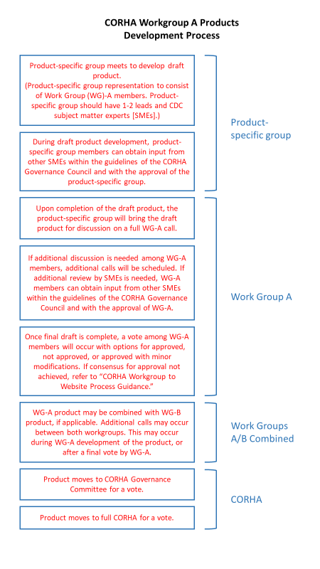

CORHA Workgroup to Website Process Guidance
Approved by the Governance Committee on Xday, 2018 | Amended July 2018

Background
This guidance describes the process by which CORHA-developed products advance from the workgroups to the CORHA website. This process aims to: standardize the workflow process for CORHA staff; establish Governance Committee (GC) and Council review priorities; prepare workgroup leads and SMEs for product presentations and; and allow for cohesive product branding.

Workgroup to Website Processes
The workgroup to website process consists of three phases:

PHASE I (Workgroup Packet Preparation)
Upon the completion of the workgroup product, Michael and Steven will:
- Finalize the workgroup content and copy. For the roles and expectations of CORHA workgroup members during product review periods, please refer to Appendix A.
- Compile all accompanying and supplemental materials/resources into one packet (refer to Appendix B for CORHA workgroup packet requirements).
- Send the product packet to Martha, copying Kate, Bonnie, and the workgroup Co-Chairs.

PHASE II (CDC and Governance Committee Review)
Upon receipt of the workgroup packet, Martha will:
- Send the packet to the Governance Committee for review and discussion via conference call or email
- The purpose of this GC review is for leadership awareness. In the event that GC members have pertinent comments that need to be addressed, Martha will submit those comments to the workgroup Co-Chairs and coordinators to address.
- During this review period, CDC Governance Committee representative (Joe) will pursue informal scientific review from CDC.

PHASE III (CORHA Voting Member Review and Vote)
Upon Governance Committee review of the workgroup packet, Martha, will:
- Send the packet to CORHA voting members for review.
- If an All-CORHA call is scheduled within the next four weeks, the workgroup Co-Chairs will be expected to present the product on that call (refer to Appendix C for a guide on CORHA Council presentations).
- Following the call, the final packet, including voting instructions, will be sent to CORHA voting members, officially marking the beginning of the open review period. For the roles and expectations of CORHA voting members during open review periods, please refer to Appendix A.
- If there is not an all-CORHA call on the calendar within the next four weeks, CORHA voting members will be expected to send their comments or feedback via email during the open review period, which will be specified in the email. Please refer to Appendix D for more information on open and review periods.
- Upon the closing of the review period, voting results will be generated via a Qualtrics report. A product is considered approved by a simple majority vote. Approved products will be branded and posted to the CORHA website.
Unapproved products and comments from voting members will be returned to the workgroup for consideration.

APPENDIX A
Roles and expectations of CORHA workgroup and voting members during workgroup review periods:
CORHA workgroup members are encouraged to review and provide feedback on workgroup products during the development process. Comments are expected to build on the contributions of the workgroup, advance the work developed and aim to achieve consensus. Ultimately, the aim of product reviews is to ensure that recommendations align with CORHA’s mission and are consistent with current science. A workgroup consensus is achieved when a majority of workgroup members agree on the final product, or when the workgroup Co-Chairs and CDC SMEs determine the product draft is final and ready for advancement.

Per the CORHA bylaws, voting members representing CORHA membership organizations listed below are expected to review CORHA products during the open review period and submit their votes. Voting members are considered representatives of their respective organizations and are responsible for reviewing products to help the Council avoid discordance with their organizations’ official guidance and policies. During the open review period, voting members may consult with their organizations or subject-matter experts within their networks to help guide their feedback and vote as a CORHA member. Partner organizational representatives or organizational staff involved in CORHA will be expected to support their organizations’ voting members in updating their organizations on CORHA products, obtaining the appropriate internal approvals, tracking the status of their voting members’ reviews, and communicating updates to CORHA staff.

Voting Members
ASTHO: | Gerd Clabaugh, Kris Ehresmann, Joe Miner
CSTE: | Wendy Bamberg, Erin Epson, Marion Kainer
CDC: | Joe Perz, Elizabeth Mothershed
NACCHO: | Dawn Terashita, Hilary Hanson
APIC: | Linda Greene
APHL: | Jafar Razeq
SHEA: | Waleed Javaid

APPENDIX B
All CORHA product packets should include the following:
- A Microsoft Word copy of the final watermarked draft, exclusive of markups or comments, and formatted in 14-point headings in Calibri font, and 11-point body text in Calibri font.
- The official title of the document.
- All current/active links to supplemental resources and materials.
- A current roster of all active workgroup members and subject-matter experts that participated in the product development process.

APPENDIX C
CORHA product presentations by CORHA workgroup Co-Chairs or SMEs should include the following:
- A brief overview of the product (purpose, content, etc).
- The rationale behind the product development process (justifications, frameworks used, important research referenced, conclusions reached, etc).
- References cited in the product and supplemental resources that will be linked to the product at the bottom of the CORHA product webpage.
- Acknowledgement of workgroup Co-Chairs, members, and SMEs.
- Time for questions and discussion.

Appendix D
Open and Closed Product Review Periods
Open review periods are designated timeframes during which CORHA voting members can review and submit comments on CORHA products before casting their votes. Open review time periods will be specified by CORHA staff during communication with CORHA voting members.
Review periods are considered closed when the product voting link is deactivated and the product progresses to the next step in the approval process. Comments or feedback submitted after the review period is closed will be accepted for future consideration.

Appendix E
Interim Guidance
In the event that a CORHA product requires further refinement, a conference call with the CORHA GC, Workgroup Co-Chairs and SMEs will be scheduled to decide whether the product should be posted to CORHA website with accompanying language explaining that a successive draft will follow.

Policy Workgroup Co-Chair Welcome and Invitation Letters

Dear Dr. Terashita,
We are pleased to welcome you as a Co-Chair of the Council for Outbreak Response: Healthcare-Associated Infections (HAI) and Antibiotic-Resistant (AR) Pathogens (CORHA) workgroup on Policy and Legal Considerations Related to HAI Outbreaks (“Policy Workgroup”). Dr. Maureen Tierney, HAI/AR Program Manager at the Nebraska Department of Health and Human Services will be asked to serve as your Co-Chair on this workgroup.
The CORHA Policy Workgroup seeks to seeks to address the legal and policy considerations related to HAI outbreaks, including those caused by AR pathogens, and make recommendations to policy makers at all levels to improve the detection, reporting, investigation, control and prevention of HAI/AR outbreaks.
To address these priorities, the Workgroup will work in sequence to address the following focus areas:
- Improve reporting of HAI/AR outbreaks and exposure events.
- Explore options to enhance legal authority and policy options to support best practices.

As Co-Chair of the Policy Workgroup, you will be tasked with leading the development of workgroup products, guiding workgroup activities, updating the CORHA Governance Committee and full Council on the progress of workgroup activities, and overseeing the accomplishment of the workgroup charge enclosed in this letter.
All CORHA workgroup Co-Chairs will be assisted by CORHA staff, who will support the logistical and administrative tasks of the workgroup, as well as provide a connection between the Policy Workgroup and other CORHA workgroups and products.
To officially launch the Policy Workgroup, we would like to schedule a “virtual meet and greet” with representatives from the Council’s Governance Committee, your Workgroup Co-Chair, and CORHA staff. This call will be an opportunity for you to discuss activities and directions for the Workgroup with your Workgroup Co-Chair and ask questions of the Governance Committee. Please send us at least 5 dates and times you are available for a 1-hour call in the month of August. We kindly ask that you reply by Friday, August 10.
Should you have any questions or require any further information, feel free to contact a CORHA staff member copied in this email.
Sincerely,
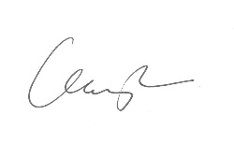  Gerd Clabaugh, MPA  Co-Chair  Council for Outbreak Response: Healthcare-Associated Infections and Antimicrobial-Resistant Pathogens | 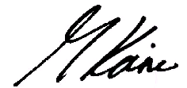  Marion A. Kainer MD, MPH, FRACP, FSHEA  Co-Chair  Council for Outbreak Response: Healthcare-Associated Infections and Antimicrobial-Resistant Pathogens

Dear Dr. Tierney,
We are pleased to inform you that you have been selected by the Council for Outbreak Response: Healthcare-Associated Infections (HAI) and Antibiotic-Resistant (AR) Pathogens (CORHA)’s Governance Committee to serve as a Co-Chair of the CORHA workgroup on Policy and Legal Considerations Related to HAI Outbreaks (“Policy Workgroup”). Dr. Dawn Terashita, Chief of the Healthcare Outreach Unit at the County of Los Angeles Department of Public Health, Acute Communicable Disease Control Program will serve as your Co-Chair on this workgroup.
As you know, CORHA is a public health-healthcare collaborative that works to improve practices and policies at the local, state, and national levels for detection, investigation, control and prevention of HAI and AR infections and outbreaks across the healthcare continuum. CORHA is funded by CDC’s Division of Healthcare Quality Promotion and co-led by the Association of State and Territorial Health Officials (ASTHO) and the Council of State and Territorial Epidemiologists (CSTE).
The CORHA Policy Workgroup seeks to seeks to address the legal and policy considerations related to HAI outbreaks, including those caused by AR pathogens, and make recommendations to policy makers at all levels to improve the detection, reporting, investigation, control and prevention of HAI/AR outbreaks.
To address these priorities, the Workgroup will work in sequence to address the following focus areas:
- Improve reporting of HAI/AR outbreaks and exposure events.
- Explore options to enhance legal authority and policy options to support best practices.

As Co-Chair of the Policy Workgroup, you will be tasked with leading the development of workgroup products, guiding workgroup activities, updating the CORHA Governance Committee and full Council on the progress of workgroup activities, and overseeing the accomplishment of the workgroup charge enclosed in this letter.
All CORHA workgroup Co-Chairs will be assisted by CORHA staff, who will support the logistical and administrative tasks of the workgroup, as well as provide a connection between the Policy Workgroup and other CORHA workgroups and products.
To officially launch the Policy Workgroup, we would like to schedule a “virtual meet and greet” with representatives from the Council’s Governance Committee, your Workgroup Co-Chair, and CORHA staff. This call will be an opportunity for you to discuss activities and directions for the Workgroup with your Workgroup Co-Chair and ask questions of the Governance Committee. Please send us at least 5 dates and times you are available for a 1-hour call. We kindly request that you reply by Friday, August 10.
Should you have any questions or require any further information, feel free to contact a CORHA staff member copied in this email.
Sincerely,
Gerd Clabaugh, MPA  Co-Chair  Council for Outbreak Response: Healthcare-Associated Infections and Antimicrobial-Resistant Pathogens | Marion A. Kainer MD, MPH, FRACP, FSHEA  Co-Chair  Council for Outbreak Response: Healthcare-Associated Infections and Antimicrobial-Resistant Pathogens

Policy Workgroup Members
Name | Affiliation | Notes
Ruth Link-Gelles | CDC
Kris Ehresmann | Minnesota HD
Lisa McGiffert | Patient Safety Action Network
Matthew Penn | CDC
Dawn Terashita | La County HD | Co-chair
Maureen Tierney | Nebraska HD | Selected as co-chair
Jill Burcum | Minneapolis Star Tribune

