Policy Workgroup
New Member Packet

Contents
Invitation Letter 2
Council Strategic Map 3
Policy Workgroup Scope of Work (Charge) 4
Workgroup Member Roles and Responsibilities 5
Workgroup Tentative Timeline 5
Workgroup Logistics 6
Workgroup Product Presentation and Council Approval Process 6
Workgroup Confidentiality Agreement 6
Key Resources to Get Started 6

Invitation Letter

Dear [Name]:
You are invited to serve as a workgroup member on the Council for Outbreak Response: Healthcare-Associated Infections (HAI) and Antibiotic-Resistant (AR) Pathogens (CORHA) workgroup on Policy and Legal Considerations Related to HAI Outbreaks. You were identified and highly recommended by members of the CORHA Governance Committee. Dr. Dawn Terashita, Chief of the Healthcare Outreach Unit at the County of Los Angeles Department of Public Health, Acute Communicable Disease Control Program and Dr. Maureen Tierney, HAI/AR Program Manager at the Nebraska Department of Health and Human Services will serve as your Co-Chairs on this workgroup.
CORHA is a public health-healthcare collaborative that works to improve practices and policies at the local, state, and national levels for detection, investigation, control and prevention of HAI and AR infections and outbreaks across the healthcare continuum. CORHA is funded by CDC’s Division of Healthcare Quality Promotion and co-led by the Association of State and Territorial Health Officials (ASTHO) and the Council of State and Territorial Epidemiologists (CSTE).
The CORHA Policy Workgroup seeks to seeks to address the legal and policy considerations related to HAI outbreaks, including those caused by AR pathogens, and make recommendations to policy makers at all levels to improve the detection, reporting, investigation, control and prevention of HAI/AR outbreaks.
To address these priorities, the Workgroup will work in sequence to address the following focus areas:
- Improve reporting of HAI/AR outbreaks and exposure events.
- Explore options to enhance legal authority and policy options to support best practices.

The CORHA Policy Workgroup will benefit from your subject-matter expertise. Your input on workgroup discussions and feedback on related activities will help advance the charges listed above and be of value to public health policy and legal practices related to HAI outbreaks.
Attached for your reference are the following workgroup-related materials:
- Council Strategic Map
- Workgroup Scope of Work (Policy Workgroup Charge).
- Workgroup Tentative Timeline.
- Workgroup Product Presentation and Council Endorsement Process.
- Workgroup Member Roles and Responsibilities.
- Workgroup Confidentiality Agreement.
- Key Resources to Get Started.
Please review these materials and feel free to request additional information as needed. Should you have additional questions, contact a CORHA staff member. We ask that you respond to this invitation no later than Xday, September X, 2018.

Council Strategic Map
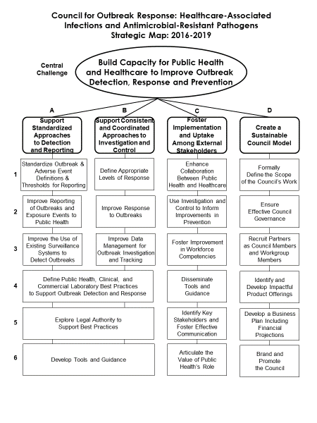

CORHA Policy Workgroup Charge
Approved by the CORHA Governance Committee on July 12, 2018

Workgroup purpose:
The CORHA Policy Workgroup seeks to address the legal and policy considerations related to outbreaks of healthcare-associated infection (HAI), including those caused by antimicrobial-resistant (AR) pathogens, and make recommendations to policy makers at all levels to improve the detection, reporting, investigation, control and prevention of HAI/AR outbreaks.

To address these priorities, the Workgroup will work in sequence to address the following focus areas:

- Improve reporting of HAI/AR outbreaks and exposure events
Outbreak Reporting, Notification, and Disclosure.
For the purposes of this workgroup, the following definitions are important:
- Outbreak reporting is defined as activities that occur when a facility reports a possible outbreak to a local and/or state health department(s).
- Notification occurs when individuals, including patients potentially affected by an outbreak or otherwise have a right to know are informed of their risk.
- Disclosure is defined as activities that occur to inform individuals beyond the patients potentially affected by an outbreak.

To address outbreak reporting, notification, and disclosure, Policy Workgroup members will conduct the following activities in Phase I:
  - Assess current state laws relating to HAI outbreak reporting, notification, and disclosure practices;
  - Assess current federal requirements relating to HAI outbreak reporting, notification, and disclosure practices;
  - Explore and describe common HAI outbreak reporting, notification, and disclosure burdens;
  - Define and describe levels of HAI outbreak public disclosure;
  - Describe ethical and legal issues related to HAI outbreak reporting, including but not limited to timeliness of reporting, notification and disclosure;
  - Highlight examples of promising or effective tools for HAI outbreak public reporting and disclosure practices; and
  - Identify key resources to improve and support standardized approaches to HAI outbreak reporting, notification, and disclosure to patients, local and state health departments and relevant stakeholders.

- Explore options to enhance legal authority and policy options to support best practices
To address the legal authorities and other policy options associated with HAI outbreak reporting, notification, and disclosure, Policy Workgroup members will conduct the following activities in Phase II:
  - Describe and codify best practices and considerations for HAI outbreak reporting, notification, and disclosure options, as identified through the Phase I activities described above;
  - Describe legal issues or barriers that impact HAI outbreak reporting, notification and disclosure;
  - Promote best practices, supporting examples, and recommendations on legal issues and policy options relating to HAI outbreak reporting, notification, and disclosure; and
  - Develop or promote state and local policy options for consideration or policy language to support best practices for HAI outbreak reporting, notification, and disclosure.

All Policy Workgroup activities will occur in coordination with CORHA workgroups focused on promoting standardized approaches on outbreak detection and reporting, and investigation and control.

Policy Workgroup Members should consider representation from the following perspectives:
1) Experts on state law relating to reporting and disclosure practices (attorneys general, health department legal counsel, etc.), 2) Ad-hoc contributors from federal and/or accreditation agencies with knowledge of their respective agency HAI outbreak reporting requirements 3) Infection control staff at the state and local levels, 4) Health department communication staff, 5) Hospital and facility staff knowledgeable of day-to-day workflow, data collection and reporting effort, 6) Experts who are able to speak to ethical issues relating to HAI outbreak reporting, notification, and disclosure, 7) patient advocates, and 8) persons knowledgeable of optimal pathogen-specific intervention timelines to guide discussion of timeliness of reporting.

A future phase may focus more specifically on legal authorities related to investigation activities.

Workgroup Member Roles and Responsibilities
CORHA workgroup members are strongly encouraged to:
- Attend and actively participate on workgroup calls and meetings.
- Provide expertise and guidance during the product development process.
- Provide comments and feedback on workgroup materials.
- Support the workgroup co-chairs in guiding workgroup discussions and priorities.
- Identify and suggest resources to inform the development process.
- Obtain input from subject matter experts as needed to inform workgroup products.
- Present products to the full Council for vote and approval as needed.

Workgroup Tentative Timeline
The development of CORHA workgroup products typically spans 4 to 6 months. The group is expected to convene biweekly via teleconference and at least once, in-person. Please see below for a tentative plan of the workgroup’s activities.
Sample CORHA Policy Workgroup Tentative Timeline
Activity | Platform
Introductory and Product Development Call #1  - Outbreak reporting, notification and disclosure definitions | Conference Call
Product Development Call #2  - Review of definitions  - Section 1.1 | Conference Call
Product Development Call #3  - Review of section 1.1  - Section 1.2 | Conference Call
In-person Product Development Meeting  - Review of section 1.2  - Sections 1.3, 1.4 and 1.5 | Conference Call
Product Development Call #4
- Section 1.6 and 1.7
Product Completion and Review Call | Conference Call
Product Presentation for Council Endorsement | Conference Call

Workgroup Logistics
Workgroup teleconference calls are facilitated by the workgroup co-chairs. Workgroup call notes, product drafts, materials, resources and other documents are hosted on Basecamp, a project management platform, to which you will be granted access.
Workgroup members are strongly encouraged to attend CORHA in-person meetings. Travel expenses for all non-federal workgroup members will be supported by the hosting partner organization (ASTHO or CSTE).

Workgroup Product Presentation and Council Approval Process
All CORHA Workgroup products requiring approval and a vote will follow the guidelines outlined in the CORHA Workgroup to Website process.

Workgroup Confidentiality Agreement
By accepting to serve as a member of the CORHA Policy Workgroup, you are accepting the following:
- All workgroup call and meeting discussions will be kept confidential.
- Non-approved CORHA materials, drafts or resources will be kept within the confines of the workgroup unless given written permission by the workgroup co-chairs and a member of CORHA’s Governance Committee.

Key Resources to Get Started

