

The CORHA Brand
CORHA is aligning itself as a multidisciplinary group of experts in the field of healthcare-associated infections (HAIs) who have developed best-practices and “go-to” recommendations for the detection, investigation, control and prevention of HAIs.

CORHA Website
The CORHA website is the most prominent, front-facing piece of the brand. The website should be current, informational, visually appealing and easy to navigate. Information and products on CORHA’s clearinghouse/resource library should be well-organized and easily accessible. Resources, documents, or other information retrieved from health departments, partner or other stakeholder websites that are referenced on the CORHA website should be hyperlinked. External resources hosted on the CORHA website will require permission from the source organization.

CORHA Voice
Formal, straightforward and concise.

CORHA Colors

HEX: “1d2f40”
RGB: (29,47,64)
HEX: “3296d2”
RGB: (50,150,210)

CORHA Logo Usage
The CORHA logo helps establish the CORHA brand and should be strategically placed and used for maximum and quality exposure. Please refer to the guidelines below.
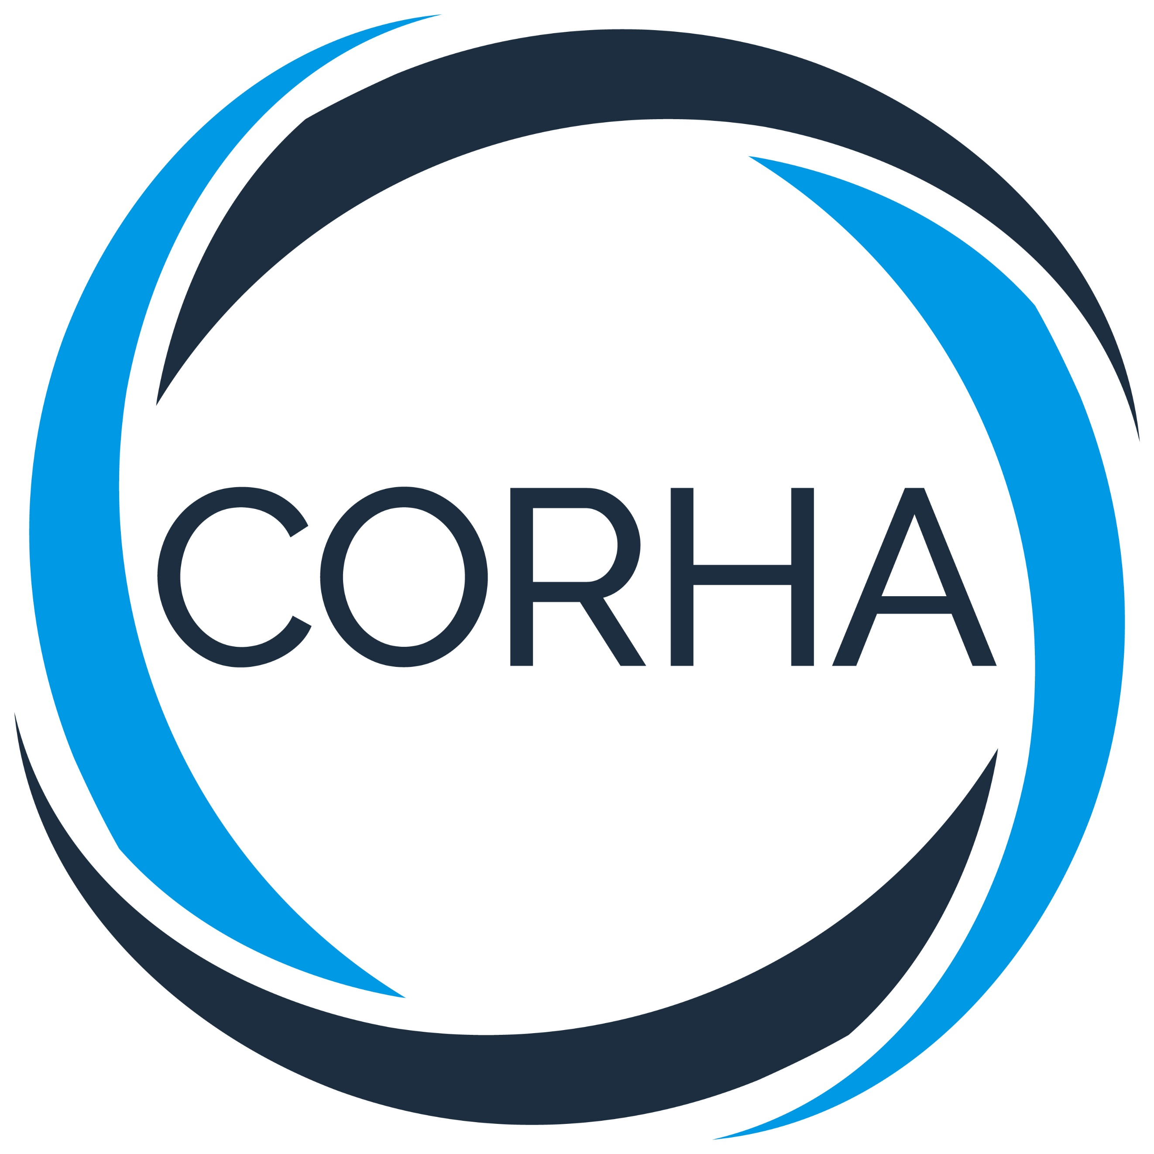
Secondary CORHA Logotype
Primary CORHA Logotype

Letterheads
- The primary CORHA logo should be used on any formal document, including but not limited to letters, invitations and Council workgroup products.

Website
- The primary CORHA logo should be used on the frontpage of the website.
- The secondary CORHA logo should be used on subsites and secondary pages.

External Usage
Upon written request only, logos can be sent to partners, external organizations or affiliates for use on websites, partner documents such as sign-on letters, PowerPoint presentations and other Council-approved materials. Please contact a CORHA staff member for additional clarification on using CORHA logos.

Other
- The primary CORHA logo should be used on CORHA folders, name badges and other meeting materials.
- Staff and Council members may use the secondary CORHA logo on email signatures and other internal or external materials, as they see fit.

CORHA Type Fonts
Standard headings: Calibri 16-point bold in RGB: (29,47,64)
Sub-headings: Calibri 14-point bold in RGB: (29,47,64)
Standard body text: Calibri 12-point in black.

CORHA Templates
Microsoft PowerPoint
Available on Basecamp

Letterheads
Available on Basecamp

