
920 farmington avenue, ste. 100
west hartford, ct 06107
860.232.3667
www.theclariongroup.com
cOUNCIL TO IMPROVE FOODBORNE OUTBREAK RESPONSE
Strategy Update Meeting Summary
March 29 – 30, 2017

Table of Contents

Introduction – March 29 1
Overview of Strategic Effectiveness 1
Introduction – March 30 2
Guidance on Successful Strategic Plan Implementation 3
Setting the Future Direction 3
Overview of Key Elements of Future Direction 4
CIFOR Vision 5
Central Challenge and Strategic Priorities 5
Development Team Highlights 7
Identify 7
Lead 8
Promote 9
Evaluate 10
Deep Dive Discussions 12
Project Definition and Approval Process 12
Council Collective Accountability and Operating Norms 15
Holistic Strategy Implementation Assessment 17
Next Steps 19
The Clarion Group’s Next Steps 19
Strategic Plan Implementation 20
“Review and Adjust” Process 20
Future Council Topics for Discussion 20

Council to Improve Foodborne Outbreak Response

Strategy Update Session

Meeting Summary: March 29 – 30, 2017

March 29, 2017: Individual Development Team Meetings

Introduction – March 29
Kirk Smith, Supervisor, Foodborne, Vectorborne and Zoonotic Diseases Unit, Minnesota Department of Health, and Joe Russell, Health Officer, Flathead City, Montana, County Health Department, co-chairs of the Council to Improve Foodborne Outbreak Response (CIFOR), welcomed participants to the Council meeting. They thanked them for their participation and made the following opening remarks:
- Good progress has been made implementing the 2015 – 2020 strategic plan.
- The Development Team structure seems to be working.
- The overall goal of the three-day Council meeting is to:
  - Make sure the Development Teams are on track and have what they need to keep moving forward.
  - Address, and hopefully resolve, any barriers to CIFOR progress.
  - Have some time to work together, in person, on the important work of CIFOR.
Kirk then introduced Ashley Agard of The Clarion Group and invited her to facilitate the meeting.

Ashley outlined the high-level agendas for the individual Development Team working sessions on March, 29, 2017 and the full Council review and adjust session on March 30, 2017 and noted the following overarching goals:
- Development Team working sessions
  - Review implementation progress using Worksheets 1 and 2 as a common tool for all Development Teams.
  - Adjust implementation plans as needed.
  - Engage in meaningful dialogue to advance the work of the Development Teams.
- Full Council strategic plan review and adjust session
  - Review progress on implementing the CIFOR 2015 – 2020 strategic plan.
  - Address any barriers to implementation requiring full Council input.
  - Update the strategy and/or implementation plans, as needed, for the remaining three years.
  - Establish clear next steps in the implementation of the strategic plan.

Overview of Strategic Effectiveness
To establish context for the Development Team working sessions and the full Council review and adjust session, Ashley provided a refresher on strategic effectiveness – an organization’s ability to set the right goals and consistently achieve them.

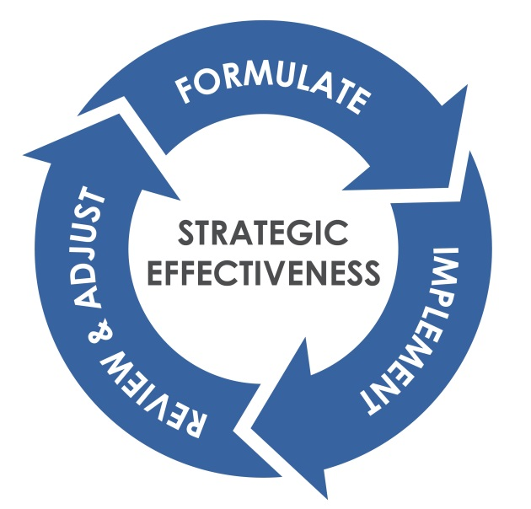

A disciplined approach to strategic effectiveness consistently produces three outcomes:
- The right goals
- Consistent goal achievement
- Development of strategic effectiveness as an organizational capability
Organizations with high strategic effectiveness:
- Quickly formulate a “good enough” strategic plan.
- Move immediately to implementation – letting implementation teach them the ways that the strategy is on target and the ways it needs to be improved.
- Review progress on implementation regularly with honesty and candor.
- Make needed adjustments based on what is working, what isn’t, and how the world has changed.
- Focus on results, not activities.

Based on learnings from the September, 2016 implementation planning session, Ashley provided additional guidance and reminders to the Development Teams:
- Work on the content, not on the process.
- Move your work forward.
- Adjust, if needed, your implementation plans.
  - Focus on the results you want to achieve by the fall Council meeting.
  - Get granular in how you’re going to drive the results: Who? When?
- Identify, and if possible, address any linkages or needed sequencing, with the other Development Teams.

March 30, 2017: Full Council Strategic Plan Review & Adjust Session

Introduction – March 30
Ashley reviewed a modified agenda based on output from the previous day’s individual Development Team working sessions and in coordination with CIFOR Council co-chairs, Kirk Smith and Joe Russell and CIFOR Council Coordinators, Thuy Kim and Dhara Shah. Revisions to the original agenda reflect the Council’s desire to host several “deep dive” discussions on topics critical to the successful implementation of the strategic plan. Ashley shared the following revised agenda for the meeting:
- Refresh participants on the principles of implementation planning.
- Review the CIFOR strategic plan.
- Confirm the 12-month (October, 2016 – September/October, 2017) implementation priorities and expected results.
- Share Development Team progress reports.
- Conduct three small group, concurrent deep dive discussions on the following topics:
  - Project definition and approval process
  - Council collective accountability and operating norms
  - Holistic strategy implementation assessment
- Refine the Development Team plans.
- Establish Council alignment around next steps.

Guidance on Successful Strategic Plan Implementation
Ashley shared with the Council the following principles for good strategic plan implementation:
- Focus on clear thinking, not long writing.
- Remember the worksheets are tools.
- Let the “good enough” principle guide your planning.
- Learn by doing – and adjust accordingly.

Ashley then discussed the keys to successful strategic plan implementation, noting that leadership in all roles is the most important factor for successful implementation of a strategy.
- Effective leadership in three critical roles:
  - Executive/sponsoring leader
  - Front-line leader
  - Consultative/supportive leader
- Strong teams staffed with the right people
- Clearly defined, results-based implementation plans
- Aligned human and financial resources
- An effective approach to monitoring implementation and making appropriate adjustments
- Well-defined indicators/measures of success
- A clear line of sight that lets each person/organization see:
  - “How I /we make a difference”
  - How strategic effectiveness is a part of “my” work

Setting the Future Direction

Overview of Key Elements of Future Direction
To establish context for the day’s deep dive discussions, Ashley shared the Mission-to-Strategy framework, illustrated below, pointing out the Council’s desire to spend time discussing, via the planned deep dive discussions, topics within the two foundational components of the framework:
- Organizational/system implications
- Leadership and people implications
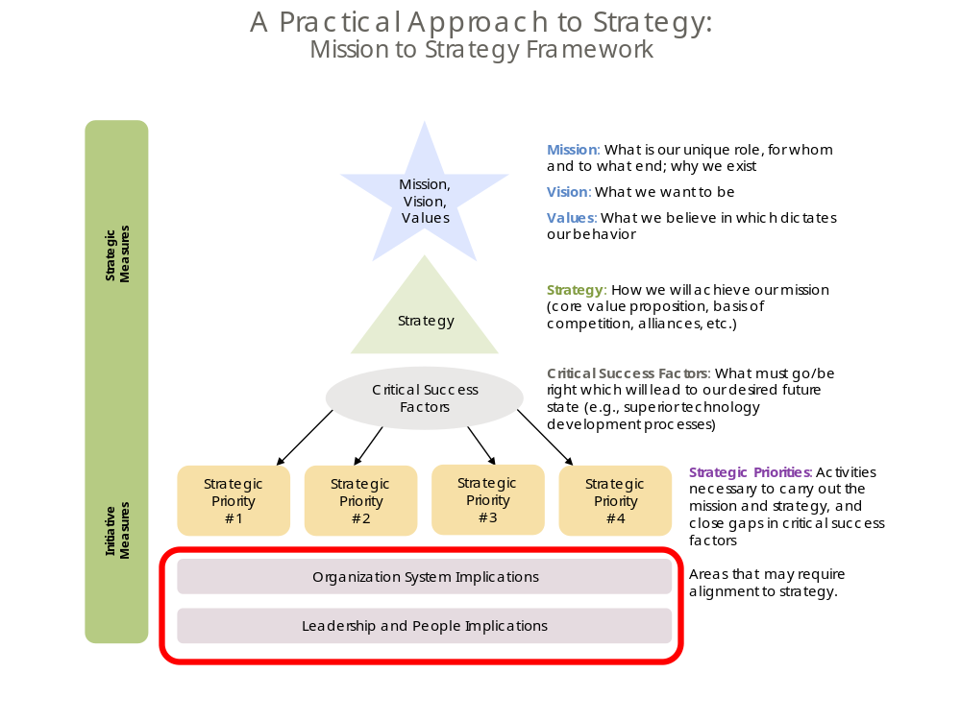

Ashley provided a brief overview of the key elements of an organization’s future direction.
- An organization’s mission states why it exists, its reason for being, its fundamental purpose. It’s an enduring statement that usually remains the same for many years, providing long-term continuity and direction for the organization. Good mission statements are:
  - Clear: stated in plain language without jargon that needs to be explained; easy for everyone to understand
  - Concise: not necessarily "25 words or less" but a brief description of the essence of the organization
  - Enduring: will be as true 10 or 15 years from now as it is today
  - Distinctive: expresses the uniqueness of the organization, how it is different from other organizations
  - Motivational: uses language that captures purpose and emotion, motivating people to commit
- Vision articulates the long-term outcome or end-state that the organization will make a definitive contribution to creating.
- An organization’s core values and/or guiding principles outline its unique approach, its norms for “how we do things” in the organization.
- Strategy outlines what the organization needs to do at this point in its history. It is more focused and time bound than mission and vision – often looking to the next three to five years.
- Critical success factors identify the most important things the organization has to get right to ensure strategic success, e.g., culture, technology, customer understanding.
- Finally, an organization’s tactics outline “how to” implement its strategy.

CIFOR Vision
To ground the strategic plan review and adjust work ahead and provide a compass for work planning, Ashley shared the CIFOR vision:

Local, state and federal partners collaborating effectively to reduce the burden of foodborne illness in the United States.
The ensuing, brief discussion included the following points:
- Collaboration is critical, but often very difficult given:
  - Competing priorities
  - Finite funding
  - Lack of geographic proximity
- Greater Council focus in future meetings should be on fostering more collaboration, particularly with the federal regulatory agencies.
- “Reducing the burden of foodborne illness” implies there is a known baseline from which to measure progress.
  - Metrics are critical to CIFOR success.
  - Alignment around two dimensions of metrics must be established:
    - What metrics should be included in the baseline.
    - How the metrics should be calculated.

Central Challenge and Strategic Priorities
Drawing a one-page graphic representation of a strategic map, Ashley refreshed the Council on the concepts of central challenge and strategic priorities.
- The oval at the top of the strategic map is the central challenge.
  - It is the focal point for strategy.
  - It focuses on what the organization needs to do in the next three years to support its mission.
- The central challenge is supported by some number of strategic priorities.
  - Strategic priorities are the few critical things we must do in order to meet our central challenge.
  - The number of strategic priorities can vary, but is never fewer than three or more than six.

- There are two tests of a strategic priority:
  - Is each priority necessary to meet the central challenge?
  - Are the strategic priorities taken together sufficient to meet the challenge?
- The boxes under each strategic priority are strategic objectives. Strategic objectives are the next level of “what to do” to achieve the strategic priority.
Ashley reviewed the CIFOR current strategic plan, noting the alignment to the strategic map construct.

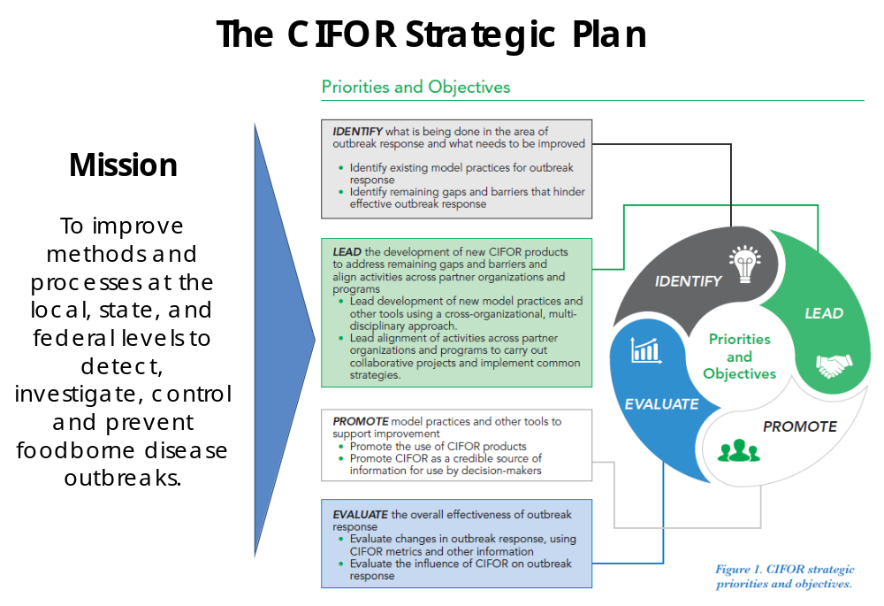

A Strategic Map View of the Current CIFOR Strategy
After brief roundtable discussion on the probable central challenge for the current strategy, Ashley shared the following as a possible strategic map presentation of the current strategy.

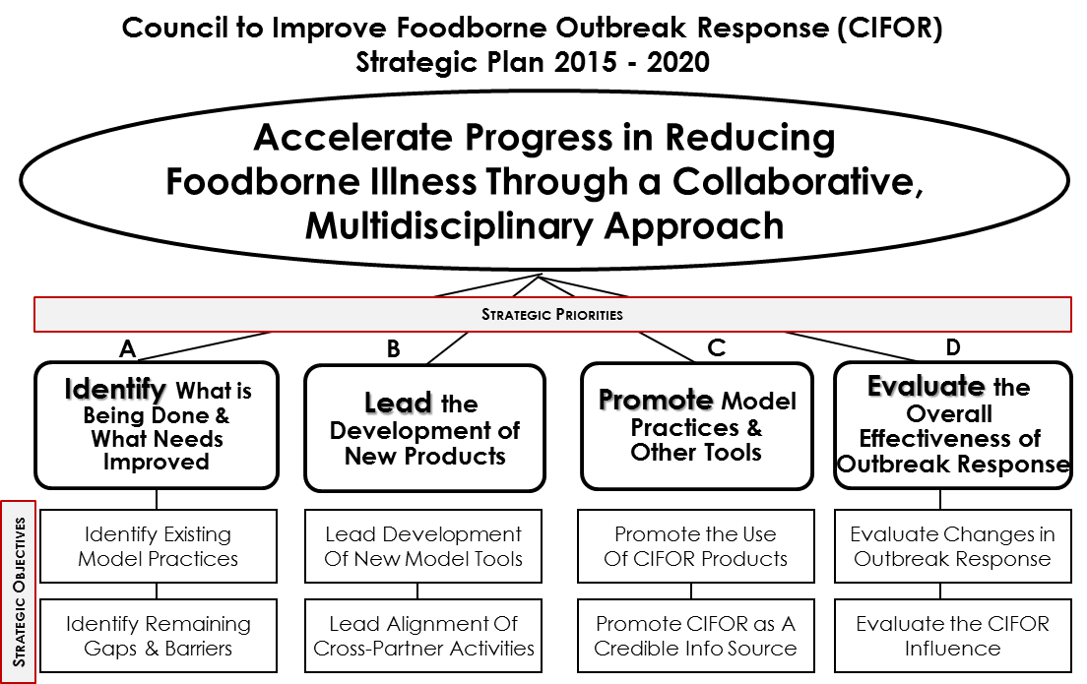

Development Team Highlights
Each CIFOR Development Team presented the highlights of the previous day’s working session.

A summary of the small group reports follows.

Identify
- Results expected between now and the fall Council meeting (September/October, 2017) were refined as follows:
  - Model practices for inclusion in the guidelines are identified
  - List of recognized gaps and best practices generated and are informing potential project proposals
  - High priority gaps and/or best practices identified and moving toward project status
  - CIFOR projects aligned with identified gaps and best practices
  - IFSAC attribution data review complete; pathogen food pairing priority identified
- Development Team highlights shared with the Council included the following points:
  - The Development Team has been challenged by lack of scope clarity.
    - It is unclear where there should be hand-offs to another Development Team.
    - It seems to make the most sense for the Identify Development Team to focus on research and determining potential CIFOR projects based on that research.
  - A comprehensive gap analysis will require the input of the full Council as well as select SMEs.
  - The Council needs to discuss and determine its role in determining the root causes of foodborne illness.
    - There is a perspective that the CIFOR efforts should rely on others to determine root causes and focus on applying the learnings from outbreaks to prevent future outbreaks.
    - There is a differing perspective that CIFOR should focus more heavily on prevention with significant focus on root cause determination.

Lead
- Results expected between now and the fall Council meeting (September/October, 2017) were refined as follows:
  - CIFOR Guidelines updated
  - Foodborne illness complaint system guidance document developed
  - OUE Guidelines Phase II completed
  - List created of project proposals approved or tabled but not funded
  - Current multidisciplinary foodborne outbreak training options identified
- Development Team highlights shared with the Council included the following points:
  - Updating the CIFOR Guidelines should be the most important priority for the organization.
    - This will require close coordination between the Lead Development Team and:
      - The Revisions Working Group
      - The Identify Development Team which will be focusing on identifying gaps and best practices
    - The timeline for content completion is aggressive – June 30, 2018; this is driven by funding availability and guidelines.
  - Craig Hedberg will continue to lead the work on the Complaint System Guidance document.
  - The Lead Development Team will update the timeline for the OUE Guidelines Phase II on the next working call.
  - The intent of Result 4, “List created of project proposals approved or tabled but not funded”, is to ultimately enable the Council to better apply learnings from past project proposals to refine or further the CIFOR efforts.
  - Result 5, “Current multidisciplinary foodborne outbreak training options identified”, implies a need for close collaboration with the Promote Development Team.
    - The goal is to get more people aware of and using the CIFOR Guidelines.
    - There is an opportunity to better utilize “short-burst” training techniques, e.g., webinars, podcasts, etc.
    - The CDC COEs should be leveraged to promote CIFOR Guideline training.
  - The Lead Development Team presented a suggested structure (illustrated below) for approaching the CIFOR Guidelines update.
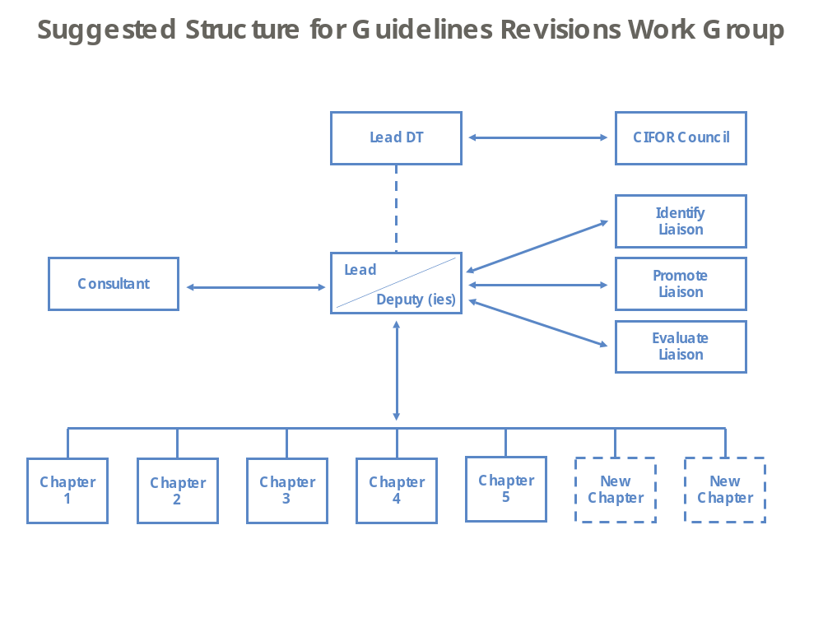

Promote
- Results expected between now and the fall Council meeting (September/October, 2017) were refined as follows:
  - Website redesigned and enhanced
  - Marketing strategy and implementation plan implemented
  - CMET usage has increased.
- Development Team highlights shared with the Council included the following points:
  - An overview of the marketing plan was shared for Council comment. Double click on the icon below to access the presentation slides.


- The high frequency of turnover among public health leadership requires constant education and messaging.
- For CIFOR messaging/marketing to be effective, it must be anchored in the fundamental CIFOR “reason for being” – “prevent illness, save lives”.
- A primary goal of CIFOR marketing is to increase the application of the CIFOR Guidelines.
  - Immediately post an outbreak is an opportune time to increase marketing efforts.
  - CIFOR must recognize and create balance between the public health goal of doing everything possible to prevent foodborne outbreaks and meeting the mandatory/regulated minimum standards.
- Future marketing efforts will increase the focus on leveraging federal partners (e.g., CDC, FDA) to endorse and advocate for CIFOR.

Evaluate
- Results expected between now and the fall Council meeting (September/October, 2017) were refined as follows:
  - Preliminary analysis of CIFOR performance measures reported to CMET
  - List of metrics to evaluate outbreak response established
  - List of metrics to evaluate CIFOR impact on outbreak response established
  - Framework created for an After Action Report for the CIFOR Council
- Development Team highlights shared with the Council included the following points:
  - There is an urgent need to clarify the role of CIFOR in defining, creating, compiling, and/or reporting the core metrics relevant to measuring the reduction in the burden of foodborne illness outbreaks in the United States.
    - Potentially duplicative efforts exist between the CIFOR CMET work and the CDC FoodCORE program.
    - Alignment needs to be established around three metric dimensions:
      - The “right” metrics
      - How to calculate the “right” metrics – and whether there will be a single prescribed methodology
      - Who (e.g., CIFOR, CDC) will take the lead in developing and reporting the “right” metrics.
  - More work needs to be done to determine the scope and focus of the CIFOR after action approach and process.
    - Other organizations (e.g., the FDA) have well-established after action processes already in place.
    - The CIFOR after action work must contemplate the two fundamental ways to approach after action reporting:
      - Conducting an intensive assessment of all aspects of a single outbreak
      - Focusing the assessment on a single aspect across multiple outbreaks

Full Council discussion following the individual Development Team reports included the following points:
- Development Team contribution to updating the CIFOR Guidelines, particularly given the aggressive timing, should – and will – be the first result for each Development Team.
- There is a need for more regular cross-Development Team conversation to manage linkages and necessary sequencing of work.
  - This should be the focus on the monthly Development Team co-leads call.
  - Future Council meetings should allow ample time to discuss and resolve any issues around cross-team work.
Based on the work completed in the individual Development Team meetings, along with the full Council discussion and decision to include updating the CIFOR Guidelines as a result area for each Development Team, the one-page illustration below was created to help the Council:
- Capture the 2015 – 2020 strategy and one-year expected implementation results in an easy-to-read, graphic format.
- Understand the linkage of the expected results to the overall strategy.
- Identify linkages and needed sequencing in work across the Development Teams.
- Assess work decisions through the lens of the CIFOR strategic plan.
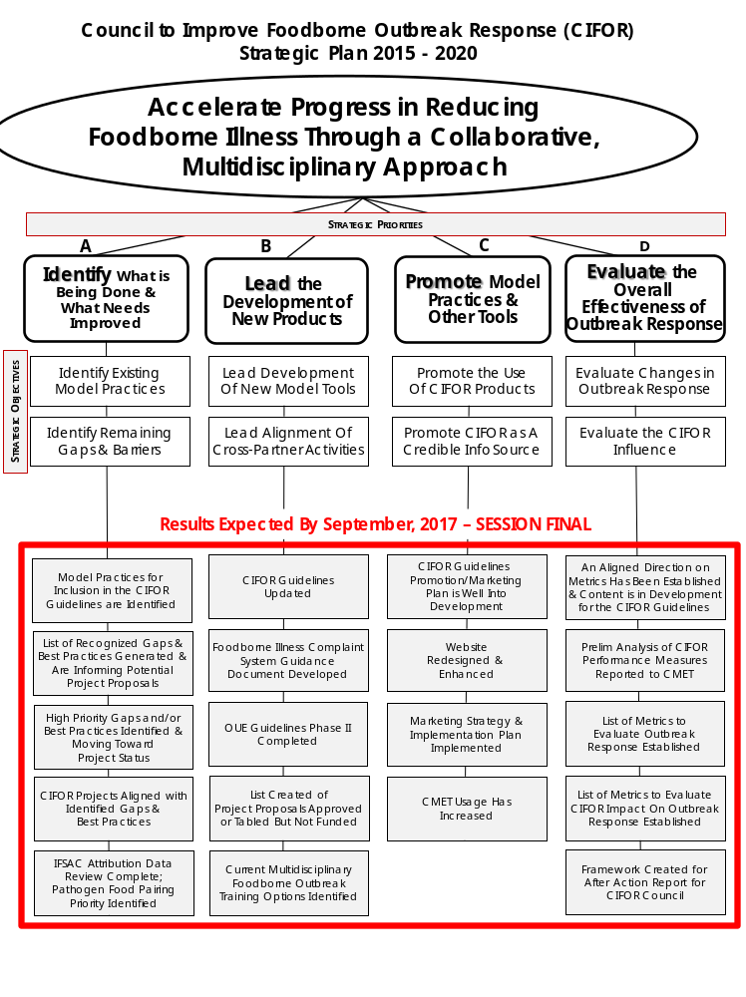

Deep Dive Discussions
To eliminate barriers to strategic plan implementation and accelerate progress, the Council identified three areas for more intense discussion:
- Project definition and approval process
- Council collective accountability and operating norms
- Holistic strategy implementation assessment
Participants counted off into three groups and were asked to assign a facilitator for the conversation, a recorder to capture the small group’s key points, decisions and/or recommendations, and a spokesperson to present a summary of the small group discussion to the full Council. Each small group was asked to consider the following:
- Why is this area impeding and/or a barrier to strategic plan implementation success?
- What could be done to eliminate the identified impediments or barriers?
- What are the small group’s specific recommendations?
A summary of the small group reports follows.

Project Definition and Approval Process

Abe Kulungara, Jen Li, Carina Blackmore, Joe Russell, Willy Lannier, Shari Shea, Tom Collaro, Carlota Medus, Brandi Hopkins, Dave Boxrud, Don Sharp, Ernest Julian
- The diagram below illustrates the group’s visualization of how projects currently emanate and flow:

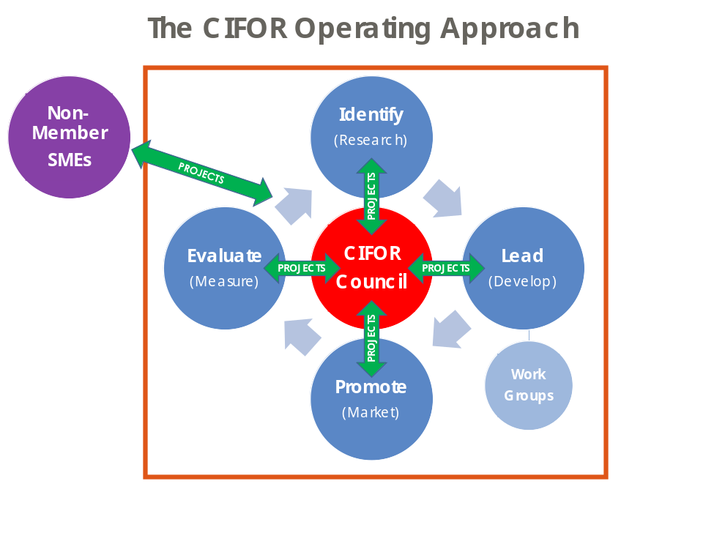

- Two current projects in consideration were selected to focus the conversation:
  - Developing an inventory of current foodborne outbreak training options available
  - Creating a synopsis of all major efforts related to reducing outbreaks of foodborne illnesses (e.g., FoodCORE, CDC COEs, FoodNet)
- The Problem Statement, as defined by previous Council discussion, was framed as follows:
  - Lack of clarity around what projects must go to Council for approval
  - Lack of clarity around where project proposals can come from (i.e., who can propose a project)
  - Lack of clarity around what constitutes Council approval
  - Project approval “sessions” are too far apart (bi-annually)
  - The project proposal template is cumbersome.
- A specific assignment was given to the small group:
  - Considering the current project processes outlined in the bylaws, design a better, simpler and more practical project proposal process.
  - Consider the following:
    - Do ALL projects require Council approval? If not, what is the criteria for requiring Council approval?
    - Can a Development Team create and execute a project?
    - How could the Development Team co-lead team be better leveraged to accelerate the identification and execution of strategically aligned projects?
    - How could the project proposal process be simplified and/or accelerated?
- The small group presented several recommendations to the full Council and after discussion, the following was agreed upon by the Council:
  - If a project is internal use only (i.e., within a Development Team charter or for use by the whole Council), no Council approval needed; Development Team co-leads are empowered to make this determination.
  - If any of the following project criteria are met, the project requires Council approval:
    - Requires funding
    - Intends to leverage the CIFOR brand
    - Will produce a project that is intended to be distributed to external audiences
    - Is expected to require significant resource time
    - Requires a working group to execute
  - If project is to update “canned” tools, no Council approval needed; this will primarily encompass work emanating from the Promote Development Team (e.g., flyers, fact sheets, slide decks)
  - For all projects requiring Council approval:
    - The project request template must be completed.
    - The project will be put to Council vote via an online voting mechanism.
      - Many projects are expected to pass an online vote saving time and increasing member ability to focus on other CIFOR work.
      - If the online vote fails (2 or more “no” votes) or there is a Council member request for discussion, the project will be discussed and voted upon at the next in-person Council meeting.
  - Council project approval requires no more than 1 “no” vote; votes are considered by member organization, not by individual.
- Action Items
  - Create a visual flowchart to illustrate the revised project approval process.
  - Assess and revise as needed, the project request form (format, medium and/or content).
    - The Promote Development Team will lead this effort.
    - Final approval for the revised form will be the responsibility of the Development Team co-chairs.
  - Coordinate internally member organization approvals to ensure only one electronic vote.
  - Utilize the RACI Decision-Making framework, as appropriate, to help clarify project roles:
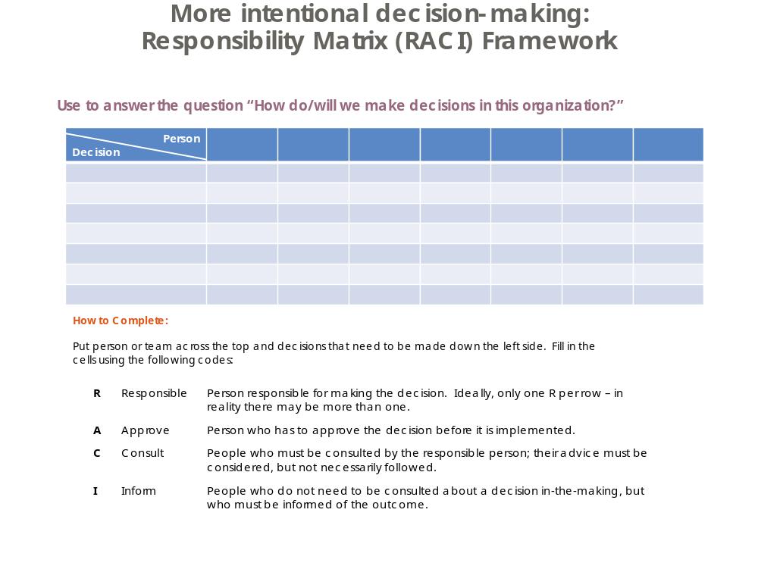

Council Collective Accountability and Operating Norms

Kirk Smith, Dale Morse, Scott Holmes, Sandra Whitehead, John Tilden, Travis Goodman, Ian Williams, Angie Hagy, Kirsten Larson, John Dunn
- The Problem Statement, as defined by previous Council discussion, was framed as follows:
  - There is a lack of collective, or aligned, accountability to the CIFOR work (this is different than individual accountability) which is significantly slowing progress.
  - Norms (“how we be together”) have not been established and thus are left to individual interpretation.
  - It’s not clear there is alignment around the CIFOR priorities.
- The assignment given to the small group was:
  - Define, in detail, the norms and behaviors that are needed to ensure CIFOR success.
  - Consider the following:
    - What individual commitments are necessary?
    - What expectations do you have of each other?
    - How will you hold each other accountable?
    - How will you address mis-aligned behaviors?
- This strategic plan implementation impediment was refined by the small group to include the following points:
  - There is consistently uneven participation in CIFOR work (i.e., meetings, calls).
    - Silence/lack of response is often interpreted as disinterest or disagreement.
    - There is some sense that CIFOR work is at times undermined outside of the CIFOR meetings and calls.
    - There is a need to articulate how CIFOR members are committed to working for the Council and among each other.
  - There is uneven workload distribution in the work of CIFOR; a relatively small number of members carry the bulk of the workload.
- Several themes emerged related to what could be done to ensure consistently productive, professional and aligned working relationships among Council members, including:
  - More frequent direct, open and honest conversations
  - Greater clarity of roles and responsibilities
  - Attention to peoples’ time and commitment to use it wisely
- The small group presented several recommendations to the full Council and after discussion, the following was agreed upon by the Council:
  - The Council’s operating norms:
    - Courageous dialogue (recognizing the value of healthy conflict)
    - Responsiveness
    - Participation in discussions, reviews of projects, etc.
    - Commitment, time and passion
    - Attendance at meetings and on calls (“be present”)
    - Better communication around meeting agendas, scheduling, decision points and/or outcomes
    - Safe environment
    - Supportive of CIFOR work (with a focus on behaviors that demonstrate)
      - Silence doesn’t equal support.
      - Some affirmation of support is desired.
    - A philosophy of 100% support, recognizing there will almost always be less than 100% agreement (i.e., the 70/100 rule)
  - Mis-aligned behavior will be managed as follows:
    - Overall responsibility will be with the agency or association
    - Development Team staff will follow up with non-participatory members.
    - Development Team staff will provide Development Team co-leads with participation information.
    - Development Team co-chairs will intercede with non-participatory members as needed, recognizing the impact of peer-to-peer dialogue.
  - Project plans should be more clearly defined.
  - Worksheets (for implementation plans) need to be adhered to.
  - Project champions need to see work through the Development Team process.
  - Projects need to be spelled out and more transparent. (The Promote Team will incorporate this into the project request form revision.)
  - Communications:
    - Need to delineate between FYIs, discussions, decisions and work
    - Need to be frequent enough to provide adequate project check points
  - Accountabilities, roles and responsibilities need to:
    - Be very clearly defined
    - Be documented
    - Recognize four distinct roles:
      - Lead
      - Core
      - Input
      - Support
  - Agencies and associations need to be responsible for bringing the right folks to the table and re-assessing effectiveness.
  - Priorities aligned to the core mission are key.
  - There is a need for a better (more formalized) on- and off-ramping procedure for members.
- Action items
  - The Governance Committee will strengthen the on- and off-ramping procedure to members.
  - CDC and APHL will coordinate on the next steps around dissemination and promotion of the OUE guidelines.
  - Scott Holmes will draft for Council review and approval a 1-2 pager delineating participant expectations and memorializing the Council’s agreed-upon norms to include:
    - Member categories
    - Council members
    - SMEs
    - Consultants
    - Association input and role
    - Work Group members

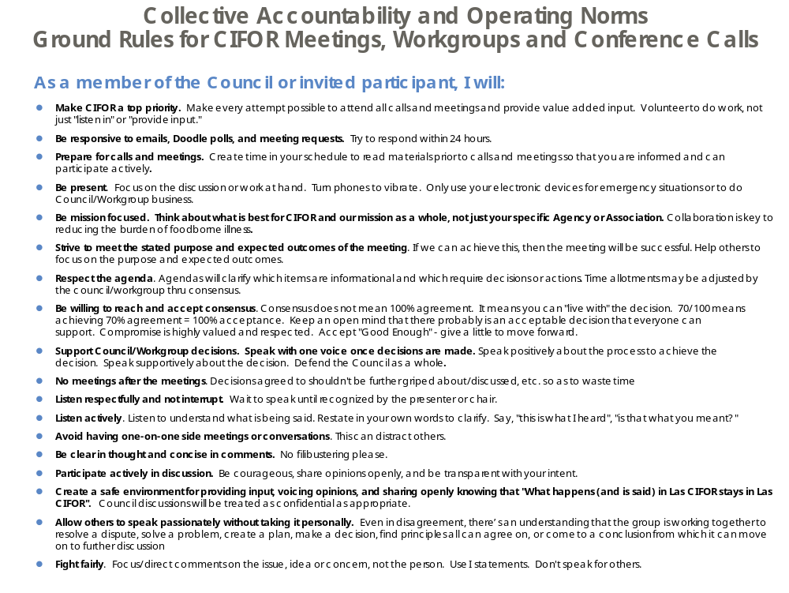
Note: Prior to the conclusion of the session, Scott with input from others, created and disseminated the following draft “ground rules” for CIFOR meetings, workgroups, and conference calls.

Holistic Strategy Implementation Assessment

Joshua Leinbach, Kari Irvin, Adam Kramer, Monica McKenzie, Lynne Madison, Rachel Jervis, Robyn Atkinson-Dunn, Craig Hedberg, Venessa Cantu, Sherri McGarry, Susan Lance
- The Problem Statement, as defined by previous Council discussion, was framed as follows:
  - There might be more on the CIFOR Council “plate” that there are resources to ensure successful execution.
  - There may be higher value efforts that should be contemplated.
  - There might be redundancies across the Development Teams.
  - Results may need clarification.
- The assignment given to the small group was to:
  - Review the overview of the planned strategy implementation expected results by September/October, 2017, considering:
    - Are these correct? Enough? Too much?
    - Are there sufficient resources assigned to ensure successful execution?
    - Are there edits needed to individual Development Team plans?
  - Be ready to:
    - Present suggested edits to the Development Team plans as needed.
    - Discuss any linkages or sequencing that the Development Team co-chairs need to pay attention to.
- The strategic plan implementation learnings, and impediments, were expanded to include the following points:
  - Focus on updating the CIFOR Guidelines needs to be increased, noting specifically that there are two “moving targets” that can impact the progress with the CIFOR Guidelines update:
    - The timing for getting the consultant hired and in place
    - Completion of the gap analysis
      - This will inform content related issues and help determine if there is a need for new chapters.
      - Development Team link into the chapter work group is critical.
      - A number of suggestions were made (during the subsequent March 31, 2017 Council working session) for potential new CIFOR Guideline chapters or expanded content:
        - Root causes/best practices
        - Information tracebacks
        - Enhancing sub-cluster investigations
        - WGS
        - CIDT
        - Complaint-based systems
        - After Action Reports
        - Legal
        - Metrics
        - Information sharing
        - Environmental assessment
  - There may be duplication or sequencing needs with regards to After Action Reports (AARs).
    - Future CIFOR efforts should include:
      - Piloting outbreaks followed from beginning to end to identify gaps and inform CIFOR Guidelines
      - Assessing and/or suggesting model practices that may become a CIFOR guideline chapter
      - Considering development of a multidisciplinary best practice approach
      - Focus on both learnings and best practices processes.
    - It is important to consider (and include guidelines for) both large multi-state outbreaks and local or limited outbreaks.
- Two key themes emerged related to what could be done to improve implementation efforts:
  - Increase cross-Development Team communication.
  - Establish more regular Development Team working sessions.
- The small group presented several recommendations to the full Council and after discussion, the following was agreed upon by the Council:
  - Updating the CIFOR Guidelines is the top priority for CIFOR.
  - Each Development Team will have a result included in their implementation plan to reflect contribution/participation in the Guidelines update.
  - Development Teams need to ensure participation in the CIFOR Guidelines working group and chapter workgroups.
  - Development Teams need to identify how current projects feed into the CIFOR Guidelines update.
  - Development Teams:
    - Need regular calls
    - Need to assign tasks to individuals and include deadlines
    - Need facilitation that brings out all “voices”
    - Need to clarify support roles
  - Project management:
    - Must be realistic about how long work will actually take
    - Must be committed to deadlines
    - May want to consider differentiating between long-term, medium-term and short-term goals
    - Should break big plans into do-able tasks and assign responsibility
    - Should review progress regularly and re-assess (i.e., adjust) as needed
    - Should use successes of Development Teams to inform other Development Teams of model practices; Development Team co-chairs should support and share problems and solutions with each other
- Action items
  - The Identify and Evaluate Teams need to coordinate Development Team efforts related to AARs.
  - Development Team co-chairs will develop and communicate consistent support role expectations.

Next Steps
At the conclusion of the meeting, the group identified the following next steps.

The Clarion Group’s Next Steps
The Clarion Group will provide the following to Thuy Kim and Dhara Shah by April 21, 2017 for distribution to all Council members:
- A comprehensive written summary of the strategic planning portion of the Council meeting
- A PDF of the “raw” output produced during small group discussions and full-Council discussions

Strategic Plan Implementation
- The Development Teams need to revisit and confirm the completion of action plans to ensure delivery by the fall Council meeting of each result including accountabilities and deadlines (Worksheet 2).
- Development Team co-leads will begin to integrate discussion around cross-team linkages, any need for sequencing work across the teams, and resource constraints into their monthly calls.

“Review and Adjust” Process
In closing, Ashley outlined the following as recommended elements of a review and adjust process for the CIFOR Council.
- Use the regular Council calls for:
  - Implementation updates
  - Resolution of implementation issues/problems
  - Deep dive discussions on major barriers to strategic plan implementation success
- Continue to conduct periodic review and adjust sessions two or three times during the year that include:
  - Review of progress with implementation of each track of work, including:
    - Accomplishments
    - Issues/problems/gaps
    - Lessons learned
    - Next steps
  - Review of the implementation plans, making adjustments as necessary
- Conduct a formal annual strategy update session at the fall Council meeting – this would typically be a one-day session to:
  - Review progress on implementation.
  - Create a comprehensive strategic map starting with the current CIFOR strategic plan and based on:
    - What was learned from implementation
    - What’s working and what isn’t
    - How the environment has changed
  - Set implementation priorities for the next 12 months.
  - Align anticipated funding and human resources.

Future Council Topics for Discussion
Throughout the course of the three-day meeting, several topics were identified for future Council discussion:
- The role of industry in the CIFOR work
- How to increase the productivity of Council calls and meetings (Note: the “Discuss, Debate, Decide” agenda format was briefly discussed.)
- How CIFOR should “weight” identifying root causes of outbreaks
- The role of CIFOR with regards to foodborne illness outbreak metrics
- The possibility of shifting from static CIFOR Guidelines, updated every few years, to a more dynamic presentation (e.g., continually updated chapters/content online)
- The optimal CIFOR After Action Report product, recognizing a number of others already exist

