Universal Screening for Alcohol Use in Emergency Departments
  - An strategy to reduce harms related to excessive drinking

Excessive alcohol use is a leading cause of preventable death in the United States and is responsible for more than 95,000 deaths each year.¹ Binge drinking, defined as 5 or more drinks for men or 4 or more drinks for women on an occasion, is the most common, costly, and deadly pattern of excessive alcohol use in the United States.^{2,3} Most people who binge drink do not have a severe alcohol use disorder.¹

Routine Alcohol Screening and Brief Intervention can reduce alcohol-related harms.
Research has found that routine alcohol screening and brief intervention (ASBI) in emergency departments can significantly reduce the harms related to excessive alcohol use, including alcohol-impaired driving, readmissions for injury treatment, subsequent ED visits, and even can reduce excessive alcohol use among patients over time.⁴⁻⁶
Excessive alcohol consumption can also interfere with medications and treatment for emergency conditions, and screening for excessive alcohol use not onlyinforms patient care but also identifies patients who could benefit from a brief intervention or referral for further treatment. The National Commission on Prevention Priorities ranked ASBI as one of the five most effective preventive services, based on cost effectiveness and the clinically preventable burden of disease. The remaining four top preventive services include screenings for high blood pressure, cholesterol, and breast cancer; and annual influenza vaccination.⁷
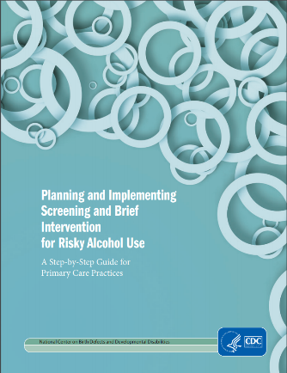
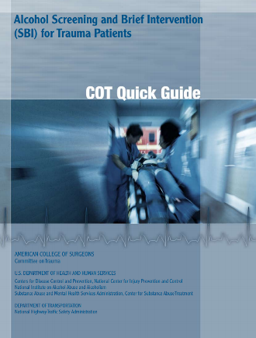
However, while ASBI is an effective practice, it is underutilized. Studies have found alcohol screening rates from 8% to 68% in ED settings. Higher alcohol screening rates (up to 97%) have been achieved when the screening tool is incorporated into the ED electronic records.⁴⁻⁶ A recent assessment of a panel of ED physicians found that 16% reported always or usually screening for alcohol use, 70% reported sometimes screening, and 14% reported never screening adult patients for excessive alcohol use.⁸ The key barriers reported were limited time and treatment options for patients with drinking problems. However, standards-based ASBI strategies are available and can be integrated into the ED workflow.
Resources exist to plan and implement a routine ASBI program. Two screening tools are recommended:
- Abbreviated Alcohol Use Disorders Identification Test-Consumption (AUDIT-C)
- National Institute on Alcohol Abuse and Alcoholism’s Single Alcohol Screening Question (SASQ)

Patients who screen positive receive a brief intervention
When patients report drinking excessively, a brief behavioral intervention can help them recognize that their drinking is unhealthy and reduce excessive drinking. These brief interventions typically involve general feedback, for example understanding how their drinking fits within recommended limits, or ways to reduce drinking. Some key considerations for brief interventions include:
- They can be administered in person by ED staff, online, or using printed materials.
- Some patients who screen positive for excessive drinking may benefit from a referral to their primary care physician or a behavioral health specialist, who can then follow up with a more in-depth risk assessment.
- Including the screening results in the electronic health record can alert other care providers that further screening and intervention may be appropriate.

References
1. Esser MB, Sherk A, Liu Y ea. Deaths and years of potential life lost from excessive acohol use — United States, 2011–2015. Morbidity and Mortality Weekly Report. 2020;69:1428-1433.
2. Sacks J, Gozales K, Bouchery E, Tomedi L, Brewer R. 2010 national and state costs of excessive alcohol consumption. American Journal of Preventive Medicine. 2015;49(5):e73-e79.
3. Stahre M, Roeber J, Kanny D, Brewer R, Zhang X. Contribution of excessive alcohol consumption to deaths and years of potential life lost in the United States. Preventing Chronic Disease. 2014;11:130293.
4. Desy PM, Howard PK, Perhats C, Li S. Alcohol screening, brief intervention, and referral to treatment conducted by emergency nurses: an impact evaluation. Journal of Emergency Nursing. 2010;36(6):538-545.
5. D'Onofrio G, Fiellin DA, Pantalon MV, et al. A brief intervention reduces hazardous and harmful drinking in emergency department patients. Annals of emergency medicine. 2012;60(2):181-192.
6. Mello MJ, Nirenberg TD, Longabaugh R, et al. Emergency department brief motivational interventions for alcohol with motor vehicle crash patients. Annals of emergency medicine. 2005;45(6):620-625.
7. Maciosek MV, LaFrance AB, Dehmer SP, et al. Updated priorities among effective clinical preventive services. Annals of family medicine. 2017;15(1):14-22.
8. Uong S, Tomedi LE, Gloppen KM, et al. Screening for Excessive Alcohol Consumption in Emergency Departments: A Nationwide Assessment of Emergency Department Physicians. Journal of public health management and practice : JPHMP. 2021.

