MSH|^~\&|SQ^2.16.840.1.113883.3.697^ISO|Bryan Medical Center^28D0679424^CLIA|NEDOH|NE-ELR|20170302111842||ORU^R01^ORU_R01|73|P|2.5.1|||NE|NE|||||PHLabReport-NoAck^HL7^2.16.840.1.113883.9.11^ISO||
SFT|Sunquest Information Systems, Inc.^L^^^^SQ&2.16.840.1.113883.3.697&ISO^XX^^^123544|7.1.1|Sunquest Laboratory|7.1.1001 Patch 1||20130609|
PID|1||LC-1705850908080^^^Bryan Medical Center&28D0679424&CLIA^MR^SQ&2.16.840.1.113883.3.697&ISO||CLAUS^SANTA^A^^^^L|^^|20160101|M|||4100 North Pole^^Anchorage^AK^68504^^H||^^|^^||||||||||||||||||||Bryan Medical Center^28D0679424^CLIA|337915000^HOMO SAPIENS^SCT^HUMAN^HUMAN^L^4^4
PV1|1|O|LC^^^|||||||||||||||OS^||||||||||||||||||||||||||201702270000|201702280000|||||||
ORC|RE|1705850908080-0^Bryan Medical Center^28D0679424^CLIA|M46031020170227^SQ^2.16.840.1.113883.3.697^ISO|M460310^SQ^2.16.840.1.113883.3.697^ISO||||||||01465^FRED^FLINSTONE^^^^^^SQ&2.16.840.1.113883.3.697&ISO^L^^^DN^SQ&2.16.840.1.113883.3.697&ISO||^WPN^PH^^^402^4444444|||||||^^^^^^|^^^^|^WPN^PH^^^402^5555555|COMPLETE CHILDREN'S HEALTH^3262 SALT CREEK CR^LINCOLN^NE^68504^^B|
OBR|1|1705850908080-0^Bryan Medical Center^28D0679424^CLIA|M46031020170227^SQ^2.16.840.1.113883.3.697^ISO|21020-3^BACTERIA IDENTIFIED^LN^SKIN^SUPERFICIAL WOUND CULTURE^L^^v1^SUPERFICIAL WOUND CULTURE|||20170227152700|||||||||01465^RUBBLE^BARNIE^^^^^^SQ&2.16.840.1.113883.3.697&ISO^L^^^DN^SQ&2.16.840.1.113883.3.697&ISO|^WPN^PH^^^402^4444444|277||M460310||20170301123405|||F|&&&&&|||||||||||
OBX|1|CWE|45335-7^BACTERIA INDENTIFICATION TEST^LN^CULT^CULTURE^L^^v1^CULTURE|1.1|L-24801^STAPHYLOCOCCUS AUREUS^SCT^STA^STAPHYLOCOCCUS AUREUS^L^^v1|||A^Abnormal^HL70078^A^Abnormal^HL70078^2.5.1^V1^Abnormal|||F|||20170227152700|||||20170228213357||||Bryan Medical Center West^^^^^CLIA&2.16.840.1.113883.4.7&ISO^XX^^^28D0679424|2221 South 17th Street STE 100^^Lincoln^NE^68502|1043392608^Silenieks^Aina^I^^^^^NPI&2.16.840.1.113883.3.72.5.26&ISO^L^^^NPI^^^^^^^^MD|||^^^^^^^^^|
NTE|1|L|STAPHYLOCOCCUS AUREUS
SPM|1|1705850908080-0&Bryan Medical Center&28D0679424&CLIA^M46031020170227&SQ&2.16.840.1.113883.3.697&ISO||ANKL^ANKLE^HL70487^ANKL^ANKLE^L^1|||||||||||||20170227152700|20170228003400|
OBR|2|1705850908080-0^Bryan Medical Center^28D0679424^CLIA|M46031020170227^SQ^2.16.840.1.113883.3.697^ISO|21020-3^BACTERIA IDENTIFIED^LN^SKIN^SUPERFICIAL WOUND
CULTURE^L^^v1^SUPERFICIAL WOUND CULTURE|||20170227152700|||653^SCHUMACHER,CARRIE J|G|||||01465^MATTHIAS^MONICA(SARAH)^^^^^^SQ&2.16.840.1.113883.3.697&ISO^L^^^DN^SQ&2.16.840.1.113883.3.697&ISO|^WPN^PH^^^402^4655600|277||M460310||20170301123405|||F|45335-7&BACTERIA INDENTIFICATION TEST&LN&CULT&CULTURE&L^1.1^STAPHYLOCOCCUS AUREUS|||1705850908080-0&Bryan Medical Center&28D0679424&CLIA^M46031020170227&SQ&2.16.840.1.113883.3.697&ISO|||||||||||||||||||||21020-3^BACTERIA IDENTIFIED^LN^SKIN^SUPERFICIAL WOUND CULTURE^L^^v1^SUPERFICIAL WOUND CULTURE
OBX|1|SN|18961-3^OXACILLIN^LN^OXI^OXACILLIN (IV)^L^^v1^OXACILLIN (IV)|1|<=^0.25|||S^Susceptible^HL70078^S^Susceptible^HL70078^2.5.1^V1^Susceptible|||F|||20170227152700|||||20170301123405||||Bryan Medical Center West^^^^^CLIA&2.16.840.1.113883.4.7&ISO^XX^^^28D0679424|2221 South 17th Street STE 100^^Lincoln^NE^68502|1043392608^Silenieks^Aina^I^^^^^NPI&2.16.840.1.113883.3.72.5.26&ISO^L^^^NPI^^^^^^^^MD|||^^^^^^^^^|
OBX|2|SN|18919-1^ERYTHROMYCIN^LN^EO^ERYTHROMYCIN (PO)^L^^v1^ERYTHROMYCIN (PO)|1|=^0.5|||S^Susceptible^HL70078^S^Susceptible^HL70078^2.5.1^V1^Susceptible|||F|||20170227152700|||||20170301123405||||Bryan Medical Center West^^^^^CLIA&2.16.840.1.113883.4.7&ISO^XX^^^28D0679424|2221 South 17th Street STE 100^^Lincoln^NE^68502|1043392608^Silenieks^Aina^I^^^^^NPI&2.16.840.1.113883.3.72.5.26&ISO^L^^^NPI^^^^^^^^MD|||^^^^^^^^^|
OBX|3|SN|19000-9^VANCOMYCIN^LN^VANI^VANCOMYCIN (IV)^L^^v1^VANCOMYCIN (IV)|1|<=^0.5|||S^Susceptible^HL70078^S^Susceptible^HL70078^2.5.1^V1^Susceptible|||F|||20170227152700|||||20170301123405||||Bryan Medical Center West^^^^^CLIA&2.16.840.1.113883.4.7&ISO^XX^^^28D0679424|2221 South 17th Street STE 100^^Lincoln^NE^68502|1043392608^Silenieks^Aina^I^^^^^NPI&2.16.840.1.113883.3.72.5.26&ISO^L^^^NPI^^^^^^^^MD|||^^^^^^^^^|
OBX|4|SN|18928-2^GENTAMICIN^LN^GMI^GENTAMICIN (IV)^L^^v1^GENTAMICIN (IV)|1|<=^0.5|||S^Susceptible^HL70078^S^Susceptible^HL70078^2.5.1^V1^Susceptible|||F|||20170227152700|||||20170301123405||||Bryan Medical Center West^^^^^CLIA&2.16.840.1.113883.4.7&ISO^XX^^^28D0679424|2221 South 17th Street STE 100^^Lincoln^NE^68502|1043392608^Silenieks^Aina^I^^^^^NPI&2.16.840.1.113883.3.72.5.26&ISO^L^^^NPI^^^^^^^^MD|||^^^^^^^^^|
OBX|5|SN|18908-4^CLINDAMYCIN^LN^CDO^CLINDAMYCIN (PO)^L^^v1^CLINDAMYCIN (PO)|1|=^0.25|||S^Susceptible^HL70078^S^Susceptible^HL70078^2.5.1^V1^Susceptible|||F|||20170227152700|||||20170301123405||||Bryan Medical Center West^^^^^CLIA&2.16.840.1.113883.4.7&ISO^XX^^^28D0679424|2221 South 17th Street STE 100^^Lincoln^NE^68502|1043392608^Silenieks^Aina^I^^^^^NPI&2.16.840.1.113883.3.72.5.26&ISO^L^^^NPI^^^^^^^^MD|||^^^^^^^^^|
OBX|6|SN|18998-5^TRIMETHOPRIM+SULFAMETHOXAZOLE^LN^TSO^TMP/SMX (PO)^L^^v1^TMP/SMX (PO)|1|<=^10|||S^Susceptible^HL70078^S^Susceptible^HL70078^2.5.1^V1^Susceptible|||F|||20170227152700|||||20170301123405||||Bryan Medical Center West^^^^^CLIA&2.16.840.1.113883.4.7&ISO^XX^^^28D0679424|2221 South 17th Street STE 100^^Lincoln^NE^68502|1043392608^Silenieks^Aina^I^^^^^NPI&2.16.840.1.113883.3.72.5.26&ISO^L^^^NPI^^^^^^^^MD|||^^^^^^^^^|
OBX|7|SN|18906-8^CIPROFLOXACIN^LN^CPO^CIPROFLOXACIN (PO)^L^^v1^CIPROFLOXACIN (PO)|1|<=^0.5|||S^Susceptible^HL70078^S^Susceptible^HL70078^2.5.1^V1^Susceptible|||F|||20170227152700|||||20170301123405||||Bryan Medical Center West^^^^^CLIA&2.16.840.1.113883.4.7&ISO^XX^^^28D0679424|2221 South 17th Street STE 100^^Lincoln^NE^68502|1043392608^Silenieks^Aina^I^^^^^NPI&2.16.840.1.113883.3.72.5.26&ISO^L^^^NPI^^^^^^^^MD|||^^^^^^^^^|
OBX|8|SN|18974-6^RIFAMPIN^LN^RIFO^RIFAMPIN (PO)^L^^v1^RIFAMPIN (PO)|1|<=^0.5|||S^Susceptible^HL70078^S^Susceptible^HL70078^2.5.1^V1^Susceptible|||F|||20170227152700|||||20170301123405||||Bryan Medical Center West^^^^^CLIA&2.16.840.1.113883.4.7&ISO^XX^^^28D0679424|2221 South 17th Street STE 100^^Lincoln^NE^68502|1043392608^Silenieks^Aina^I^^^^^NPI&2.16.840.1.113883.3.72.5.26&ISO^L^^^NPI^^^^^^^^MD|||^^^^^^^^^|
OBX|9|SN|20629-2^LEVOFLOXACIN^LN^LEVO^LEVOFLOXACIN^L^^v1^LEVOFLOXACIN|1|<=^0.12|||S^Susceptible^HL70078^S^Susceptible^HL70078^2.5.1^V1^Susceptible|||F|||20170227152700|||||20170301123405||||Bryan Medical Center West^^^^^CLIA&2.16.840.1.113883.4.7&ISO^XX^^^28D0679424|2221 South 17th Street STE 100^^Lincoln^NE^68502|1043392608^Silenieks^Aina^I^^^^^NPI&2.16.840.1.113883.3.72.5.26&ISO^L^^^NPI^^^^^^^^MD|||^^^^^^^^^|
OBX|10|SN|29258-1^LINEZOLID^LN^LZD^LINEZOLID^L^^v1^LINEZOLID|1|=^2|||S^Susceptible^HL70078^S^Susceptible^HL70078^2.5.1^V1^Susceptible|||F|||20170227152700|||||20170301123405||||Bryan Medical Center West^^^^^CLIA&2.16.840.1.113883.4.7&ISO^XX^^^28D0679424|2221 South 17th Street STE 100^^Lincoln^NE^68502|1043392608^Silenieks^Aina^I^^^^^NPI&2.16.840.1.113883.3.72.5.26&ISO^L^^^NPI^^^^^^^^MD|||^^^^^^^^^|
OBX|11|SN|18993-6^TETRACYCLINE^LN^TETO^TETRACYCLINE (PO)^L^^v1^TETRACYCLINE (PO)|1|<=^1|||S^Susceptible^HL70078^S^Susceptible^HL70078^2.5.1^V1^Susceptible|||F|||20170227152700|||||20170301123405||||Bryan Medical Center West^^^^^CLIA&2.16.840.1.113883.4.7&ISO^XX^^^28D0679424|2221 South 17th Street STE 100^^Lincoln^NE^68502|1043392608^Silenieks^Aina^I^^^^^NPI&2.16.840.1.113883.3.72.5.26&ISO^L^^^NPI^^^^^^^^MD|||^^^^^^^^^|
OBX|12|SN|35789-7^DAPTOMYCIN^LN^DAP^DAPTOMYCIN^L^^v1^DAPTOMYCIN|1|=^0.5|||S^Susceptible^HL70078^S^Susceptible^HL70078^2.5.1^V1^Susceptible|||F|||20170227152700|||||20170301123405||||Bryan Medical Center West^^^^^CLIA&2.16.840.1.113883.4.7&ISO^XX^^^28D0679424|2221 South 17th Street STE 100^^Lincoln^NE^68502|1043392608^Silenieks^Aina^I^^^^^NPI&2.16.840.1.113883.3.72.5.26&ISO^L^^^NPI^^^^^^^^MD|||^^^^^^^^^|
OBX|13|SN|31039-1^MOXIFLOXACIN^LN^MXF^MOXIFLOXACIN^L^^v1^MOXIFLOXACIN|1|<=^0.25|||S^Susceptible^HL70078^S^Susceptible^HL70078^2.5.1^V1^Susceptible|||F|||20170227152700|||||20170301123405||||Bryan Medical Center West^^^^^CLIA&2.16.840.1.113883.4.7&ISO^XX^^^28D0679424|2221 South 17th Street STE 100^^Lincoln^NE^68502|1043392608^Silenieks^Aina^I^^^^^NPI&2.16.840.1.113883.3.72.5.26&ISO^L^^^NPI^^^^^^^^MD|||^^^^^^^^^|
OBX|14|CWE|25240-3^CEFOXITIN XXX-MCNC^LN^CFXS^CEFOXITIN SCREEN WELL^L^^v1^CEFOXITIN SCREEN WELL|1|R-40759^NEGATIVE^SCT^NEG^NEGATIVE^L^^v1|||S^Susceptible^HL70078^S^Susceptible^HL70078^2.5.1^V1^Susceptible|||F|||20170227152700|||||20170301123405||||Bryan Medical Center West^^^^^CLIA&2.16.840.1.113883.4.7&ISO^XX^^^28D0679424|2221 South 17th Street STE 100^^Lincoln^NE^68502|1043392608^Silenieks^Aina^I^^^^^NPI&2.16.840.1.113883.3.72.5.26&ISO^L^^^NPI^^^^^^^^MD|||^^^^^^^^^|
OBX|15|CWE|61188-9^CLINDAMYCIN.INDUCED SUSC ISLT^LN^ICD^INDUCIBLE CLINDAMYCIN TEST^L^^v1^INDUCIBLE CLINDAMYCIN TEST|1|R-40759^NEGATIVE^SCT^NEG^NEGATIVE^L^^v1|||S^Susceptible^HL70078^S^Susceptible^HL70078^2.5.1^V1^Susceptible|||F|||20170227152700|||||20170301123405||||Bryan Medical Center West^^^^^CLIA&2.16.840.1.113883.4.7&ISO^XX^^^28D0679424|2221 South 17th Street STE 100^^Lincoln^NE^68502|1043392608^Silenieks^Aina^I^^^^^NPI&2.16.840.1.113883.3.72.5.26&ISO^L^^^NPI^^^^^^^^MD|||^^^^^^^^^|
SPM|1|1705850908080-0&Bryan Medical Center&28D0679424&CLIA^M46031020170227&SQ&2.16.840.1.113883.3.697&ISO||119303007^Microbial isolate specimen^SCT|||||||||||||20170227152700|20170228003400|

THIS IS HOW THE TEST LOOKS WHEN IT GETS INTO OUR APPLICATION: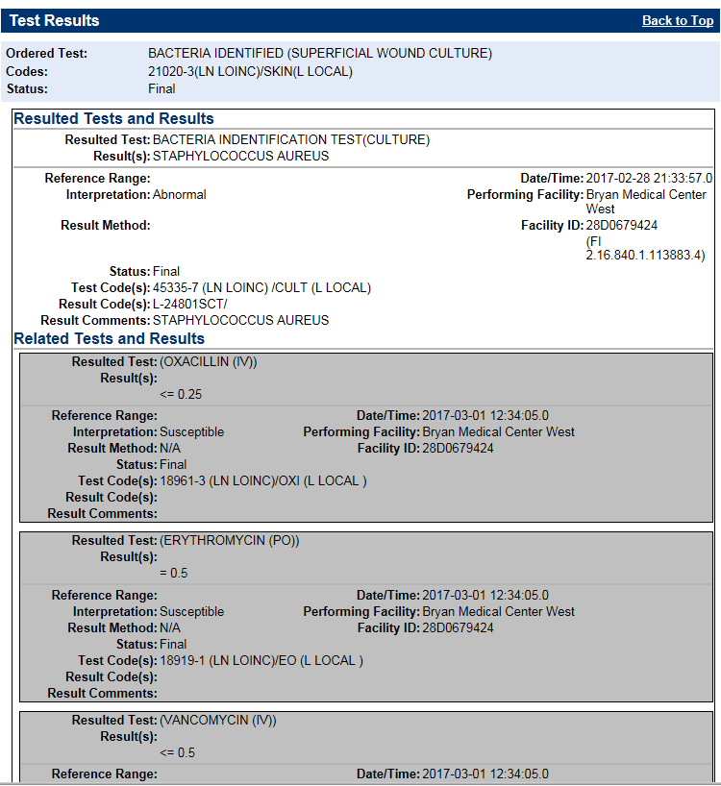
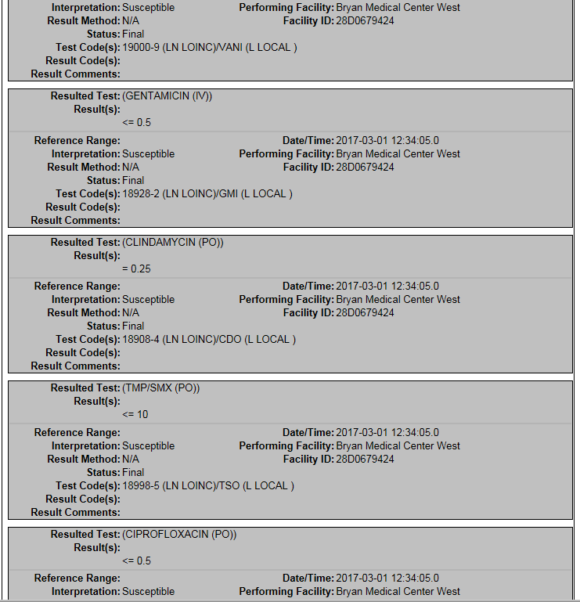
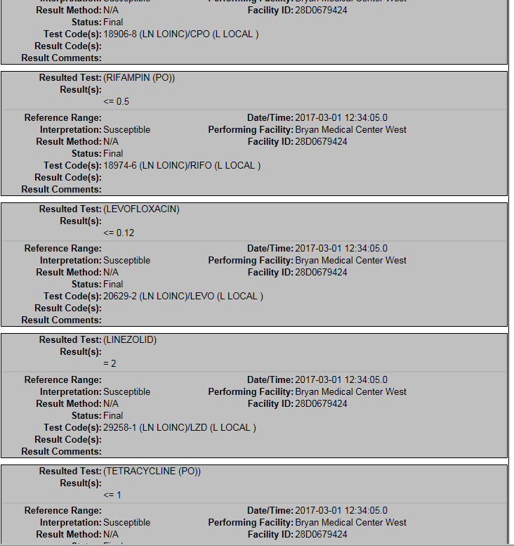
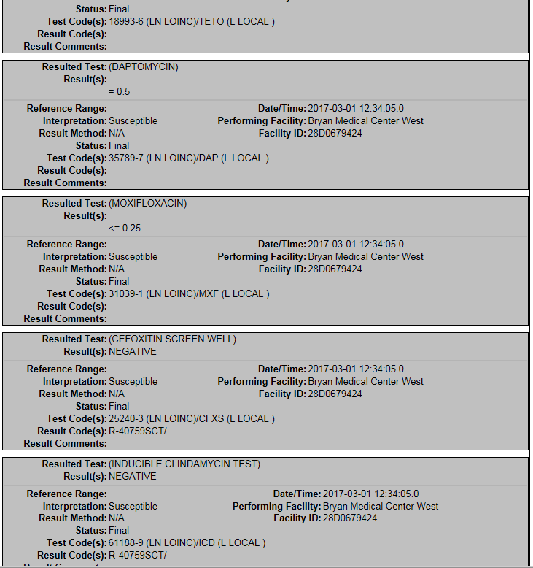
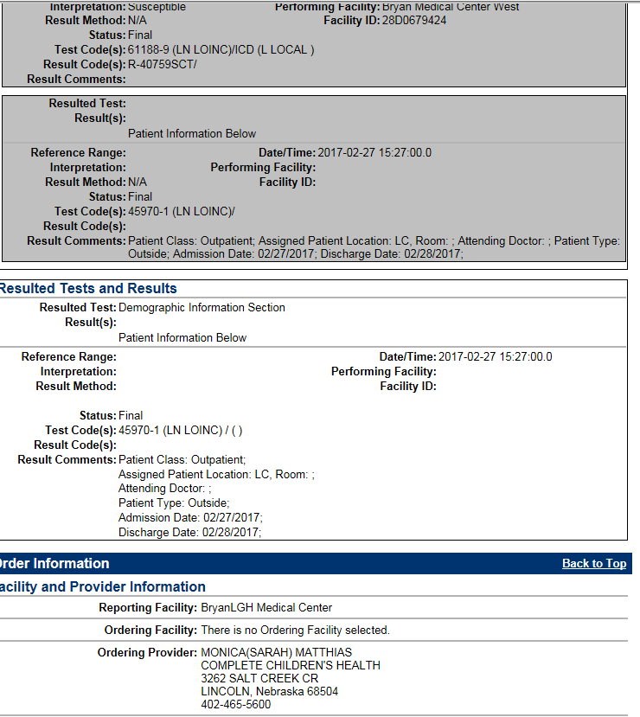

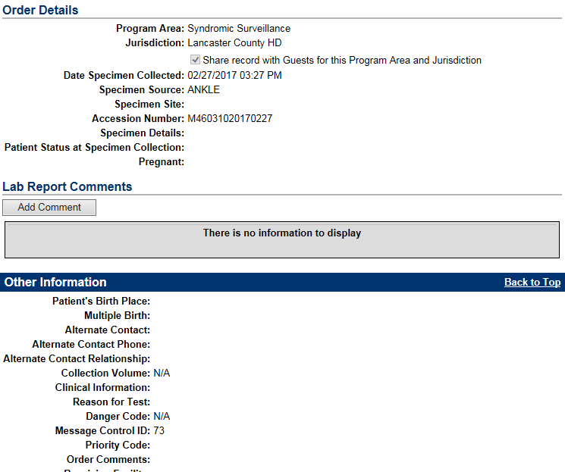

EXAMPLE #2 POLYMICROBIAL WITH THREE DIFFERENT BUGS WITH THEIR ASSOCIATED ANTIMICROBIAL SUSCEPTIBILITIES

MSH|^~\&|SQ^2.16.840.1.113883.3.697^ISO|ANCHORAGE Community Hospital^28D0679419^CLIA|NEDOH|NE-ELR|20170304121555||ORU^R01^ORU_R01|7|P|2.5.1|||NE|NE|||||PHLabReport-NoAck^HL7^2.16.840.1.113883.9.11^ISO||
SFT|Sunquest Information Systems, Inc.^L^^^^SQ&2.16.840.1.113883.3.697&ISO^XX^^^123544|7.2.2|Sunquest Laboratory|7.2.2014||20140522|
PID|1||27194^^^ANCHORAGE Community Hospital&28D0679419&CLIA^MR^SQ&2.16.840.1.113883.3.697&ISO~508342787^^^SSN&2.16.840.1.113883.4.1&ISO^SS^SSA&2.16.840.1.113883.3.184&ISO||CLAUS^MRSSANTA^L^^^^L|^^|19321225|F||WHITE|1111 MAIN ST^^NORTHPOLE^NE^68107^^H||^PRN^PH^^^402^9999999|^^||||||||N^Not Hispanic or Latino^HL70189^NOT_HISPANIC^Not Hispanic or Latino^L^2.5.1^1||||||||||||ANCHORAGE Community Hospital^28D0679419^CLIA|337915000^HOMO SAPIENS^SCT^HUMAN^HUMAN^L^4^4
PV1|1|O|LB^^^|||||NS941^NO PRIM CARE^PROVIDED^^^^^NPCP^SQ&2.16.840.1.113883.3.697&ISO^L^^^DN^SQ&2.16.840.1.113883.3.697&ISO||||||||||OP^O|10332153^^^SQ&2.16.840.1.113883.3.697&ISO^LR^ANCHORAGE Community Hospital&28D0679419&CLIA|M||||||||||||||||||||||||201702280000|201702280000|||||||
ORC|RE|90021802114-A310549-0^ANCHORAGE Community Hospital^28D0679419^CLIA|T2589220170228^SQ^2.16.840.1.113883.3.697^ISO|T25892^SQ^2.16.840.1.113883.3.697^ISO||||||||00563^PEKNY^CRAIG^MD^^^^CPEK^SQ&2.16.840.1.113883.3.697&ISO^L^^^DN^SQ&2.16.840.1.113883.3.697&ISO||^WPN^PH^^^402^9999999||||||| ANCHORAGE Community Hospital^L^^^^ ANCHORAGE Community Hospital&28D0679419&CLIA^XX^^^28D0679419|9999 99th St. Ste. 999^ ANCHORAGE^NE^68107^^^B|^WPN^PH^^^402^9999999|1111 MAIN AVE.^^ ANCHORAGE^NE^68107^^B|
OBR|1|90021802114-A310549-0^ANCHORAGE Community Hospital^28D0679419^CLIA|T2589220170228^SQ^2.16.840.1.113883.3.697^ISO|630-4^BACTERIA UR CULT^LN^CURC^URINE CULTURE, CATH^L^^v1^URINE CULTURE, CATH|||20170228103000|||468^FOLTZ, RUTH^^^^^^^SQ&2.16.840.1.113883.3.697&ISO^L^^^DN^SQ&2.16.840.1.113883.3.697&ISO||SETUP DATE/TIME:^201702281137||||00563^PEKNY^CRAIG^MD^^^^CPEK^SQ&2.16.840.1.113883.3.697&ISO^L^^^DN^SQ&2.16.840.1.113883.3.697&ISO|^WPN^PH^^^402^5642816|468||T25892||20170304121547|||F|&&&&&|||||||||||
OBX|1|CWE|6463-4^Bacteria XXX Cult^LN^CULT^CULTURE^L^^v1^CULTURE|1|L-23401^PSEUDOMONAS AERUGINOSA^SCT^PSAER^Pseudomonas aeruginosa^L^^v1|||A^Abnormal^HL70078^A^Abnormal^HL70078^2.5.1^V1^Abnormal|||F|||20170228103000|||||20170304121547||||^^^^^CLIA&&ISO^XX|^^^^||||^^^^^^^^^|
NTE|1|L|PSEUDOMONAS AERUGINOSA
OBX|2|CWE|6463-4^Bacteria XXX Cult^LN^CULT^CULTURE^L^^v1^CULTURE|2|L-15301^CITROBACTER FREUNDII^SCT^CIFRE^Citrobacter freundii^L^^v1|||A^Abnormal^HL70078^A^Abnormal^HL70078^2.5.1^V1^Abnormal|||F|||20170228103000|||||20170304121547||||^^^^^CLIA&&ISO^XX|^^^^||||^^^^^^^^^|
NTE|1|L|CITROBACTER FREUNDII
OBX|3|CWE|6463-4^Bacteria XXX Cult^LN^CULT^CULTURE^L^^v1^CULTURE|3|L-1E601^ENTEROCOCCUS FAECALIS^SCT^ENFAE^Enterococcus faecalis^L^^v1|||A^Abnormal^HL70078^A^Abnormal^HL70078^2.5.1^V1^Abnormal|||F|||20170228103000|||||20170304121547||||^^^^^CLIA&&ISO^XX|^^^^||||^^^^^^^^^|
OBX|4|CWE|6463-4^Bacteria XXX Cult^LN^CULT^CULTURE^L^^v1^CULTURE|4|L-1E621^VANCOMYCIN RESISTANT ENTEROCOCCUS^SCT^VRE^Vancomycin Resistant Enterococcus^L^^v1|||A^Abnormal^HL70078^A^Abnormal^HL70078^2.5.1^V1^Abnormal|||F|||20170228103000|||||20170304121547||||^^^^^CLIA&&ISO^XX|^^^^||||^^^^^^^^^|
NTE|1|L|ENTEROCOCCUS FAECALIS VANCOMYCIN RESISTANT ENTEROCOCCUS
NTE|2|L|Notified Dr. Lemke, by DocHalo 3/4/17 1213 JT, read at 1214.
SPM|1|90021802114-A310549-0&ANCHORAGE Community Hospital&28D0679419&CLIA^T2589220170228&SQ&2.16.840.1.113883.3.697&ISO||G-8130^URINE^SCT^CATH^Catheterized Urine^L|||||||||||||20170228103000|20170228112400|
OBR|2|90021802114-A310549-0^ANCHORAGE Community Hospital^28D0679419^CLIA|T2589220170228^SQ^2.16.840.1.113883.3.697^ISO|630-4^BACTERIA UR CULT^LN^CURC^URINE CULTURE, CATH^L^^v1^URINE CULTURE, CATH|||20170228103000|||468^FOLTZ, RUTH^^^^^^^SQ&2.16.840.1.113883.3.697&ISO^L^^^DN^SQ&2.16.840.1.113883.3.697&ISO|G|SETUP DATE/TIME:^201702281137||||00563^PPPPPP^CCCCC^MD^^^^CPEK^SQ&2.16.840.1.113883.3.697&ISO^L^^^DN^SQ&2.16.840.1.113883.3.697&ISO|^WPN^PH^^^402^9999999|468||T25892||20170304121547|||F|6463-4&Bacteria XXX Cult&LN&CULT&CULTURE&L^1^PSEUDOMONAS AERUGINOSA|||90021802114-A310549-0&ANCHORAGE Community Hospital&28D0679419&CLIA^T2589220170228&SQ&2.16.840.1.113883.3.697&ISO|||||||||||||||||||||630-4^BACTERIA UR CULT^LN^CURC^URINE CULTURE, CATH^L^^v1^URINE CULTURE, CATH
OBX|1|SN|18860-7^AMIKACIN SUSC ISLT^LN^AK4^Amikacin^L^^v1^Amikacin|1|<=^16|||S^Susceptible^HL70078^S^Susceptible^HL70078^2.5.1^V1^Susceptible|||F|||20170228103000|||||20170303084315||||^^^^^CLIA&&ISO^XX|^^^^||||^^^^^^^^^|
OBX|2|SN|18879-7^CEFEPIME^LN^CPE4^Cefepime^L^^v1^Cefepime|1|<=^4|||S^Susceptible^HL70078^S^Susceptible^HL70078^2.5.1^V1^Susceptible|||F|||20170228103000|||||20170303084315||||^^^^^CLIA&&ISO^XX|^^^^||||^^^^^^^^^|
OBX|3|SN|18893-8^CEFTAZIDIME^LN^CAZ4^Ceftazidime^L^^v1^Ceftazidime|1|<=^1|||S^Susceptible^HL70078^S^Susceptible^HL70078^2.5.1^V1^Susceptible|||F|||20170228103000|||||20170303084315||||^^^^^CLIA&&ISO^XX|^^^^||||^^^^^^^^^|
OBX|4|SN|18906-8^CIPROFLOXACIN^LN^CP4^Ciprofloxacin^L^^v1^Ciprofloxacin|1|<=^1|||S^Susceptible^HL70078^S^Susceptible^HL70078^2.5.1^V1^Susceptible|||F|||20170228103000|||||20170303084315||||^^^^^CLIA&&ISO^XX|^^^^||||^^^^^^^^^|
OBX|5|SN|18928-2^GENTAMICIN^LN^GM4^Gentamicin^L^^v1^Gentamicin|1|<=^4|||S^Susceptible^HL70078^S^Susceptible^HL70078^2.5.1^V1^Susceptible|||F|||20170228103000|||||20170303084315||||^^^^^CLIA&&ISO^XX|^^^^||||^^^^^^^^^|
OBX|6|SN|18932-4^IMIPENEM^LN^IMP4^Imipenem^L^^v1^Imipenem|1|<=^1|||S^Susceptible^HL70078^S^Susceptible^HL70078^2.5.1^V1^Susceptible|||F|||20170228103000|||||20170303084315||||^^^^^CLIA&&ISO^XX|^^^^||||^^^^^^^^^|
OBX|7|SN|20629-2^LEVOFLOXACIN^LN^LVX4^Levofloxacin^L^^v1^Levofloxacin|1|<=^2|||S^Susceptible^HL70078^S^Susceptible^HL70078^2.5.1^V1^Susceptible|||F|||20170228103000|||||20170303084315||||^^^^^CLIA&&ISO^XX|^^^^||||^^^^^^^^^|
OBX|8|SN|18970-4^PIPERACILLIN+TAZOBAC^LN^PT4^Pip/Tazobactam^L^^v1^Pip/Tazobactam|1|<=^16|||S^Susceptible^HL70078^S^Susceptible^HL70078^2.5.1^V1^Susceptible|||F|||20170228103000|||||20170303084315||||^^^^^CLIA&&ISO^XX|^^^^||||^^^^^^^^^|
OBX|9|SN|18996-9^TOBRAMYCIN^LN^TO4^Tobramycin^L^^v1^Tobramycin|1|<=^4|||S^Susceptible^HL70078^S^Susceptible^HL70078^2.5.1^V1^Susceptible|||F|||20170228103000|||||20170303084315||||^^^^^CLIA&&ISO^XX|^^^^||||^^^^^^^^^|
SPM|2|90021802114-A310549-0&ANCHORAGE Community Hospital&28D0679419&CLIA^T2589220170228&SQ&2.16.840.1.113883.3.697&ISO||119303007^Microbial isolate specimen^SCT|||||||||||||20170228103000|20170228112400|
OBR|3|90021802114-A310549-0^ANCHORAGE Community Hospital^28D0679419^CLIA|T2589220170228^SQ^2.16.840.1.113883.3.697^ISO|630-4^BACTERIA UR CULT^LN^CURC^URINE CULTURE, CATH^L^^v1^URINE CULTURE, CATH|||20170228103000|||468^FOLTZ, RUTH^^^^^^^SQ&2.16.840.1.113883.3.697&ISO^L^^^DN^SQ&2.16.840.1.113883.3.697&ISO|G|SETUP DATE/TIME:^201702281137||||00563^PPPPP^CCCCC^MD^^^^CPEK^SQ&2.16.840.1.113883.3.697&ISO^L^^^DN^SQ&2.16.840.1.113883.3.697&ISO|^WPN^PH^^^402^9999999|468||T25892||20170304121547|||F|6463-4&Bacteria XXX Cult&LN&CULT&CULTURE&L^2^CITROBACTER FREUNDII|||90021802114-A310549-0&ANCHORAGE Community Hospital&28D0679419&CLIA^T2589220170228&SQ&2.16.840.1.113883.3.697&ISO|||||||||||||||||||||630-4^BACTERIA UR CULT^LN^CURC^URINE CULTURE, CATH^L^^v1^URINE CULTURE, CATH
OBX|1|SN|18860-7^AMIKACIN SUSC ISLT^LN^AK4^Amikacin^L^^v1^Amikacin|1|<=^16|||S^Susceptible^HL70078^S^Susceptible^HL70078^2.5.1^V1^Susceptible|||F|||20170228103000|||||20170303084315||||^^^^^CLIA&&ISO^XX|^^^^||||^^^^^^^^^|
OBX|2|SN|28-1^AMPICILLIN^LN^AM4^Ampicillin^L^^v1^Ampicillin|1|>^16|||R^Resistant^HL70078^R^Resistant^HL70078^2.5.1^V1^Resistant|||F|||20170228103000|||||20170303084315||||^^^^^CLIA&&ISO^XX|^^^^||||^^^^^^^^^|
OBX|3|SN|18865-6^AMPICILLIN+SULBAC^LN^AS4^Ampicillin/Sulbactam^L^^v1^Ampicillin/Sulbactam|1|>16/8|||R^Resistant^HL70078^R^Resistant^HL70078^2.5.1^V1^Resistant|||F|||20170228103000|||||20170303084315||||^^^^^CLIA&&ISO^XX|^^^^||||^^^^^^^^^|
OBX|4|SN|18878-9^CEFAZOLIN^LN^CFZ4^Cefazolin^L^^v1^Cefazolin|1|>^16|||R^Resistant^HL70078^R^Resistant^HL70078^2.5.1^V1^Resistant|||F|||20170228103000|||||20170303084315||||^^^^^CLIA&&ISO^XX|^^^^||||^^^^^^^^^|
OBX|5|SN|18886-2^CEFOTAXIME^LN^CFT4^Cefotaxime^L^^v1^Cefotaxime|1|=^32|||I^Intermediate^HL70078^I^Intermediate^HL70078^2.5.1^V1^Intermediate|||F|||20170228103000|||||20170303084315||||^^^^^CLIA&&ISO^XX|^^^^||||^^^^^^^^^|
OBX|6|SN|20460-2^CEFUROXIME^LN^CRM4^Cefuroxime^L^^v1^Cefuroxime|1|>^16|||R^Resistant^HL70078^R^Resistant^HL70078^2.5.1^V1^Resistant|||F|||20170228103000|||||20170303084315||||^^^^^CLIA&&ISO^XX|^^^^||||^^^^^^^^^|
OBX|7|SN|18906-8^CIPROFLOXACIN^LN^CP4^Ciprofloxacin^L^^v1^Ciprofloxacin|1|=^4|||R^Resistant^HL70078^R^Resistant^HL70078^2.5.1^V1^Resistant|||F|||20170228103000|||||20170303084315||||^^^^^CLIA&&ISO^XX|^^^^||||^^^^^^^^^|
OBX|8|SN|35802-8^ERTAPENEM^LN^ETP4^Ertapenem^L^^v1^Ertapenem|1|<=^2|||S^Susceptible^HL70078^S^Susceptible^HL70078^2.5.1^V1^Susceptible|||F|||20170228103000|||||20170303084315||||^^^^^CLIA&&ISO^XX|^^^^||||^^^^^^^^^|
OBX|9|SN|18928-2^GENTAMICIN^LN^GM4^Gentamicin^L^^v1^Gentamicin|1|<=^4|||S^Susceptible^HL70078^S^Susceptible^HL70078^2.5.1^V1^Susceptible|||F|||20170228103000|||||20170303084315||||^^^^^CLIA&&ISO^XX|^^^^||||^^^^^^^^^|
OBX|10|SN|20629-2^LEVOFLOXACIN^LN^LVX4^Levofloxacin^L^^v1^Levofloxacin|1|=^4|||I^Intermediate^HL70078^I^Intermediate^HL70078^2.5.1^V1^Intermediate|||F|||20170228103000|||||20170303084315||||^^^^^CLIA&&ISO^XX|^^^^||||^^^^^^^^^|
OBX|11|SN|18955-5^NITROFURANTOIN^LN^FD4^Nitrofurantoin^L^^v1^Nitrofurantoin|1|<=^32|||S^Susceptible^HL70078^S^Susceptible^HL70078^2.5.1^V1^Susceptible|||F|||20170228103000|||||20170303084315||||^^^^^CLIA&&ISO^XX|^^^^||||^^^^^^^^^|
OBX|12|SN|18996-9^TOBRAMYCIN^LN^TO4^Tobramycin^L^^v1^Tobramycin|1|<=^4|||S^Susceptible^HL70078^S^Susceptible^HL70078^2.5.1^V1^Susceptible|||F|||20170228103000|||||20170303084315||||^^^^^CLIA&&ISO^XX|^^^^||||^^^^^^^^^|
OBX|13|SN|18998-5^TMP SMX^LN^TS4^TMP/SMX^L^^v1^TMP/SMX|1|<=2/38|||S^Susceptible^HL70078^S^Susceptible^HL70078^2.5.1^V1^Susceptible|||F|||20170228103000|||||20170303084315||||^^^^^CLIA&&ISO^XX|^^^^||||^^^^^^^^^|
SPM|3|90021802114-A310549-0&ANCHORAGE Community Hospital&28D0679419&CLIA^T2589220170228&SQ&2.16.840.1.113883.3.697&ISO||119303007^Microbial isolate specimen^SCT|||||||||||||20170228103000|20170228112400|
OBR|4|90021802114-A310549-0^ANCHORAGE Community Hospital^28D0679419^CLIA|T2589220170228^SQ^2.16.840.1.113883.3.697^ISO|630-4^BACTERIA UR CULT^LN^CURC^URINE CULTURE, CATH^L^^v1^URINE CULTURE, CATH|||20170228103000|||468^FFFFFF, RRRRR^^^^^^^SQ&2.16.840.1.113883.3.697&ISO^L^^^DN^SQ&2.16.840.1.113883.3.697&ISO|G|SETUP DATE/TIME:^201702281137||||00563^PPPPP^CCCCC^MD^^^^CPEK^SQ&2.16.840.1.113883.3.697&ISO^L^^^DN^SQ&2.16.840.1.113883.3.697&ISO|^WPN^PH^^^402^9999999|468||T25892||20170304121547|||F|6463-4&Bacteria XXX Cult&LN&CULT&CULTURE&L^4^VANCOMYCIN RESISTANT ENTEROCOCCUS|||90021802114-A310549-0&ANCHORAGE Community Hospital&28D0679419&CLIA^T2589220170228&SQ&2.16.840.1.113883.3.697&ISO|||||||||||||||||||||630-4^BACTERIA UR CULT^LN^CURC^URINE CULTURE, CATH^L^^v1^URINE CULTURE, CATH
OBX|1|SN|28-1^AMPICILLIN^LN^AM4^Ampicillin^L^^v1^Ampicillin|1|<=^2|||S^Susceptible^HL70078^S^Susceptible^HL70078^2.5.1^V1^Susceptible|||F|||20170228103000|||||20170304121547||||^^^^^CLIA&&ISO^XX|^^^^||||^^^^^^^^^|
OBX|2|SN|18906-8^CIPROFLOXACIN^LN^CP4^Ciprofloxacin^L^^v1^Ciprofloxacin|1|>^2|||R^Resistant^HL70078^R^Resistant^HL70078^2.5.1^V1^Resistant|||F|||20170228103000|||||20170304121547||||^^^^^CLIA&&ISO^XX|^^^^||||^^^^^^^^^|
OBX|3|SN|35788-9^DAPTOMYCIN^LN^DAP4^Daptomycin^L^^v1^Daptomycin|1|=^0.5|||S^Susceptible^HL70078^S^Susceptible^HL70078^2.5.1^V1^Susceptible|||F|||20170228103000|||||20170304121547||||^^^^^CLIA&&ISO^XX|^^^^||||^^^^^^^^^|
OBX|4|SN|18955-5^NITROFURANTOIN^LN^FD4^Nitrofurantoin^L^^v1^Nitrofurantoin|1|<=^32|||S^Susceptible^HL70078^S^Susceptible^HL70078^2.5.1^V1^Susceptible|||F|||20170228103000|||||20170304121547||||^^^^^CLIA&&ISO^XX|^^^^||||^^^^^^^^^|
OBX|5|SN|20629-2^LEVOFLOXACIN^LN^LVX4^Levofloxacin^L^^v1^Levofloxacin|1|>^4|||R^Resistant^HL70078^R^Resistant^HL70078^2.5.1^V1^Resistant|||F|||20170228103000|||||20170304121547||||^^^^^CLIA&&ISO^XX|^^^^||||^^^^^^^^^|
OBX|6|SN|29258-1^LINEZOLID^LN^LZD4^Linezolid^L^^v1^Linezolid|1|=^1|||S^Susceptible^HL70078^S^Susceptible^HL70078^2.5.1^V1^Susceptible|||F|||20170228103000|||||20170304121547||||^^^^^CLIA&&ISO^XX|^^^^||||^^^^^^^^^|
OBX|7|SN|18964-7^PENICILLIN^LN^P4^Penicillin^L^^v1^Penicillin|1|=^4|||S^Susceptible^HL70078^S^Susceptible^HL70078^2.5.1^V1^Susceptible|||F|||20170228103000|||||20170304121547||||^^^^^CLIA&&ISO^XX|^^^^||||^^^^^^^^^|
OBX|8|SN|18993-6^TETRACYCLINE^LN^TE4^Tetracycline^L^^v1^Tetracycline|1|>^8|||R^Resistant^HL70078^R^Resistant^HL70078^2.5.1^V1^Resistant|||F|||20170228103000|||||20170304121547||||^^^^^CLIA&&ISO^XX|^^^^||||^^^^^^^^^|
OBX|9|SN|19000-9^VANCOMYCIN^LN^VA4^Vancomycin^L^^v1^Vancomycin|1|>^16|||R^Resistant^HL70078^R^Resistant^HL70078^2.5.1^V1^Resistant|||F|||20170228103000|||||20170304121547||||^^^^^CLIA&&ISO^XX|^^^^||||^^^^^^^^^|
SPM|4|90021802114-A310549-0&ANCHORAGE Community Hospital&28D0679419&CLIA^T2589220170228&SQ&2.16.840.1.113883.3.697&ISO||119303007^Microbial isolate specimen^SCT|||||||||||||20170228103000|20170228112400|

