How to Update Your Contact Info in CSTE’s Basecamp

- On the CSTE Cannabis Subcommittee homepage, click on ‘Set up people’.

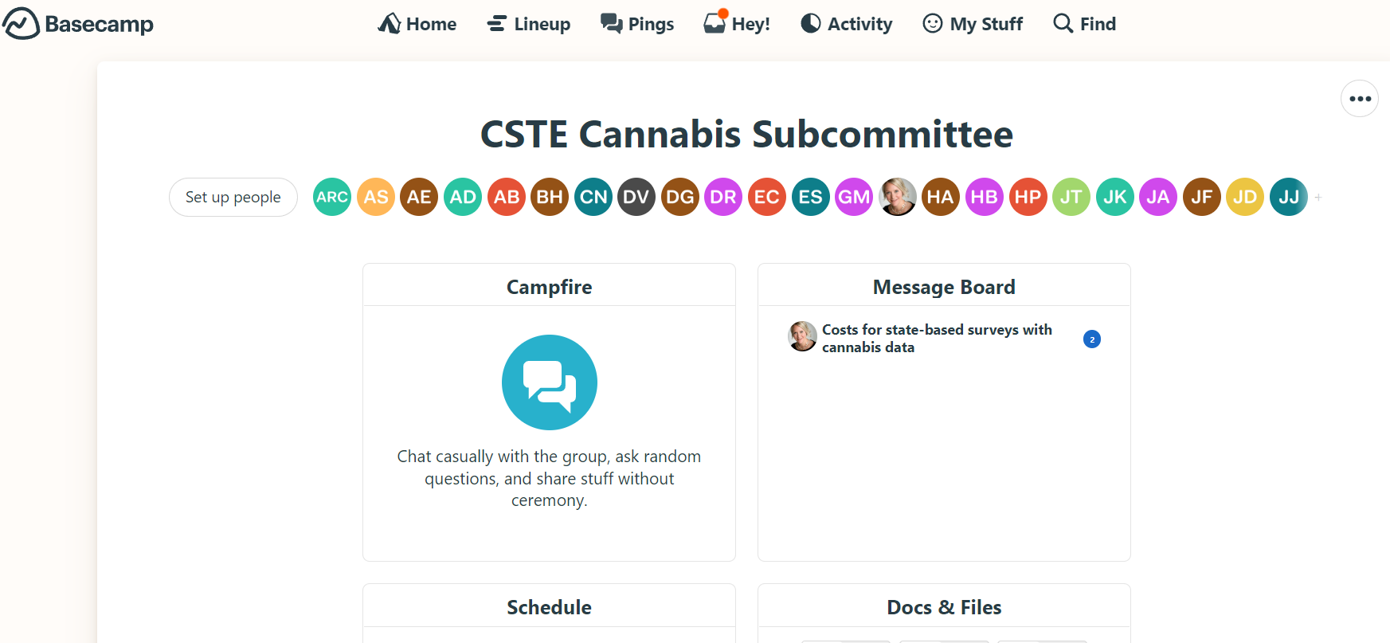

- Find your name in the list and click on the three dots. A blue box will pop-up. Click on ‘Edit info’.

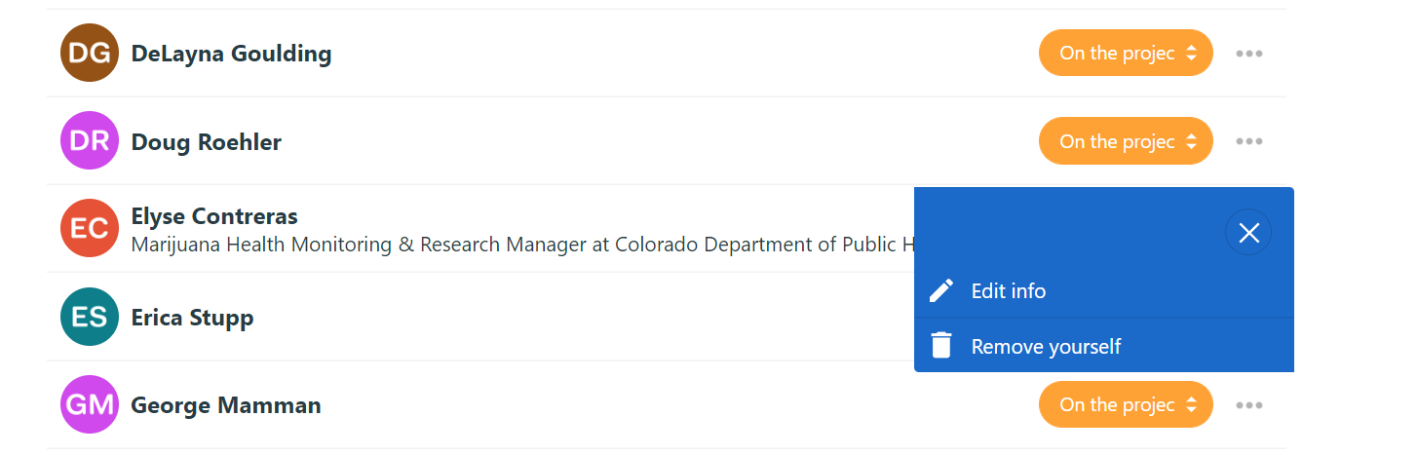

- Enter your information making sure your state/territory is mentioned.
Note: When entering your Company/Organization, a blue box will pop-up. Click on ‘add’ to save the information you typed.
- Click ‘Save changes’ when done entering info.
