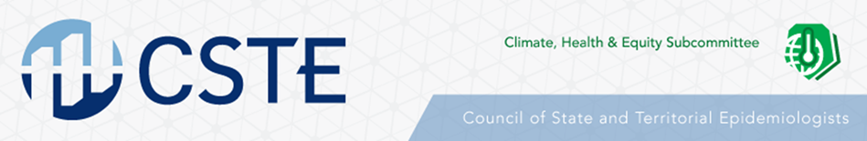

CSTE Wildfire Subgroup Call

Thursday, September 12th at 12pm ET
This call is recorded.
Agenda:
- Introduction + Roll Call – Alesha Thompson
- CSTE Updates
  - 2020 Conference:
    - Seattle, WA, June 28th – July 2nd, 2020
    - Call for Abstracts opens November 1st

  - Upcoming Subcommittee Calls
    - Urban Air & Heat Subgroup:
      - Thursday, Sept 19th at 3pm ET

    - Climate, Health and Equity Subcommittee:
      - Monday, Sept 23rd at 2pm ET
      - Featured Speaker: Brian McInerney, Climate Change scientist for NWS Forecast office in Utah

    - Aeroallergen Subgroup:
      - Wednesday, Sept 25th at 3pm ET

- Open discussion on wildfire season
- Next call: Thursday, November 14th at 12pm ET

