Background:
This document is meant to serve as a resource for EPHT recipients as well as others interested in aeroallergen work. The inventory includes information about active committees, workgroups, resources and stakeholders who are engaged in aeroallergen work.

Uses:
- Review and synthesize the scope of work currently being done
- Minimize duplication of efforts
- Identify opportunities for collaboration
- Serve as a starting point for individuals and groups new to the aeroallergen field

This resource inventory is intended to be living document. Please contact Allison Gost-Breitenother (allison.gostbreitenother@maryland.gov) to make additions or edits. Updates will be made quarterly throughout the year.

Table 1. Active aeroallergen focused committees and workgroups

Committee or Workgroup | Vision | Objectives and Strategies | Products
Aeroallergen Monitoring Science Committee (AMSC)  http://nadp.slh.wisc.edu/committees/AMSC/  Science Committee of the National Atmospheric Deposition Program | - Advance the science of aeroallergen monitoring  - Identify emerging technologies  - Evaluate methods to ensure data quality  - Coordination of monitoring stations  - Possibly, serve as a data repository | - Engage stakeholders in effective decision making, identify priority research areas, facilitate outreach and education, and seek research funding  - Support national networks that monitor aeroallergens by providing information on emerging measurement techniques, supporting efforts to standardize methods, quantifying data quality indicators, and providing best practices for data and information storage for long-term trend analysis  - Identify and prioritize knowledge gaps in the field of measuring and modeling aeroallergens and advocate for research to address those gaps  - Support development of models for the forecast, emission, transport, and removal of aeroallergens from the atmosphere  - Create and maintain communication links between the aeroallergen research community and the Executive Committee to foster collaboration with the NADP’s existing network of stations as a core component of the U.S. aeroallergen monitoring network
CSTE Aeroallergen Committee  https://www.cste.org/page/ClimateResp  Sub-team of the Climate and Respiratory Health Workgroup | - Minimize the national burden of allergic diseases associated with aeroallergens/pollen  - Improve health and awareness | - Understand risk:  - Inventory publications  - Develop indicators:  - Work with Tracking to identify indicators and measures  - Increase collaborations:  - Include CDC grantees (Climate, Tracking, Asthma)  - Articulate value  - Catalog wins (e.g., successful collaborations)  - Promote among medical public health, and public (e.g., ALA, AMA, APHA, CDC, EPA, NRDC)  - Promote in NADP network  - Define the economic burden:  - Harmonize research (e.g., BRACE grantees, universities)  - Package information and develop products:  - Identify problems, solutions, actions needed for at-risk populations and regions  - Create a web presence (website linkages)  - Prepare slide deck  - Inventory communications tools that are out there (e.g., “bites, snacks, meals”) | - CSTE position statement – serves as a policy document that is shared with identified federal partners - https://c.ymcdn.com/sites/www.cste.org/resource/resmgr/2016PS/16_EH_01.pdf
CDC National Environmental Public Health Tracking – Aeroallergen Sub-Team | - To increase the awareness of pollen as an environmental hazard and minimize the burden of allergic diseases associated with pollen. | - Conduct an inventory of pollen resources and products. Collect information about operating pollen counting stations in the U.S. and groups who are engaged in pollen work.  - Explore the development and implementation of pollen indicators and measures. In order to potentially develop a pollen NCDM, we must address several critical questions about tracking aeroallergens. | - Spreadsheet of all operating pollen counting stations in the U.S. (NAB & non-NAB). In progress.  - Review of aeroallergen partners. In progress.  - Spreadsheet of pollen indicators and measures that are being used by others (e.g., state/local agencies, NGO’s). Proposed.  - Develop recommendations for data dissemination and communication materials that summarize pollen information. Proposed.

Workgroup Structure:

CSTE Workgroup CDC Tracking NADP
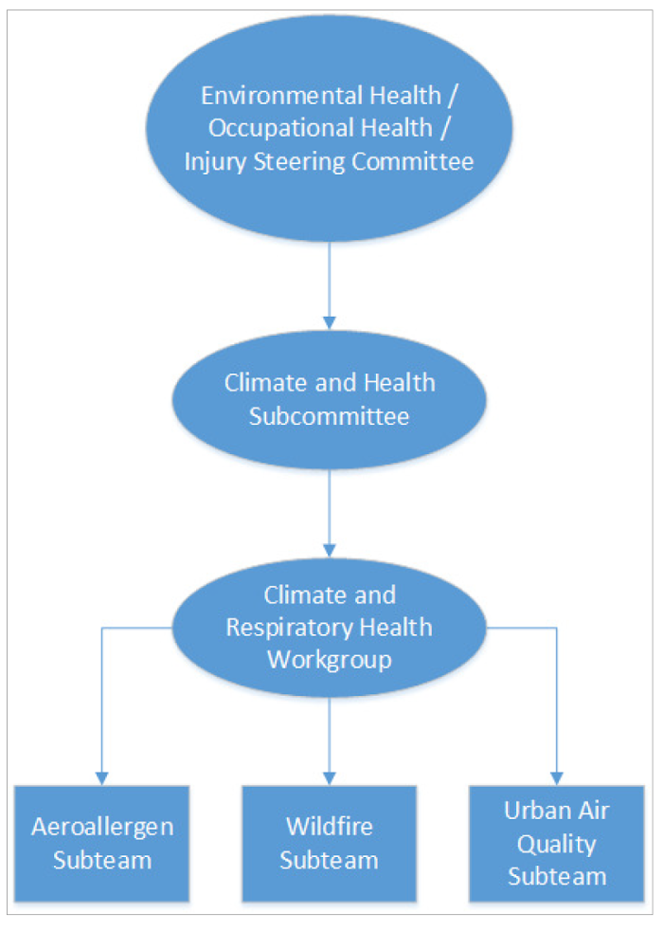
National Atmospheric Deposition Program
Science Committees
Aeroallergen Monitoring Science Committee (AMSC)
National Tracking Program
Climate Change Work Group
Pollen Sub-Team

Workgroups/Committees

- CSTE Aeroallergen Committee - Lead: Hayleigh McCall (hmccall@cste.org); Arie Manangan (mqa2@cdc.gov)
- NADP Aeroallergen Monitoring Science Committee - Co-leads: Andy Johnson (andy.johnson@maine.gov); Norman Anderson (andersonenvironmentalhealth@gmail.com)
- ASTHO Climate Change Collaborative - Lead: Kathleen Dolan (kdolan@astho.org)
  - Increase awareness of climate change work taking place at state and local health departments; discuss aeroallergen and pollen but not focused explicitly on it.
- National Environmental Public Health Tracking Aeroallergen Sub-Team – Lead: Emily Prezzato (laq7@cdc.gov)

Research, Data, & Others

- CDC
  - Climate & Health - Allergens: https://www.cdc.gov/climateandhealth/effects/allergen.htm
  - Communication - Allergens: https://www.cdc.gov/healthcommunication/toolstemplates/entertainmented/tips/Allergies.html
  - Highlight of research topics: Partnerships to study intra-urban pollen variability, literature reviews, understanding of relationship between pollen and health outcomes, modeling using proxy data, influence of ozone and air pollution on vulnerable populations (elderly), data integration (Environmental Public Health Tracking Network)

- EPA
  - Climate change indicators - ragweed: https://www.epa.gov/climate-indicators/climate-change-indicators-ragweed-pollen-season
    - central US / Canada -- indicator based on data from 1995 - 2015
  - Technical Document: https://www.epa.gov/sites/production/files/2016-08/documents/ragweed_documentation.pdf

- USDA - Agricultural Research Service
  - Website (Ragweed & climate): https://www.ars.usda.gov/news-events/news/research-news/2011/usda-study-confirms-links-between-longer-ragweed-season-and-climate-change/

- NOAA - National Centers for Environmental Information
  - Website (main page): https://www.ncdc.noaa.gov/data-access/paleoclimatology-data/datasets/pollen
  - Website (NOAA funded pollen datasets): https://www.ncdc.noaa.gov/paleo-search/reports/all?dataTypeId=16&search=true

- University of Washington (Jeremy Hess) (Website)
  - Research Gate (list of research publications): https://www.researchgate.net/scientific-contributions/2117590537_Jeremy_Hess
  - Highlight of research topics: Identification of spring onset for pollen; modeling using proxy data (i.e: google trends)

- University of Maryland (Amir Sapkota) (Website)
  - Maryland specific data - available by the middle of summer 2019
  - Highlight of research topics: climate change influence on plant pehnology and respiratory illness, air pollution and respiratory diseases, looking to identify changes in season start and end to better inform preparedness measures in Maryland

- National Institute of Environmental Health Sciences:
  - Website: https://www.niehs.nih.gov/health/topics/agents/allergens/pollen/index.cfm

- NRDC: Climate change health & air quality National maps, ragweed & ozone + asthma
  - Website (map): https://www.nrdc.org/climate-change-and-health-air-quality#/map

- Allergy and Asthma Foundation of America (AAFA): Non-profit organization for individuals with allergies and asthma.
  - Website (allergy research page): https://www.aafa.org/allergy-research/

- Climate Central: Data on spring warming, pollen season length, last freeze, co2 and pollen, etc.
  - Website: http://medialibrary.climatecentral.org/

- National Allergy Bureau (NAB): National network of (private) aeroallergen counting stations. Operates as part of the American Academy of Allergy, Asthma & Immunology (AAAAI)
  - Website: Pollen & Spore Levels: https://www.aaaai.org/global/nab-pollen-counts?ipb=1
- (Under Construction) Pollen Counting Stations Inventory: Inventory of private and public counting stations. National Environmental Public Health Tracking – Aeroallergen Sub-Team.
  - Website: Forthcoming

Private Companies

- Pollen Sense: Collaboration to combine environmental sciences, statistics, aerobiology, machine learning, communications, physics, business, and mechanical/electrical engineering to improve aeroallergen monitoring and action.
  - Website (data page: http://pollensense.com/data/

- Aerobiology (Canada): Aerobiology Research Laboratories currently operates 30 monitoring stations that gather pollen and spore samples daily using the innovative aeroallergen rotation impaction samplers, redesigned by Aerobiology Research Laboratories. They are strategically placed throughout Canada in highly populated areas and regions with differing biological diversity. This allows us to provide aeroallergen levels and forecasts that are appropriate for areas affecting the majority of the general populous.
  - Website (data page): https://www.aerobiology.ca/products/historical-data/

- Len Bielory and NE collaboration:
  - Website (pollen count, NJ data monitoring station) - http://www.nynjpollen.com/index.php

- Propeller Health: Propeller Health has developed a sensor that fits directly to a rescure inhaler, and through enrollment in the program is able to identify GPS location of use, allow individual to self-select trigger and works to improve asthma and COPD management
  - Website (list): https://www.propellerhealth.com/how-it-works/
Technical Documents & Publications:

Aeroallergens
- Katz, D. S. W., et al. (2019). "Effect of intra-urban temperature variation on tree flowering phenology, airborne pollen, and measurement error in epidemiological studies of allergenic pollen." Sci Total Environ 653: 1213-1222.
- Sapkota, A., et al. (2019). “Associations between alteration in plant phenology and hay fever prevalence among US adults: Implications for changing climate.” PLOS One doi: 10.1371/journal.pone.0212010
- Pollen Counting 1969 - 2016 (2017) doi: 10.1016/j.jaci.2016.12.394
- Anenberg, S. C., et al. (2017). "Impacts of oak pollen on allergic asthma in the United States and potential influence of future climate change." GeoHealth 1(3): 80-92.
- Schmidt, C. W. (2016) “Pollen Overload: Seasonal Allergies in a Changing Climate.” Environmental Health Perspectives. doi: 10.1289/ehp.124-A70
- Upperman, CR., et al. (2017). “Exposure to Extreme Heat Events Is Associated with Increased Hay Fever Prevalence among Nationally Representative Sample of US Adults: 1997 – 2013” Journal Allergy linical Immunology Practice. doi: 10.1016/j.jaip.2016.09.016
- Developing a National Aeroallergen Tracking Network (2016 - CSTE): https://cdn.ymaws.com/www.cste.org/resource/resmgr/2016PS/16_EH_01.pdf
- Zhang, Y., et al. (2014) “Allergenic pollen season variations in the past two decades under changing climate in the United States” Global Change Biology Vol 21 Iss 4. doi: 10.1111/gcb.12755
- Does Available Scientific Evidence Support the Inclusion of Pollen as a Nationally Consistent Data and Measure Indicator on the Environmental Public Health Tracking Network? (2012) https://cdn.ymaws.com/www.cste.org/resource/resmgr/PDFs/Pollen_White_Paper.pdf
- Extreme Allergies and Climate Change - AAFA (2012) - https://www.aafa.org/extreme-allergies-and-climate-change/

Climate Change
- USGCRP, 2016: The Impacts of Climate Change on Human Health in the United States: A Scientific Assessment. Crimmins, A., J. Balbus, J.L. Gamble, C.B. Beard, J.E. Bell, D. Dodgen, R.J. Eisen, N. Fann, M.D. Hawkins, S.C. Herring, L. Jantarasami, D.M. Mills, S. Saha, M.C. Sarofim, J. Trtanj, and L. Ziska, Eds. U.S. Global Change Research Program, Washington, DC, 312 pp. http://dx.doi.org/10.7930/J0R49NQX (https://health2016.globalchange.gov/air-quality-impacts#narrative-237)
- Nolte, C.G., P.D. Dolwick, N. Fann, L.W. Horowitz, V. Naik, R.W. Pinder, T.L. Spero, D.A. Winner, and L.H. Ziska, 2018: Air Quality. In Impacts, Risks, and Adaptation in the United States: Fourth National Climate Assessment, Volume II [Reidmiller, D.R., C.W. Avery, D.R. Easterling, K.E. Kunkel, K.L.M. Lewis, T.K. Maycock, and B.C. Stewart (eds.)]. U.S. Global Change Research Program, Washington, DC, USA, pp. 512–538. doi: 10.7930/NCA4.2018.CH13 (https://nca2018.globalchange.gov/chapter/air-quality)

