Date: Launching in early August 2021
Length: 8 hours (2 days @ 4 hours per day)
Register here: https://nnditc.org/upcoming_classes.html
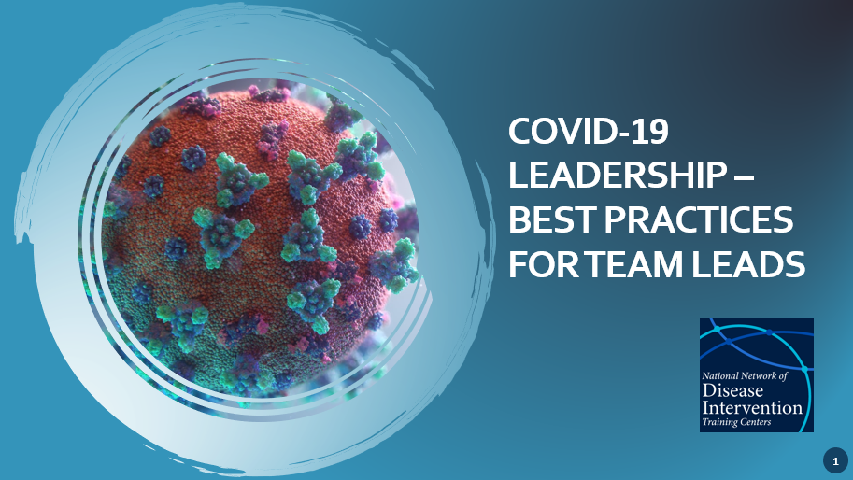
Announcing New Training Program!
COVID-19 Leadership- Best Practices for Team Leads
This virtual skills-based course is designed for public health leaders who manage case investigators and contact tracers supporting COVID-19 programs.
Course Goals:
- Strengthen the public health workforce to support culturally competent COVID-19 response activities and programming.

- Support competent and sustainable COVID-19 services that address the diverse needs of jurisdictions.
- Enhance the comprehensive leadership skills of managers working with case investigators and contact tracers.
Learning Outcomes:
By the end of this course you will:
- Have knowledge of the 10 essential public health services and how they are integrated into COVID-19 Team Lead responsibilities.
- Apply COVID-19 Team Lead responsibilities to effectively manage your team.
- Discuss strategies and techniques for managing challenging situations effectively.
- Practice coaching and communication skills that empower team members.
- Apply effective leadership skills to guide COVID-19 case investigators and contact tracers.

