CSTE/CDC Pregnancy Status Reporting Project

Assessment Findings

Contents
Assessment Findings 1
Response Summaries 3
State agencies 3
Laboratory 4
Clinicians 4
Federal health agencies 4
Respondent Profiles 5
STLT Assessment Summary 7
Clinician Assessment Summary 12
Laboratory Assessment Summary 14
Federal Agency Assessment Summary 16

Response Summaries
There were 112 responses across four assessments; 24 anonymous. Response distribution was as follows:
STLT 74
Federal 13
Clinician 15
Lab 14

Jurisdictions represented across all assessments included:
- 41 states
- 2 national organizations
- 1 territory

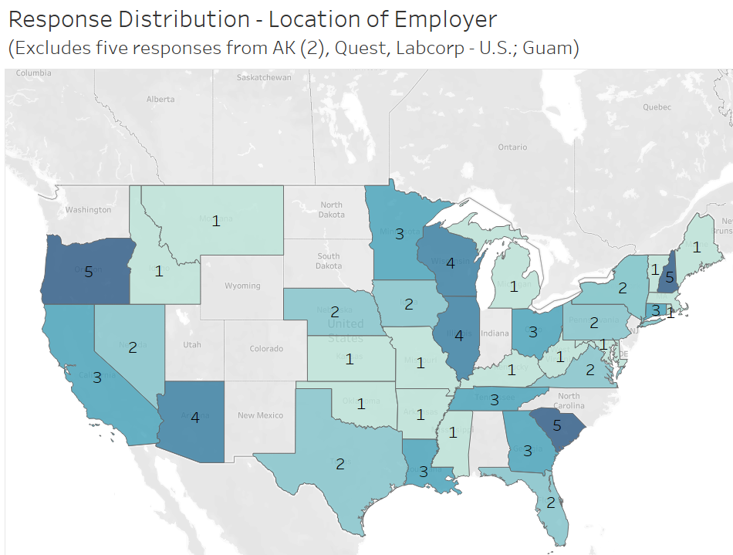

State agencies
Pregnancy status is most often obtained by patient interview, followed by ELR, provider outreach, eCR, and other fields. For non-COVID diseases, similar primary sources are used. For non-notifiable conditions of public health importance, vital statistics and hospital discharge data are the most common sources of pregnancy status. State agencies most often want a simple y/n question for obtaining pregnancy status.

In terms of barriers, inconsistency in reporting, coding, and receipt are major barriers. There is also reluctancy to share data across bureaus.

Seven respondents indicated administrative law exists to require reporting of pregnancy status. Agencies do link to vital records to obtain recent birth information.

With regards to eCR, COVID-19 is the most commonly reported condition. Expansion of eCR is focused on enteric diseases, respiratory conditions, sexually transmitted and vaccine preventable diseases. Significant expansion is slated to occur in the next year for most, with additional expansion within five years.

The biggest barriers to implementing eCR are retention and presence of staff with expertise along with external technical assistance. There was mentioned of CDC impeding a process and a vendor not delivering an enhancement.

States indicate status reporting is very important for 'notifiable condition where the health of the mother or infant are impacted' or 'new or emerging diseases where the impact to mothers or infants is unknown', as well as COVID-19.

Laboratory
Ask at order entry (AOE) is the most commonly used field for capturing pregnancy status for COVID-19 and other notifiable conditions. Relevant clinical information and diagnostic codes are sparsely used. Status is reported to public health using the 'Other' HL7 field or in 'Relevant clinical information' or 'OBX'.

Pregnancy status is most often collected for COVID-19 and Zika, followed by HIV and Syphilis. Manual data entry is required on paper lab requisition forms.

Laboratories confirm a simple picklist is the best approach to capture pregnancy status. If status were a required reporting element, codification in AOE is preferred. Laboratories indicate reporting capture burden is 4.2/10 effort. However, laboratorians do not feel pregnancy status should be captured by them unless clinically relevant. Most have a field to capture but challenges with ensuring reporting happens.

Clinicians
Clinicians report pregnancy status as diagnostic billing codes and dedicated fields when available. Most standard variables for following pregnant patients are routinely captured.

In terms of barriers to reporting to public health, clinicians cite EMR is not programmed to report to public health and lack of awareness of the need to report. However, clinicians feel reporting of all notifiable and emerging conditions is important.

Federal health agencies
Responses were smaller for this assessment. When obtained for COVID-19, pregnancy status is retrieved from vital statistics, eCR, and other files. Respondents indicated capturing status required significant effort. Expanded use of eCR is believed to improve reporting along with other state-level efforts. Respondents believe reporting of pregnancy status for all notifiable conditions is important.

Respondent Profiles
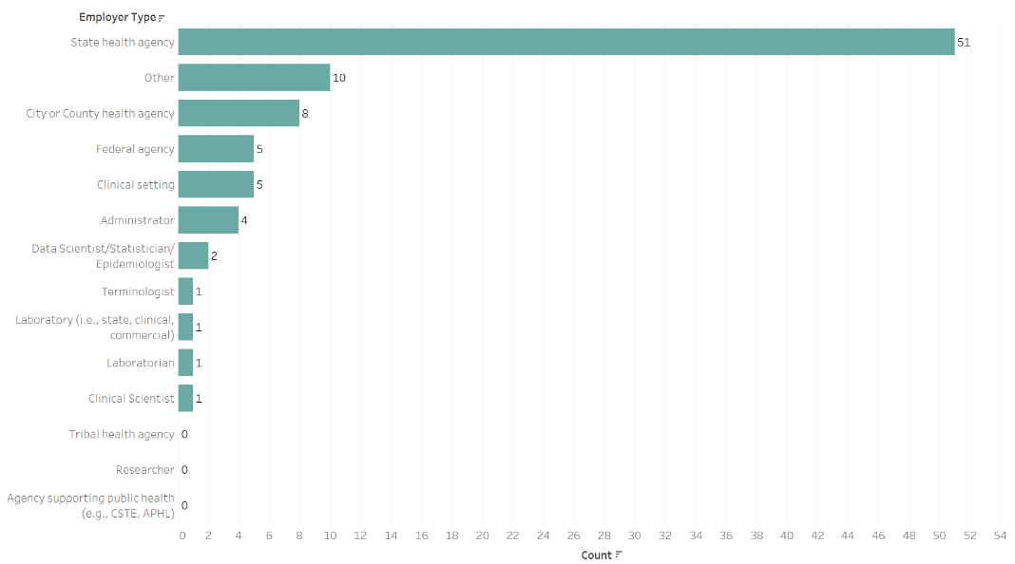
The majority of respondents were from state health agencies with 51 from state, 10 other, either city/county, five federal, five clinicians, and 10 from other agency types.

Respondent roles extended from epidemiologists (31), those in leadership roles (10), data scientists (10), and others (42).
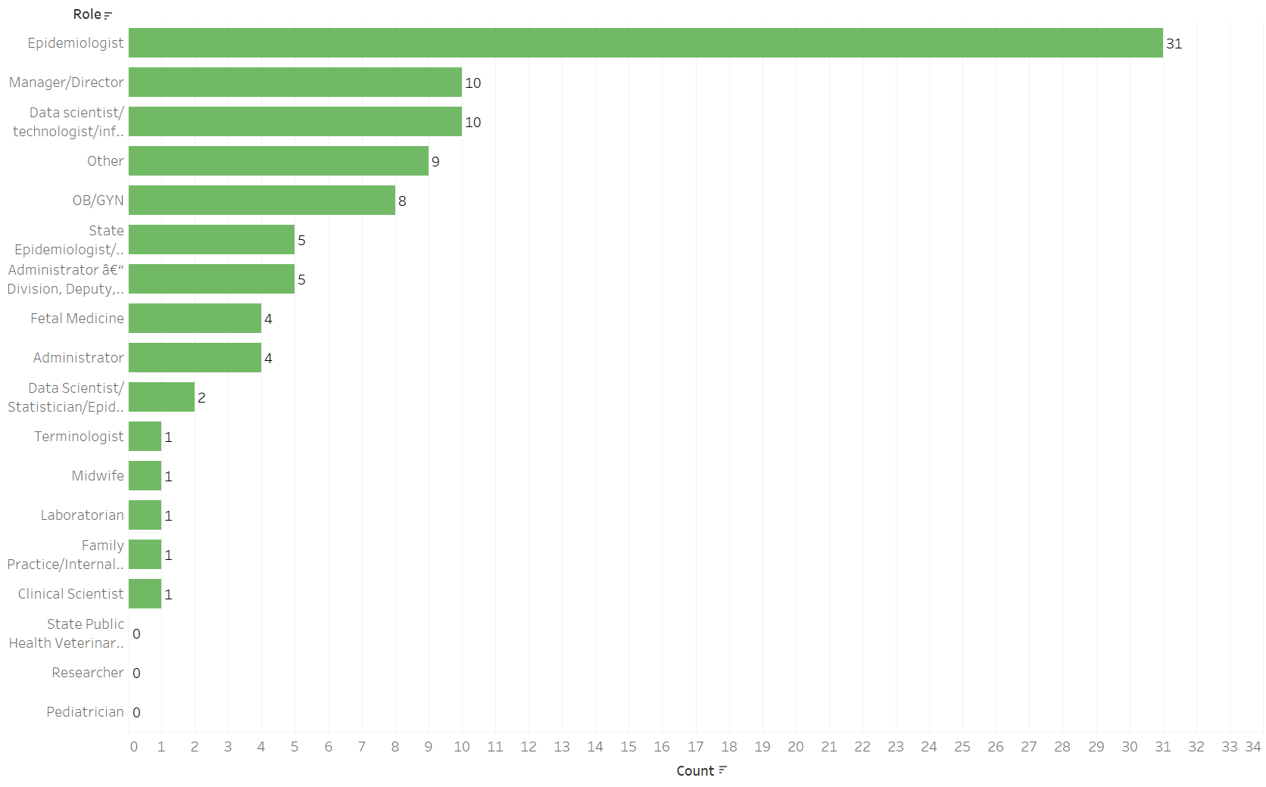

STLT Assessment Summary
How important is obtaining pregnancy status for COVID-19 and other categories of disease/condition for your agency?
COVID-19 | 8.12
Other notifiable diseases excluding COVID-19 (e.g., foodborne, arboviral) | 7.29
Non-notifiable conditions of public health importance (e.g., cancer) | 6.49
Indicate how your agency captures pregnancy status for COVID-19 and other categories of disease/condition (select all that apply).: COVID-19
Patient Interview | 32
ELR (electronic lab reporting) | 26
Provider reporting or outreach | 25
eCR (electronic case reporting) | 20
Extracted from electronic files (non-lab) | 18
Hospital discharge data | 17
Vital statistics | 17
Custom data mining | 7
I do not know | 5
Other | 3
Newborn metabolic screening | 2
Pregnancy status is NOT captured for this condition | 2
Regional health information notifications | 2
Indicate how your agency captures pregnancy status for COVID-19 and other categories of disease/condition (select all that apply).: Other notifiable diseases (excluding COVID-19)
Patient Interview | 34
Provider reporting or outreach | 29
ELR (electronic lab reporting) | 23
Vital statistics | 22
Hospital discharge data | 18
Extracted from electronic files (non-lab) | 17
eCR (electronic case reporting) | 16
Custom data mining | 10
I do not know | 8
Newborn metabolic screening | 6
Other | 6
Regional health information notifications | 5
Pregnancy status is NOT captured for this condition | 2
Indicate how your agency captures pregnancy status for COVID-19 and other categories of disease/condition (select all that apply).: Non-notifiable conditions of public health importance (e.g., cancer)
I do not know | 16
Vital statistics | 16
Hospital discharge data | 12
Newborn metabolic screening | 8
Custom data mining | 7
Extracted from electronic files (non-lab) | 7
Provider reporting or outreach | 6
Patient Interview | 5
ELR (electronic lab reporting) | 4
eCR (electronic case reporting) | 3
Other | 1
Pregnancy status is NOT captured for this condition | 1
Regional health information notifications | 1
Does your agency experience any barriers to obtaining pregnancy status for COVID-19?
Inconsistent provider reporting at lab order entry | 31
Inconsistent receipt through electronic lab reporting | 31
No standard method to receive pregnancy status | 30
Administrative code/law does not require reporting | 25
Staff time or expertise constraints | 21
Challenges in parsing status out of electronic data (ELR, eCR, or other) | 17
Inability to extract pregnancy status from EMR (electronic medical record) | 15
Lack of fields to capture pregnancy in EMR (electronic medical record) | 7
No, we do not encounter barriers to pregnancy reporting or do not solicit pregnancy reporting. | 3
Other, please describe. | 14
Not only inconsistency from providers, but also lab staff filling out either electronic form or paper-based forms in their sample shipping department.
Inconsistent coding in any data source
Staff access to other systems (e.g., vital records), reporting by providers limited
Received pregnancy status in AOE for COVID - this is no longer required to be reported
Most of our reporting comes from labs and labs do not usually collect this information/providers do not report it to labs
If reported electronically, no way to indicate if the pregnancy is the patient's current status.
Not always consistent across programs and lacking knowledge of importance
Reluctancy to share data across bureaus
Not all cases are interviewed and that is the main way pregnancy status is currently verified.
Incorrect or inconsistent reporting of pregnancy checkbox on vital records
Internal issues related to getting vital statistic information.
I don't know
I do not work on COVID-19 surveillance at this time
Don't know
Which of the following approaches has your agency taken to increase reporting of pregnancy status for any disease/condition?
Education of providers | 21
Use of electronic reporting (e.g., ELR fields) | 21
Custom data extracts | 13
Collaboration/education with laboratories | 10
Our agency has not tried to improve pregnancy reporting | 10
Other | 9
Administrative code/law requirement (please provide the URL to the requirement language if possible) | 7
Required, if available, but often is not provided
Added for some conditions
https://www.kdhe.ks.gov/DocumentCenter/View/14247/Kansas-Notifiable-Diseases-List-PDF
7 AAC 27.005
Which of the following approaches has your agency taken to increase reporting of pregnancy status for any disease/condition?
Collaboration with maternal/child health program and vital statistics
Custom queries with HIE
Linked COVID-19 case data to birth certificates
We are currently discussing the use of OBR-13 (Relevant clinical information)
Matching with Vital Statistics/Birth Records
Depends on the program as to what they have done to improve accuracy of collection of pregnancy status
Matching to Vital Records
Uncertain
Education of LHDs and case investigators on importance of completing fields during case investigation interview
In your opinion, how burdensome is pregnancy status reporting for COVID-19 for laboratories?
No or very little burden | 5.67
Would requiring laboratories to report into a central exchange (i.e., AIMS - APHL Informatics Messaging System) improve your ability to capture pregnancy status?
Maybe | 24
Yes | 13
No | 10
Which categories of diseases/conditions does your agency currently receive through eCR (electronic case reporting)?
COVID-19 ONLY | 24
Our agency is NOT receiving eCR (electronic case reports) | 9
Respiratory Conditions (infectious) | 9
Sexually Transmitted Diseases | 9
Vaccine Preventable Diseases | 8
Enteric Diseases | 7
Vectorborne Diseases | 7
Zoonotic Diseases | 7
Bloodborne Diseases | 6
Healthcare- Associated Events | 6
Waterborne (not enteric) | 6
Streptococcal Diseases | 5
Cancer | 3
Toxic Effect of Non-Medicinal Substances | 2
Neurological Diseases | 1
Respiratory Conditions (non-infectious) | 1
Injuries | 0
Systemic Conditions | 0
If your agency is working to expand eCR (electronic case reporting), which categories of diseases/conditions is your agency prioritizing?
Enteric Diseases | 23
Respiratory Conditions (infectious) | 21
Sexually Transmitted Diseases | 21
Vaccine Preventable Diseases | 19
Vectorborne Diseases | 19
Zoonotic Diseases | 19
Streptococcal Diseases | 17
Bloodborne Diseases | 16
Healthcare- Associated Events | 16
Waterborne (not enteric) | 15
Systemic Conditions | 8
Neurological Diseases | 7
Toxic Effect of Non-Medicinal Substances | 7
Cancer | 6
Respiratory Conditions (non-infectious) | 6
Injuries | 4
If your agency is planning to expand eCR (electronic case reporting) in the future, what is your agency's timeline?
Yes, within 1 year | 15
Yes, within 2-5 years | 11
Other | 5
We are not able to expand eCR (electronic case reporting) receipt, ingestion, or use right now | 4
Yes, within 5+ years | 0
Don’t know | 7
As a representative of the Infectious Disease Labs, we do not utilize eCRs. However, our state reporting of ELRs and eCRs department can better answer eCR questions.
We will follow the lead of the state health department
If your agency experienced difficulty in implementing eCR (electronic case reporting) for any notifiable disease, select all that apply.
In-house staff/specific expertise | 18
Retention of in-house staff/specific expertise | 18
External technical assistance | 14
Other | 13
Insufficient technology infrastructure (e.g., agency ability to receive messages) | 13
Lack of provider/health system/laboratory awareness or willingness | 12
Lack of EMR vendor willingness | 9
Weaknesses in notifiable disease surveillance system | 8
Project control is not with business users (i.e., controlled by centralized state IT department) | 7
No, the implementation process is easy for our agency | 2
Transitioning to new NNDSS | 3
Don’t know | 7
Other
CDC onboarding injecting themselves and hamstringing our established model leveraging Health Information Exchange.
Lack of staff - staff has expertise but does not have time to dedicate to this project
Implementing eCR is being handled by our central DOH office
We would like Epic EHR to send full trigger
TBD as we implement to production
Data received through eCR is currently incredibly dirty and much information received is irrelevant
State health department leads this
I am not at all familiar with our agency's work on implementing eCR reporting. That I've only heard about it discussed theoretically causes me to believe it has not been implemented at all.
Vendor committed to create eCR reporting capability for MAVEN-based system and hasn't met commitment.
Time constraints
Select the most important data elements for capturing pregnancy status for reporting for COVID-19 or
Pregnancy status (yes, no, possible, unknown) | 41
Pregnancy Outcome | 30
Pregnancy Outcome date (e.g., date of delivery, miscarriage) | 29
Recently delivered/postpartum (within the past three months) | 27
Delivery date | 26
Estimated Delivery Date | 25
Gestational Age | 21
Pregnancy status date recorded | 18
Evidence-based pregnancy status (i.e., LMP, ultrasound, lab test evidence) | 15
Number of children born | 11
Postpartum status | 10
Last menstrual period | 9
Expected delivery facility name | 8
All of the above | 6
Method of Gestational Age determination | 5
EDD determination method | 4
Date Gestational Age determined | 2
For each of the following, indicate the level of importance for collecting pregnancy status in the future:
Notifiable diseases limited to conditions where the health or the mother or infant are impacted (e.g., hepatitis B, syphilis) | 9.77
New or emerging diseases where the impact to mothers or infants is unknown (e.g., Zika) | 9.23
COVID-19 | 8.19
All notifiable diseases/conditions | 7.28
Are you willing to be contacted for a brief follow-up interview?
Yes | 32
No | 13
Comments/Suggestions for the COVID-19 Pregnancy Reporting Workgroup
AIMS is not very useful for us for ELR since we get most if our elr directly. AIMS could be critical for eCR pregnancy collection, especially if validated and centrally and QA is standardized. Structured lab collection the barrier seems to be whether their Systems have it. If systems have the right fields, our electronic transmission and receipt is usually pretty good. We’ve seen huge increases in race/ethnicity capture from labs once required upstream of PH systems.
As an MCH epidemiology expert, I am not very familiar with our internal ELR/eCR processes so I'm sorry my answers there might not be helpful. I think it is important for future reporting methods to include pregnancy status regardless of future outcomes and not be focused only on live births (e.g., newborn metabolic screening). I am happy to discuss more about the MCH content as needed.
I currently do not work on COVID-19 surveillance or eCR. My responses are based on my experience with chronic and perinatal hepatitis B surveillance.
Pregnancy is best determined from some form of provider reporting. The importance varies by disease, the answers here are my best guess at this time from working with epi program staff.
Vaccination status for certain conditions (i.e. hepatitis B, COVID-19) would also be helpful in context of pregnancy status. Please note we completed this survey as a team of individuals from chronic disease, infectious disease, informatics, and maternal child health
I wish i would have been able to provide more information but some of the questions are not housed with MCH so i was not able to give an accurate response
I would be excited to join a COVID-19/Infectious Disease Pregnancy Workgroup. I often check the CSTE website to see if this type of workgroup has been created. This would align with my role as the Infant and Maternal Infectious Disease Epidemiologist.
Collecting pregnancy/postpartum status is very important. To date, we have not identified a consistently reliable method for doing so. We have considered implementation of a pregnancy registry that could be used for all of the purposes above, but cost, authority/privacy, staffing, and other considerations must be realistically addressed before this could become a reality. Unfortunately, vital records does not appear to be a reliable solution at present.
My area of focus is infectious diseases. I am uncertain of the details of reporting for non-infectious conditions so I have forwarded this survey to the other appropriate units for responses from those with expertise in MCH, cancer, etc. .
I centralized repository at AIMS could be helpful. If we keep adding questions to the ELR, it requires rewriting processes for all condition areas and even mappings into the EDSS.
Seems like the rank choice questions didn't work.
Also, should be perhaps clear answering based on or dealing with my specific program or more broadly in terms of availability/use of certain resources.
Also, in terms of my role, I have a dual role, which involves more than one category. So could not really answer.

Clinician Assessment Summary
Do you submit pregnancy status as part of laboratory test requisitions for patients where reporting to public health might be required (e.g., Perinatal Hepatitis B)?
Yes | 8
Not sure | 1
No | 0
Which field(s) are used to enter pregnancy status within a lab requisition (select all that apply)?
Pregnancy-related diagnostic codes as billing codes | 6
Dedicated pregnancy status fields when available | 5
In free text comments | 3
Other | 0
Which of the following variables are routinely captured in your EMR for each patient (select all that apply)?
Estimated Delivery Date | 8
Evidence-based pregnancy status (i.e., LMP, ultrasound, lab test evidence) | 8
Gestational Age | 8
Delivery date | 7
Last menstrual period | 7
Pregnancy status (yes, no, possible, unknown) | 7
Recently delivered/postpartum (within the past three months) | 7
EDD determination method | 6
Number of children born | 6
Pregnancy Outcome | 6
Date Gestational Age determined | 5
Method of Gestational Age determination | 5
Pregnancy Outcome date (e.g., date of delivery, miscarriage) | 5
Postpartum status | 4
Pregnancy status date recorded | 3
All of the above | 2
Expected delivery facility name | 2
What do you perceive are barriers to ensuring public health notification of pregnancy status for COVID-19 and other infectious diseases of concern for pregnant women (select all that apply)?
Pregnancy related data in EMR is not programmed to be sent electronically directly to public health systems | 8
Lack of provider awareness of the need to report pregnancy status to public health | 7
Lack of standard and consistent methods to report pregnancy status when ordering laboratory tests | 7
Difficult to determine when reporting of pregnancy status is needed by public health | 6
Inability of public health to receive electronic case data | 4
Lab does not capture and send pregnancy status to public health | 4
Staff resources and time are required to review pregnancy related data in medical records and data has to be provided in writing on paper forms or entered into electronic disease reporting systems by staff | 4
Complexities of pregnancy status (may not be currently pregnant, do not know they are pregnancy, etc.) | 3
Process to report pregnancy status is burdensome for my clinic | 3
EMR does not capture pregnancy status data in dedicated fields | 0
Other | 0
For each of the following, indicate the level of importance for collecting... | Average
Notifiable diseases limited to conditions where the health or the mother or infant are impacted (e.g., hepatitis B, syphilis) | 9.75
All notifiable diseases/conditions | 9.13
New or emerging diseases where the impact to mothers or infants is unknown (e.g., Zika) | 9.13
COVID-19 | 8.75

Laboratory Assessment Summary
Please indicate how your laboratory receives pregnancy status for COVID-19 and other categories of disease/condition.: COVID-19
Ask at order entry | 12
Relevant clinical information | 2
Comments | 1
Diagnostic codes under billing information | 0
Other | 0
Part of order name/pregnancy-specific test | 0
Reason for study | 0
Please indicate how your laboratory receives pregnancy status for COVID-19 and other categories of disease/condition.: Other notifiable diseases (excluding COVID-19)
Ask at order entry | 10
Diagnostic codes under billing information | 2
Relevant clinical information | 2
Comments | 1
Other | 0
Part of order name/pregnancy-specific test | 0
Reason for study | 0
Please indicate how your laboratory receives pregnancy status for COVID-19 and other categories of disease/condition.: Non-notifiable conditions of public health importance (e.g., cancer)
Ask at order entry | 2
Comments | 1
Diagnostic codes under billing information | 1
Relevant clinical information | 1
Other | 0
Part of order name/pregnancy-specific test | 0
Reason for study | 0
In what data format is pregnancy status submitted by providers (select all that apply)?
Answers to ask at order entry | 12
Free text comments | 1
ICD-10 code | 3
ICD-10 description | 0
Other | 0
Pregnancy-related test types | 0
Which HL7 field(s) does your laboratory routinely use to report pregnancy status to public health agencies (select all that apply)? - Selected Choice
Other | 6
Relevant clinical information | 3
OBX | 3
Comments | 2
Pregnancy-related test types | 1
Reason for study | 1
Other - Text
I don't know
Does not go in HL7 field in reportable result message. For COVID19 we send a separate csv file which we merge with HL7 result message using Rhapsody for PHLIP feed only.
Depends on interface specifications
In what data format is pregnancy status submitted to public health agencies?
Answers to ask at order entry | 10
A predefined phrase/string indicating pregnancy, e.g., 'pregnant', 'prenatal', 'Pregnant: yes', etc., that is output from a data processing algorithm | 3
Pregnancy-related test types | 2
Free text comments | 2
ICD-10 code | 1
Other | 1
ICD-10 description | 0
Does your laboratory require reporting of pregnancy status for any tests related to the following conditions? (select all that apply)
COVID-19 | 6
Zika | 6
HIV | 4
Syphilis | 4
Hepatitis B | 3
Hepatitis C | 3
Rubella (diagnostic) | 2
Other | 2
Cytomegalovirus (CMV) | 1
Influenza/Respiratory Pathogen Panel, Carbapenemase Producing Organism and C. auris Colonization orders
available but not required
Please indicate which aspects of capturing or reporting pregnancy status to public health agencies require manual effort (select all that apply).
Data entry (from paper lab requisition forms) | 8
Only initial electronic laboratory requisition and data management system programming | 7
Initial system programming, ongoing data management, and quality control activities are required | 4
Ongoing data management and quality control | 4
Other | 3
Need to able to collect and store the data, then be able able to report it to public health agencies
Pregnancy status is not collected on manual lab requisitions at this time. Also not currenlty sent to us by any HL7 order placer we partner with. Only place we capture preg status is in our Lab WebPortal which is only in use for select orderable tests as AOE.
AOE from electronic submitters
Has your laboratory experienced technical limitations/challenges in capturing and reporting pregnancy status for COVID-19?
Yes, please describe. | 4
No | 4
Not sure | 4
Large level of effort to set up the collection and reporting. Also dependent on clients supplying the information - can be a client dis-satisfier to have to answer an AOE.
Question has come up as to where we do/should receive AOE questions and where to place them in HL7 results messages. TN SPHL captures and transmits AOE under Order Observation Request Group dedicated to Epidemiologic Important Information. Some order senders/results receivers would like AOE under Order Observation Request Group of test that was ordered, not as separate ORC/OBR/OBXs
It was originally in the patient information that did not always get updated with each new visit. Moved the pregnancy question out of the patient form where is asked each time
AOE reporting limitations with our LIMS
If Ask at Order Entry is routinely used to capture pregnancy status, which of the following helps guide provider reporting?
Picklist of Yes, No, Unknown or similar | 7
Picklist of specifics about pregnancy status (e.g., Postpartum, currently pregnant) | 2
Only a checkbox | 3
Other | 1
trimester
How is reporting of pregnancy within the Ask at Order Entry field configured?
Provider may select "unknown" or similar | 6
Provider may leave a response blank | 3
Other | 2
May leave blank or select Unknown
varies site to site, client to client
What obstacles, if any, might your laboratory have to adding a dedicated field at order entry to capture pregnancy status?
Laboratories should not be required to report pregnancy status unless clinically relevant to the test being performed | 6
Our lab already has a field to capture pregnancy status | 5
Technical limitations | 3
Other | 3
Limited financial resources/incentives if not clinically relevant | 0
Limited time to implement | 0
We don't have any obstacles to adding the field and would be receptive to adding | 0
We don't have any obstacles to adding the field but are not supportive of a field only for pregnancy | 0
Staff resource limitations
current HL7 lab order placer partners do not send this information, reconfiguring business rules to send in HL7 orders is not a priority of this department. Orders placed in Lab WebPortal will continue to collect this information which can be transmitted to PH authorities via HL7 ELR messages.
Ask on order entry should be good enough. This can be mapped for HL7 reporting. Don't need a dedicated field in the system.
If capture of pregnancy status were to become a required data element for reporting to Public Health Agencies, which of the following would be the best approach to obtaining pregnancy information? (select all that apply)
Codified in Ask at Order Entry | 9
Other | 2
OBR 31 | 1
OBR-31 if supported. Should not be an AOE with a separate OBX to report.
separate OBX segment
In your opinion, how burdensome is pregnancy status reporting for COVID-19... | Average
No or very little burden | 4.2

Federal Agency Assessment Summary
Please indicate how your agency receives pregnancy status for COVID-19 and other categories of disease/condition (select all that apply).: COVID-19
Vital statistics | 2
eCR | 1
Extracted from electronic files (non-lab) | 1
Newborn metabolic screening | 1
Other | 1
Provider reporting or outreach | 1
Custom data mining | 0
ELR | 0
Hospital discharge data | 0
Not sure | 0
Patient Interview | 0
Pregnancy status is NOT captured for this condition | 0
Regional health information notifications | 0
STLT case report | 0
Please indicate how your agency receives pregnancy status for COVID-19 and other categories of disease/condition (select all that apply).: Other notifiable diseases (excluding COVID-19)
Hospital discharge data | 1
Patient Interview | 1
Provider reporting or outreach | 1
Vital statistics | 1
Custom data mining | 0
eCR | 0
ELR | 0
Extracted from electronic files (non-lab) | 0
Newborn metabolic screening | 0
Not sure | 0
Other | 0
Pregnancy status is NOT captured for this condition | 0
Regional health information notifications | 0
STLT case report | 0
Please indicate how your agency receives pregnancy status for COVID-19 and other categories of disease/condition (select all that apply).: Non-notifiable conditions of public health importance (e.g., cancer)
Not sure | 1
Custom data mining | 0
eCR | 0
ELR | 0
Extracted from electronic files (non-lab) | 0
Hospital discharge data | 0
Newborn metabolic screening | 0
Other | 0
Patient Interview | 0
Pregnancy status is NOT captured for this condition | 0
Provider reporting or outreach | 0
Regional health information notifications | 0
STLT case report | 0
Vital statistics | 0
Does capture of pregnancy status for COVID-19 require manual effort by your program?
Yes, significant effort | 2
Yes, some effort | 1
We do not actively solicit pregnancy status information | 0
We only capture pregnancy status in a case investigation form | 0
Yes, minimal effort | 0
Does your program provide technical assistance to states working to improve capture of pregnancy status?
No | 2
Yes, please describe. | 1
Not sure | 0
Limited. We have not been able to offer additional funding for what is a new item
Select the most important data elements for capturing pregnancy status for reporting for COVID-19 or
Delivery date | 3
Gestational Age | 3
Pregnancy Outcome | 3
Pregnancy Outcome date (e.g., date of delivery, miscarriage) | 3
Pregnancy status (yes, no, possible, unknown) | 3
Estimated Delivery Date | 2
Pregnancy status date recorded | 2
Recently delivered/postpartum (within the past three months) | 2
Expected delivery facility name | 1
Last menstrual period | 1
Number of children born | 1
Postpartum status | 1
All of the above | 0
Date Gestational Age determined | 0
EDD determination method | 0
Evidence-based pregnancy status (i.e., LMP, ultrasound, lab test evidence) | 0
Method of Gestational Age determination | 0
Select the most important data elements for capturing pregnancy status for reporting for COVID-19 or other notifiable diseases/conditions (select all that apply).
Gestational Age | 3
Pregnancy Outcome | 3
Estimated Delivery Date | 2
Last menstrual period | 2
Pregnancy status (yes, no, possible, unknown) | 2
Pregnancy status date recorded | 2
Expected delivery facility name | 1
Method of Gestational Age determination | 1
Postpartum status | 1
Pregnancy Outcome date (e.g., date of delivery, miscarriage) | 1
Certainty status of pregnancy (i.e., LMP, ultrasound, lab test evidence) | 0
Date Gestational Age determined | 0
EDD determination method | 0
Which initiatives do you believe would be most impactful in improving reporting of pregnancy status (select all that apply)?
Expanded provider use of eCR | 2
Implementation of STLT reporting requirements for pregnancy status | 1
Improved receipt, ingestion, and use of eCR by STLT | 1
Incentives for providers to report pregnancy status for notifiable diseases/conditions | 1
Standardized/codified capture of pregnancy status by laboratories | 1
Other | 0
USCDI 3 adoption with the inclusion of pregnancy data elements | 0
For each of the following, indicate the level of importance for collecting pregnancy status in the future:
Notifiable diseases limited to conditions where the health of the mother or infant are impacted (e.g., hepatitis B, syphilis) | 9.5
New or emerging diseases where the impact to mothers or infants is unknown (e.g., Zika) | 9
COVID-19 | 8.33
All notifiable diseases/conditions | 8

