MMG Onboarding Process Checklist – Tennessee
Initial Draft Created: June 15, 2018
ONBOARDING PREP:
☐ Review vendor onboarding tools and resources here:
https://nbscentral.sramanaged.com/redmine/documents/197
☐ Obtain SAMS Level 2 access for all users who will access the MVPS dashboard. Then review SAMS, MVPS, and METS
Tool Training and other NMI resources at: http://www.cdc.gov/nmi/ta-sams.html
☐ NBS System Administrator should verify that state has obtained state/application-specific OIDs for each NBS
environment and has updated NEDSS.properties appropriately.
☐ Check condition codes for the conditions to be onboarded; these should all be 5-digit NND Event Codes and NOT
local codes (see red arrow & box below) in order to onboard.
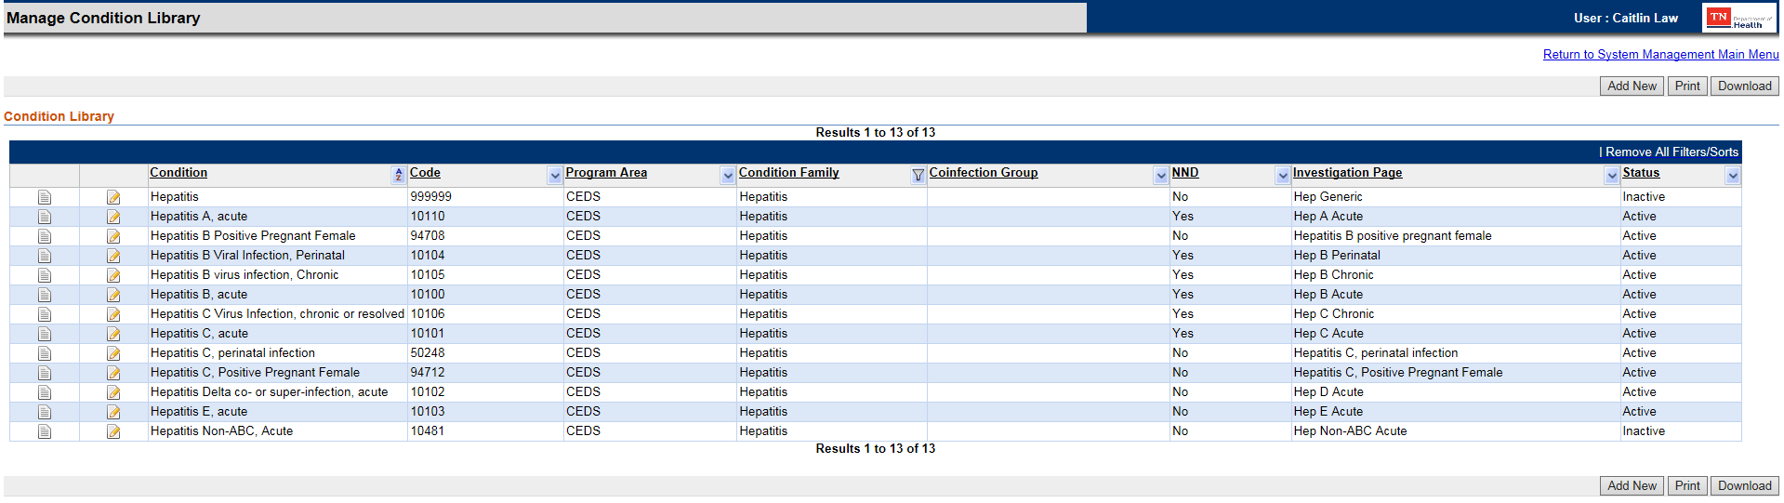
☐ Also check page(s) themselves:
- If the page isn’t created, contact the program to develop. Add any locally defined fields as necessary, referring to the MMG to make sure to get as much as possible into standardized questions (there will be cases this is not possible, in which case, mapping will need to be completed at a later step). When finished, make sure appropriate condition codes are associated to the page(s) and publish.

- Make sure the data ported correctly. Repeat for each environment (at least Staging and Production*); export the page as a template and import into the next environment for best results. The pages need to match between environments to reduce discrepancies in message validation.
*Prod pages must be published on a weekend

- For pages that are already published, ensure that the pages are the same in Staging and Production environments. Not matching can cause problems during message generation and validation.

- Ask the System Admin to pull the metadata script; alternately, if in version 5.4, push the button to run, to compare metadata between page(s) and the MMG. Any discrepancies need to be resolved before continuing to the onboarding process (see next step below).
☐ Enter an NBS Central ticket to work with the support team to ensure don’t need any updates to existing pages,
including assistance with the metadata comparison and any vocabulary update scripts.
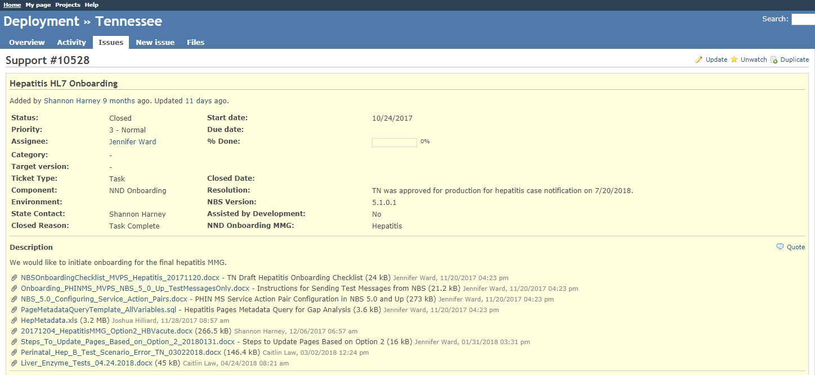
☐ Begin the process in Staging/Test and take a backup of the Staging/Test NBS database.
☐ Turn on or off the lab data to send to CDC. There is an indicator flag located in the condition_code table in the SRT
database (lab_report_enable_ind); ‘Y’ indicates to include related lab block in NND messages and ‘N’ indicates to
NOT include related lab block in NND messages.
☐ Enter the Test Case Scenario data. Fake data can be entered; this does NOT have to follow the scenario from the TCS
as long as the TCS worksheet is updated to reflect what was entered. Populate both the investigation and the lab.
TCSs found here: https://wwwn.cdc.gov/nndss/case-notification/message-mapping-guides.html
See the Hepatitis MMG screenshot below. The information will be in vertical format, so work through one
column at a time. Also, for conditions that include more than just generic version 2 (core) data elements,
there will be other TABS of data (extended elements) that need to be completed.
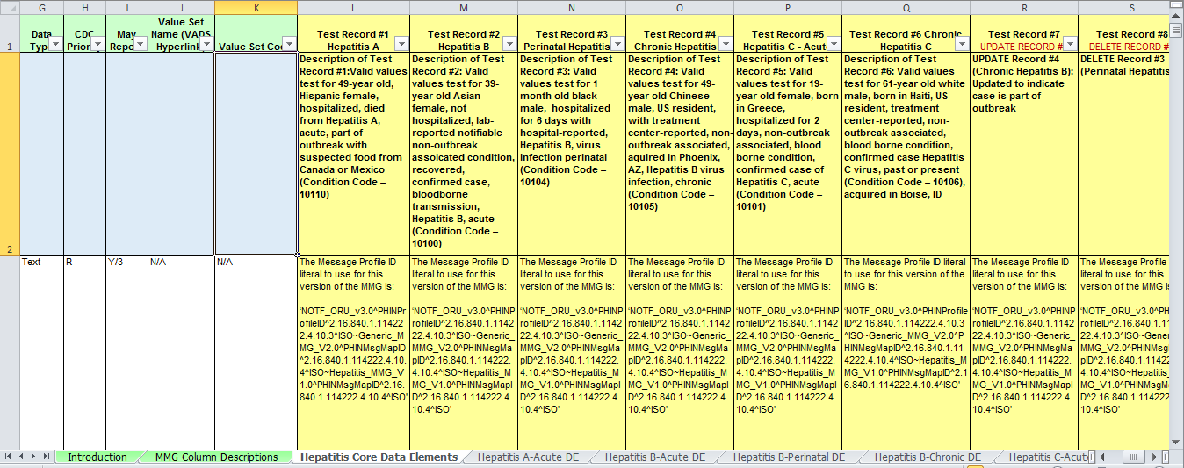
☐ Complete the Implementation Spreadsheet. Compare this to both the metadata query and the user interface
to ensure what is sent or not sent is marked appropriately. This sheet will also include any notes on mapping (blue
box below; if needed to map local question info to a standard question’s usual segment) and database information.
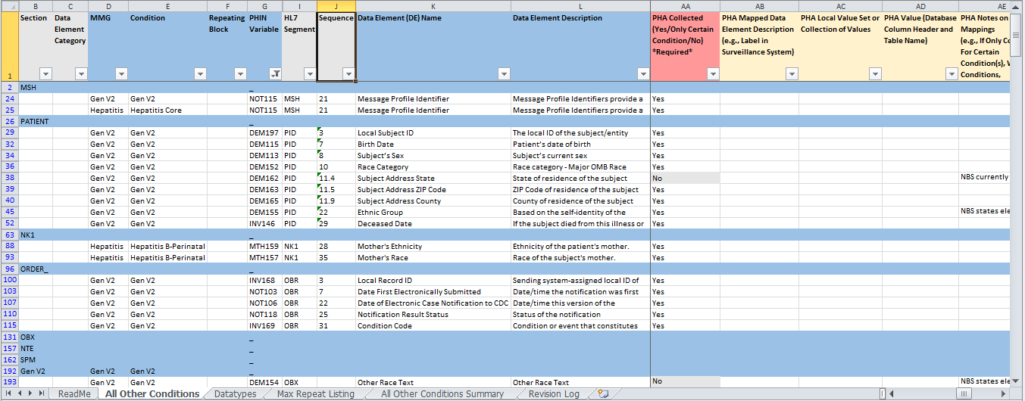

☐ Once the Test Case Scenarios (TCS) and Implementation Spreadsheet (IS) are complete, pull the notifications
generated for the TCSs to compare to the IS and TCS. This will reduce a lot of back and forth during test
scenario/message evaluation.
These can be evaluated in METS or HL7 Soup (SAS – HL7 Parse Code*) to check the structure and for any missing
fields/data elements. Keep CSRA updated on this progress; they will assist with any discrepancies found.
METS:
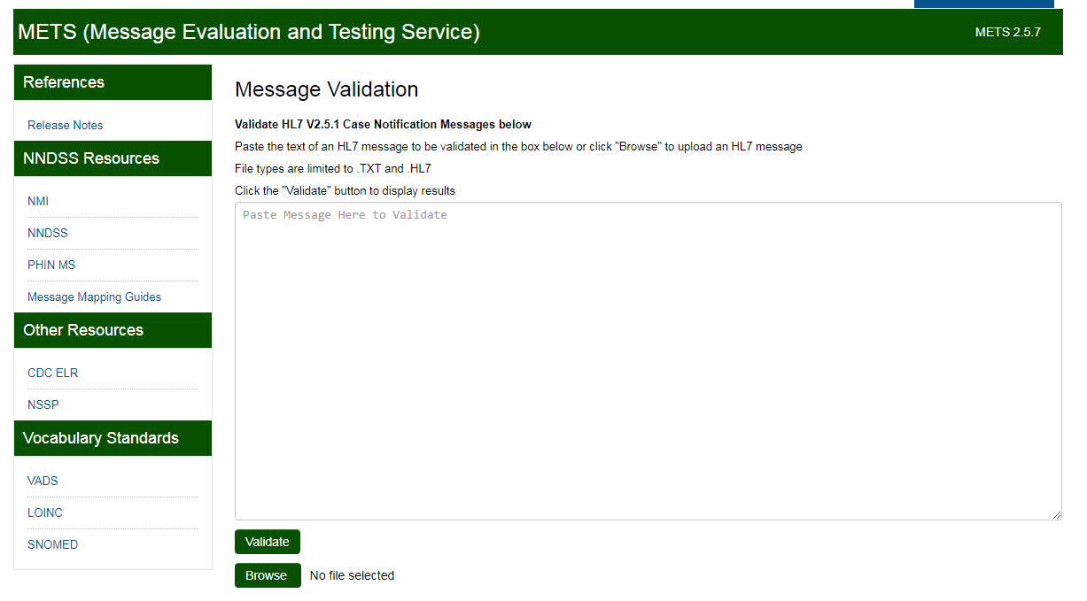
Copy extracted notification message and paste here
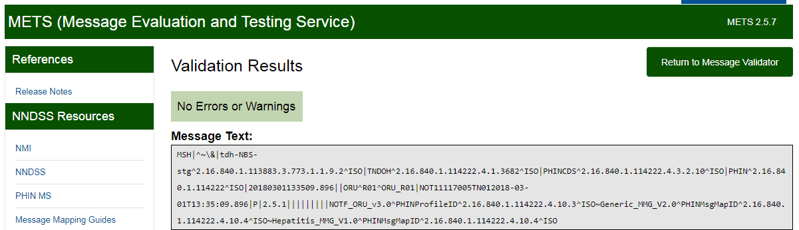

HL7 Soup:
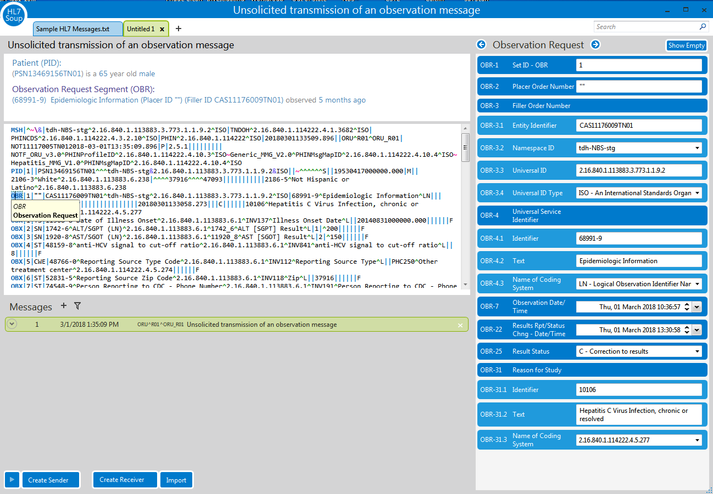

Copy extracted notification message and paste here

Check message validation here

☐ Correct any errors found in the pre-validation process. If needed, re-map the questions on the page or edit the page
as appropriate with guidance/assistance from CSRA. If changes are needed, re-validate the messages after
implementing to ensure the element is properly addressed.

ONBOARDING:
☐ Send an email to EDX@CDC.GOV with the completed Implementation Spreadsheet and Test Case Scenarios
attached.
☐ CDC will schedule an onboarding kickoff call. Coordinate a time frame to send the initial TCSs to MVPS.
☐ Starting in the Staging/test environment, send the TCS messages to CDC’s MVPS Onboarding Environment. On the
front end (System Management), turn the Guide setting from Master Message to the appropriate Message Mapping
Guide (HL7) in the Page Management/Page Details menu.
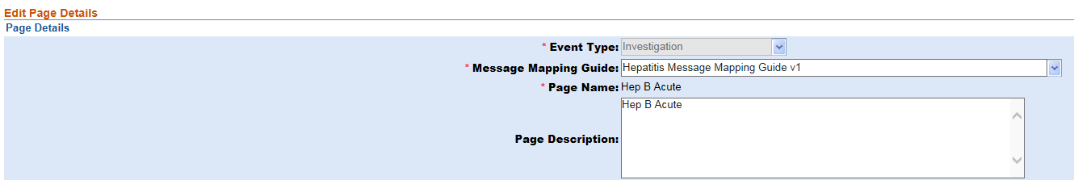
Most of the rest of this is IT team work, but Also reference the
Onboarding_PHINMS_MVPS_NBS_5_0_up_TestMessageOnly document for instructions on changing service action
pairs to assist the IT team.
☐ Once messages are sent, check MVPS.
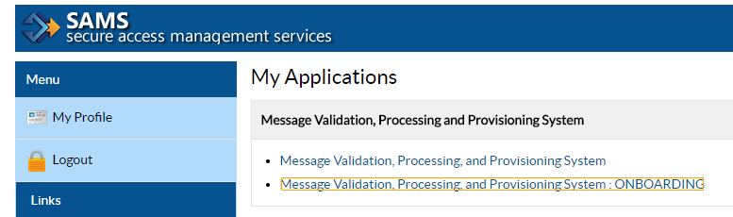
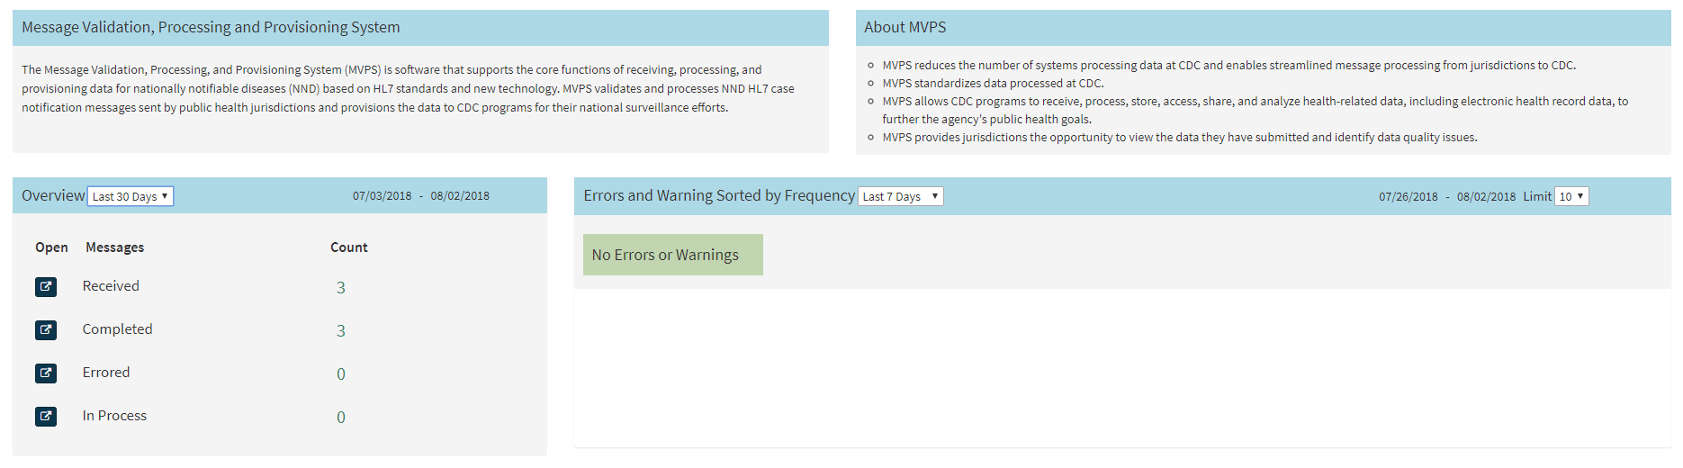
If/when successful, send an email to the EDX/NMI team that they were successfully sent.
☐ CDC will evaluate the sent messages. Hopefully with the validation completed on the front end, these will pass
validation within the first few review passes. Continue to work with CDC and CSRA to correct any issues
identified in the message review and resend until messages pass validation.
☐ If any page changes are completed in Staging/Test to appropriately send the message, ENSURE these are pulled over
to Production before the next step. Otherwise, the same error will occur.
☐ Once the Staging Test Case Scenarios are validated, CDC will approve to move forward. Pick a number of limited
Production messages to send to the MVPS Onboarding environment. Preferably, these will be as fully populated as
possible; it is beneficial to consult/search the Reporting Database to find these cases.
Which MMG is being onboarded will determine how many limited production messages to send. Generally, it’s 1-2
cases /messages per condition being onboarded, with an exception for Gen v2.
☐ The system admin will need to repeat the back end configurations to set NBS Production up properly to route to
MVPS Onboarding environment. On the front end, again change the Message Mapping Guide in Page Details, but
turn it back to Master Message and turn off the configurations once these few cases are sent.
☐ The evaluation process starts over again; continue working with CDC and CSRA to get the Prod messages validated.
☐ Once the limited production messages are validated and approved, a YTD file will be sent.
- If onboarding after the annual reconciliation process, only the current YTD file may need to be sent*.
- If onboarding before reconciliation is closed, the previous YTD file along with the current YTD file may need to be sent.
*Confirm this with CDC; this could be a hepatitis-only situation due to volume/high burden
☐ Monitor MVPS while the YTD file is being sent and make any changes associated with any errors received. The system
should be holding all other notifications until the YTD file is verified.
☐ If the YTD file passes validation, CDC will send approval to go live!
The system administrator will have to ensure all back end configurations are appropriate and the system can start
sending notifications again.
☐ Start monitoring MVPS for errors (weekly) and reach out to programs to resolve any issues.

